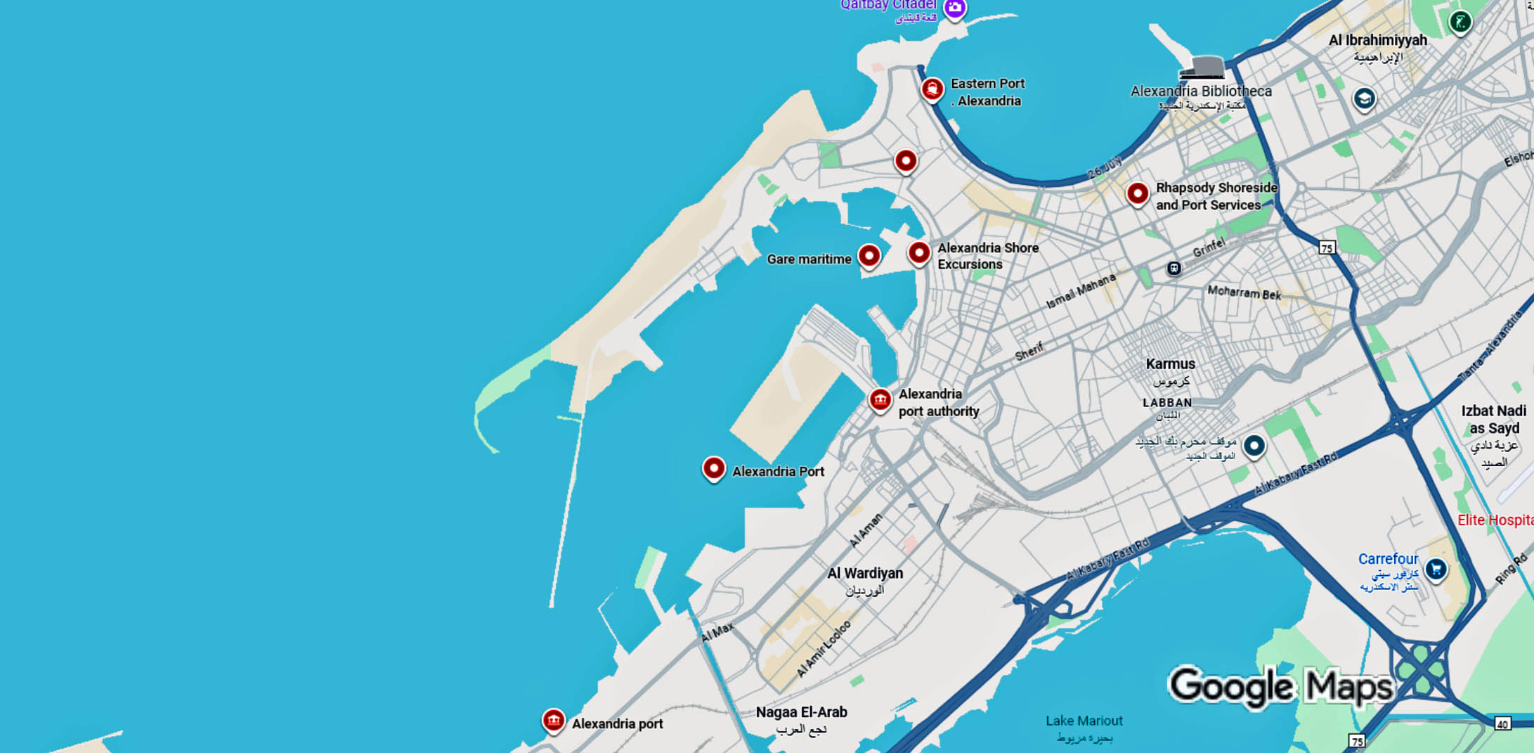
Self-Guided Walking Tour:
Approx. Time: 2.5 hours | Total Distance: 1.5 miles (2.4 km) | Start & End: Alexandria Cruise Terminal / Western Harbor

1. Cruise Terminal and Corniche (Start)
Time: Begin directly from the terminal
Highlight: Step outside onto the Corniche, Alexandria’s famous seaside boulevard that stretches for miles along the Mediterranean. Watch fishing boats in the harbor and take in views of the modern city built over layers of ancient history.
Tip: The Corniche is ideal for photos, especially early morning when light reflects off the sea.

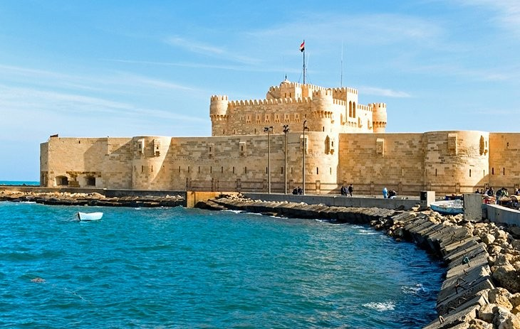
2. Qaitbay Citadel
Time: 10-minute walk west along the Corniche
What to See: The Qaitbay Citadel stands on the site of the ancient Pharos Lighthouse, one of the Seven Wonders of the Ancient World. Built in the 15th century, it guarded the harbor against invaders.
Inside: Small exhibits display naval history and panoramic views across the Mediterranean. Don’t miss standing on the same ground where the lighthouse once stood.

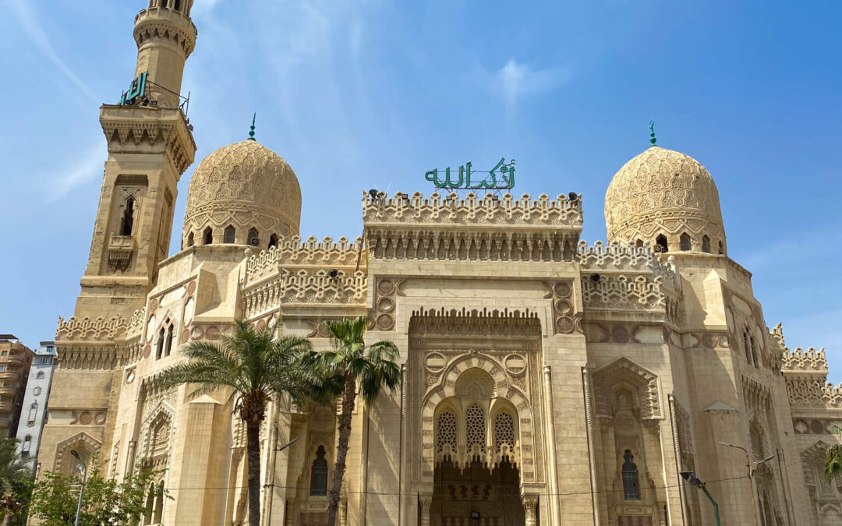
3. Abu El Abbas Al Mursi Mosque
Time: 10 minutes south through the Anfushi district
Highlight: Alexandria’s most beautiful mosque, built in 1945 in Moorish style. Its domes, arches, and calligraphy create a striking skyline visible from the Corniche.
Note: Non-Muslims may enter the courtyard outside prayer times. Dress modestly — shoulders and knees covered.

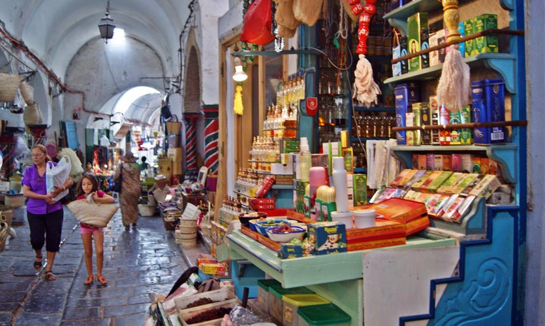
4. The Fish Market (Souk El-Samak)
Time: 5-minute walk back toward the harbor
What to See: A lively seafood market where local fishermen sell the morning’s catch — red mullet, squid, and Mediterranean shrimp. Nearby restaurants will cook your choice on the spot.
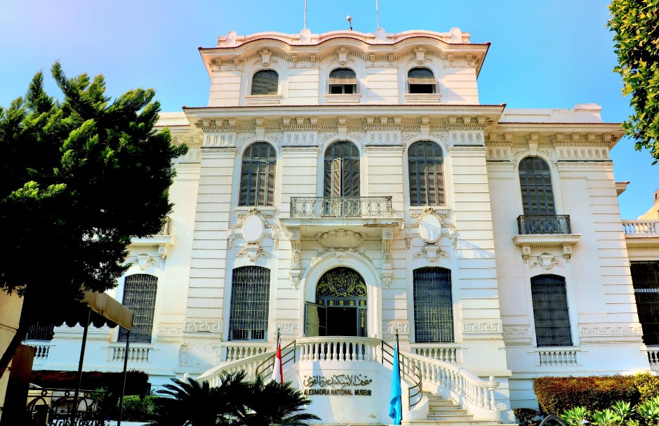
Tip: Try grilled sea bass with lemon and tahini — a local favorite.

5. The Alexandria National Museum
Time: 15-minute taxi or 25-minute walk east along the Corniche
Highlight: Set in a restored Italian-style mansion, the museum covers 5,000 years of Alexandria’s history — from Pharaonic artifacts to Roman statues retrieved from the harbor floor.
Don’t Miss: The underwater archaeology section featuring relics from the lost royal quarter of ancient Alexandria.

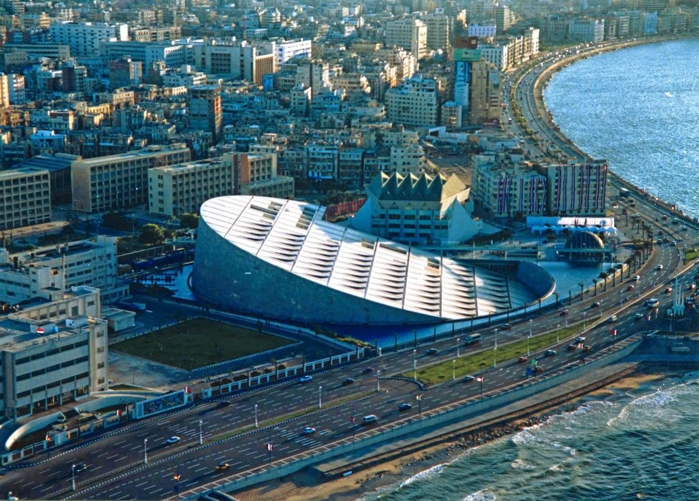
6. Bibliotheca Alexandrina (Modern Library of Alexandria)
Time: 10-minute walk along the Corniche
What to See: Inspired by the legendary Library of Alexandria, this modern architectural marvel holds millions of books, art galleries, and museums. The building’s slanted granite façade is inscribed with scripts from every known language.
Tip: The open plaza and reflecting pools make great photo stops. Inside, guided tours run regularly and last about 45 minutes.

7. Return Along the Corniche
Time: 20-minute walk or short taxi back to the cruise terminal
Highlight: Enjoy a leisurely stroll back along the seafront. Stop for a fresh juice or espresso at a café such as Trianon or Délices, both historic institutions dating from Alexandria’s cosmopolitan golden age.

Local Tips
- Currency: Egyptian Pound (EGP); small USD or Euro notes sometimes accepted.
- Language: Arabic; English widely understood in tourist areas.
- Dress: Modest casual clothing; light and breathable for the climate.
- Safety: Very safe for pedestrians; watch traffic crossings.
- Hydration: Bring bottled water — Alexandria’s sun can be intense.
- Tipping: 10–15% for cafés, taxis, and guides.

Total Walking Time: ~2.5 hours (plus museum or library stops)
Difficulty: Easy to moderate – mostly flat with some cobblestone sections

“Keep exploring — your next favorite discovery might be waiting along the shores of ancient Alexandria.”

