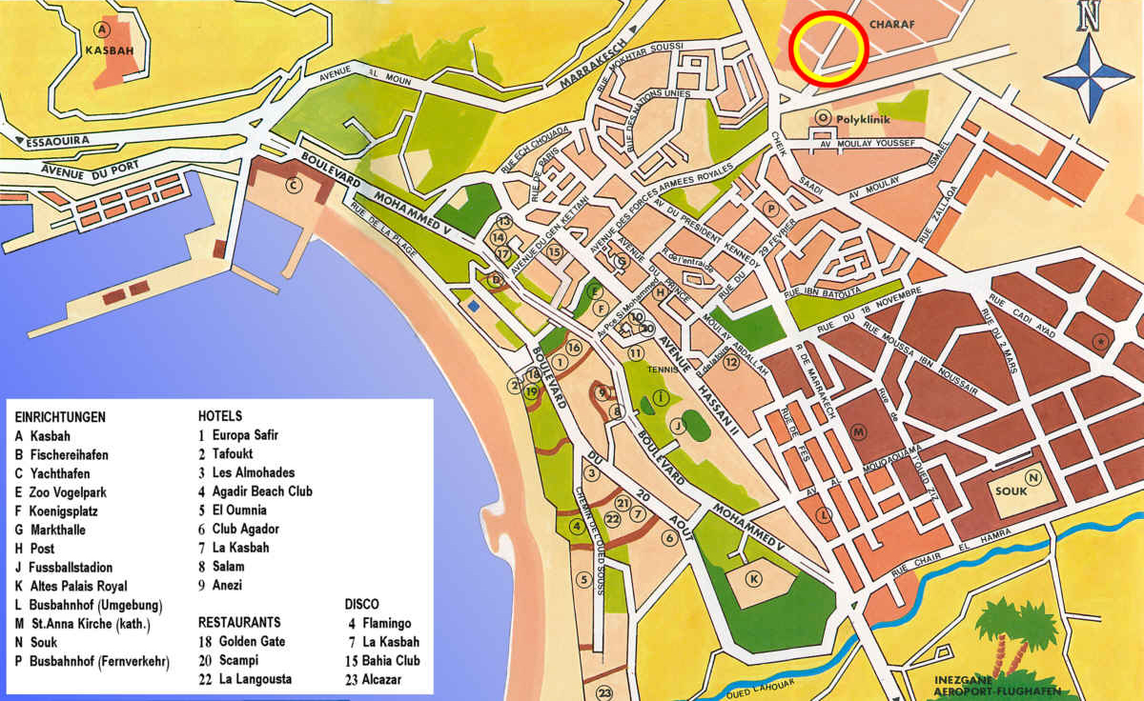
Self-Guided Walking Tour: Agadir, Morocco
Approx. Time: 2 hours | Total Distance: 1.4 miles (2.2 km) | Start & End: Agadir Cruise Terminal

1. Agadir Cruise Terminal and Marina (Start)
Time: 10 minutes from the ship
Highlight: Begin your walk at the Agadir Marina, a modern hub lined with cafés, boutiques, and luxury yachts. It’s the best place to start soaking in the relaxed seaside atmosphere before heading into town.
Tip: Stop at Café Jour et Nuit or La Terrasse for Moroccan mint tea and views of the harbor.

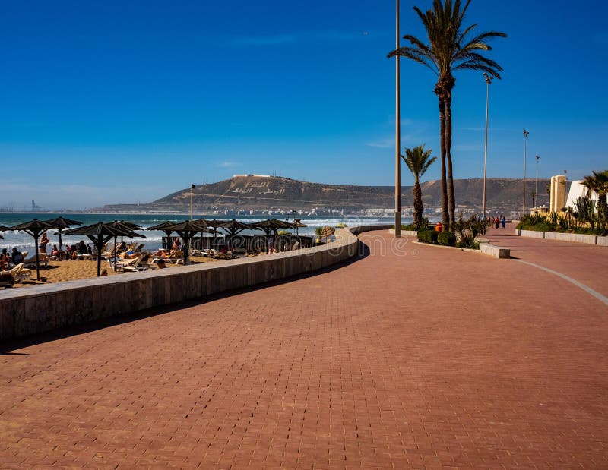
2. Agadir Beach Promenade (Corniche)
Time: 5-minute stroll south from the marina
What to See: The Corniche stretches for miles along the Atlantic. Palm-lined and lively, it’s perfect for people-watching, photography, and enjoying Agadir’s sunny climate. Locals jog, families gather, and vendors sell roasted nuts and fresh orange juice.
Photo Stop: The “I ♥ Agadir” sign near the main promenade is an ideal place for pictures.
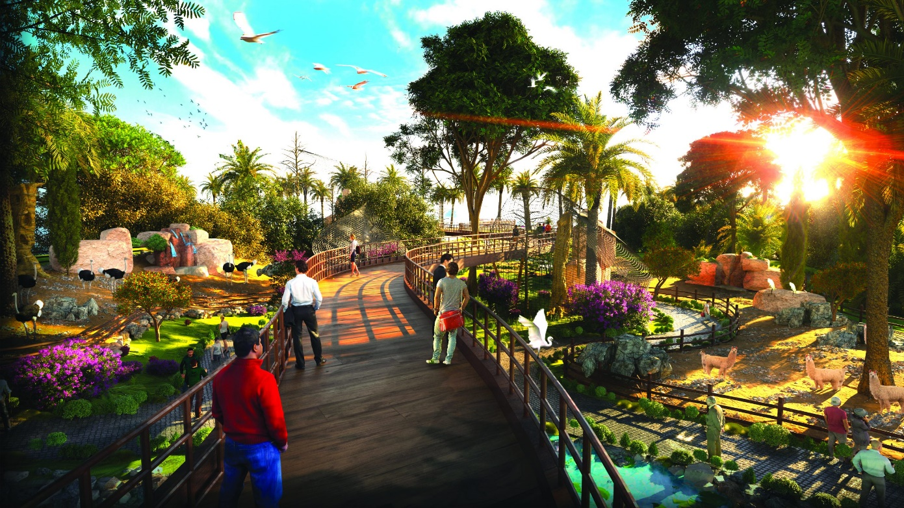
3. Agadir Birds Valley (Vallée des Oiseaux)
Time: 10-minute walk inland along Boulevard du 20 Août
Highlight: A small but lovely zoological garden running through the city center, free to enter and shaded with palm trees. Parrots, flamingos, and peacocks share space with landscaped gardens and local art.
Tip: It’s a quiet break from the sun and a favorite stop for nature lovers.

4. Souk El Had (The Grand Market)
Time: 15-minute taxi ride or 30-minute walk inland
What to See: The Souk El Had is one of Morocco’s largest enclosed markets, with over 3,000 stalls selling spices, textiles, leather, ceramics, and argan oil. The name means “Sunday Market,” but it’s open daily except Monday.
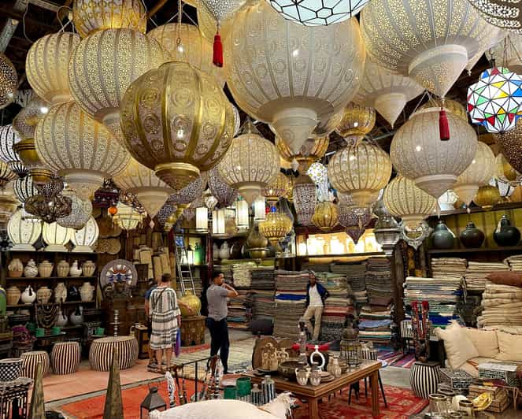
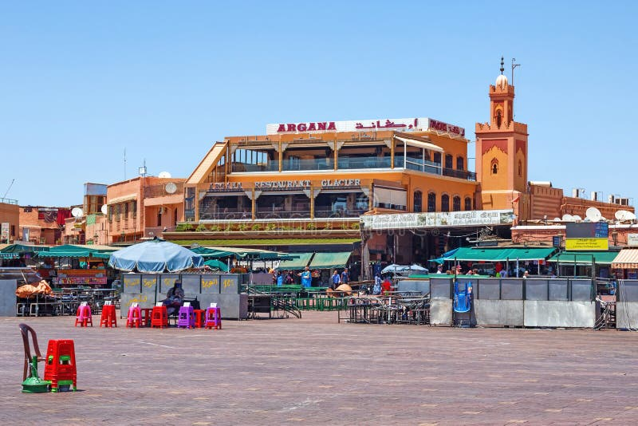
Tip: Practice friendly bargaining, start around half the asking price. Keep small bills ready for easy purchases. 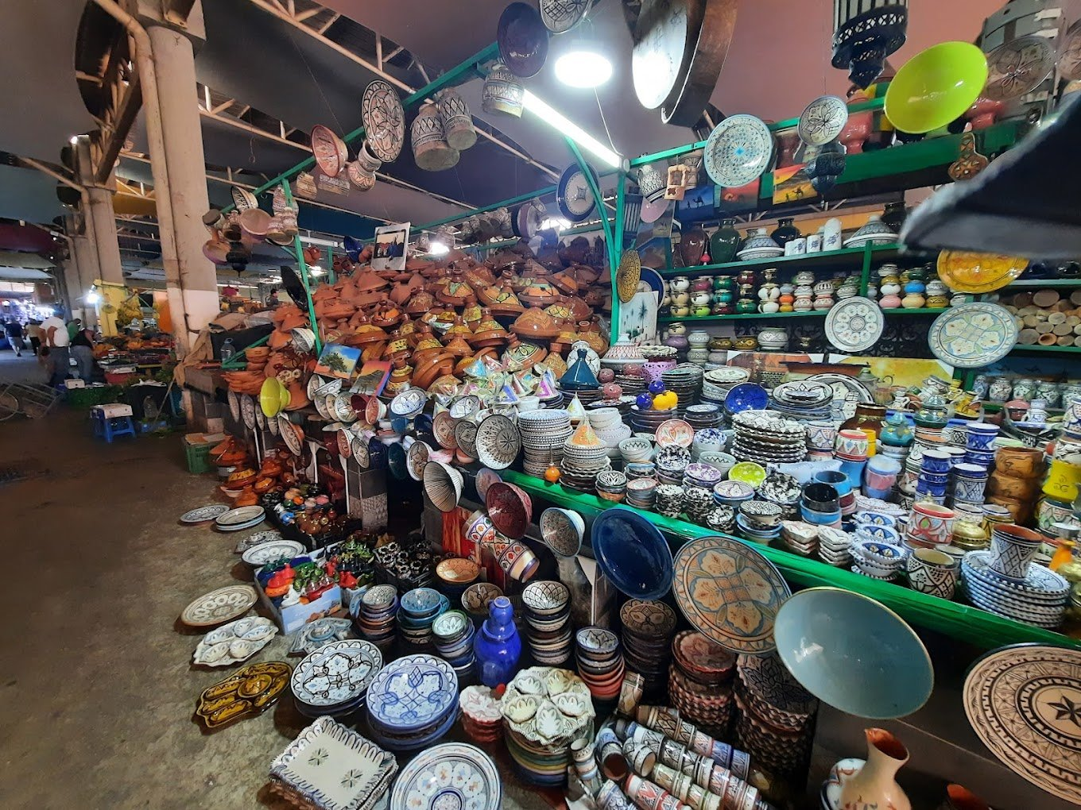

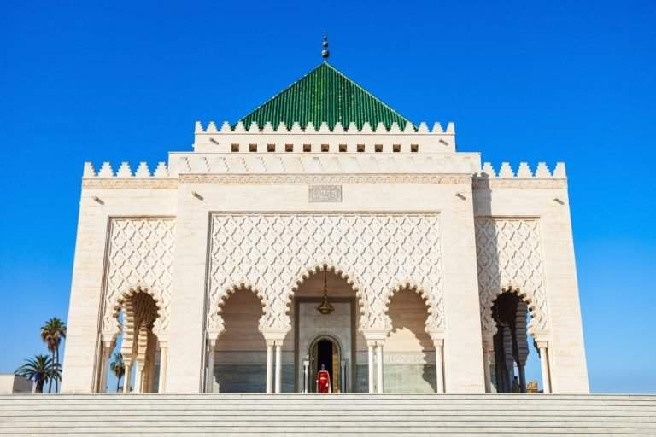
5. Mohamed V Mosque
Time: 10-minute walk east of the Souk
Highlight: Built after the 1960 earthquake, this mosque showcases beautiful Moroccan craftsmanship, geometric tilework, carved plaster, and a distinctive square minaret.
Note: Non-Muslims cannot enter but can admire the exterior and take photographs respectfully.
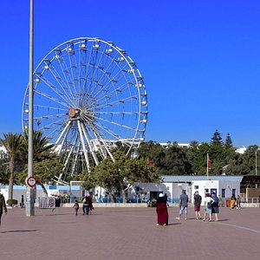
6. Jardin de Olhão (Olhao Garden)
Time: 10 minutes south toward Avenue Hassan II
What to See: A tranquil garden honoring Agadir’s partnership with the Portuguese city of Olhão. Pathways, fountains, and shaded seating areas offer a peaceful retreat. The Olhão Museum inside the park displays photos and stories of the 1960 earthquake that reshaped the city.

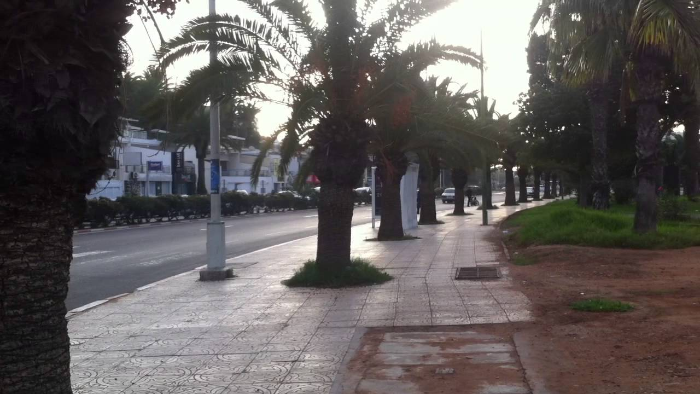
7. Return Walk via Avenue Mohammed V
Time: 20-minute walk or short taxi ride back to the cruise terminal
Highlight: Avenue Mohammed V connects downtown with the beachfront. The route is filled with shops, cafés, and small art galleries. You’ll rejoin the promenade near the marina where you began.
Optional: Take the short taxi or funicular up to Agadir Oufella (Kasbah Hill) for panoramic views over the city and bay, best at sunset.

Local Tips
- Currency: Moroccan Dirham (MAD).
- Language: Arabic and French; English in tourist areas.
- Dress: Modest casual attire; light fabrics for warm weather.
- Safety: Very safe; stay aware in markets.
- Hydration: Carry bottled water, the sun can be strong year-round.
- Tipping: 10% appreciated in cafés and taxis.

Total Walking Time: ~2 hours (plus optional Souk visit)
Difficulty: Easy – flat and fully paved routes

Tagline for footer:
“Keep exploring, your next favorite discovery might be waiting along Agadir’s sunny Corniche.”

