Aconcagua: Chile’s Bold and Diverse Wine Region
Region Overview
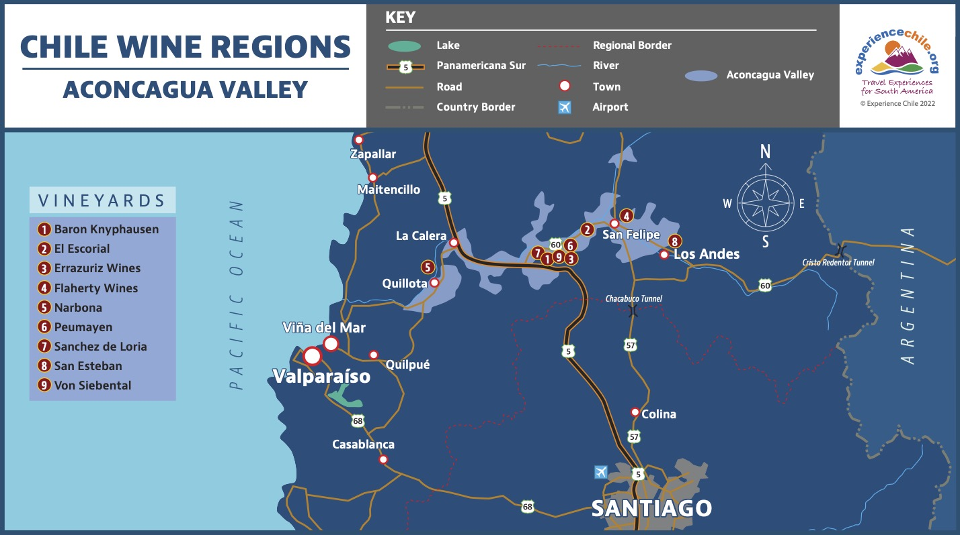
The Aconcagua wine region, located in central Chile, is one of the country’s most historically significant wine-producing areas. Named after Mount Aconcagua—the highest peak in the Western Hemisphere—this region benefits from a Mediterranean climate, diverse terroirs, and a reputation for producing powerful red wines and elegant whites.
Situated between 32° and 33° latitude south, Aconcagua’s vineyards stretch from the Andes Mountains in the east to the Pacific Ocean in the west, creating three distinct viticultural zones: Aconcagua Valley, Casablanca Valley, and San Antonio Valley. These areas showcase the breadth of Chilean winemaking, from rich Cabernet Sauvignon and Syrah in the warmer inland valleys to crisp Sauvignon Blanc and Chardonnay near the cool coast.
Key Grape Varieties
Aconcagua is best known for its full-bodied reds, but the region also produces high-quality whites, particularly in its coastal valleys:
- Cabernet Sauvignon – Aconcagua Valley’s flagship variety, producing bold wines with cassis, black cherry, and structured tannins.
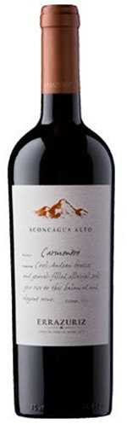
- Syrah – Powerful and spicy, with dark fruit, smoky notes, and excellent aging potential.
- Carmenère – Deep and velvety, with black fruit, green pepper, and a signature herbal character.
- Sauvignon Blanc – Expressive and vibrant, thriving in coastal areas like Casablanca and San Antonio.
- Chardonnay – Mineral-driven and elegant, often with citrus, white flower, and saline notes.
- Pinot Noir – Gaining recognition in Casablanca and San Antonio, where the cool climate produces delicate and aromatic styles.
Wine Classification System
Aconcagua is recognized under Chile’s Denomination of Origin (DO) system and is divided into three primary subregions:
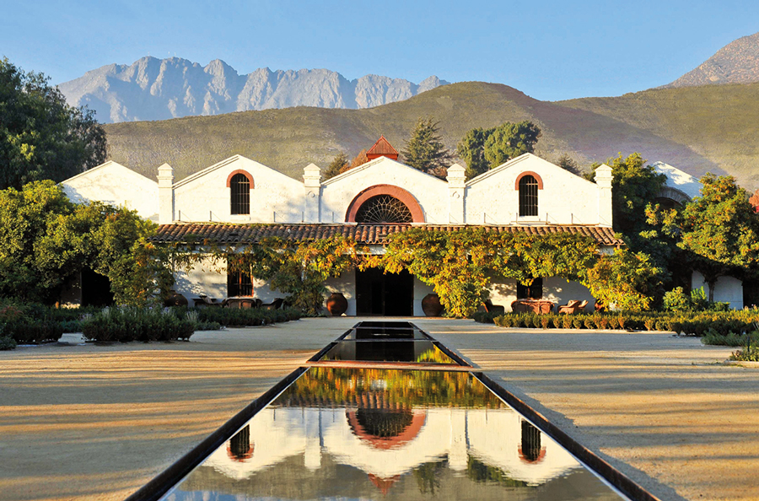
- Aconcagua Valley – One of Chile’s warmest wine-growing areas, specializing in full-bodied reds, particularly Cabernet Sauvignon and Syrah. Some of the country’s most prestigious wineries, such as Viña Errázuriz, are located here.
Figure 1 Viña Errázuriz
- Casablanca Valley – A cool-climate coastal region, heavily influenced by the Humboldt Current, producing highly aromatic Sauvignon Blanc, Chardonnay, and Pinot Noir.
- San Antonio Valley – Even cooler than Casablanca, known for mineral-rich Sauvignon Blanc, structured Pinot Noir, and fresh Syrah. The Leyda subregion, in particular, has gained international acclaim for its white wines.
Notable Wine Styles
- Rich, Structured Cabernet Sauvignon – Concentrated black fruit, firm tannins, and excellent aging potential.
- Spicy, Elegant Syrah – Deep and expressive, with layers of black pepper, dark fruit, and floral notes.
- Cool-Climate Sauvignon Blanc – Intense aromatics, crisp acidity, and vibrant citrus flavors.
- Silky, Fresh Pinot Noir – Earthy and red-fruited, with refined tannins and bright acidity.
- Limestone-Driven Chardonnay – Bright, mineral, and well-structured, with citrus and saline elements.
Additional Context
Aconcagua’s wine industry has evolved from a region dominated by bold reds to a more diverse viticultural area. While Aconcagua Valley remains a stronghold for full-bodied Cabernet Sauvignon and Syrah, the coastal subregions of Casablanca and San Antonio have transformed Chile’s reputation for white wines, particularly Sauvignon Blanc and Chardonnay.
Producers in Aconcagua are increasingly adopting sustainable and organic viticulture, with a focus on terroir-driven winemaking. The influence of pioneering wineries such as Viña Errázuriz and Matetic Vineyards has cemented Aconcagua’s place among Chile’s most important wine regions.
Takeaway for Sommeliers
Aconcagua is a must-know region for sommeliers looking to understand Chile’s diverse winemaking landscape. From powerful, structured reds in the Aconcagua Valley to fresh, vibrant whites and Pinot Noir along the coastal zones, this region offers wines suited to both traditional and modern palates. Understanding the three subregions and their distinct expressions is key to appreciating the full spectrum of Aconcagua’s wines.
References
- Robinson, J., & Harding, J. (2020). The Oxford Companion to Wine (5th ed.). Oxford University Press.
- Wines of Chile. (2023). Regional Profiles and Climate Data. Retrieved from https://www.winesofchile.org
- Tapia, P. (2022). The Wines of South America. Infinite Ideas.
- Wine Spectator. (2022). Top-Rated Wines from Aconcagua. Retrieved from https://www.winespectator.com

