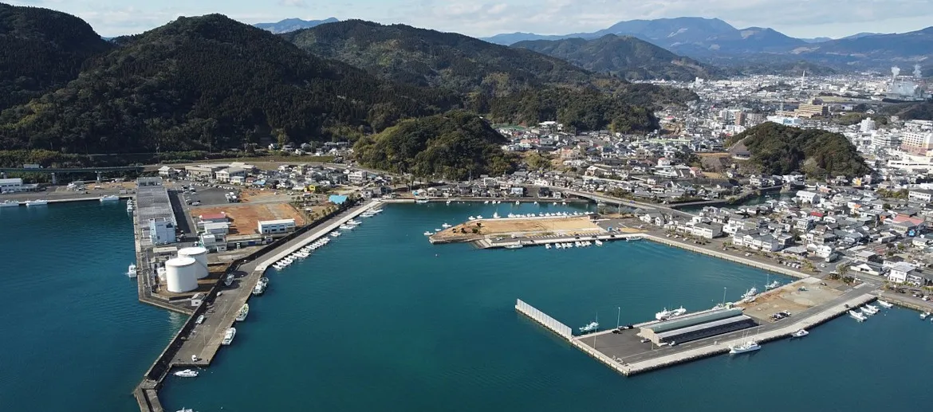
Aburatsu Japan Walking Tour
Welcome to Aburatsu
Welcome to Aburatsu, a charming coastal town in Miyazaki Prefecture on Japan’s southern island of Kyushu. Small, warm, and wonderfully local, Aburatsu offers a glimpse of everyday Japanese life away from the big cities.
It’s best known as the gateway to Udo Shrine and Nichinan’s scenic coastline, but the port itself, with its narrow streets, traditional shops, and relaxed harbor atmosphere, is ideal for exploring on foot.
Today’s walking tour highlights Aburatsu’s harbor front, old town, and local shrines, ending at a peaceful seaside overlook.

Starting Point – Aburatsu Port Cruise Terminal
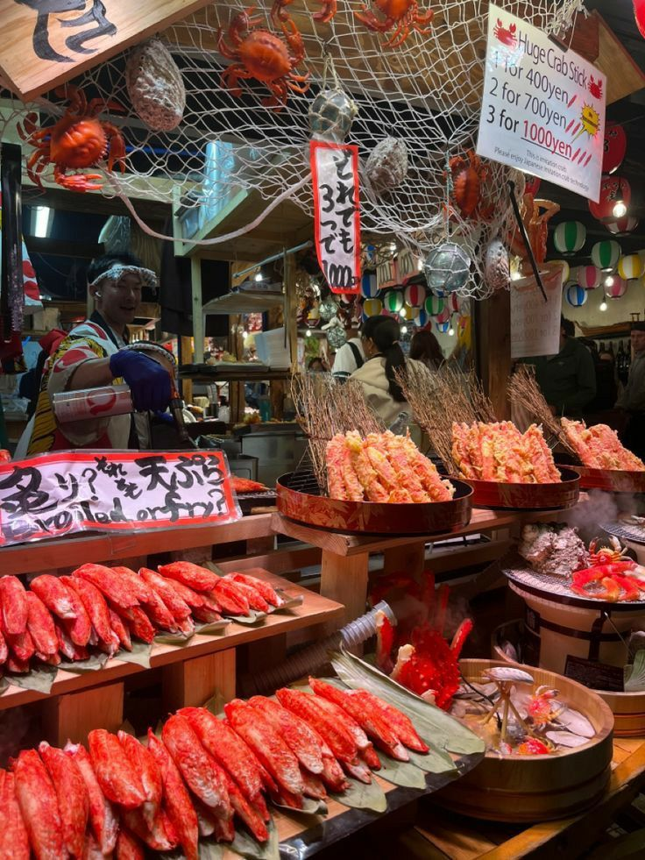
Your ship arrives at Aburatsu Port, one of Kyushu’s smaller cruise stops and a working fishing harbor. The air smells faintly of the sea and pinewood, a sign you’ve reached Japan’s sunniest southern coast.
From the terminal, it’s about a 10-minute walk into town along quiet, flat streets lined with homes, small boats, and palm trees swaying in the breeze.

Stop 1 – Aburatsu Harborfront & Fish Market
Start your walk along the harborfront, where local fishermen unload their morning catch. You’ll often see trays of tuna, mackerel, and squid, the area is famous for its fresh seafood.
A small fish market near the port sells sashimi bento boxes, dried fish snacks, and local specialties like katsuo tataki (seared bonito). It’s a perfect spot for photos and a taste of Aburatsu’s maritime life.

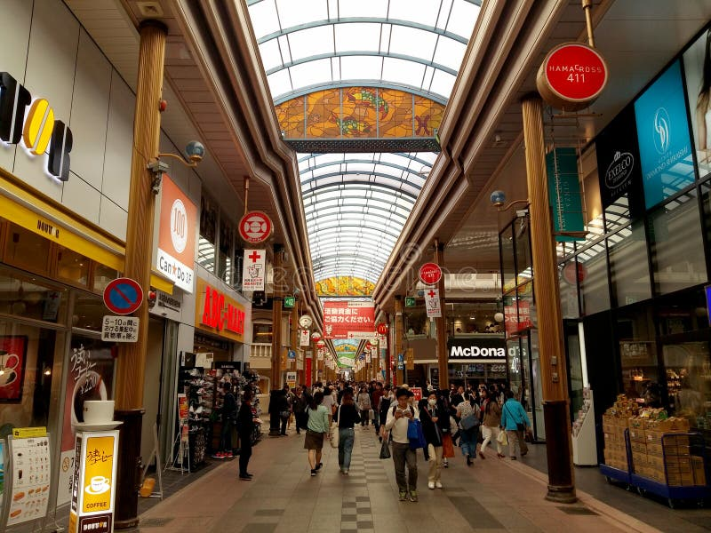
Stop 2 – Aburatsu Shopping Street (Shotengai)
Head into town toward the Aburatsu Shotengai, a covered pedestrian arcade filled with small shops, cafés, and local craft stores.
You’ll find friendly merchants selling hand-carved woodwork, regional souvenirs, and homemade sweets.
Stop for a matcha latte or a scoop of mango ice cream, made from local Nichinan mangoes, a southern Kyushu favorite.
The pace here is slow, and shopkeepers often wave hello as you pass.

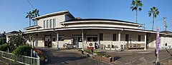
Stop 3 – Aburatsu Station & Retro Railway Ambience
A few blocks inland, you’ll reach Aburatsu Station, a quaint local stop on the Nichinan Line.
If you’re lucky, you might see the Umisachi Yamasachi Sightseeing Train, a beautiful white-and-wood excursion train that runs between Miyazaki and Nichinan. It’s known for its panoramic coastal views and interior crafted entirely from local wood.
Even if you’re not boarding, the station itself is a great example of small-town Japan, tidy, charming, and full of local pride.

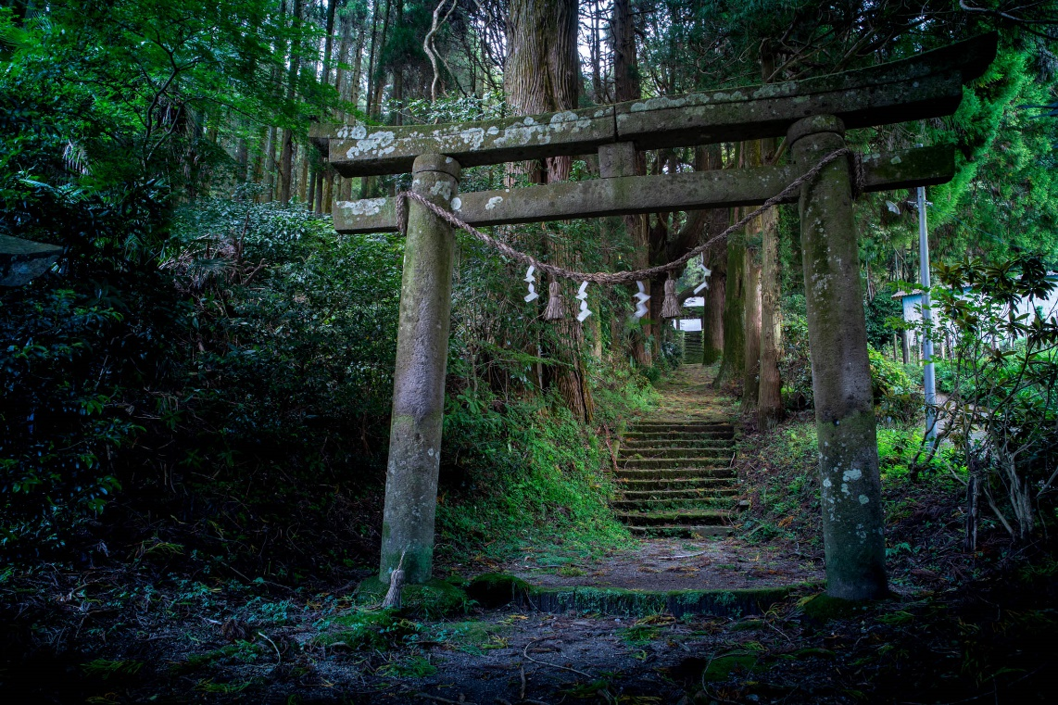
Stop 4 – Shintomi Shrine (Local Heritage Stop)
Walk a few minutes from the station to Shintomi Shrine, a peaceful local temple surrounded by tall cedar trees. It’s small and often quiet, a good place to pause and listen to birds or the soft ringing of the wind chime by the main hall.
Shrines like this are an essential part of everyday life in Japan’s smaller towns, serving as places for seasonal festivals and quiet reflection.

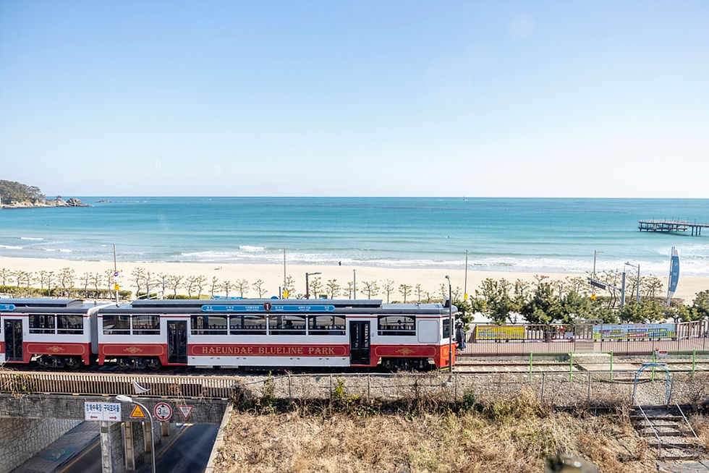
Stop 5 – Nichinan Line Walkway & Seaside Path
From town, you can follow the Nichinan Line walkway back toward the sea. The trail parallels the coastal railway and offers wide-open views of the Pacific Ocean.
On clear days, you can see as far as Cape Toi in the distance. It’s a lovely, gentle walk with benches for resting and taking in the salty air.
The coastline here defines the rhythm of life, calm, blue, and deeply connected to the sea.

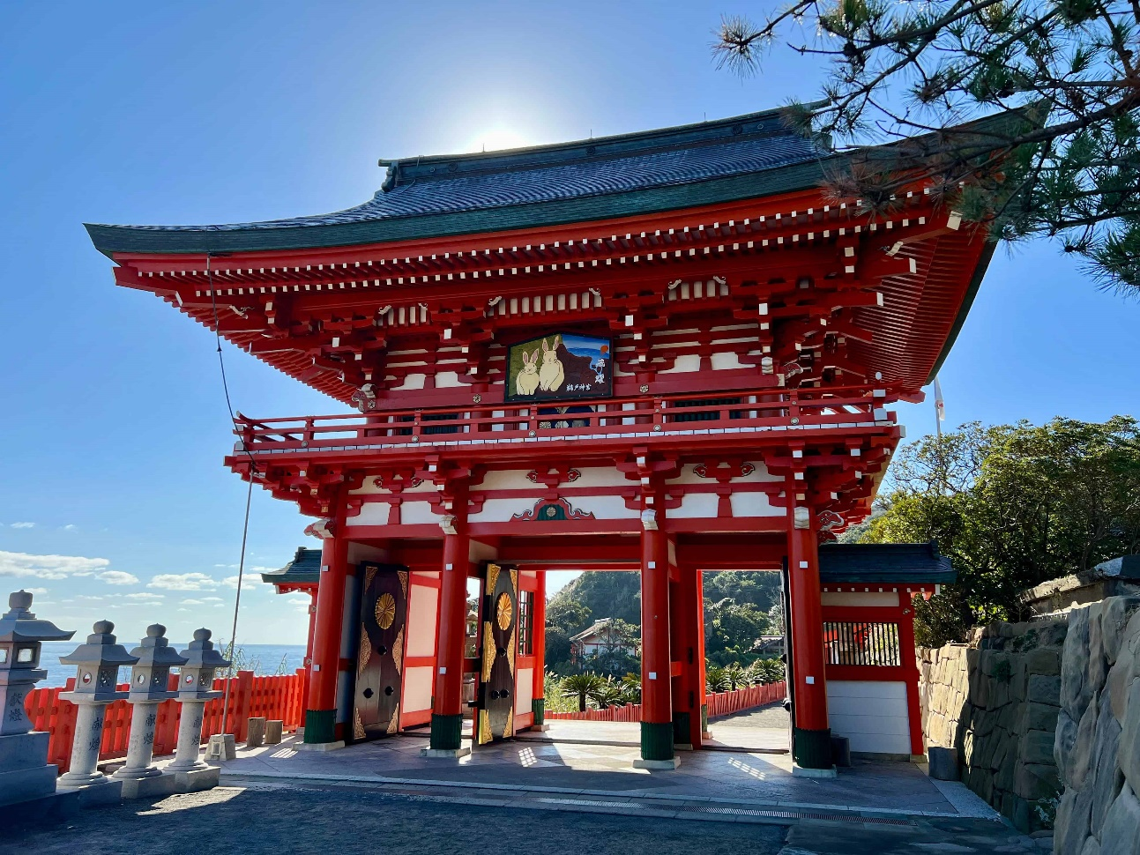
Stop 6 – Udo Shrine (Optional Half-Day Extension)
If you have time for a short excursion, take a taxi (about 20 minutes) to Udo-jingū, one of Japan’s most breathtaking coastal shrines.
Built into seaside cliffs overlooking the waves, it’s dedicated to the father of Japan’s first emperor. The shrine’s bright red buildings and ocean cave setting make it one of the most photographed spots in southern Kyushu.
Visitors toss clay balls toward a sacred target on the rocks below for good luck, an unforgettable local tradition.

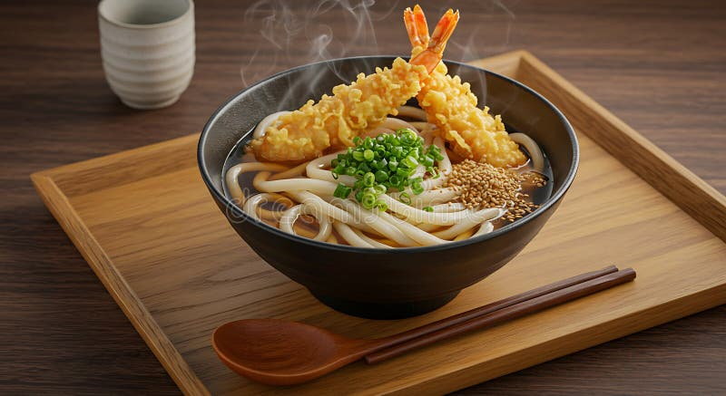
Stop 7 – Local Cafés & Portside Lunch Spots
Back in town, stop for lunch at one of Aburatsu’s harbor cafés or izakaya. Local specialties include:
- Katsuo tataki – seared bonito with citrus and soy.
- Chicken nanban – fried chicken in sweet vinegar with tartar sauce, a Miyazaki classic.
- Udon with tempura shrimp – a comfort food favorite.
Pair your meal with Hyuganatsu juice, a local citrus drink, and enjoy the slow pace of this fishing port.

Stop 8 – Aburatsu Port Park & Overlook
End your walk at the Port Park Overlook, just a few minutes from where your ship is docked. From here, you can see the bay, the town’s rooftops, and the green hills rolling into the distance.
It’s a quiet spot to sit, watch the boats, and reflect on the peaceful rhythm of southern Japan’s smaller coastal towns.

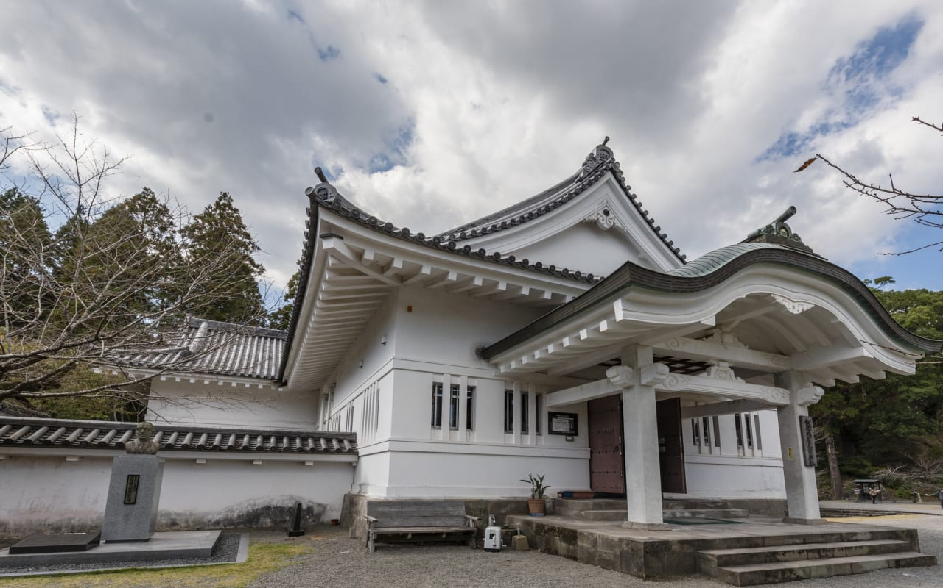
Optional Add-Ons
If you have extra time or transportation:
- Visit Obi Castle Town, known as “Little Kyoto of Kyushu,” with samurai homes and museums (25 minutes by car).
- Stop at Sun Messe Nichinan, famous for its seaside replicas of Easter Island moai statues.
- Or take a drive along the Nichinan Coast, one of Japan’s most scenic ocean roads.

Return Toward Port
As you return to the port, the late afternoon sun often glows golden on the water. You’ll hear the quiet sounds of seagulls, fishing boats, and the low hum of the small-town harbor settling into evening.
Aburatsu may be modest in size, but its character and hospitality make it one of the most memorable small ports in Japan.

Aburatsu is the kind of place that reminds travelers why small ports matter, where every smile is genuine and every corner tells a story of connection to land and sea.
It’s a town that doesn’t rush, doesn’t boast, and doesn’t need to. Here, the beauty lies in the quiet, in the rhythm of the tide and the warmth of the people who call this little harbor home.

