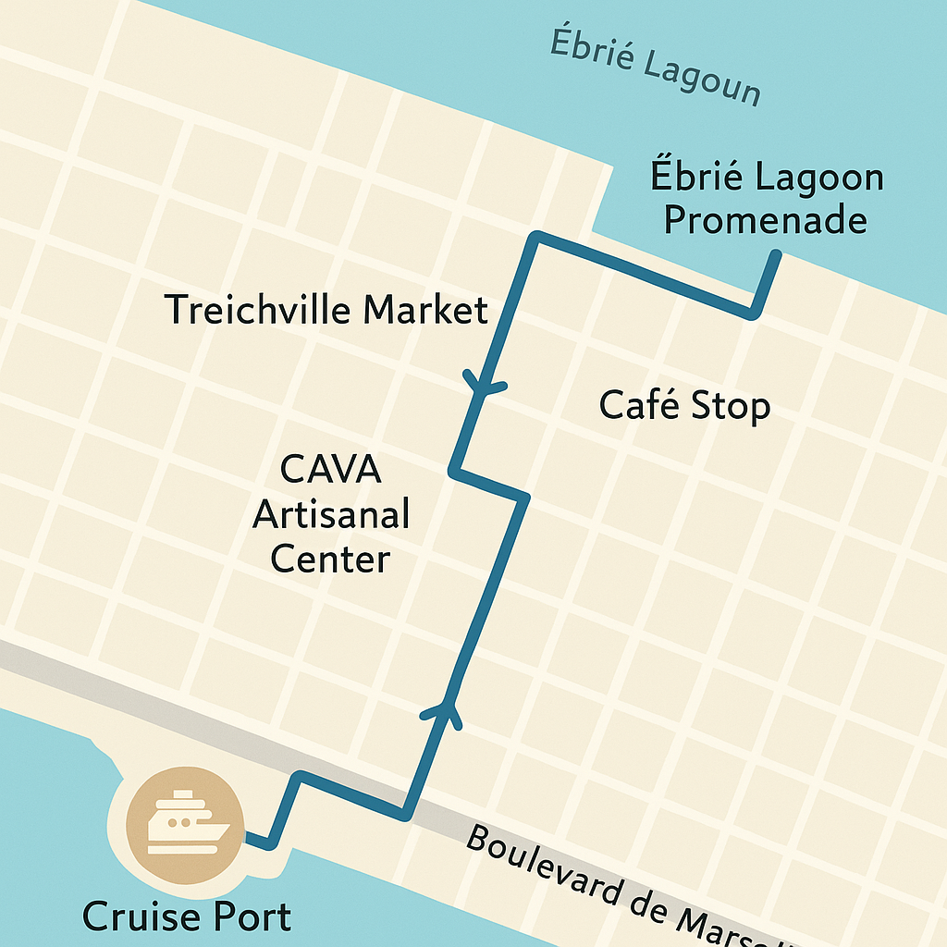
Abidjan Ghana Self-Guided Walking Tour: Exploring Abidjan from the Cruise Port
Starting Point: Abidjan Cruise Terminal, Treichville District
Total Distance: Approximately 2 miles (3.2 km) round trip
Estimated Time: 1.5 to 2 hours at an easy pace
Difficulty: Easy — mostly flat terrain
Language Note: French is the main language, but many vendors and drivers speak basic English.

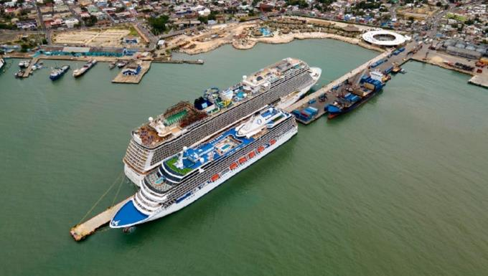
1. From the Cruise Port to Avenue de Marseille
Step out of the cruise terminal and walk north toward Avenue de Marseille, the main artery through the Treichville district.
You’ll immediately sense the city’s pulse, the air is thick with music, cooking aromas, and the buzz of daily life.
Along the way, you’ll pass small kiosks selling fresh fruit, handmade jewelry, and phone cards. This short walk (about 10 minutes) is a window into Abidjan’s everyday rhythm.
Tip: Street vendors appreciate a friendly “Bonjour” before you ask prices.

2. Treichville Market (Marché de Treichville)
A few blocks inland, you’ll find the sprawling Treichville Market, one of the largest in the city. It’s busy, colorful, and full of energy. Inside, vendors sell everything from vibrant wax-print fabrics to carved wooden masks, spices, and handmade baskets.
You’ll catch whiffs of grilled fish and spices mingling with fresh fruit, the true scent of Abidjan. This is a great place to pick up local souvenirs or simply enjoy the people-watching.
Time here: 20–30 minutes
Tip: Bargaining is expected, but always done with humor and courtesy. Keep valuables close, it’s lively but friendly.

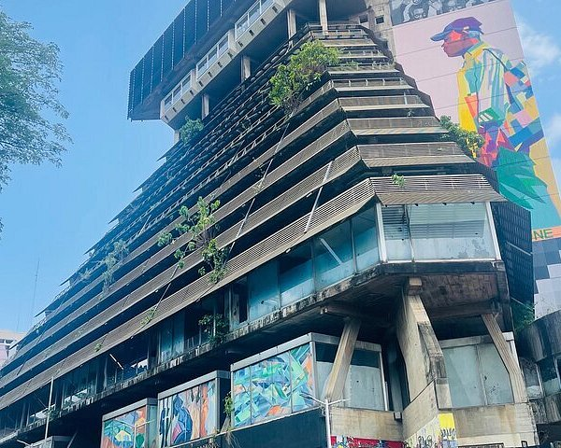
3. CAVA Artisanal Center (Centre Artisanal de la Ville d’Abidjan)
From the market, walk about 15 minutes northeast to reach CAVA, a cooperative of local artists and craftsmen. Unlike the bustling open-air market, this space is calmer and more organized. Each stall represents an artisan, offering wood carvings, jewelry, traditional masks, and paintings.
It’s one of the best spots in Abidjan to buy authentic handcrafts directly from the makers.
Ask questions, many vendors love to explain the symbolism behind their masks or sculptures.
Tip: Bring small CFA notes. Prices are often negotiable but still fair.
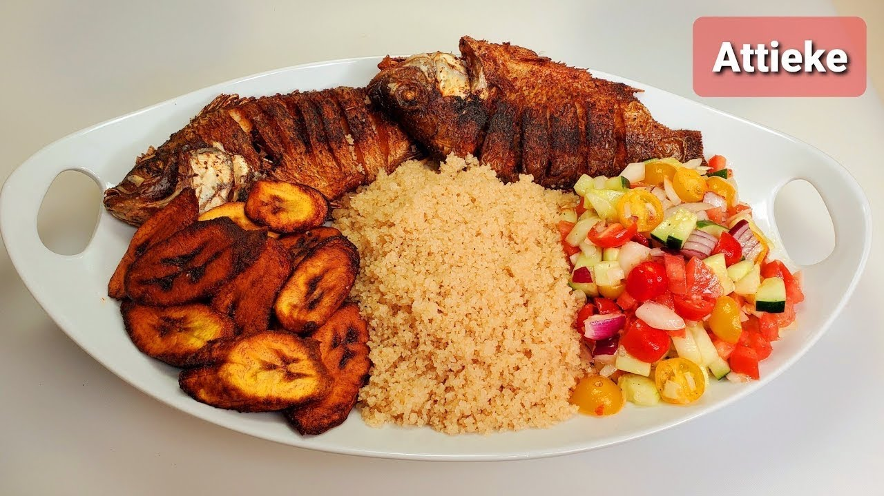
4. Café Stop, Relax with a Local Flavor
After shopping, pause at a nearby café or outdoor bar for a refreshment. Around Boulevard de Marseille, you’ll find several local spots serving strong Ivorian coffee or cold Bock beer.
Try a plate of attiéké (a couscous-like cassava dish) with grilled tilapia, a local favorite. It’s simple, delicious, and perfectly captures the coastal flavor of Abidjan.
Tip: Most cafés have restrooms available for customers.

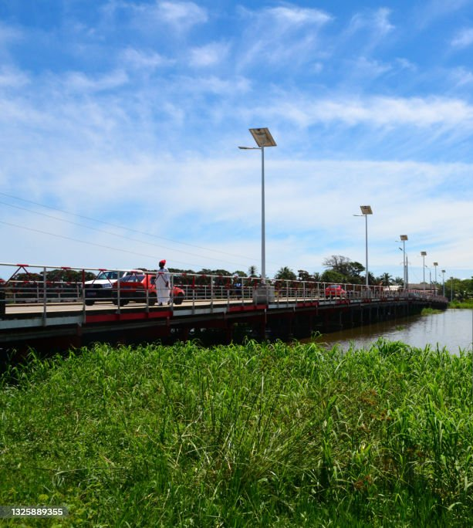
5. Ébrié Lagoon Promenade
Continue north toward the water, where you’ll reach the Ébrié Lagoon. From here, you can watch ferries crossing to the Plateau district, the modern skyline visible in the distance.
The view captures Abidjan’s dual personality: a city both vibrant and evolving, blending traditional Africa with urban modernity.
It’s a relaxing spot to rest, take photos, and watch the city in motion.

6. Return to the Port
Loop back to the cruise terminal along Boulevard de Marseille, retracing your path through Treichville. You’ll pass colorful murals and small street-side shops playing Ivorian pop music. The entire return walk takes about 20 minutes.
Tip: If it’s hot, consider taking a short taxi ride back to the port, fares are inexpensive, and taxis are easy to find.

Before You Go
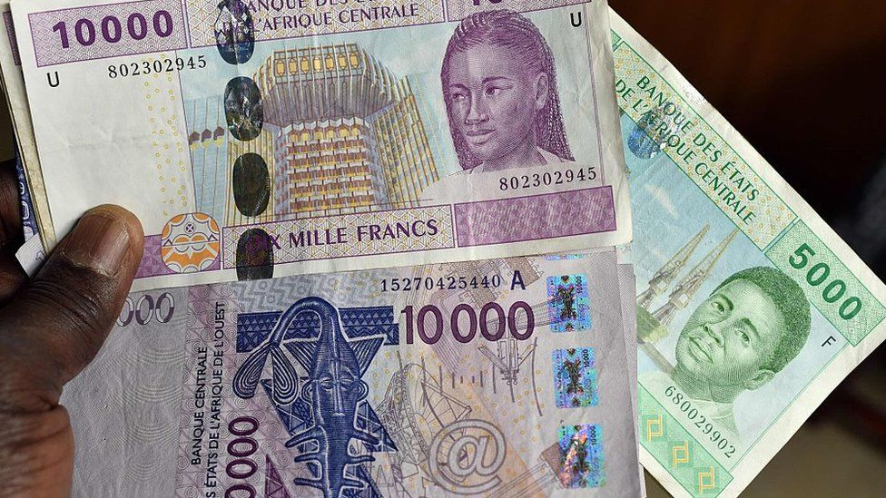
- Currency: The local currency is the West African CFA franc (XOF). U.S. dollars are rarely accepted, so bring small local notes.
- Safety: The main routes in Treichville are safe during daylight hours, but avoid alleyways or isolated areas.
- Weather: Abidjan’s tropical climate means it can be hot and humid year-round. Wear light clothing and sunscreen, and stay hydrated.
- Etiquette: A polite greeting (“Bonjour” or “Bonsoir”) is appreciated before starting a conversation.

In Summary
This short loop through Treichville gives you a taste of Abidjan’s warmth and rhythm. You’ll see everyday life, meet local artisans, and experience the sensory pulse of West Africa, all within walking distance of your ship.
Abidjan may not be on every traveler’s radar yet, but it’s growing fast, and you’re among the lucky few to see it now.

