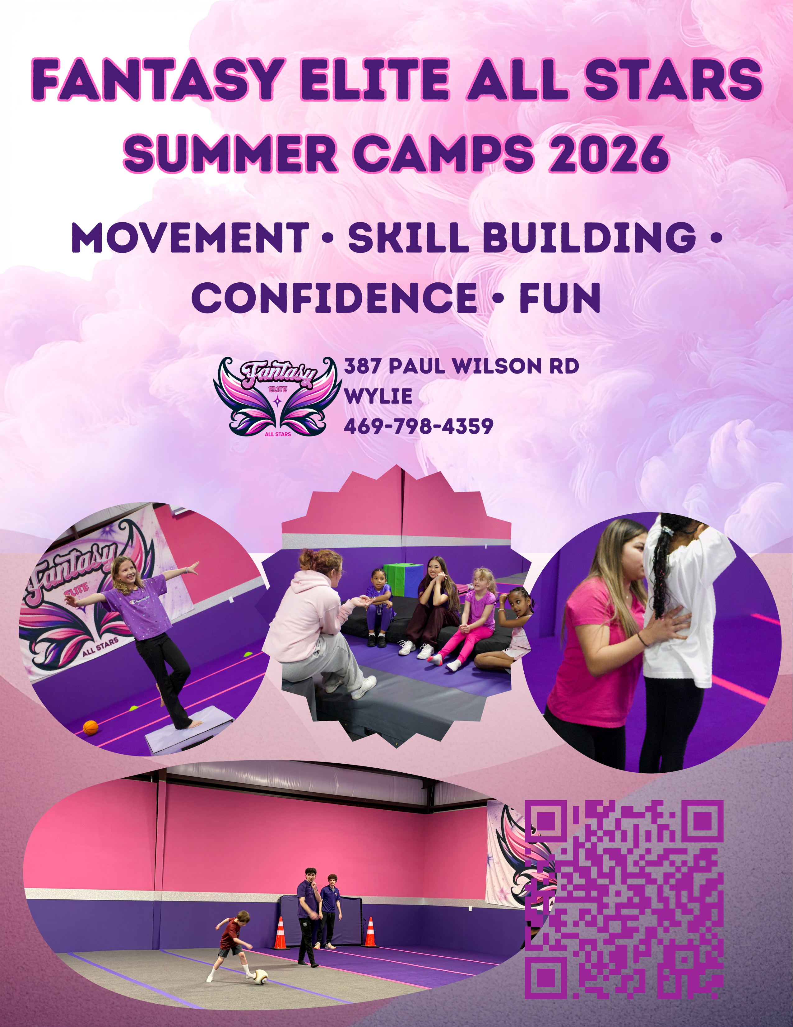



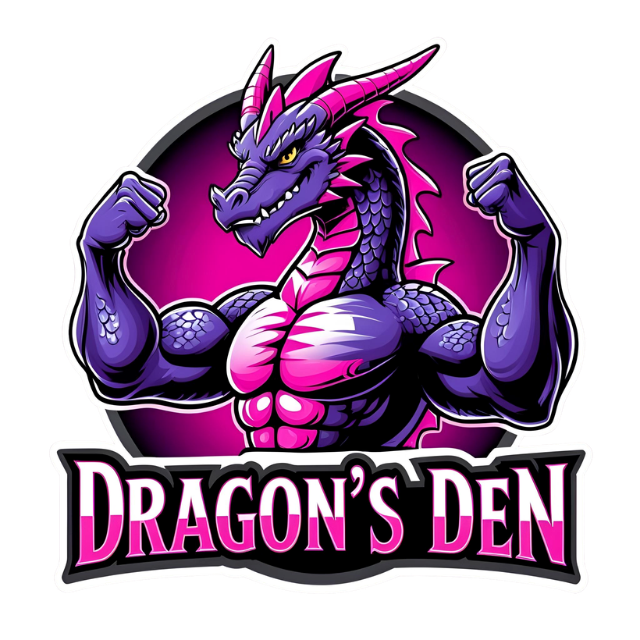


Themed Weeks
Skill Building
Movement Based
Creative Time
Safe, Structured,

Coach Led
A Great Place to
Make Friends
Every week has a unique theme
that keeps kids excited and
engaged.
Tumbling, agility, coordination,
teamwork, and problem
‑
solving
woven into every day.
Obstacle courses, games, cheer or
sports performance basics, drills,
and active play.
Daily crafts tied to the weekly
theme
Low ratios, trained staff,
predictable routines.
Social skills, teamwork, and
confidence building.
We Provide Snacks
One snack + one drink and
water provided daily
Bring Your

Own Lunch
Parents pack lunch

+
water bottle.


A rotating mix of high
‑
energy themes woven into

every week of camp
Nerf Battle Week — Nerf challenges, team missions, obstacle courses,
and target games.
•

Movie Magic Week — Pixar day, superhero day, costumes, skits, and
themed crafts.
•

Olympics Week — Relays, team colors, medals, opening/closing
ceremonies.
•

American Ninja Week — Ninja courses, agility, balance, and strength
challenges.
•

Superhero Training Week — Power poses, missions, obstacle courses,
cape crafts.
•

Spirit Week — Cheer basics, jumps, chants, spirit crafts, and a
mini
‑
showcase.
•

Adventure & Exploration Week — Treasure hunts, maps, team
challenges.
•

Sports Sampler Week — Soccer, flag football, relay races, agility
games.
Themes rotate weekly and may be combined to keep each week fresh, exciting, and
full of variety
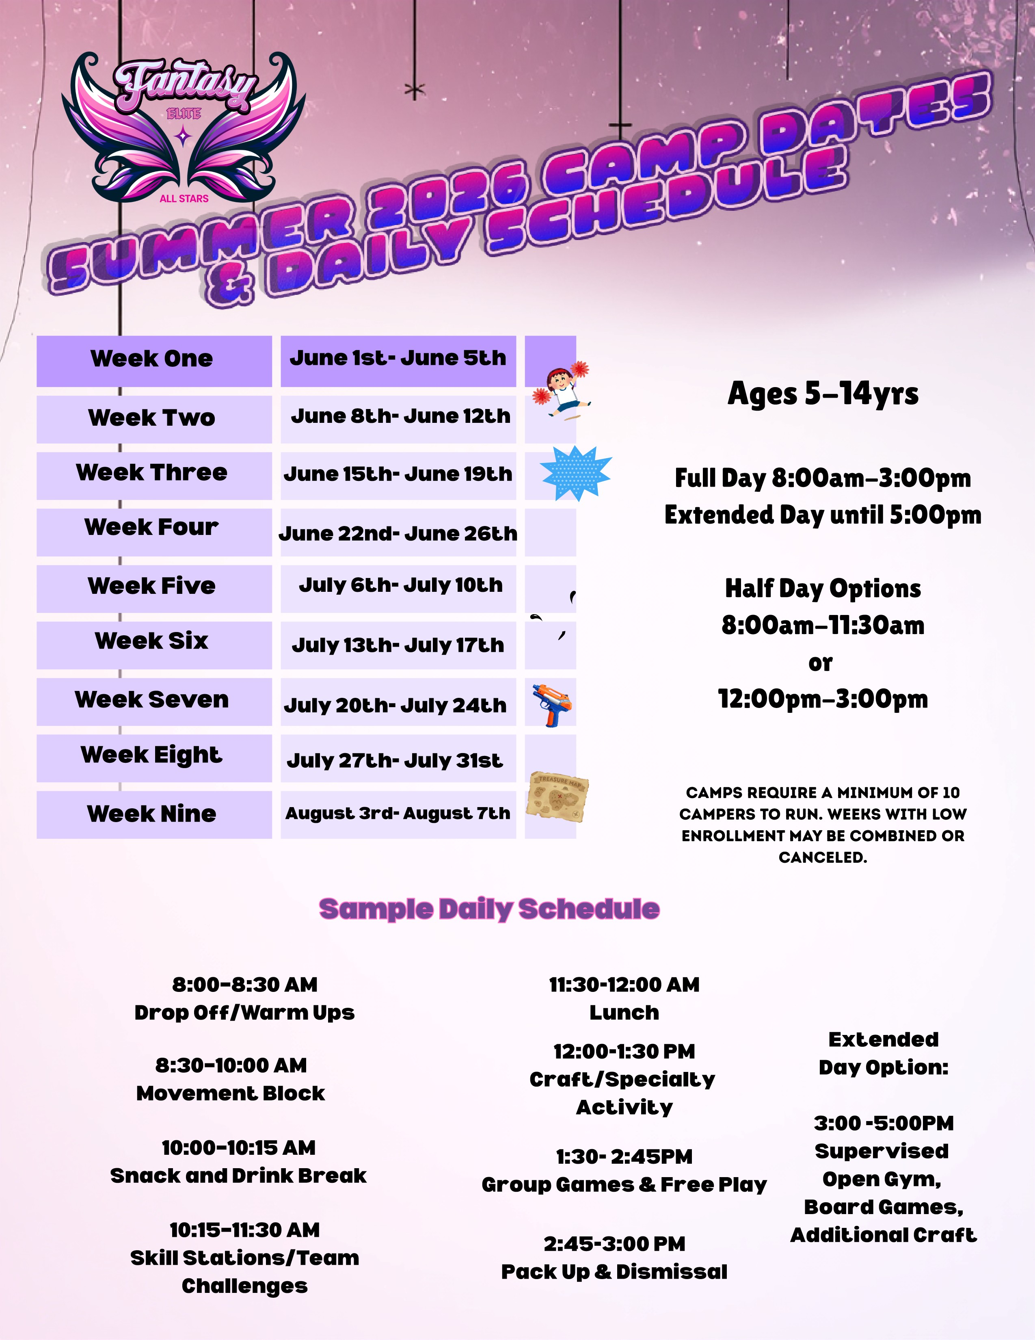

5
‑
Day Full
‑
Day Camp
$349/week
A full week of
movement,
skill
‑
building, crafts,
and themed activities
3
‑
Day Full
‑
Day Camp
$299/week
A flexible option with
the same great
experience

in a shorter week
Extended Day Add ON
$20 per day or $75 per week
5
‑
Day Half
‑
Day Camp
8:00
am-11:30am or 12:00pm-3:00pm
$205/week
A full week of
movement,
skill
‑
building, crafts,
and themed activities
3
‑
Day Half
‑
Day Camp
8:00
am-11:30am or 12:00pm-3:00pm
$169/week
A flexible option with
the same great
experience

in a shorter week
$55 Summer Registration Fee
Waived for all registrations completed before April 1st
Includes daily snack + drink, craft supplies, and administrative
processing
Pricing & Enrollment Options
Pricing & Enrollment Options


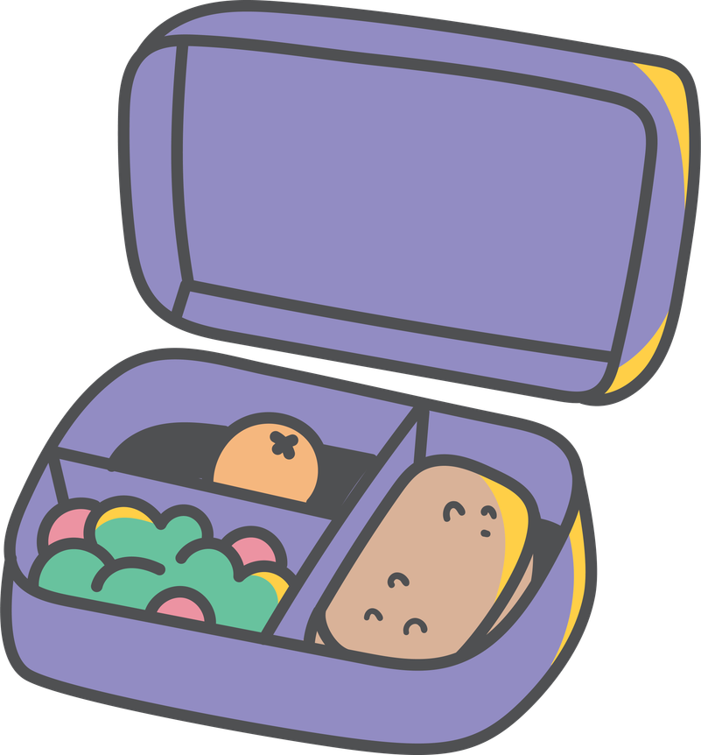



Daily Essentials
•

Packed Lunch — Please send a lunch each day. We are a nut
‑
aware facility.
•

Water Bottle — Labeled and filled each morning.
•

Comfortable Clothing — Athletic wear that allows movement.
•

Closed
‑
Toe Shoes — Required for all activities.
•

Sunscreen — Apply before arrival; we do not apply sunscreen.
Provided Daily
•

One snack + one drink
•

All craft supplies
•

All activity materials
Optional Items
•

Tablets or Phones — Allowed, but use will be limited to quiet time and supervised
settings. Devices must stay in backpacks unless staff gives permission.
•

Towel

•

Theme
‑
Week Accessories (Nerf blasters, costumes, superhero capes, etc.)
All Nerf items must be labeled. We provide darts.
Please Avoid Bringing
•

Money or valuables
•

Toys from home (unless theme
‑
related)
•

Open
‑
toe shoes or sandals
Label Everything
All personal items must be labeled with your child’s name.
If your child has allergies or medical needs, please notify staff before
the first day
What to Bring to Camp
What to Bring to Camp


Policies & Safety Information
Attendance & Drop
‑
Off
•

Drop
‑
off begins at 8:00 AM for all campers.
•

Pick
‑
up is at 3:00 PM for full
‑
day campers and 5:00 PM for extended
‑
day campers.
•

Adults picking up must be listed on your child’s registration form.
Behavior & Expectations
•

We use positive reinforcement, clear expectations, and structured routines.
•

Unsafe or disruptive behavior will be addressed promptly and communicated to
parents.
•

Continued unsafe behavior may result in early pick
‑
up or removal from camp.
Health & Wellness
•

Children must be fever
‑
free for 24 hours before attending.
•

Please keep your child home if they are vomiting, have diarrhea, or show signs of
illness.
•

Notify staff of any allergies or medical needs before the first day.
•

We do not administer medication unless previously arranged with written
permission.
Safety Procedures
•

All staff are trained in basic first aid and emergency procedures.
•

Emergency contacts must be up
‑
to
‑
date in your registration.
•

Our facility follows strict safety protocols for equipment, movement
activities, and transitions.
Electronics Policy
•

Tablets and phones are allowed but use is limited to quiet time and staff
‑
approved
moments.
•

Devices must stay in backpacks unless permission is given.
•

We are not responsible for lost or damaged electronics.
Refunds & Cancellations
•

Cancellations made 14+ days before the camp week receive a full refund (minus
processing fees).
•

Cancellations made 7–13 days before receive a 50% refund.
•

Cancellations made within 7 days are non
‑
refundable.
•

If Fantasy Elite cancels a week due to low enrollment, you may choose a full refund
or transfer to another week.
Minimum Enrollment
•

Each camp week requires 10 campers to run.
•

Weeks with low enrollment may be combined or canceled with advance notice.
Late Pick
‑
Up Policy
•

Pick
‑
ups after 3:10 PM (or 5:10 PM for extended day) incur a $1/minute late fee.
•

This fee is paid directly to the staff supervising late pick
‑
up


