Hay Feeder Instructions:
Panel Screws 30 Item A
Nuts 30 Item B
Back Panel 1 Item C
Top 1 Item D
Front Panel 1 Item E
Vertical Panels 5 Panel 1 = Item F
Panel 2-4 = Item G
Panel 5 = Item H
Mounting Frame 1 Item I
4 mounting bolts = Item J
4 locking washers = Item K
4 flat washes = Item L
4 nuts = Item M
Wood Bolts 3 Item N
Steel Bolts 3 Item O
Front Door 1 Item P
Protective Corner for TOP 2 Item Q
Protective Corner for BOTTOM 2 Item R
Also included:
Outdoor electrical box (preinstalled)
Timer (preinstalled)
Battery (preinstalled)

NOTES: a. Work gloves must be worn to protect from sharp
sheet metal edges
b. Read all directions before you begin
c. Two-person assembly
d. Assemble on work bench
STEP ONE
- Stand panel ONE (F) up vertically with the back panel (C) standing up vertically and INSIDE the panel ONE fold, matching the marks.
TOP VIEW: 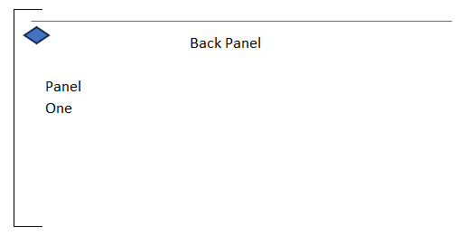
- Using 2 panel screws (A), from the outside/back of the unit, screw into the middle and bottom holes only, using a nut (B) on the inside of the unit. Tightening by hand at this time: 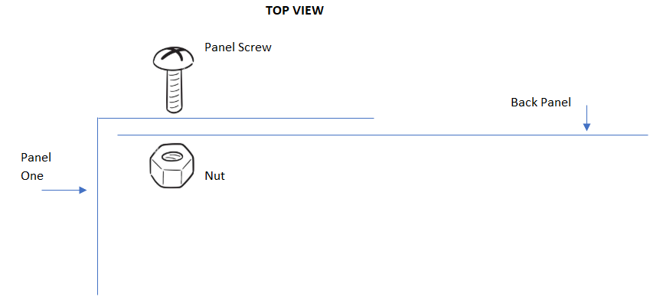
- Attach Panel TWO (G):
  - The TRAP DOOR must be horizontal, swing door up
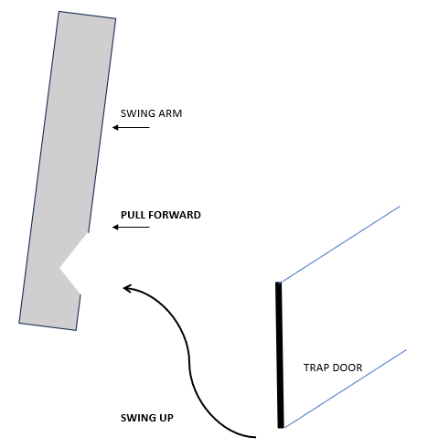
  - Match the marks
  - Insert the PIVOT ROD into the rear bottom hole
  - Using 2 panel screws, from the outside/back of the unit, screw into the middle and bottom holes only, using a nut on the inside of the unit. Tightening by hand at this time.
- Attach Panel THREE (G):
  - The TRAP DOOR must be horizontal, swing door up
  - Match the marks
  - Insert PIVOT ROD
  - 2 panel screws into the middle and bottom holes only, using a nut on the inside of the unit. Tightening by hand at this time.
- Attach Panel FOUR (G):
  - The TRAP DOOR must be horizontal, swing door up
  - Match the marks
  - Insert PIVOT ROD
  - 2 panel screws into the middle and bottom holes only, using a nut on the inside of the unit. Tightening by hand at this time.
- Attach Panel FIVE (H):
  - The back panel will go inside the fold of panel FIVE
  - The TRAP DOOR must be horizontal, swing door up
  - Match the marks
  - Insert PIVOT ROD
  - 2 panel screws into the middle and bottom holes only, using a nut on the inside of the unit. Tightening by hand at this time.
TOP VIEW:
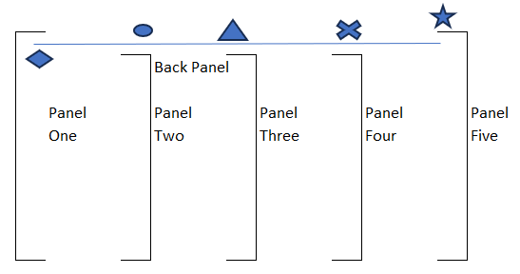
STEP TWO
- Affix the Front Panel (E) using panel screws from the front and nuts inside the unit, aligning the marks on the Front Panel and panel ONE
FRONT VIEW:
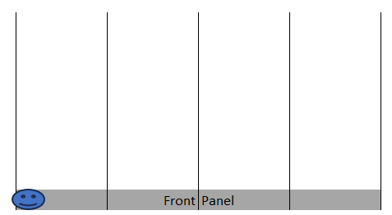
Panel 5

Panel 1

- Hand-tighten front panel screws and nuts on panels 2-5.

STEP THREE
- WIRING
  - ?
  - ?
  - ?

STEP FOUR
Attaching Frame (I)
- Using four 3/8 inch bolts (J), flat washers (K), locking washers (L), and bolts (M), attach the Mounting Frame to the outside of the unit at the points on the outside of panel 1 and panel 5

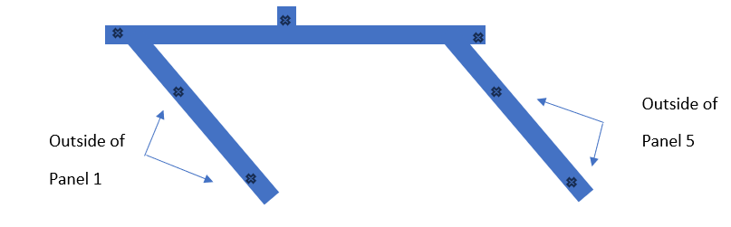
STEP FIVE
- Secure TOP (D) using ??? panel screws and nuts, aligning the marks
- Hand-tighten screws
STEP SIX
- Using a square, check your work.
- Check the back and front:
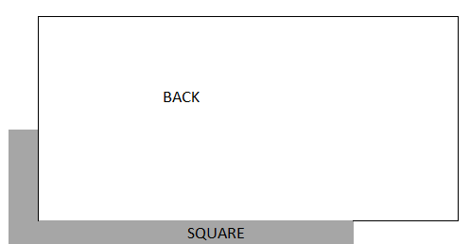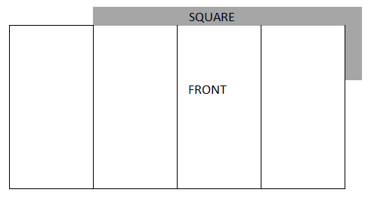

STEP SEVEN
TIGHTEN all nuts / bolts, keeping in square
STEP EIGHT
Mounting Frame Prep (Included are 3 bolts for mounting on WOOD [N] and 3 bolts for mounting on STEELE [O])
- Our recommendation is to measure 69 inches from ground to where you will pre-drill the top anchor hole > drill hole.
- MARK the top anchor hole vertically and horizontally so it’s easy to find: 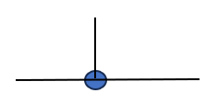
STEP NINE
- It would be a good idea to affix a 2x4 (36 inches long) on the wall to SET THE UNIT ON when putting it up to the wall:

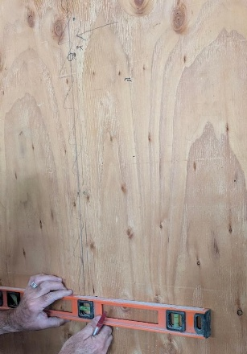
PREDRILLED ANCHOR HOLE

- If you follow the recommended height above for the top anchor hole, place the top of this temporary support 47.25 inches ground up.

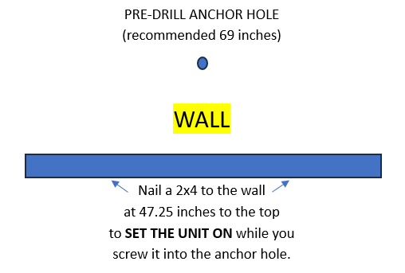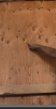
Predrilled
Anchor hole

2x4 support
- Also, a temporary 47 inch front support is helpful when holding the unit up on the wall.
- Make sure all trap doors are still locked in place and LIFT UNIT
- Using either the wood mounting screw or the 3 metal mounting screw, affix the UNIT to the wall, using the pre-drilled hole from step eight above
- Make sure the unit is LEVEL 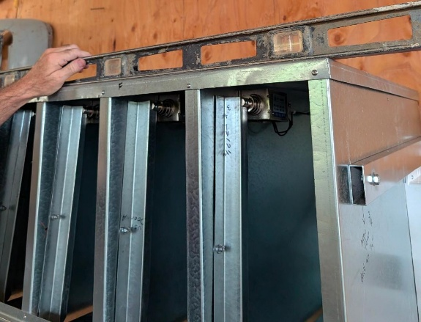
- Use the other two mounting screws (wood versus metal) on either side of frame
- REMOVE all temporary supports
STEP TEN
Front Door (P) … can be set for a right or left open
- Remove the Upper Pivot Rod Bracket (upper right)

Lock screw hole
Mount screw
Rod hole

- Drop the pivot rod WITH WASHER into the hole (bottom right or left)
- Place Upper Rod Bracket over the top pivot rod
- Reattach the Upper Pivot Rod bracket to the unit (right or left)
- Adjust as needed
STEP ELEVEN
Affix protective corners
- Two prong on top front (Q): 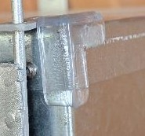
- Three prong on bottomfront (R): 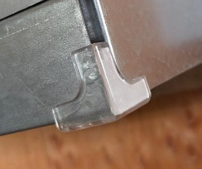
STEP TWELVE
- UNBOX BATTERY
- PLUG IN POSITIVE (BLACK) AND NEGATIVE (RED) TERMINALS
- PLUG IN 110V BATTERY CHARGER
- PLUG IN 110V CONTROLLER
STEP THIRTEEN
LOADING THE HAY
- Make sure all trap doors are set horizontal / affixed inside the swing-arm notch:
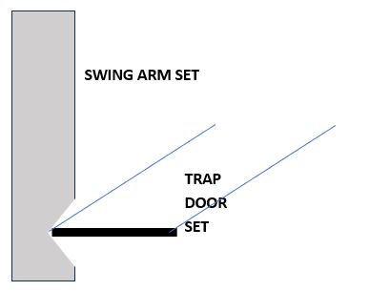
- With front door open, insert hay flakes at an angle:

BIN A BIN B BIN C BIN D
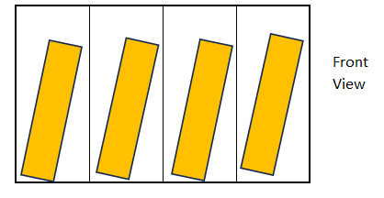
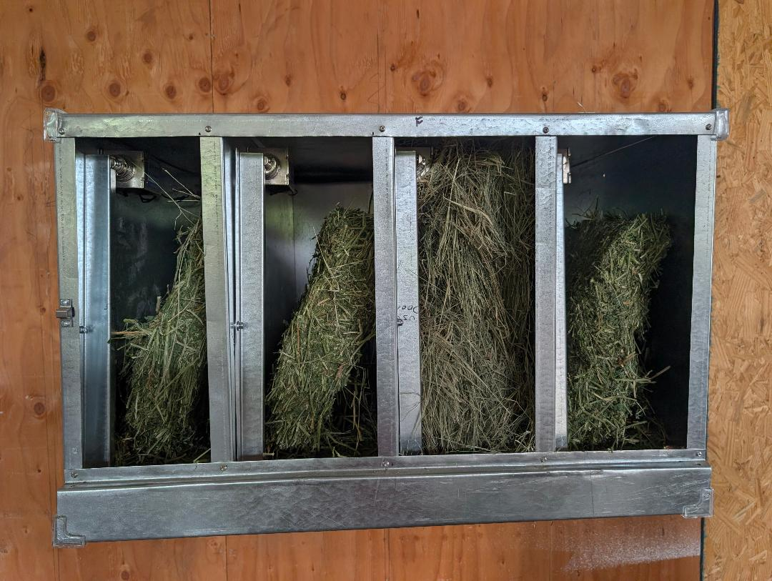

Note: You can also place cans of grain in the BINS:
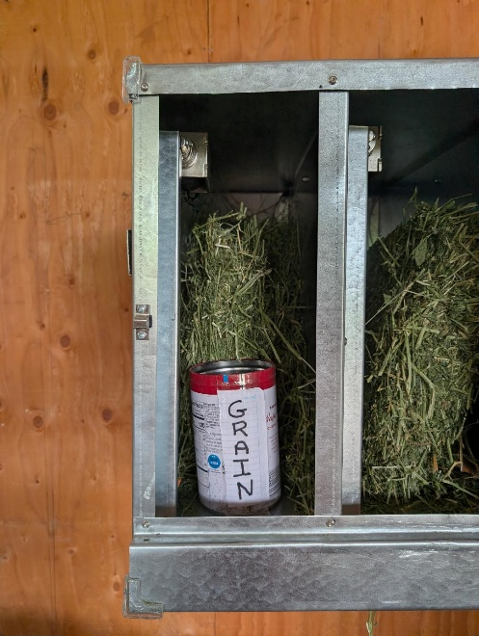

Front door closed: 