HAY DROP TIMER
- PLUG IN TO POWER (NOTE: THIS SECTION ONLY NEEDS TO BE DONE ONCE [baring power outages].)
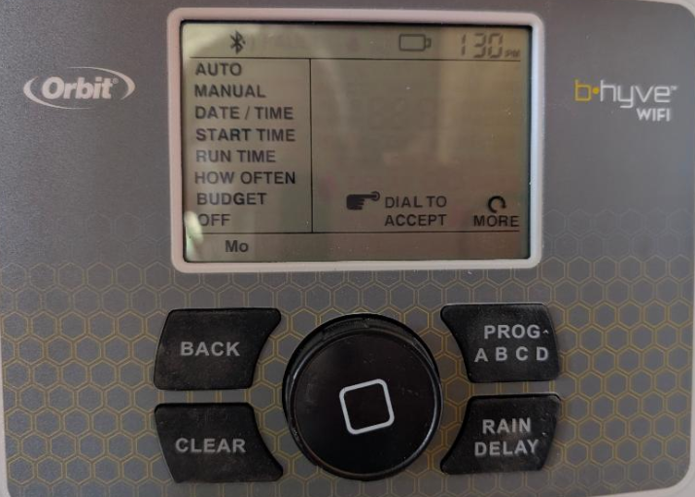
  - Rotate  dial to DATE / TIME
  - Press = ENTER
  - Rotate dial to set the YEAR
  - ENTER
  - Rotate dial to set the MONTH
  - ENTER
  - Rotate dial to set the DAY/DATE
  - ENTER
  - Rotate dial to set the HOUR (AM vs PM)
  - ENTER
  - Rotate dial to set the MINUTE
  - ENTER
  - BACK

- NOTE: THIS SECTION ONLY NEEDS TO BE DONE ONCE (baring power outages).
  - Rotate dial to RUN TIME
  - ENTER > ENTER
  - You are now on PROG A (which is BIN A)
    - Rotate Dial to 1 MIN
    - ENTER
    - Select 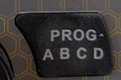 PROG
    - ENTER
  - You are now on PROG B (which is BIN B)
    - ENTER
    - Rotate Dial to 1 MIN
    - ENTER
    - Select PROG
    - ENTER
  - You are now on PROG C (which is BIN C)
    - ENTER
    - Rotate Dial to 1 MIN
    - ENTER
    - Select PROG
    - ENTER
  - You are now on PROG D (which is BIN D)
    - ENTER
    - Rotate Dial to 1 MIN
    - ENTER
    - Select PROG
    - ENTER
  - BACK

- NOTE: THIS SECTION ONLY NEEDS TO BE DONE ONCE, unless you want the feeding TIMES to change (baring power outages).
  - Rotate dial to START TIME
  - ENTER
  - PROG A will be displayed
    - ENTER
    - Rotate dial to your desired drop time for BIN A
    - Enter
    - Press PROG
  - PROG B will be displayed
    - ENTER
    - Rotate dial to your desired drop time for BIN B
    - Enter
    - Press PROG
  - PROG C will be displayed
    - ENTER
    - Rotate dial to your desired drop time for BIN C
    - Enter
    - Press PROG
  - PROG D will be displayed
    - ENTER
    - Rotate dial to your desired drop time for BIN D
    - Enter
  - BACK

EXAMPLE: Set Bin A at 0800
Set Bin B at 1700
Set Bin C at 0800
Set Bin D at 1700

- (This is the ONLY thing you will do EVERY TIME the Feeder is loaded)
  - Rotate dial to HOW OFTEN
    - ENTER
    - Press 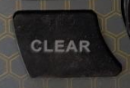 Clear
    - You are now in program A (for bin A)
      - Rotate Dial to the DAY OF THE WEEK YOU WANT BIN A TO DROP
      - ENTER
      - Press 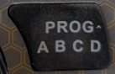 PROG
      - CLEAR
    - You are now in program B (for bin B)
      - Rotate Dial to the DAY OF THE WEEK YOU WANT BIN B TO DROP
      - ENTER
      - Press PROG
      - CLEAR
    - You are now in program C (for bin C)
      - Rotate Dial to the DAY OF THE WEEK YOU WANT BIN C TO DROP
      - ENTER
      - Press PROG
      - CLEAR
    - You are now in program D (for bin D)
      - Rotate Dial to the DAY OF THE WEEK YOU WANT BIN D TO DROP
      - ENTER
  - BACK
EXAMPLE: IF YOU ARE LOADING THE FEEDER ON MONDAY NIGHT
Set BIN A for TUESDAY
Set BIN B for TUESDAY
Set BIN C for WEDNESDAY
Set BIN D FOR WEDNESDAY

DONE! HAY WILL DROP TUESDAY AT 8 AM AND 5 PM
HAY WILL DROM WEDNESDAY AT 8 AM AND 5 PM

NOTE: STATION 1 IS THE ONLY STATION USED; MAKE NO CHANGES TO “STATION.”

