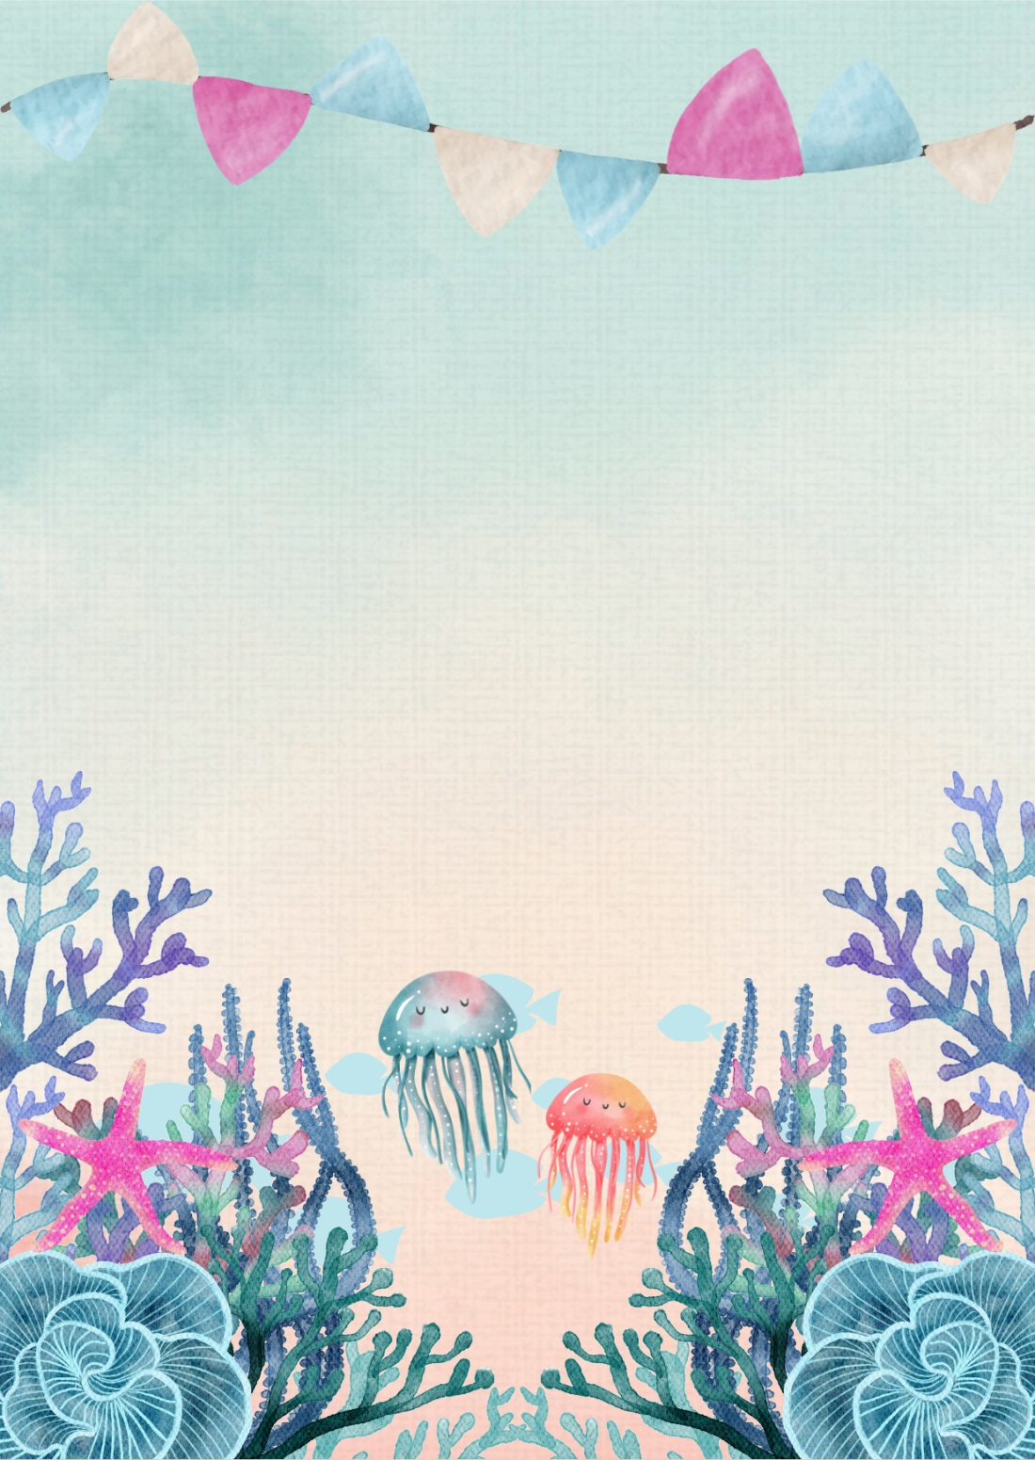
RVSP to Christina by SMS at 123-456-7891
05/07
SATURDAY
04:00
PM
123, Under the Sea Avenue, City, State
Olivia is two!
JOIN US TO CELEBRATE

