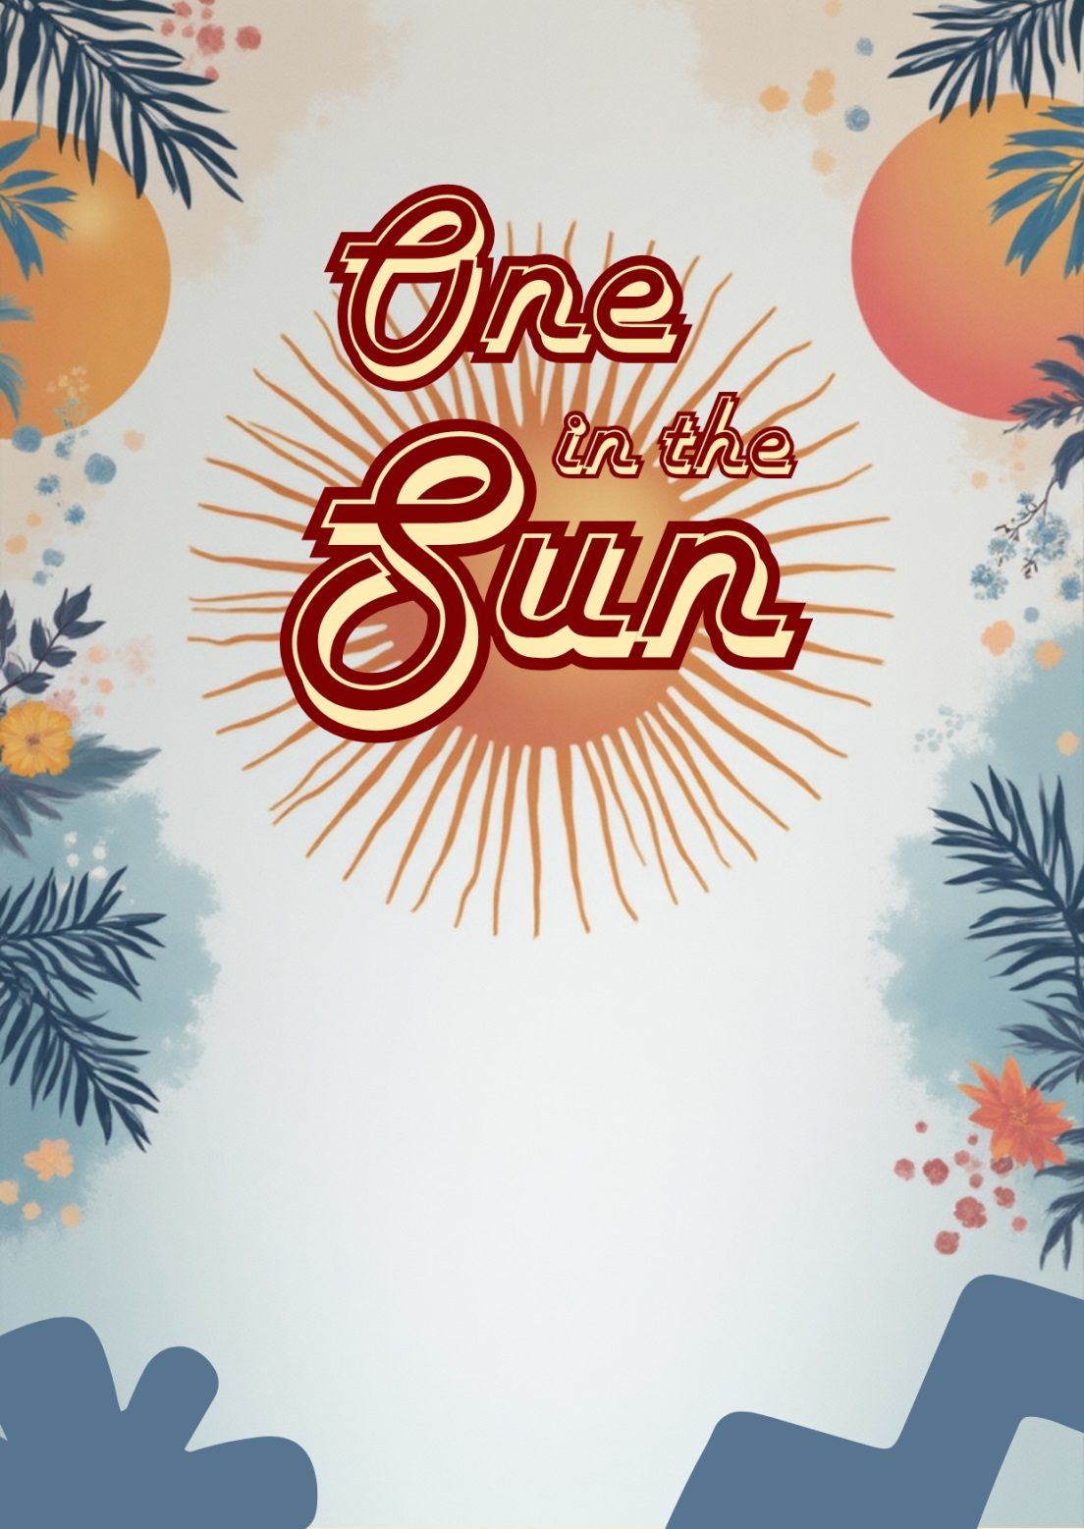
Saturday, 3rd of December at 4.00pm
at 123, Happy Park Road, City, State
Please RVSP to Helen via SMS at
123-456-7891
Solomon’s
FIRST TRIP AROUND THE SUN
JOIN US TO CELEBRATE

