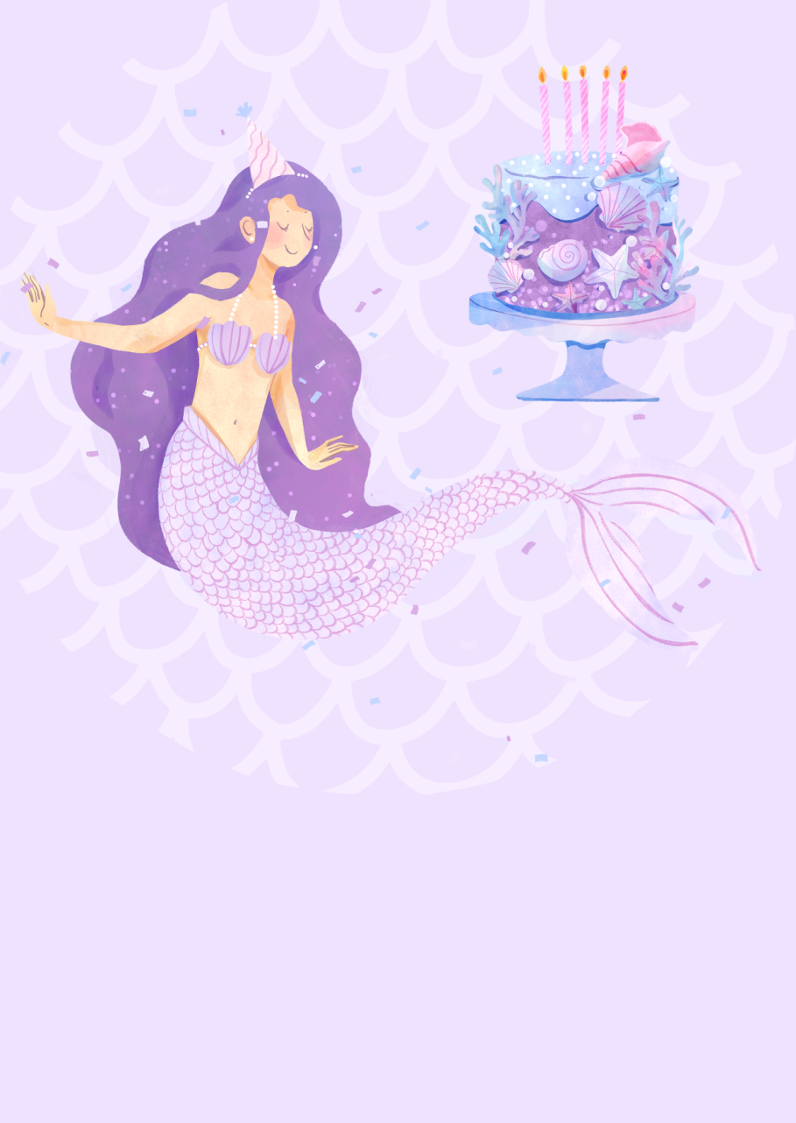
123, Under the Sea Avenue, City, State
04:00
PM
JOIN US TO CELEBRATE
Joanna is turning five!
RVSP to Christina by SMS at 123-456-7891
05/07
SATURDAY

