ISO 9001:2015 Quality Management System (QMS) Exam
Part 1: Questions 1 to 25
Q1: What is the primary focus of ISO 9001:2015?
A) Reducing manufacturing costs.
B) Customer satisfaction and meeting applicable requirements.
C) Employee health and safety.
D) Environmental protection.
Q2: The "Process Approach" in QMS includes the use of:
A) PDCA cycle and Risk-based thinking.
B) Only financial audits.
C) Hiring more managers.
D) Ignoring external providers.
Q3: Which clause covers the "Context of the Organization"?
A) Clause 4
B) Clause 5
C) Clause 8
D) Clause 10
Q4: According to ISO 9001, "Top Management" must demonstrate leadership by:
A) Delegating all quality tasks to the secretary.
B) Ensuring the Quality Policy and objectives are established.
C) Only attending the final audit.
D) Reducing the quality budget.
Q5: "Risk-based thinking" enables an organization to:
A) Eliminate all possible business risks.
B) Determine factors that could cause processes to deviate from planned results.
C) Avoid hiring new employees.
D) Stop all new projects.
Q6: Quality Objectives must be "SMART," which means they should be:
A) Secret and small.
B) Measurable and consistent with the Quality Policy.
C) Determined only by customers.
D) Changed every day.
Q7: Which of the following is an "Internal Issue" (Clause 4.1)?
A) International market trends.
B) Organizational culture and values.
C) New legal regulations.
D) Competitor activities.
Q8: "Documented Information" (Clause 7.5) is required to:
A) Be complex and long.
B) Support the operation of processes and have confidence they are carried out as planned.
C) Impress the auditors only.
D) Replace the need for training.
Q9: Clause 8 focuses on:
A) Support.
B) Operation.
C) Planning.
D) Leadership.
Q10: Customer communication (Clause 8.2.1) includes:
A) Providing information relating to products and services.
B) Handling enquiries and contracts.
C) Obtaining customer feedback.
D) All of the above.
Q11: When a product does not meet requirements, it is called:
A) A masterpiece.
B) Nonconforming output.
C) A financial gain.
D) External provider error.
Q12: Internal Audits must be conducted at:
A) Random times without notice.
B) Planned intervals.
C) Only when a customer complains.
D) Once every 10 years.
Q13: "Traceability" (Clause 8.5.2) means:
A) Following employees to their homes.
B) The ability to identify the output and its history/origin.
C) Reading the company's history book.
D) Tracking the CEO's car.
Q14: Management Review (Clause 9.3) outputs must include:
A) Opportunities for improvement.
B) Any need for changes to the QMS.
C) Resource needs.
D) All of the above.
Q15: "External Providers" (Clause 8.4) refers to:
A) Suppliers and outsourced processes.
B) Only the government.
C) The organization's own employees.
D) Customers who pay late.
Q16: Clause 7.1.2 (People) requires the organization to:
A) Hire as few people as possible.
B) Determine and provide the persons necessary for the effective implementation of the QMS.
C) Replace all staff with machines.
D) Monitor employees' personal social media.
Q17: The Quality Policy must be:
A) Kept in the CEO's drawer.
B) Available and maintained as documented information.
C) Written in a secret code.
D) Changed every time a new product is sold.
Q18: Performance evaluation (Clause 9) includes:
A) Monitoring and measurement.
B) Customer satisfaction analysis.
C) Internal audit and management review.
D) All of the above.
Q19: "Competence" (Clause 7.2) is based on:
A) Personal friendship.
B) Education, training, or experience.
C) Age and height.
D) The ability to speak many languages.
Q20: Improvement (Clause 10) requires the organization to:
A) React to nonconformities and take corrective actions.
B) Wait for the auditor to suggest improvements.
C) Only improve if the budget increases.
D) Ignore small errors.
Q21: "Organizational Knowledge" (Clause 7.1.6) is:
A) Information from the local news.
B) Knowledge specific to the organization, gained by experience.
C) A collection of novels in the breakroom.
D) Only found in textbooks.
Q22: Infrastructure (Clause 7.1.3) includes:
A) Buildings and associated utilities.
B) Equipment (hardware and software).
C) Transportation and information technology.
D) All of the above.
Q23: The scope of the QMS must consider:
A) External and internal issues.
B) Requirements of relevant interested parties.
C) The products and services of the organization.
D) All of the above.
Q24: "Calibration" (Clause 7.1.5.2) is related to:
A) Measuring instruments.
B) Employee salaries.
C) Office furniture layout.
D) Marketing campaigns.
Q25: In PDCA, "Do" refers to:
A) Designing the plan.
B) Implementing the processes.
C) Monitoring the results.
D) Taking action to improve.

Answer Key (1-25)
1-B, 2-A, 3-A, 4-B, 5-B, 6-B, 7-B, 8-B, 9-B, 10-D, 11-B, 12-B, 13-B, 14-D, 15-A, 16-B, 17-B, 18-D, 19-B, 20-A, 21-B, 22-D, 23-D, 24-A, 25-B.

ISO 9001:2015 QMS Exam - Part 2 (Questions 26-50)
Q26: Which clause requires the organization to "Plan for Changes" to the QMS?
A) Clause 4.4
B) Clause 6.3
C) Clause 9.1
D) Clause 5.2
Q27: "Interested Parties" (Clause 4.2) may include:
A) Shareholders and Owners.
B) Legal and regulatory authorities.
C) End users and the community.
D) All of the above.
Q28: Top Management must ensure that responsibilities and authorities are:
A) Kept secret to avoid confusion.
B) Assigned, communicated, and understood.
C) Given only to external consultants.
D) Ignored during busy seasons.
Q29: What is "Validation" in the context of production and service provision?
A) Checking the spelling of the manual.
B) Confirming that the resulting output can meet the specified requirements through a process.
C) Paying the supplier on time.
D) Buying new insurance for the factory.
Q30: "Statutory and Regulatory requirements" are:
A) Optional for small businesses.
B) Mandatory laws and regulations applicable to the organization.
C) Only applicable to the medical industry.
D) Suggestions from the board of directors.
Q31: When determining the "Environment for the Operation of Processes," the organization considers:
A) Social and psychological factors (e.g., non-discriminatory).
B) Physical factors (e.g., temperature, humidity).
C) Stress prevention and emotional protection.
D) All of the above.
Q32: In Clause 8.3, "Design and Development" is required when:
A) The organization buys off-the-shelf products.
B) Specific requirements are not yet established for a new product/service.
C) The CEO wants a new office.
D) The company changes its logo.
Q33: "Design and Development Outputs" must:
A) Meet the input requirements.
B) Be vague to allow for errors.
C) Be discarded after the first prototype.
D) Only be shared with the marketing team.
Q34: Control of "External Providers" (Clause 8.4) includes evaluating them based on:
A) Their ability to provide processes or products/services in accordance with requirements.
B) Their personal relationship with the manager.
C) Their company's colors.
D) Only the price, regardless of quality.
Q35: "Post-delivery activities" (Clause 8.5.5) include:
A) Warranty provisions.
B) Maintenance services and recycling.
C) Contractual obligations.
D) All of the above.
Q36: What should the organization do with "Nonconforming Outputs" (Clause 8.7)?
A) Sell them as premium products.
B) Segregate, contain, return, or suspend provision of products/services.
C) Hide them from the auditor.
D) Delete the production records.
Q37: "Customer Satisfaction" (Clause 9.1.2) must be monitored by:
A) Guessing based on the number of sales.
B) Obtaining information relating to customer perception of the extent to which their needs were met.
C) Asking the employees if they think customers are happy.
D) Checking the company's Instagram likes only.
Q38: The "Audit Criteria" in an internal audit refers to:
A) The personal opinion of the auditor.
B) The standards, policies, and requirements against which the audit is performed.
C) The number of hours the audit takes.
D) The lunch menu during the audit day.
Q39: Top Management shall review the QMS to ensure its continuing:
A) Suitability, Adequacy, and Effectiveness.
B) High price and luxury.
C) Complexity and length.
D) Control over every employee's move.
Q40: A "Corrective Action" (Clause 10.2) must be appropriate to:
A) The mood of the manager.
B) The effects of the nonconformities encountered.
C) The cheapest solution available.
D) What the competitor is doing.
Q41: "Clause 7.1.1" (General Resources) requires the organization to consider:
A) The capabilities of, and constraints on, existing internal resources.
B) What needs to be obtained from external providers.
) Both A and B.
D) Only hiring new staff.
Q42: "Measurement Traceability" (Clause 7.1.5.2) is essential when:
A) It is a requirement of the customer or standard.
B) The organization wants to save money.
C) The equipment is brand new.
D) Employees work from home.
Q43: The Quality Policy must be communicated to:
A) The organization's internal employees only.
B) Persons working under the organization's control.
C) Relevant interested parties as appropriate.
D) Both B and C.
Q44: "Clause 6.1" (Actions to address risks and opportunities) replaces which term from the old version?
A) Corrective Action.
B) Preventive Action.
C) Audit Finding.
D) Quality Objective.
Q45: When an organization changes its QMS, it must:
A) Carry out the changes in a planned manner.
B) Change everything overnight.
C) Keep the old system and the new one running together forever.
D) Inform only the external auditor.
Q46: "Preservation" (Clause 8.5.4) applies to:
A) Raw materials only.
B) Finished products only.
C) Outputs during production and service provision.
D) Only products kept in the freezer.
Q47: "Clause 8.6" (Release of products and services) requires that:
A) Products are released as soon as they are made.
B) Release occurs only after planned arrangements have been satisfactorily completed.
C) The customer signs for the product before it is tested.
D) All products are released by the CEO personally.
Q48: "Analysis and Evaluation" (Clause 9.1.3) results are used to evaluate:
A) Conformity of products and services.
B) The degree of customer satisfaction.
C) The performance and effectiveness of the QMS.
D) All of the above.
Q49: An internal auditor should not audit:
A) A different department.
B) Their own work.
C) The quality manager.
D) The documentation.
Q50: Continuous improvement can be achieved through the use of:
A) Quality policy and objectives.
B) Audit results and management review.
C) Corrective actions.
D) All of the above.

ISO 9001:2015 QMS Exam - Part 3 (Questions 51-75)

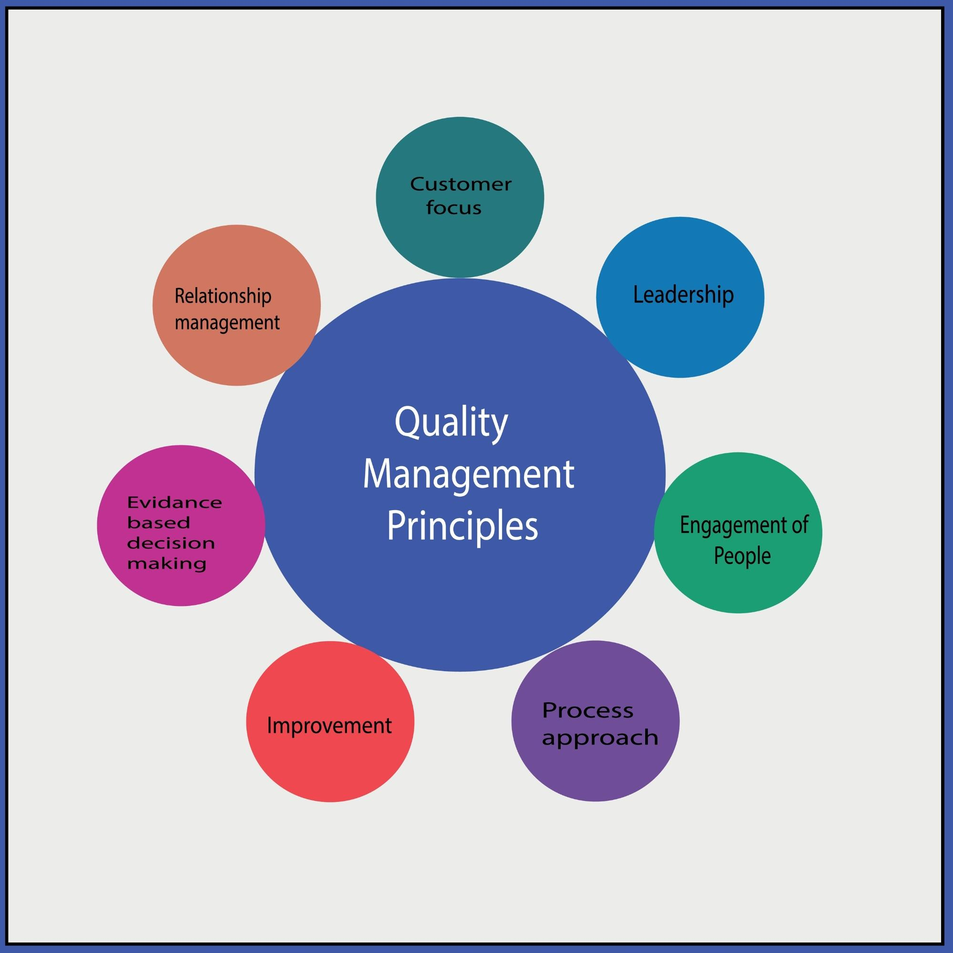
Shutterstock
Q51: Which of the following is a key benefit of implementing ISO 9001?
A) Guaranteed increase in stock prices.
B) Improved ability to consistently provide products that meet customer requirements.
C) Elimination of the need for any management meetings.
D) Automated hiring of new staff.
Q52: According to Clause 7.1.4, "Environment for the operation of processes" includes:
A) Social factors such as non-discriminatory and calm atmosphere.
B) Psychological factors such as stress reduction.
C) Physical factors such as temperature and humidity.
D) All of the above.
Q53: What does the term "Standardization" primarily aim to achieve?
A) Making every employee work the same number of hours.
B) Ensuring consistency in output and process performance.
C) Reducing the salary of the workforce.
D) Creating as much paperwork as possible.
Q54: Clause 8.5.1 (Control of production and service provision) requires the use of:
A) Monitoring and measuring resources.
B) Appointment of competent persons.
C) Implementation of release, delivery, and post-delivery activities.
D) All of the above.
Q55: "Customer Property" (Clause 8.5.3) includes:
A) Intellectual property and personal data provided by the customer.
B) The customer's office building.
C) Products the customer bought from a competitor.
D) Public information found on the internet.
Q56: If customer property is lost or damaged, the organization must:
A) Hide the damage and hope the customer doesn't notice.
B) Report this to the customer and retain documented information.
C) Charge the customer for a replacement.
D) Fire the employee who was handling the property.
Q57: "Post-delivery activities" (Clause 8.5.5) are determined based on:
A) Statutory and regulatory requirements.
B) The nature, use, and intended lifetime of products.
C) Customer requirements and feedback.
D) All of the above.
Q58: "Control of changes" (Clause 8.5.6) requires the organization to:
A) Review and control changes for production to ensure continued conformity.
B) Stop all production whenever a small change occurs.
C) Avoid making any changes to the production process.
D) Only change processes if the auditor suggests it.
Q59: According to Clause 9.1.3, the results of analysis shall be used to evaluate:
A) The performance of external providers.
B) The need for improvements to the QMS.
C) The effectiveness of actions taken to address risks.
D) All of the above.
Q60: The "Audit Program" (Clause 9.2.2) must define:
A) The frequency, methods, and responsibilities.
B) The lunch breaks for the auditors.
C) The personal background of the auditors.
D) Only the dates of the audits.
Q61: During a Management Review, Top Management must consider:
A) Changes in external and internal issues.
B) Information on the performance and effectiveness of the QMS.
C) Adequacy of resources.
D) All of the above.
Q62: When a nonconformity occurs, Clause 10.2 requires the organization to:
A) Correct it and deal with the consequences.
B) Evaluate the need for action to eliminate the cause.
C) Review the effectiveness of any corrective action taken.
D) All of the above.
Q63: Documented information of "Corrective Actions" must include:
A) The nature of the nonconformities and subsequent actions taken.
B) The names of employees who made the mistake.
C) The cost of the error in local currency.
D) Only the date the error was found.
Q64: "Continual Improvement" (Clause 10.3) means the organization must:
A) Improve every single process every single day.
B) Continually improve the suitability, adequacy, and effectiveness of the QMS.
C) Hire a new quality manager every year.
D) Reach a point where no more improvements are possible.
Q65: The "Quality Policy" must include a commitment to:
A) Satisfy applicable requirements.
B) Continually improve the QMS.
C) Both A and B.
D) Selling the most expensive products in the market.
Q66: Clause 7.3 (Awareness) requires persons doing work to be aware of:
A) The Quality Policy and relevant Quality Objectives.
B) Their contribution to the effectiveness of the QMS.
C) The implications of not conforming with QMS requirements.
D) All of the above.
Q67: "Communication" (Clause 7.4) requires the organization to determine:
A) What, when, with whom, and how to communicate.
B) Only how to use email.
C) Only how to talk to the media.
D) Only internal communication between managers.
Q68: "Internal Communication" should include:
A) Communication regarding the effectiveness of the QMS.
B) Personal gossip between staff.
C) Private financial data of the CEO.
D) Information about the competitors' staff.
Q69: Documented information from "External Origin" must be:
A) Ignored because it wasn't created by the company.
B) Identified as appropriate and controlled.
C) Rewritten to look like internal documents.
D) Deleted after one use.
Q70: "Operational Planning and Control" (Clause 8.1) includes:
A) Determining the requirements for products and services.
B) Establishing criteria for processes and acceptance of products.
C) Determining the resources needed.
D) All of the above.
Q71: Before committing to supply a product to a customer, the organization must:
A) Review the requirements to ensure it has the ability to meet them.
B) Check if the customer has enough money in their bank account.
C) Start production immediately without a contract.
D) Ask the competitor if they want the order instead.
Q72: Design and development "Inputs" (Clause 8.3.3) include:
A) Functional and performance requirements.
B) Statutory and regulatory requirements.
C) Information derived from previous similar designs.
D) All of the above.
Q73: "Design and Development Controls" (Clause 8.3.4) include:
A) Reviews, Verifications, and Validations.
B) Only checking the color of the design.
C) Asking the marketing team if they like the design.
D) Waiting for a customer complaint to verify the design.
Q74: "Verification" (in Design) is done to ensure:
A) The outputs meet the input requirements.
B) The product can be sold at a high price.
C) The design team worked on weekends.
D) The customer likes the packaging.
Q75: Information provided to "External Providers" must describe:
A) The processes, products, and services to be provided.
B) The approval of products, methods, and equipment.
C) Competence requirements for personnel.
D) All of the above.

ISO 9001:2015 QMS Exam - Part 4 (Questions 76-100)
Q76: What is the primary purpose of "Management Review" (Clause 9.3)?
A) To ensure the QMS remains suitable, adequate, and effective.
B) To identify which employees should be promoted.
C) To rewrite the Quality Policy every month.
D) To double the sales targets for the next year.
Q77: Clause 8.4.2 (Type and extent of control) requires that external processes do not adversely affect:
A) The external provider's bank balance.
B) The organization's ability to consistently deliver conforming products and services.
C) The local community's traffic flow.
D) The number of holidays the staff takes.
Q78: Which of the following must be retained as "Documented Information" in Clause 8.2.3?
A) The results of the review of requirements for products and services.
B) The minutes of every casual lunch conversation.
C) A list of all the competitors' prices.
D) The CEO's personal travel expenses.
Q79: What should the organization do if requirements for products and services are changed?
A) Continue production using the old requirements to save time.
B) Ensure that relevant documented information is amended and relevant persons are made aware.
C) Wait until the customer complains before changing anything.
D) Fire the salesperson who accepted the change.
Q80: Clause 7.1.5 (Monitoring and measuring resources) is intended to ensure:
A) Valid and reliable results when monitoring or measuring is used.
B) That the organization buys the most expensive tools.
C) That all employees carry a ruler at all times.
D) That the weather is monitored every hour.
Q81: In Clause 8.3.5 (Design and development outputs), outputs must refer to:
A) The names of the designers' family members.
B) Monitoring and measurement requirements and acceptance criteria.
C) Only the aesthetic color of the product.
D) The total number of coffee cups consumed during design.
Q82: Clause 8.4.3 requires the organization to communicate its requirements to external providers regarding:
A) The approval of products and services, methods, and processes.
B) The company's internal social club rules.
C) The personal hobbies of the procurement officer.
D) None of the above.
Q83: What is meant by "Release of products and services" (Clause 8.6)?
A) Advertising the product on television.
B) The final stage where the product is confirmed to meet requirements before delivery.
C) Lowering the price of the product for a sale.
D) Throwing away old inventory.
Q84: Clause 9.1.1 states that the organization shall determine:
A) What needs to be monitored and measured.
B) The exact date of the next bank holiday.
C) How many words are in the Quality Manual.
D) The color of the office walls.
Q85: An "Audit Finding" can be either:
A) A gift or a punishment.
B) Conformity or Nonconformity.
C) A secret or a public announcement.
D) Always a negative result.
Q86: Management Review "Inputs" must include trends in:
A) Nonconformities and corrective actions.
B) The fashion industry.
C) Employee birthdays.
D) The stock market in another country.
Q87: Corrective actions must be taken without "undue delay". This means:
A) Wait exactly one year to see if it fixes itself.
B) As soon as possible to prevent the problem from happening again.
C) Only when the external auditor arrives.
D) Only if it doesn't cost any money.
Q88: Which of these is an example of "Continual Improvement"?
A) Updating a process to reduce waste based on audit data.
B) Buying a new coffee machine for the break room.
C) Repeating the same mistake three times.
D) Firing all the quality inspectors.
Q89: Clause 5.3 (Organizational roles, responsibilities and authorities) ensures that:
A) People know what they are responsible for regarding the QMS.
B) Everyone has the same job title.
C) The CEO does all the work.
D) Nobody is responsible for quality.
Q90: The "Quality Objectives" (Clause 6.2) must be relevant to:
A) Conformity of products and services and enhancement of customer satisfaction.
B) The personal goals of the staff.
C) The local sports team results.
D) Increasing the number of meetings.
Q91: Clause 7.5.3 (Control of documented information) covers:
A) Making sure everyone uses the same pen color.
B) Distribution, access, retrieval, and use.
C) Writing everything by hand only.
D) Storing documents in a location no one can find.
Q92: When planning "Design and Development" (Clause 8.3.2), the organization must consider:
A) The nature, duration, and complexity of the activities.
B) The lunch menu during the design phase.
C) Only the very last day of the project.
D) None of the above.
Q93: If an organization uses "Sampling" for inspection (Clause 8.1), it must be:
A) Always 100% of the products.
B) Based on sound statistical principles or criteria.
C) Only done when the boss is watching.
D) Avoided at all costs.
Q94: Which clause discusses "Property belonging to customers or external providers"?
A) Clause 4.1
B) Clause 8.5.3
C) Clause 10.1
D) Clause 5.1
Q95: In Clause 7.1.6 (Organizational Knowledge), what is a source of "Internal Knowledge"?
A) Lessons learned from failures and successful projects.
B) Information from the local news.
C) A collection of novels in the breakroom.
D) Only found in textbooks.
Q96: Clause 8.2.2 (Determining requirements) ensures the organization can meet:
A) The claims for the products and services it offers.
B) The claims of its competitors.
C) The requirements for unrelated industries.
D) Only the price requirements.
Q97: "Verification" (Clause 8.3.4) is to ensure that:
A) The outputs meet the design and development input requirements.
B) The product is red.
C) The customer is happy with the price.
D) The supplier has been paid.
Q98: "Validation" (Clause 8.3.4) is to ensure that:
A) The resulting product is capable of meeting requirements for specified use.
B) The documentation is in alphabetical order.
C) The manager has signed the paper.
D) The auditor is present during the test.
Q99: When a change is made to "Design and Development", the organization must:
A) Retain documented information on the review of changes.
B) Delete all previous design versions.
C) Keep the change a secret from the production team.
D) Only update the digital version of the file.
Q100: The "Process Approach" helps in:
A) Understanding and meeting requirements consistently.
B) Considering processes in terms of added value.
C) Achieving effective process performance.
D) All of the above.

ISO 9001:2015 Answer Key (76-100)
Q# | Ans | Q# | Ans | Q# | Ans | Q# | Ans | Q# | Ans
76 | A | 81 | B | 86 | A | 91 | B | 96 | A
77 | B | 82 | A | 87 | B | 92 | A | 97 | A
78 | A | 83 | B | 88 | A | 93 | B | 98 | A
79 | B | 84 | A | 89 | A | 94 | B | 99 | A
80 | A | 85 | B | 90 | A | 95 | A | 100 | D
Would you like me to create a summary of the most important clauses to help your students or team prepare for this exam?

