OSINT Template Report
Open-Source Intelligence Assessment
Client / Project | [Project Name or Engagement Name]
Report Date | [Date]
Analyst | [Analyst Name]
Version | [Version Number]

CONFIDENTIAL – For authorized recipients only.
Table of Contents
Confidentiality Statement 3
Version Control 3
Assessment Overview 4
Methodologies 5
Finding [X] – [Generic Finding Title] 6

Confidentiality Statement
This report contains investigative work product prepared for the authorized recipient(s) identified for this engagement. It may include research methodology, screenshots, source references, analytical notes, and findings derived from publicly available information.
This document is intended solely for the use of the designated recipient(s) and should not be copied, distributed, published, or shared outside its intended purpose without prior authorization. Any third-party names, usernames, images, links, or identifiers referenced in this report are included only to document the findings of a lawful open-source intelligence investigation.
Disclaimer
This report is based exclusively on information that was publicly accessible at the time of collection. Open-source intelligence is time-sensitive by nature, and online content may be edited, removed, restricted, or updated after it is identified and preserved.
All findings, observations, and conclusions in this report are derived from lawful OSINT methods conducted using publicly available information. No unauthorized access, intrusion, phishing, pretexting, social engineering, credential use, or direct interaction with restricted systems or accounts was performed unless explicitly authorized and documented within the scope of the engagement.
The accuracy and completeness of open-source findings depend on the availability, reliability, and timing of public information. As a result, findings should be interpreted within the context of the documented collection period, cited sources, and preserved evidence.

Version Control
Version | Date | Author | Description
0.1 | [Date] | [Author] | Notes
0.2 | [Date] | [Author] | Notes
0.9 | [Date] | [Author] | Notes
1.0 | [Date] | [Author] | Notes

Assessment Overview
This report documents the results of an open-source intelligence investigation conducted using lawful and ethical passive collection methods. The objective of the assessment was to identify, collect, analyze, and document publicly available information relevant to the defined research goals while maintaining a clear distinction between confirmed findings and analytical inference.
The assessment relied exclusively on publicly accessible sources, including search engines, websites, social media platforms, public records, archived content, maps, images, and other open-source materials available during the collection period. Information was gathered, preserved, and reviewed in context to support defensible conclusions and provide a structured record of the investigative process.
This report is organized to present the scope of the research, the methodology used, the supporting evidence collected, and the resulting findings. Across all sections, the focus of the assessment was to apply a repeatable OSINT workflow that emphasized source validation, contextual analysis, careful documentation, and clear reporting.

Methodology

Planning

The research objective was reviewed first to identify the information needed, likely source types, and required evidence. This helped structure the investigation before collection began.

Collection

Information was collected from publicly available sources such as search engines, websites, social media platforms, maps, public records, news articles, and archived content. Screenshots and source URLs were preserved throughout the process.

Verification

Key findings were compared against additional public sources whenever possible to reduce reliance on a single artifact and improve confidence in the final conclusion.

Analysis

Collected information was reviewed in context to identify patterns, connect related data points, and distinguish supported findings from tentative leads.

Reporting
Findings were documented in a structured format with supporting screenshots, source references, analytical notes, and clear distinctions between confirmed and inferred information.

Finding [X] – [Generic Finding Title]
Objective
[Insert objective here.]
Key Findings
[Insert summary of the main finding here.]
Methodology
[Insert how the information was identified, collected, and assessed.]
Evidence Summary
[Insert bullet points or short numbered findings here.]

Technical Evidence – [Source Type / Step Name]
OSINT | [Insert activity performed.]
Link(s) | [Insert URL(s).]
Notes: | [Insert what this source showed and why it mattered.]
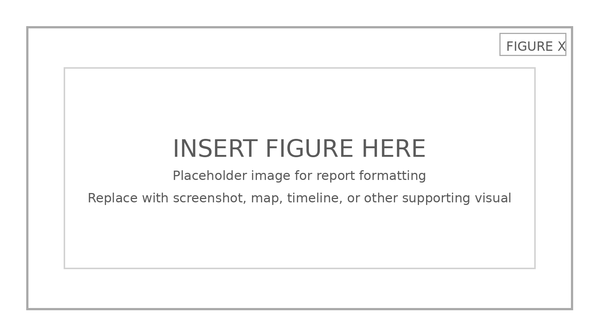
Figure [X]: [Insert figure caption here.]
Technical Evidence – [Source Type / Step Name]
OSINT | [Insert activity performed.]
Link(s) | [Insert URL(s).]
Notes: | [Insert what this source showed and why it mattered.]
Figure [X]: [Insert figure caption here.]
Analysis
[Insert interpretation of the evidence, noting what is confirmed versus inferred.]
Conclusion
[Insert final answer or assessment here.]

