Extraversion as a Predictor for Pro-Social Behavior

Steven R. Jordan
Department of Psychology, University of South Carolina
PSYC 221: Psychological Research Methods
Dr. Samuel D. McQuillin
April 22, 2026

Abstract
It seemed fairly-well established in current literature that a weak-at-best relationship exists between a person’s degree of extroversion, and their level of pro-social behavior (PSB). As pro-sociability involves a range of behaviors, this study sought to determine if this correlation holds true across the board, or if a person’s outgoingness serves as a predictor for only certain metrics of PSB. The study involved a series of 15 questions asking participants for some demographics, and self-perceived measures of personality, self-extension, and other habits. This online survey was shared within an undergraduate Psychology class’s Blackboard LMS system, and a Psychology student club on GroupMe. Data collected analyzed using SPSS found no significant relation between extroversion and the PSB aspects measured in the study.
Keywords: extroversion, pro-social behavior, self-extension, generosity, volunteering

Extraversion as a Predictor for Pro-Social Behavior
It may seem logical to believe there exists a link between the degree to which a person is outwardly sociable, and their exhibition of pro-social tendencies. Many of the studies examined during the literature review of this research go on to attribute particular pro-social behaviors to extraversion, while others correlate this to other personality traits. The goal of this study is to determine to what degree extraversion may be used as an indicator for PSB.
One study divided pro-social habits into two categories of either pro-social or anti-social (Riaz et al., 2021) and this is the broad framework used to determine the specific behaviors measured in this study. While there may be an enormity of sociability factors one could measure, for the sake of brevity, this study sought to select a limited number of these, in order to reduce the effects of survey fatigue on the participants. Determining which to use as our metrics then, became the challenge.
The capacity to forgive others is paramount to a functioning society, and it is which seemingly well-researched. One such study concluded that a positive correlation of over 0.97 was found linking gratitude and extroversion, and even higher between extroversion and forgiveness (Amjal et al., 2016). They surmised extroverts have a propensity of display more consistent levels of forgiveness as these personality types are more concerned with their social image. Another’s findings suggested that personality played a less impactful role as a predictor of forgiveness and gratitude (Skalski-Bednarz et al., 2024), though here, extroversion was found to be a weakly-significant determinant for forgiveness. And yet, another study (Abdullah, 2020) concluded that Agreeableness is the primary personality trait that drives PSB. Last, still another group stated that it may be understood that extraversion could motivate persons to perform positive PSB (Trishala, 2021). Given the diversity of findings on this topic, the need for further research into the intersection of personality and social behaviors becomes apparent.
The research hypothesis we tested in this study was to see if a correlational link exists between extroversion and pro-social behavior. Our null hypothesis is that there is no difference between introverted and extroverted individuals when it comes to exhibiting PSB, while our alternative is that there is a difference between these groups.
Method
Participants
The participants of the study were primarily college undergraduates at the University of South Carolina. A link to the questionnaire was posted in a Psychology Research Methods course Blackboard, as well as in the Psychology Club student group on the university’s GroupMe platform. The 14 participants consisted of 10 females (72%), and predominately Psychology majors (93%) in their sophomore year (58%) of college. The mean age of the group was 21 years.
Materials and Procedure
The study used a 15-question survey, created using Google Forms, and contained several inquiries on the participant’s demographics, before proceeding to sections posing two to three questions each, based on the pro-social behaviors of interest. Most of the questions in these sections asked the participants to rate their experiences on a scale ranging from 1 to 4 (or to 5 in some cases). The survey should have taken the average person less than five minutes to complete. In the introduction to the survey, a clause was included that participant emails were not going to be recorded when the form was submitted. The setting to randomize the order of the questions in each section was also used.
The four major sections of the survey were listed as Self-Extension, Generosity, and Volunteering, and Personality. The questions with a numeric rating were summed in each section to arrive at a total, which served as the metric for the respective behavior. The section labeled as Personality sought to determine if the participant is more introverted or extroverted. The first question in this section asks the user to rate a series of statements such as “I am good at stirring things up” (Ivanova). The second question has a similar setup, asking “You seek out and enjoy the company of others” (Okun).
Results
Over the course of the study, we conducted a one-way ANOVA, and one Pearson Correlation for each of our pro-social behaviors of interest.
A one-way between-subjects ANOVA was conducted to determine if Extraversion differed among Freshmen (M = 2.65, SD = 0.575), Sophomores (M = 3.18, SD = 0.287), Juniors (M = 3.65, SD = 0.575), and Seniors (M = 3.35, SD = 0.575). There was no significant effect overall, F(3, 11) = 0.534, p = 0.669. Although it may appear that Freshmen differ greatly from the rest of the upperclassmen, SPSS reported no significant differences among these groups (Figure 1).
Next, a Pearson correlation analysis was conducted to determine whether there was a relationship between Self-Extension (M = 3.19, SD = 0.77) and Extraversion (M = 3.88, SD = 0.77). Results showed there was a weak, negative relationship, r(12) = -0.051, p = 0.863. So, although no statistically significant, we do see that as self-extension increases, Extraversion decreases slightly (Figure 2).
Similarly, a Pearson correlation was conducted between Generosity (M = 3.64, SD = 0.49) and Extraversion (M = 3.19, SD = 0.77). Results also showed a weak, negative relationship, r(12) = -0.027, p = 0.926. So again, an increase in generosity showed a slight decrease in Extraversion (Figure 3).
Our final Pearson correlation was conducted to determine whether there was a relationship between Volunteering behavior (M = 2.11, SD = 0.59) and Extraversion (M = 3.19, SD = 0.77). Results showed there was a weak, positive relationship, r(12) = 0.095, p = 0.748. Again, SPSS found no statistical significance, though does report a slight increase in Extraversion scores alongside rising volunteering behaviors (Figure 4).
Discussion
While some research proports a weak association between extroverted personality and general PSB (Skalski-Bednarz et al., 2024), the goal for the study was to ascertain a correlational relationship between extraversion and propensity to display certain pro-social behaviors. Here we used generosity, volunteering, tipping behavior, and self-extension as criteria to measure against a person’s extroversion score. Our hypothesis was that there is a relation between these factors and extroversion, but after the analysis by SPSS, the survey data failed to detect a significant association.
Perhaps the primary limitation of this non-experimental study was the insufficient number of participants. As there were fewer than 30 participants, the statistical validity was likely highly compromised. Another consideration was that the questionnaire contained only 15 prompts. While this was intentionally done to help limit fatigue effects of the participants, and thus aim to keep authenticity of responses high, we also acknowledge that having fewer questions may also reduce ability to verify the accuracy of responses. Last, the survey was shared with college students, and as the data corroborates this, the sample is not representative of the overall population; a threat to the study’s external validity. Future research into this topic may do well to take these shortcomings into consideration.
It has often been stated that human beings are social creatures, so broadening our understanding of what personality factors impact how we interact with others may help us better understand ourselves and how to mitigate potential friction in adverse situations. While the above considerations are likely to have impacted these inconclusive results, it does not rule out the possibility that a relationship may exist between extraversion and the exhibition of pro-social behavior.
References
Abdullah, A. A., Hamsan, H. H., & Ma’rof, A. A. (2020). How do personality factors associate with prosocial behavior? The mediating role of empathy. International Journal of Academic Research in Business and Social Sciences, 10(16), 206-219.
Ajmal, A., Amin, R., & Bajwa, R. S. (2016). Personality traits as predictors of forgiveness and gratitude. Pakistan Journal of Life & Social Sciences, 14(2), 91-95.
Ivanova, K. (102 C.E.). Sociability/Extraversion Scale. PsycTESTS. H ttps://doi.org/10.1037/t58793-000
Okun, M. A., Pugliese, J., & Rook, K. S. (102 C.E.). Extraversion Measure. PsycTESTS. https://doi.org/10.1037/t11449-000
Riaz, M. N., Rashid, I. Q. R. A., & Akhtar, M. A. S. U. D. (2021). Relationship of personality factors with pro-social and anti-social behaviors in university students. International Review of Social Sciences, 9(4), 163-170.
Skalski-Bednarz, S. B., Toussaint, L. L., Konaszewski, K., & Surzykiewicz, J. (2024). Personality traits as predictors of forgiveness and gratitude/awe: A two-wave longitudinal study. Current Psychology: A Journal for Diverse Perspectives on Diverse Psychological Issues. https://doi.org/10.1007/s12144-024-06768-x
Trishala, M. (2021). Big Five Personality traits as determinants of pro-social behaviour. Indian Journal of Positive Psychology, 12(2), 200-203.

Figure 1
Average Extraversion by Class Year
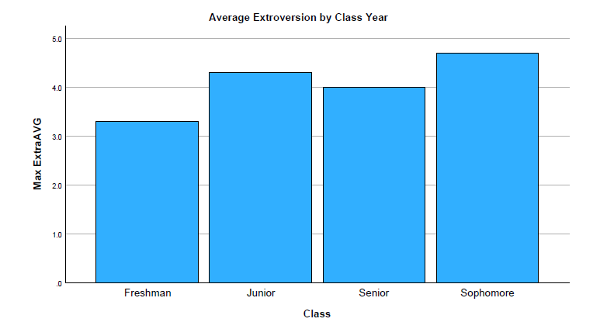
Figure 2
Self-Extension by Extraversion
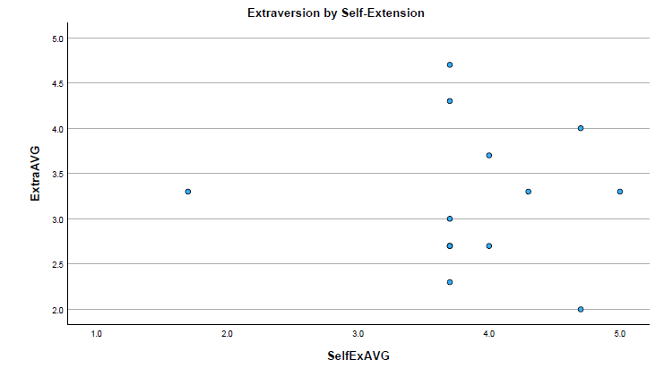

Figure 3
Generosity by Extraversion
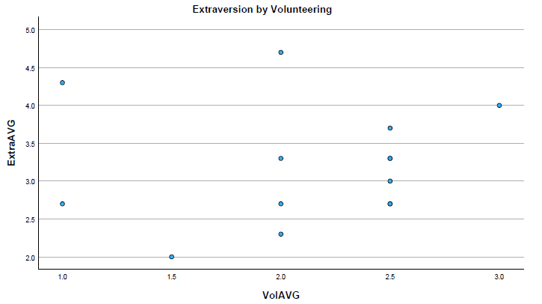
Figure 4
Volunteering by Extraversion 