Prospective authors are invited to submit their full paper(s) electronically through the Cmt3 conference website. However, there are changes to submission processes for CITISIA 2023 with the requirements for:

- A double-blind review to be conducted (i.e., the reviewer does not know the author and vice versa) – instructions can be found below.
- Full author registration on CMT site while do the paper submission (i.e., all authors must be listed with full contact details

Submission Procedure:

Step 1:

Your CMT3 account:

Log in to CMT 3 if you have an existing account, DO NOT CREATE A NEW CMT ACCOUNT IF YOU ALREADY HAVE ONE.

If you are new to CMT3, register yourself on the Microsoft Conference Management tool at https://cmt3.research.microsoft.com/User/login. Click ‘Register’.

The following criteria apply and MUST be followed:

- Register yourself with an email that you check regularly (+ create a password when prompted)
- Complete the login details and Register
- Microsoft will send you an email acknowledgement to which you need to respond to confirm registration.

Step 2:

- Register your paper on the CMT3 website
  - Enter your paper title
  - Enter yourself as the corresponding author with your email, phone number and affiliation.
  - Enter any other authors with their email, phone number and affiliation.

Step 3:

- Remove all names and affiliations from the title page of your paper (for the double-blind review)
- Attach your full paper (no name) as Microsoft WORD document – do not attempt to submit pdf documents as these will be rejected.
- Once your work has been received, identification of you as the author is only possible through the CMT3 website by Chairs or Co-Chairs – reviewers will not know who you are.
Author Submission – How to: USE KNOWN CONFERENCE URL (https://citisma.org) for CITISMA 2026 or just the conference name as” CITISMA”

https://cmt3.research.microsoft.com/CITISMA2026

OR

SEARCH FOR CONFERENCE URL IN CMT
- Log into CMT and click on All Conferences to search for the Conference to which you will submit your paper.
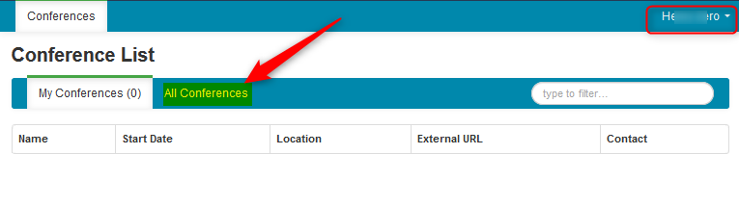
- Use the filter field in the upper right to search for the Conference you need. The search key should be - CITISMA.
- 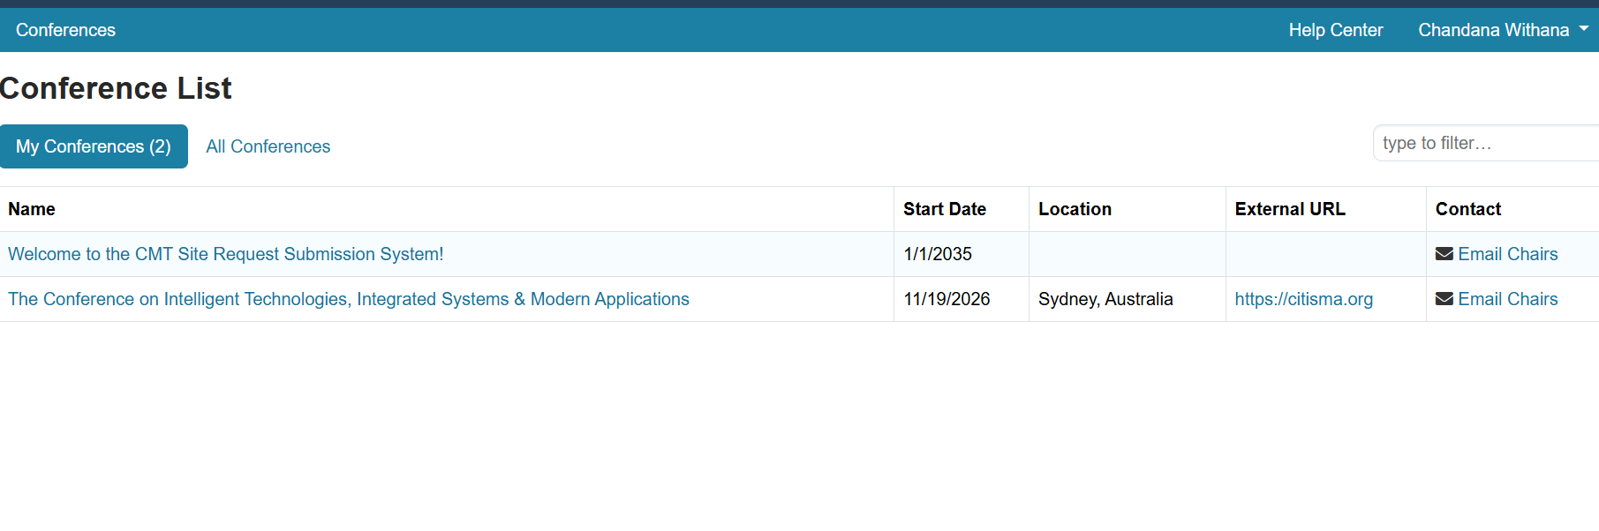
The Author Console page appears.

SUBMIT TO A SINGLE TRACK CONFERENCE

NOTE
If there is no '+ Create new submission' button, that means the Chairs have not enabled this phase of the conference. Please contact the Chairs.
- In a single track conference, click on the “+ Create new submission” button.
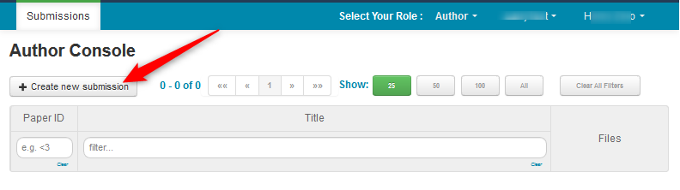

Please direct queries regarding the above to admin@citisma.org

Papers will be reviewed by the Program Committee for technical merit and content. Only accepted and presented papers will be published as Scopus-indexed chapters in two volumes under a reputable book publisher and information will be updated as soon as the official approval letter is available. If you do not present your paper at the conference, it will not be posted to Scopus-indexed chapters; however, it will still be a copyrighted and published paper through being in the conference proceedings.

