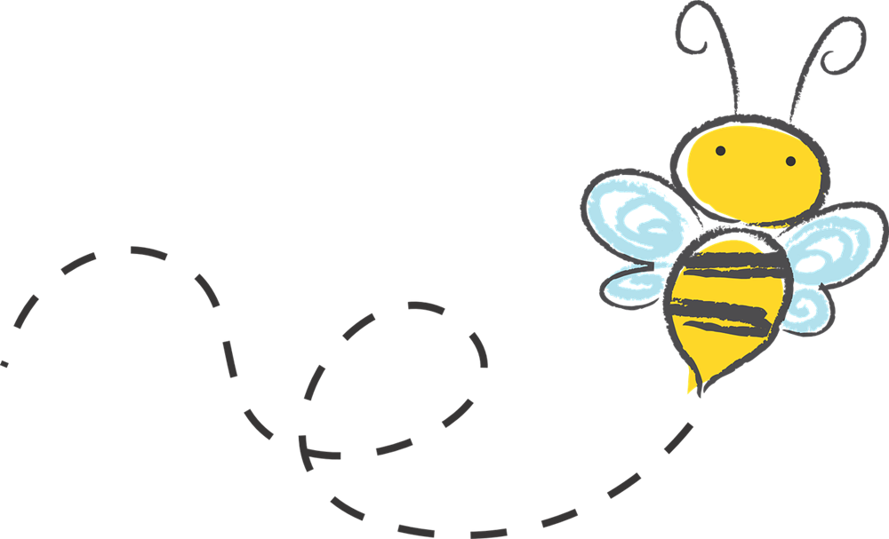
North Shore Beekeepers Association
2026 Membership Information

Please Print Clearly

______ Renewing Member ______ New Member

Date:____________________

1. Name _____________________________________________________________

2. Name _____________________________________________________________

Street_____________________________________ City _____________________

State_________ Zip_________ Home Phone_______________________________

Cell Person #1 ___________________________________________________

Cell Person #2 ___________________________________________________

E-mail Person #1_____________________________________________________

E-mail Person #2 _____________________________________________________

_______ I am a new beekeeper. I plan to start ______ hive(s) this year.

_______ I would appreciate some help getting my hive started.

_______ I currently am a beekeeper with _______ hives.

_______ I am willing to mentor a new beekeeper if needed.

_______ I am willing to serve on the Association Committees or Board

Club Dues: $20.00 single $30.00 Family
Checks should be made out to NorthShore Beekeepers Association.

Dues can be paid in person at our meetings or mailed to Treasurer, Dave Harder at 8404 W. Poplar Dr, Mequon, WI 53097. Membership dues run from January 1st to December 31st.

********************************************************************************************
OFFICE USE North Shore Beekeepers Association

Date_________________ Amount of Dues Accepted__________________

Cash _______ Check _______ Check Number ____________

Accepted by_____________________________________________

