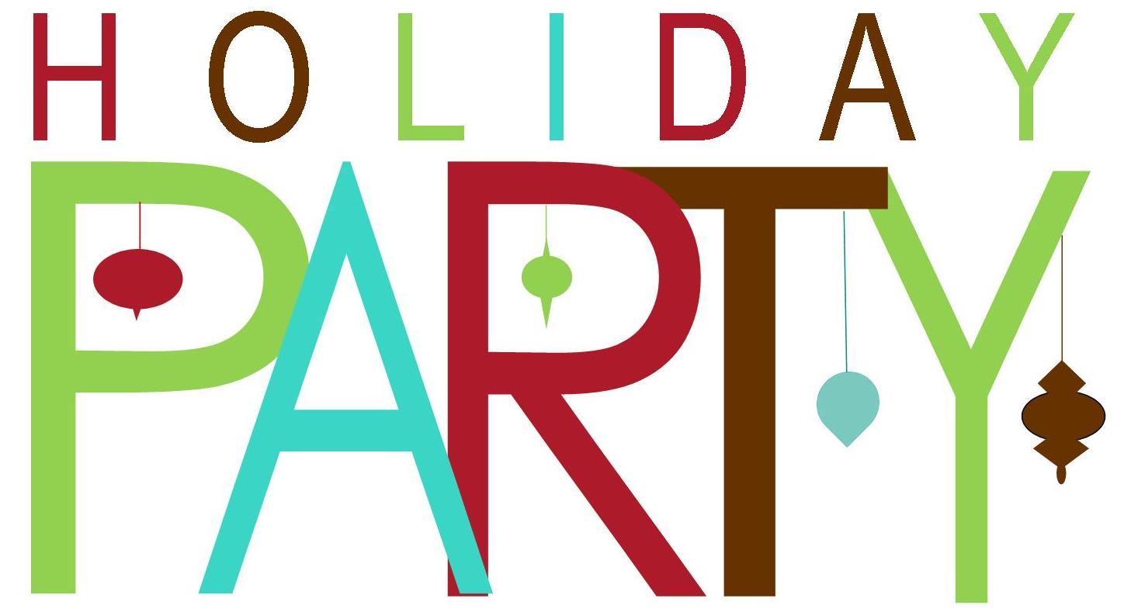

We would like to invite you to
Join the North Shore Beekeepers Association in an evening of Holiday Cheer and a Pot Luck Dinner from 5-9 pm

Wednesday, December 17th 2025
Social Hour-Cocktails 5:00-6:15 PM – Dinner 6:15 PM
Cash Bar with bartender all evening.
Cost $10 per person to cover the room rental

Cedarburg’s Peter Wollner American Legion Post #288
W57N481 Hilbert Avenue
Cedarburg, WI 53012

Bring your spouse, significant other or a friend.
The club will provide the main entrée and ask that you bring a side dish, salad or a dessert to share.

Call or text Donna at 414-550-4450 by Saturday Dec. 13th to indicate what dish you will bring and how many guests.
Please send payment to Dave with form found below or pay at the door.

Name_____________________________________________________

Number of Guests________ at $10 per person Total___________

Make checks out to North Shore Beekeepers Assoc.

Send this form by Saturday, Dec. 13th with payment to
Dave Harder at 8404 W Poplar Drive, Mequon WI 53097
Sunday, Dec. 13th to 8404 W. Poplar Drive
8404 W Poplar, Mequon WI 53097

