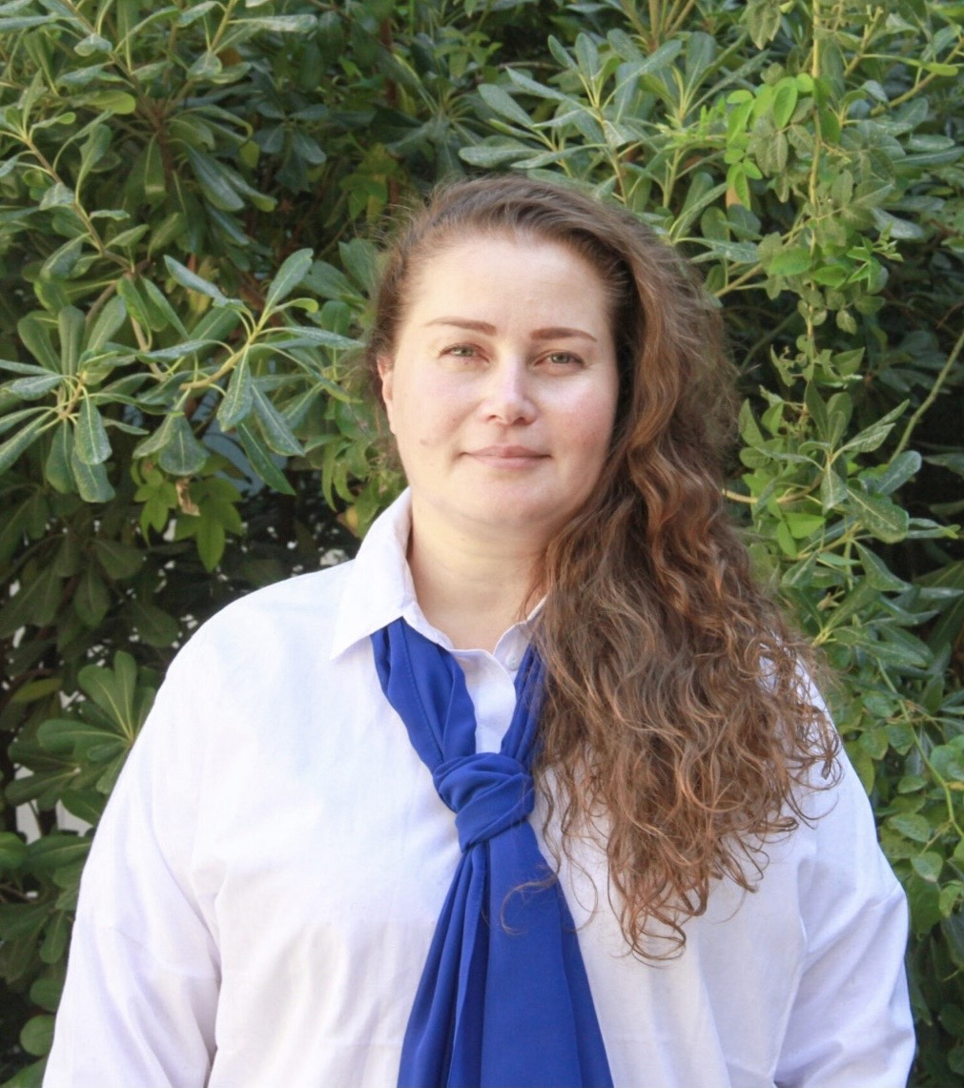
Natavan Məmmədova
Date of Birth: 17 January 1975
Location: Baku, Azerbaijan
Origin: Lankaran
Marital Status: Single

Profile
Experienced Russian language teacher with extensive background in education. Skilled in modern teaching methodologies, student-centered learning, and effective communication. Capable of working with diverse age groups and creating engaging learning environments.

Work Experience
ABC – Azerbaijan British College
Russian Language Teacher | March 2022 – Present
- Teaching Russian language
- Developing lesson plans
- Improving students' language skills
Secondary School №247, Baku
Russian Language Teacher | Sep 2021 – Mar 2022
- Teaching and assessment
- Lesson planning
Hedef Courses
English & Russian Teacher | Nov 2017 – Feb 2022
- Group and individual teaching
Secondary School №3, Lankaran
Russian Language Teacher | Sep 1997 – Sep 2004
- Long-term teaching experience

Education
Azerbaijan International University – 2007
Baku Slavic University – 1997

Skills
- Teaching and curriculum planning
- Communication
- Teamwork
- Classroom management

Languages
Azerbaijani — Native
Russian — Fluent
English — Fluent

