EU Omnibus Package: What It Means for Hong Kong and China Businesses
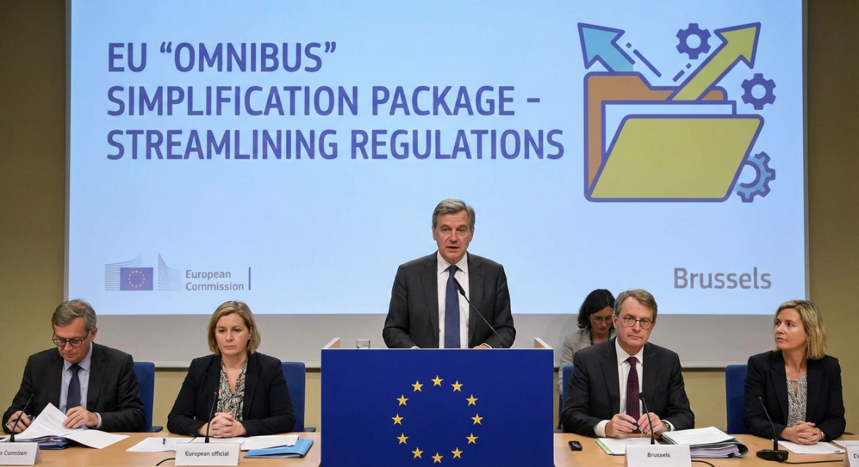
The European Commission’s proposed “Omnibus” simplification package, published on 26 February 2025, would significantly reshape the EU sustainability compliance landscape. While the proposals do not remove the Corporate Sustainability Reporting Directive (“CSRD”), the Corporate Sustainability Due Diligence Directive (“CSDDD”), the Carbon Border Adjustment Mechanism (“CBAM”) or the EU Taxonomy, they would narrow scope, delay implementation and reduce reporting burdens if adopted.
For businesses in Hong Kong and mainland China exporting into the EU, and for large EU companies operating in China, the proposals are important. The overall effect is likely to be a more targeted compliance framework — but not a retreat from sustainability regulation.
| The Omnibus package points to simplification, not deregulation.

Reduced disclosure pressure under CSRD
One of the headline proposals is a major reduction in the number of companies subject to mandatory CSRD reporting. The Commission expects the changes could cut the in-scope population by around 80%, with the regime refocused primarily on larger undertakings with more than 1,000 employees.
For some Hong Kong and China-based groups, this may reduce the prospect of falling directly within the EU sustainability reporting regime. Non-EU turnover thresholds would also increase, which may further limit direct application to overseas businesses.
However, indirect pressure is likely to remain. Even if suppliers in Hong Kong or China are not themselves required to report under the CSRD, they may still receive information requests from EU customers needing sustainability data for their own compliance purposes.
| Many Asia-based businesses may fall outside direct reporting scope, but still remain within the EU compliance ecosystem.

Value-chain requests may become more manageable
The package would also strengthen protections against excessive value-chain reporting requests. This is particularly relevant for suppliers in China that have faced increasingly detailed ESG questionnaires from European customers.
If adopted, the new approach could help curb disproportionate data demands from large in-scope companies, especially for businesses with up to 1,000 employees. That may ease some administrative burden across regional supply chains.

CBAM remains a key issue for exporters
For exporters of carbon-intensive goods, CBAM remains the most commercially relevant EU measure. The proposed changes would simplify compliance and exempt small importers below a new de minimis threshold. But the core mechanism remains firmly in place.
That means Hong Kong and China exporters in sectors such as steel, aluminium, cement and related products should continue preparing to provide reliable emissions data to EU importers and customers.
| For carbon-intensive exporters, the compliance burden may be lighter — but the need for credible emissions data is not going away.

Impact on large EU companies in China
For large EU companies with operations, sourcing or manufacturing in China, the proposed changes to the CSDDD are also significant. The Commission proposes to focus due diligence primarily on direct business partners, reduce the frequency of periodic assessments and narrow stakeholder engagement requirements.
This could make compliance more practical for companies managing complex supply chains and operating structures in China. Even so, large EU groups should not assume sustainability risk management will become a lower priority. Regulatory expectations may soften, but investor, customer and reputational pressures will remain.

Looking ahead
The Omnibus package is still only a proposal and will now move through the EU legislative process. The final outcome may differ from what has been published. For now, companies should treat the package as a signal that the EU is seeking a more proportionate model — while still preserving the core architecture of sustainability reporting, due diligence and carbon border regulation.

|The right response is reassessment, not complacency.
Businesses in Hong Kong, China and Europe should now review how the proposed changes affect their reporting exposure, supply chain data strategy and EU customer relationships.

Tony Wong,
Alaya Consulting and Curator ESG GATE

