TITLE OF YOUR ABSTRACT
First Author¹, Second Author², Third Author³

¹Department, University, Country
²Department, University, Country
³Department, University, Country
email.address@presentingauthor.com

This template shows how your abstract should be written and submitted for publishing in the book of abstracts. The abstract should ideally be prepared as a MS Word document as shown here and detailed below. Upon submission, the abstract can be uploaded as a Word document.
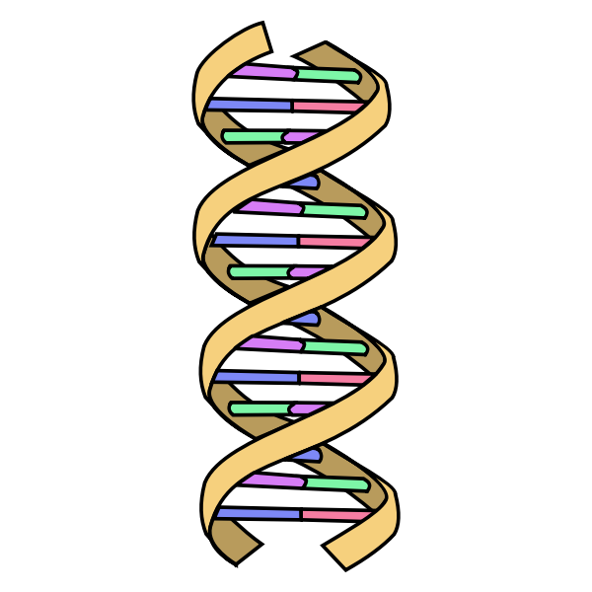
The abstract (written in English) must fit on one A4 page with page margins of 20mm for top, bottom, right, and left, using single line spacing for the text. Please do not add spaces before or after paragraphs except after author names and after the email address. Please use text formatting as described: a) the abstract title – 16pt, Arial font, Bold, ALL CAPS, Centered, no more than three lines; b) author names – 12 pt, Arial font, Normal, Centered – written as shown with presenting author‘s name underlined; c) author affiliations – 10pt, Arial font, Normal, Centered; use numerical superscripts for identification; d) email address of presenting author – 10pt, Arial, Underlined, Centered; e) the abstract body – 10pt, Arial font, Normal, left- and right-justified.
The first line of each paragraph should be indented by 1 cm. This rule does not apply to title, affiliations, and figure captions. References and in-text citations are not recommended and should not be included in the abstract. The abstract body can have a maximum of 2000 characters (with formatting and spaces). The first sentences should provide the background of the work. This should be followed by the experimental details, with a conclusion of one or two sentences.
The abstract may include equations and figures (Fig. 1) and should be embedded in the abstract document. Do not use smaller than 8 pt in figures and graphs or anywhere in the text for that matter.
Figure 1. A simplistic DNA model intended for giving an example of how figures should be formatted.

It is the responsibility of all investigators that all studies are performed with respect to national legislation, international legislation, and ethical guidelines both with regards to humans and animals. The Scientific Committee of LMD reserves the right to reject any submitted abstract that is believed to violate these principles.
The abstract book will be published online and distributed to participants electronically, so full-color figures may be included. Colored text in this template is used just for emphasis; we do not recommend using it in your abstract.
NOTE: It is the author’s responsibility to read through the abstract carefully before submitting it. There will be no alterations made by the organizers except formatting changes necessary for publication purposes.

