DIY T-Shirt Planters Guide
Materials Needed:
- Old t-shirts
- Scissors
- Potting soil
- Seeds or small plants
- Water
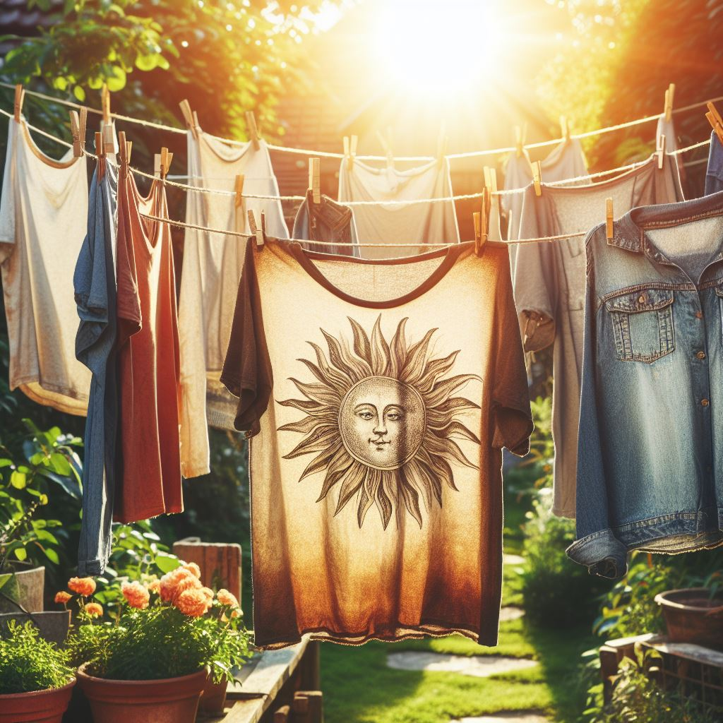

Instructions:
- Prepare the T-Shirts:
  - Lay the t-shirt flat and cut across from under the armpits to remove the top portion.


  - Cut off the sleeves and set them aside; these will become your planters.
- Create the Planter Base:
  - Turn one sleeve inside out and sew or tie the bottom to close it off, creating a pouch.
- Add Soil:
  - Turn the sleeve right side out again, and fill it halfway with potting soil.
- Plant:

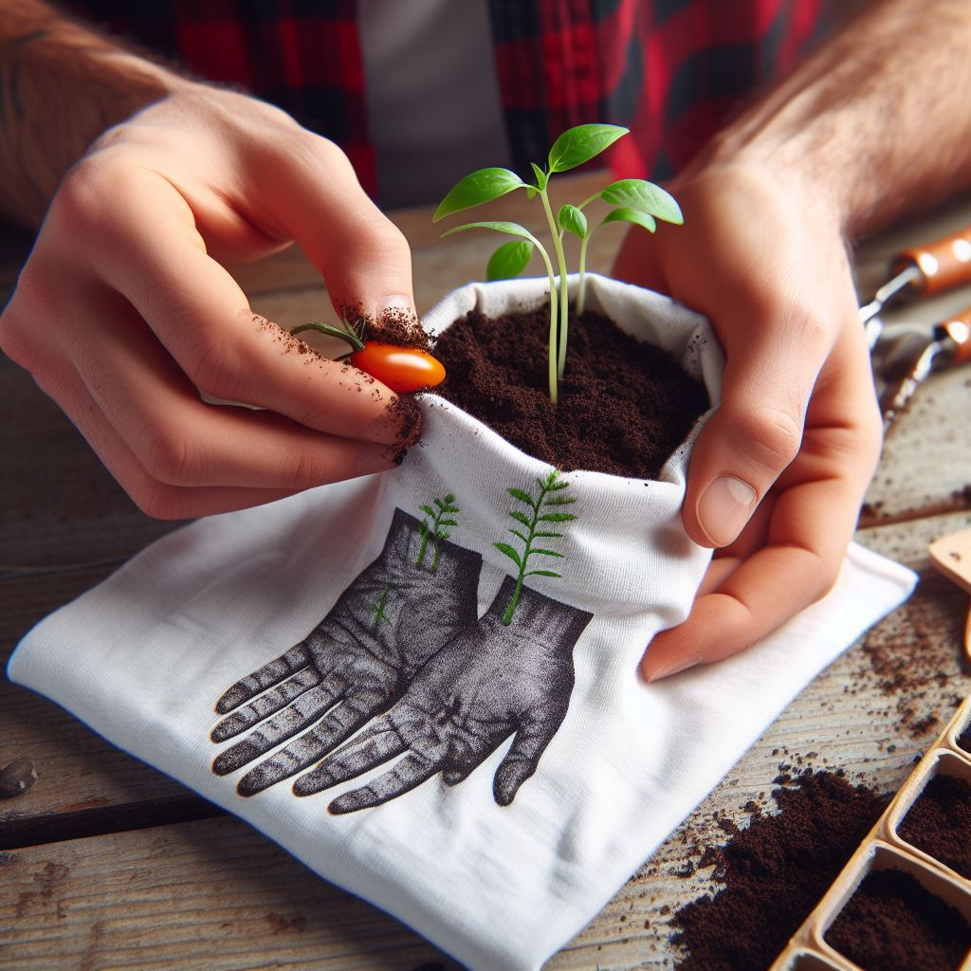

  - Place your seeds or a small plant inside the soil.
  - Add more soil on top to secure the plant in place.
- Water Your Plant:
  - Gently water the plant, making sure the soil is moist but not waterlogged.
- Hang Your Planter:
  - Use the remaining part of the sleeve to create a loop for hanging.
  - Hang your new t-shirt planter in a sunny spot.
- Care for Your Plant:
  - Ensure your plant gets enough sunlight and water it regularly.

Tips:
- Drainage: Consider making small holes at the bottom for drainage if you’re hanging the planters outside.
- Decoration: Get creative and decorate the outside of your t-shirt planters with fabric paint or markers.
Enjoy your new, eco-friendly t-shirt planters! They’re perfect for adding a touch of green to any space and are a great way to recycle old clothing. 🌱👕

