
NoAH
The Dirt
Newsletter
November 2025

The Purpose of NoAH is to:
- Promote all aspects of the growing of plants
- Provide education to our members and the public
- Community service
- Encourage the enjoyment of horticulture
NoAH membership is open to all who are interested in gardening.

UPCOMING GARDEN CLUB MEETING TOPICS IN
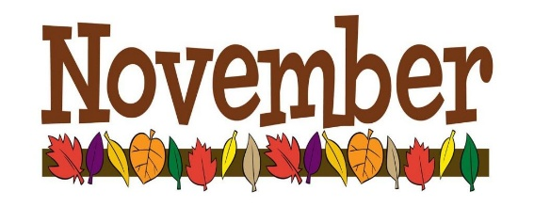

Hi everyone,
Just a quick heads-up about tentative topics we plan to discuss, but are not limited to, at our next business meeting on November 13 at @6:30 at the church.
• Secretarial and Treasurer Reports - Be sure to read September’s Business Meeting
Report.
• Election of officer candidates or reexamine the status of the club.
• Vote on a yearly membership fee of $20 with no late fees for renewing membership.
• Dottie Pedersen and Ruth Lang from the NoAH Christmas Party Committee will share
with members.
• Indoor Plant Sale - Please label your plant with its name, watering needs, sunlight
requirements, and any other necessary information for successful growth. Limit to no
more than 5 of the same plant.
• Any club-related topics from the floor?

We hope to see you all there!

Northwest Association of Horticulture
Business Meeting Minutes
Date: September 11, 2025

- The September 11, 2025, Business Meeting Minutes will be approved at the November 13 business meeting.
- The meeting was called to order by President Joan Bailey.
- Forty-five members attended the meeting.
- A moment of silence was held in remembrance of the tragic events on 9/11, 2001.
- Members introduced themselves.
- Everyone enjoyed the delicious refreshments provided by Dorathy Schatz, Kim Kraft, and Barb Gilbertson.
- The business meeting minutes from June and August’s meetings were previously sent out in newsletters. No corrections or additions were made. Barb Gilbertson motioned to accept the reports. Dennis Schatz seconded, and the motion passed.

TREASURER’S REPORT:
Dorathy Schatz reported a balance of $8534.19 with one outstanding bill as of the
meeting. Barb Matteson motioned to accept the report. Dennis Schatz seconded, and
the motion passed.

COMMITTEE REPORTS:
- Hospitality: Sandy Horob noted that no greeters were needed for October’s outing at Berry Acres.
- Depot: Kelly Weinheimer shared her appreciation for the volunteers who’ve watered the depot plantings. Volunteers are needed for the next two weeks. Contact Kelly at (701) 301-0388 to sign up!
- Education: Warren Graves reported that scholarship letters were sent to Bottineau College with an October 15 deadline for submission to the club.

OLD BUSINESS:
- Members who are not receiving newsletters or other club emails should check their spam or junk folders or contact Anne Smart at annemichellesmart@gmail.com with their updated contact information.
- Nancy Fry (nancyfry227@gmail.com) is our newsletter editor. Please send Nancy your articles and pictures to that address before the end of the month.
- Volunteers have signed up to plan and organize the 2025 Christmas Party, which will be held at the church on December 9. A big thank you to Dottie Pedersen and Ruth Lang for chairing this committee, and to all the volunteers who signed up to make this event happen for your fellow members!
- The members discussed the pros and cons of moving the 2026 Christmas Party from December to June and having a social event in December 2026 for members. They agreed to table the issue for now with no further action.
- Joan Bailey, President, reported that candidates are needed for the offices of
President, Vice President, and Treasurer for the upcoming November election.
Sitting officers will provide support to assist their successors. It was discussed that having these offices filled is crucial for the club to continue. Joan shared that she would consider continuing for 1 year if the other positions were filled. Notify Joan Bailey (701-240-8044) to volunteer.
- Members with unwanted flower vases can bring them to the NoAH meetings in
February and March 2026.

NEW BUSINESS:
- Lanyards will be replaced by single-use sticky name tags at meetings.
- A proposal to change the yearly membership fee to $20, with no late fees for
renewing memberships, was discussed. This will be voted on in November.
- An informal survey of attending members suggested that enough people would be at Berry Acres in October to qualify for the group discount.
- Guests attending meetings will receive one free visit, except during a yard tour or
plant sale, where guests pay $5 to attend. After the first free visit, they will be
charged $5 for each additional meeting unless they purchase a yearly membership.
- An informal survey of attending members showed many were interested in a
Saturday day trip to the International Peace Garden in 2026, with transportation
provided by NoAH.
- As we look ahead to the spring cleanup at the Amtrak depot in 2026, a trailer will be needed to haul gravel. Contact Kelly Weinheimer at (701) 301-0388 for further information.
- Check out our beautiful website! It's now live and waiting for you to explore. Visit
- https://gardeningnoah.com to explore all the exciting things we have to offer. A big Thank you to Jennifer and Anne!

- Door prizes were handed out to us lucky members!
- The next business meeting will be held at the church on November 13 at @6:30 PM. We will have the election of officers and an indoor plant auction.
- NoAH members will be going to Berry Acres (on the grounds of Green Thumb Greenhouse) for an outing on October 10. Special rate of $7 for adults; children under 3 are free.
- The motion to adjourn the meeting was made by Cindy Rudnick and seconded by Barb Matteson.

PROGRAM:
The membership enjoyed buying plants at the Fall Plant Auction. Ken Eraas was the auctioneer. Many thanks to everyone involved, whether by donating, buying, bidding, or helping to distribute plants. The event was a success, with numerous donations and fantastic bargains. Special thanks to those who labeled their donations, which provided potential buyers with a better idea of how the plants could fit into their garden beds.

Submitted by Barb Matteson, NoAH Secretary

9 Brilliant Ways To Reuse Old Potting Soil Instead Of Tossing It Out

Story by Katharine Hansen

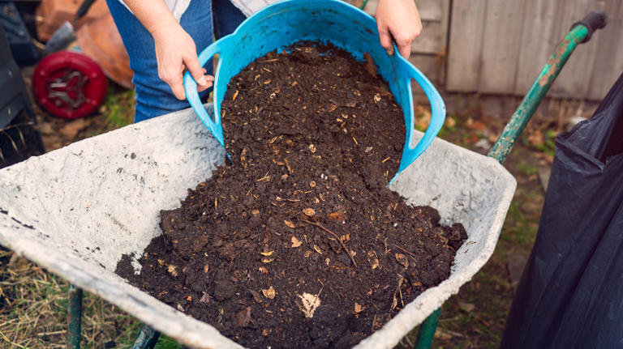
At a time when most of us are looking for ways to cut spending, it's helpful to learn that you can save on potting soil by knowing when to refresh versus when to replace. Old potting soil is safe to reuse as long as the plants they were used for were not diseased. Your used potting soil has undergone some depletion but still has much to offer by adding it to compost, filling holes in your yard, and using it in a custom soil mix.

Recycling your potting soil provides a number of advantages beyond saving money. Because potting soil is made primarily from organic materials, it can contribute in numerous ways to your garden's vitality. Your old potting mix contains microorganisms that help make nutrients available to plants and contribute to plant health. Similar to compost, old potting soil builds soil structure as it decomposes, especially if it's amended with additional organic materials. Reusing your old potting mix is a sustainable practice that also keeps it from going to waste in a landfill.

Add Old Potting Soil To Compost
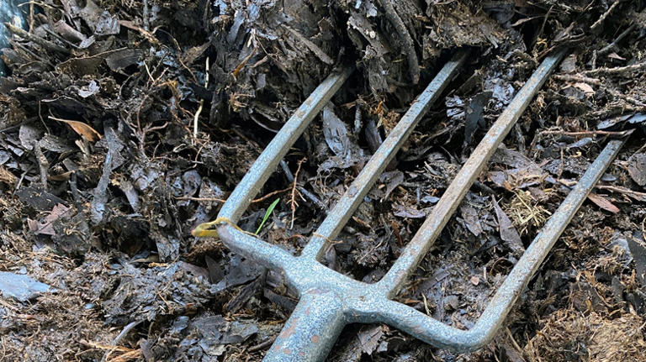
Your compost bin or pile will benefit from your used potting soil. If you are hot-composting using green (nitrogen-rich) materials and brown (carbon-rich) materials, old potting soil is a serviceable brown material. Given that gardeners typically place alternating layers of green and brown materials in their hot composting bins or piles, you can use old potting soil for some of your brown layers.

Fix Lawn Issues Like Holes And Divots With Old Potting Soil
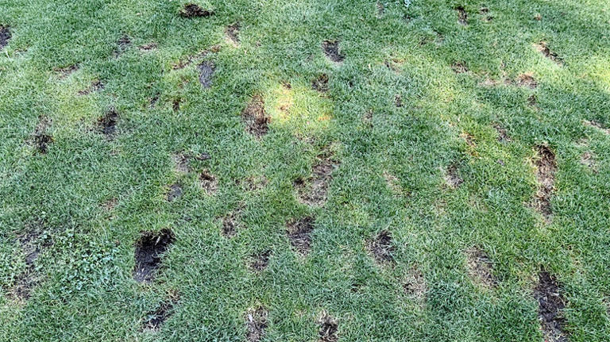
Old potting soil is extremely useful for repairing holes, divots, and bare patches in your lawn. If needed, clean out the problem area by removing debris, using a shovel to scoop it out or the water pressure of a hose to squirt it out. Then, simply shovel or trowel some of the potting soil onto the imperfection and tamp down with your feet.

Donate Old Potting Soil
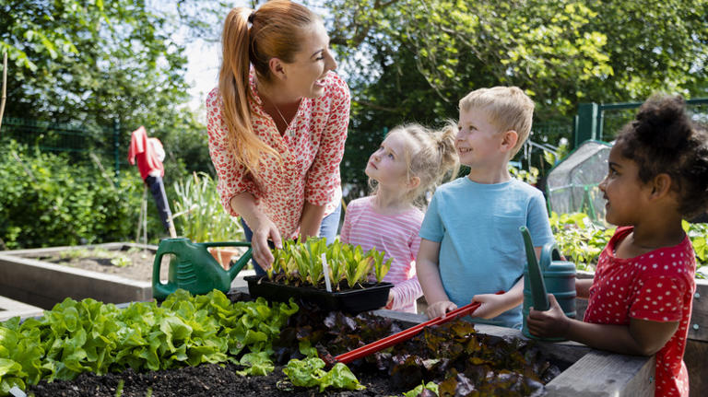
Many local organizations would likely appreciate your donation of old potting soil. Schools, camps, and organizations focusing on children often offer planting programs might benefit from your donation, as would your local food banks or organizations helping those at risk of food insecurity. Organizations holding plant or seed swaps may welcome other garden supplies like your used soil. It's also a good idea to contact your local Extension office and see if Master Gardeners could use the soil for their educational efforts or ask neighbors if they could use your extra before you toss it.

Use Old Potting Soil To Topdress Your Lawn Or Garden Beds
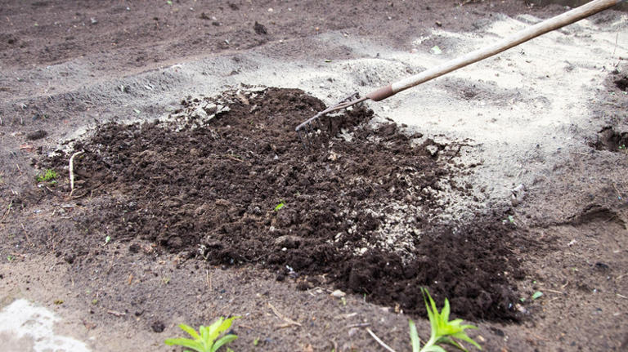
Did you know that topdressing your lawn is the easiest way to get better looking grass -- and old potting soil can help? This practice consists of spreading a light layer of material (often sand, but can be soil like your potting mix) on top of a turf lawn or garden bed. Topdressing will benefit the host location even more if you amend your old potting soil with additional organic material, but even if you don't, the potting-soil topdressing may help the soil structure in your lawn or garden beds.
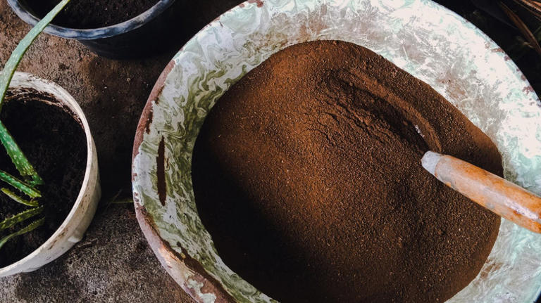
Increase Your Overall Volume Of Potting Soil By Adding Old To NewPerhaps the simplest solution for old potting soil is to simply make more potting soil by adding old to new. To keep from contaminating the new soil and diluting its nutrients with old soil, you'll likely want to both sterilize and amend the old potting soil before mixing it with the new. A 50-50 mix of old and new soil is recommended. Not only will you double your supply of potting soil, but you may find the new mix offers drainage, structural, and anti-compaction benefits.
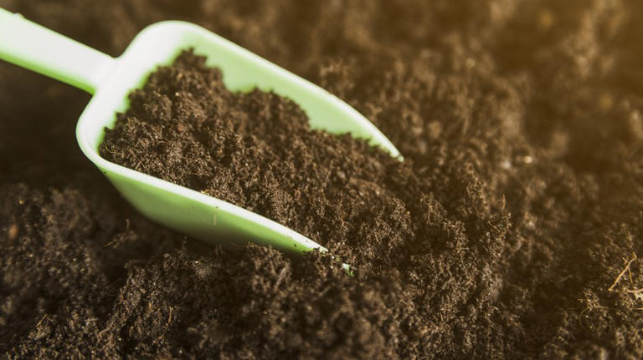
Make A Custom DIY Soil Mix With Your Used Potting SoilUsed potting soil offers a wonderful opportunity for creative gardeners with a bit of mad-scientist spirit to create their own DIY potting soil mixes. You can even target specific plant needs with your DIY mix. For succulents, for example, mix old potting soil with sand for good drainage. Create a nutrient-rich mixture by adding compost or other organic material to your old potting soil. Consider adding slow-release fertilizer and a wide array of soil amendments, such as bone meal, peat, or wood ash.

Amend Clay Soil With Old Potting Mix
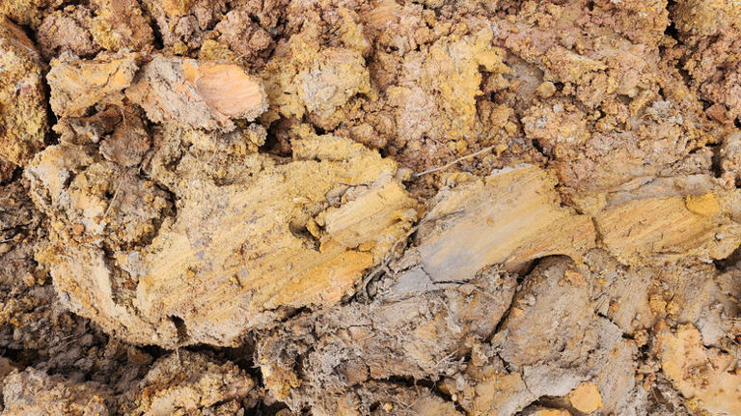
The best amendment for improving clay soil is organic material, which your used potting soil certainly offers. This is particularly helpful when you don't have richer organic materials, such as compost, on hand. You also have the option of enriching the old potting soil with other organic materials that will assist in building the clay soil's structure, as well as improving drainage and its ability to retain water.

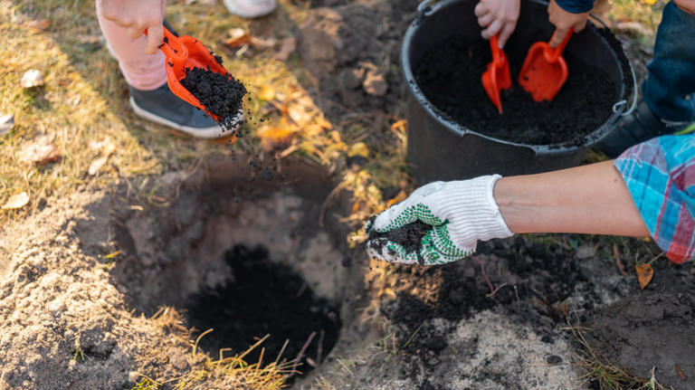
Fill Holes In The Landscape With Old Potting Soil
If landscaping updates on your property has resulted in bare spots and holes where landscape elements may have been removed, you can save some money by using your old potting soil as fill dirt. Since you're using it for filling in a void rather than for growing plants, you needn't worry about amending the potting soil. The soil surrounding the hole you've filled will benefit from the potting soil's microorganisms and ability to improve soil structure as it decomposes.
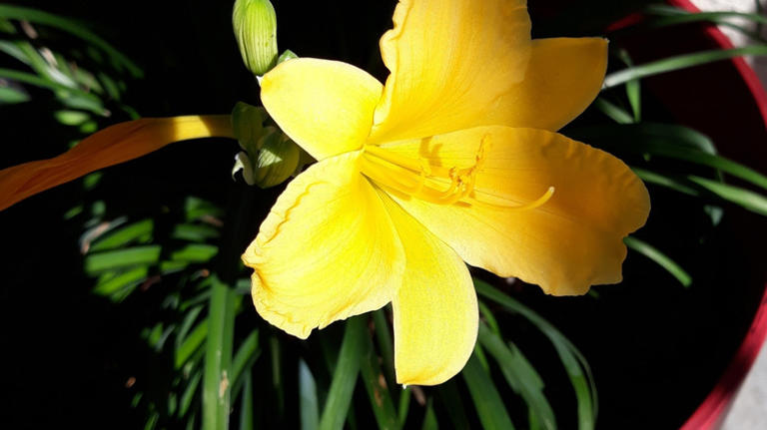
Use Old Potting Soil For Plants That Thrive In Poor Soil
Some plants flourish in problematic soil -- dry, sandy, clay, compacted, or low in nutrients. If you don't have the time to amend old potting soil, using it for plants that thrive in inferior soil is an effective way to recycle. For example, poor soil quality is no problem when growing many beautiful plants. Popular flowers that grow well in poor soil include yarrow (Achillea spp.), coneflower (Echinacea purpurea), and daylily (Hemerocallis spp.).
Read the original article on House Digest.
Should You Rake Your Leaves—or Just Mow Them? Here's What Experts Recommend
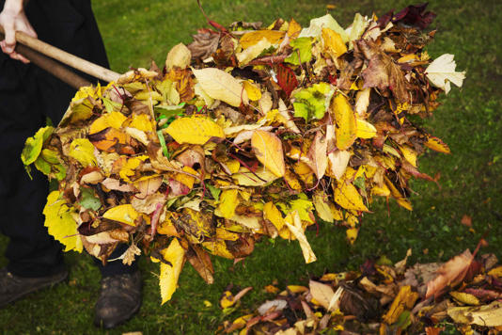
Story by Adrienne Jordan

One method is vastly more beneficial than the other.

Key Points
- Leaving fall leaves on your lawn saves time, boosts soil health, and helps nature thrive through the seasons.
- Shredded leaves decompose quickly, feeding your grass, enriching garden beds, and acting as natural mulch to stop weeds.
- Dry leaves help create rich soil while supporting insects, butterflies, and biodiversity.

As the temperature drops, so do the autumn leaves. Don't worry, though—leaves can actually be good for your lawn, enriching the soil and helping to prevent weeds. So how should you handle them: by mowing, or by raking?
The experts we talked to agree: Mowing will transform your lawn or garden. It boosts the soil, helps your lawn, promotes biodiversity, and provides a place for butterflies and flowers to grow and thrive. Ahead, learn how to treat leaves not as a nuisance, but as a boon for your lawn.

Meet Our Experts
- Rebecca McMackin, lead horticulturist at the American Horticultural Society
- John D. Faerber, director of horticulture, The Lake House on Canandaigua
- Bruce Cakebread, viticulturist, gardener, and co-owner of Cakebread Cellars

Related: 4 Surprising Ways Fall Leaves Can Supercharge Your Garden

The Benefits of Leaves
Leaves are an important natural resource for your lawn and garden. “As [they] decompose, they return vital nutrients and organic matter to the soil, strengthening your lawn and promoting healthy soil biology,” says John D. Faerber, director of horticulture at The Lake House on Canandaigua. They help retain moisture, moderate soil temperature, and provide natural insulation. Additionally, leaves create habitats for beneficial insects and wildlife, and can help suppress weeds, making them an eco-friendly way to enhance your garden.

How to Mow Leaves
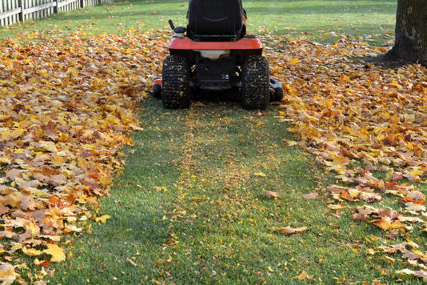
The best tool for the job is a mulching mower, but a normal mower will also work if you go over the leaves a few times. “Leaves should be dry, and spread fairly evenly on the lawn,” says Rebecca McMackin, lead horticulturist at the American Horticultural Society. “Don’t set your deck height too low—remember there is grass beneath the leaves. Leaf particle size should be dime-sized or smaller, so they can fall between grass.”

Leaves as Mulch
Mowing the leaves rather than raking them helps the shredded leaves decompose more quickly, returning nutrients to your lawn and garden. “Mulched leaves can also be spread over garden beds and vegetable gardens, where they help suppress weeds and gradually enrich the soil with organic matter,” adds Faerber. “When applied in the fall, these leaves break down over the winter, and by spring, beneficial insects and microorganisms have transformed them into rich, healthy soil, essentially creating your own natural compost right in your garden," he adds. This process saves time and labor, and keeps organic matter out of landfills.

Used in Compost
Dry fall leaves serve as a key carbon source, or a brown material, in the composting process. “These browns can then be combined with green composting materials, such as uncooked fruit and vegetable scraps, which are high in nitrogen and rich in moisture,” says Bruce Cakebread, viticulturist, gardener, and co-owner of Cakebread Cellars. Getting the right ratio is important. Without enough carbon-rich browns, green materials can quickly turn to mush and become anaerobic. Ideally, you want 15 to 20 parts brown to one part green, creating ideal conditions for microbial activity—this is what drives healthy composting.

Helping Biodiversity
“Hundreds of species of moths and butterflies use tree leaves as caterpillars, then drop down into the leaf layer to overwinter or complete the next phase of their life cycle,” says McMackin. Many homeowners are paying special attention to these leafy areas, adding low native plants beneath them so that they can grow through the fallen leaves. These convenient soft landings can double the butterfly and moth populations in your garden. "When we rake those leaves away, we’re literally raking away butterflies," McMackin says.

Read the original article on Martha Stewart

