

NoAH
The Dirt
Newsletter
January 2026

The Purpose of NoAH is to:
- Promote all aspects of the growing of plants
- Provide education to our members and the public
- Community service
- Encourage the enjoyment of horticulture
NoAH membership is open to all who are interested in gardening.

Northwest Association of Horticulture
Business Meeting Minutes
Date: November 13, 2025

SECRETARY’S REPORT:
- The November 13, 2025, Business Meeting Minutes will be approved at the January 8, 2026, business meeting.
- The meeting was called to order by Vice President Nancy Fields.
- Thirty-six members and one guest attended the meeting.
- Members introduced themselves.
- Everyone enjoyed the delicious refreshments provided by Sandee Michalenko, Cindy Rudnick, and Rhonda Maas!
- The business meeting minutes from September were previously sent out in October’s newsletter. No corrections or additions were made. Pete Hugret motioned to accept the report. Sandy Horob seconded, and the motion passed.

TREASURER’S REPORT:
Ø Dorathy Schatz reported a balance of $8,753.89, minus a $50 withdrawal for change for today’s plant auction, as of the meeting. Barb Matteson motioned to accept the report. Jennifer Kraft seconded,and the motion passed.

COMMITTEE REPORTS:
- The Christmas Party Committee, Dottie Pedersen and Ruth Lang, announced that the party will begin at 6:00 pm. Members donating items for grab bags and basket donations are asked to bring them to the church by 5:00 pm on the day of the party. Members are also encouraged to bring their favorite side dish, appetizer, or dessert to share at the potluck. Ham will be provided. The event will feature a variety of games and other engaging activities. Save the date for this eagerly anticipated annual event!
- Depot: No report.
- Education: Warren Graves reported that there were two applicants for NoAH’s $1,000 scholarship.
- Gardening Saturday (April 18, 2026) Update: Jennifer Kraft reported that speakers have been scheduled and that the event will be held at last year’s site (Minot Area Workforce Academy located on the Minot North High School Campus. Brochures will be printed soon, and members can continue to donate unwanted flower vases by bringing them to NoAH meetings at the church. We are collecting them for the flower vendor to use during Gardening Saturday 2026. Thanks!
- Membership: Nothing to report. Meeting program brochures will be printed for the new year.
- Hospitality: Sandy Horob distributed the 2026 signup sheet for members to bring light refreshments. Call Sandy at 701-570-1591 to volunteer during your favorite month
- Greeter: Cindy Neuhart Black will soon have the 2026 signup sheet available for members interested in volunteering. Feel free to call Cindy at 701-721-0207 to sign up for your preferred month! Here's a fun tip: choose a month to be a greeter, sign up to bring some light refreshments during that month, and then enjoy bragging all year long about how you volunteered twice!

OLD BUSINESS:
- An informal survey of attending members showed that many were interested in a Saturday day trip to the International Peace Garden in 2026, with a portion of the transportation costs to be provided by NoAH. Members volunteering to form a committee to organize the trip are Barb Matteson, Lanae LaBonte, and Beth Madsen. Thanks for stepping forward to plan this event for the club!
- As we look ahead to the spring cleanup at the Amtrak depot in 2026, a trailer will be needed to haul gravel. Contact Kelly Weinheimer at (701) 301-0388 for further information.
- Members discussed holding a picnic on the meeting date in June 2026. There was a consensus among those present to proceed with the picnic. A motion was made by Anne Smart to use club funds to provide hamburgers and hot dogs for the picnic, and it was seconded by Pete Hugret. The motion was approved. It was noted that the picnic in June would not replace the Christmas Party in December 2026. Members also voted to open the event to their families, with Sandy Michalenko making the motion and Barb Matteson seconding it. The motion was approved. Volunteers for the picnic committee are in the planning stage. Thanks, Jennifer Kraft, for stepping forward to look at picnic site options.

NEW BUSINESS:
- Election of Officers:
  - Susanne Hoskin was nominated for Treasurer, Beth Madsen for Vice President, and Barb Matteson for Secretary during the October member canvassing.
  - Jennifer Kraft was nominated from the floor for President, but she chose not to run this year. Joan Bailey was nominated from the floor for President. Sandy Horob moved to accept the nominations, Barb Matteson seconded, and the motion passed.
  - Officers and Committee Chairs for 2026:
    - President: Joan Bailey
    - VP: Beth Madsen
    - Treasurer: Susanne Hoskin
    - Secretary: Barb Matteson. Co: Open
    - Member-At-Large: Julie Budeau
    - Membership: Alisha Keller
    - Hospitality: Sandra Horob Co: Nancy Fields
    - Greeter: Cindy Neuharth-Black
    - Newsletter: Nancy Fry
    - Education: Warren Graves
    - Publicity: Anne Smart
    - Depot: Kelly Weinheimer Co: Open

- Alesha Keller made a motion to set the yearly membership fee at $20, with no late fees for renewals and Anne Smart seconded it. The motion was approved by 23 members voting yes and 11 members voting no through written ballots.
- A big thank you to Dennis Schott and Susanne Hoskin, who are auditing the 2025 club finances in January and will present the report to the membership in February 2026.
- Guests attending meetings will receive one free visit, except during a yard tour or plant sale, where guests pay $5 to attend. After the first free visit, they will be charged $5 for each additional meeting unless they purchase a yearly membership.

- Door Prizes were given out.
- The motion to adjourn the business meeting was made by Orbie Fields and seconded by Jennifer Kraft.
- Club members will enjoy the Christmas party at the church on December 11, 2025, at 6:30. Remember to bring donations by 5:00 pm. Also, bring your favorite side dish or dessert!
- The next business meeting will be held at the church on January 8, 2026, at 6:30 PM. The program will feature Judy and Sonja’s History of the Mohall Greenhouse.

NOVEMBER’S PROGRAM:
The Club members had a wonderful time at the Indoor Plant Auction! Ken Eraas led the event as the enthusiastic auctioneer, while helpful friends like Orbie, Nancy Fields, Pete Hugret, and Beth Madsen took turns distributing the plants. A heartfelt thank you to everyone who contributed—whether by donating, bidding, buying, or adding a bit of humor to the plant descriptions or origins. We especially appreciate those
who took the time to label their donations. Your participation made the event extra special!

IMPORTANT CONTACTS:
- Members who are not receiving newsletters or other club emails should check their spam or junk folders or contact Anne Smart at annemichellesmart@gmail.com with their updated contact information.
- Nancy Fry (nancyfry227@gmail.com) is our newsletter editor. Please send Nancy your articles, pictures, etc., to that address before the end of the month.
- Check out our beautiful website! It’s now live and waiting for you to explore. Visit https://gardeningnoah.com to explore all the exciting things we have to offer. A big thank you to Jennifer and Anne!

Submitted by Barb Matteson, NoAH Secretary

UPCOMING GARDEN CLUB MEETING
TOPICS IN
Hi everyone,
Just a quick heads-up about tentative topics we plan to discuss, but are not limited to, at our next business meeting on January 8, 2026, at @6:30 at the church.
- Secretarial and Treasurer Reports - Be sure to read November’s Business Meeting Report.
- Updates by the Gardening Saturday Committee or other committees?
- Any club-related topics from the floor?
We hope to see you all there!




GARDENING SATURDAY April 18, 2026

Please help us spread the word far and wide!

Invite a friend, a neighbor, or anyone who loves plants, flowers, and getting their hands in the soil. It’s going to be a joyful day celebrating gardening, learning, and our growing community.
And don’t forget to get your ducks in a row and register yourself!



January–March Meeting Reminder

As we settle into winter and dream of spring, please remember to bring your gardening magazines and vases to our January, February, and March meetings.


Christmas Party

2025

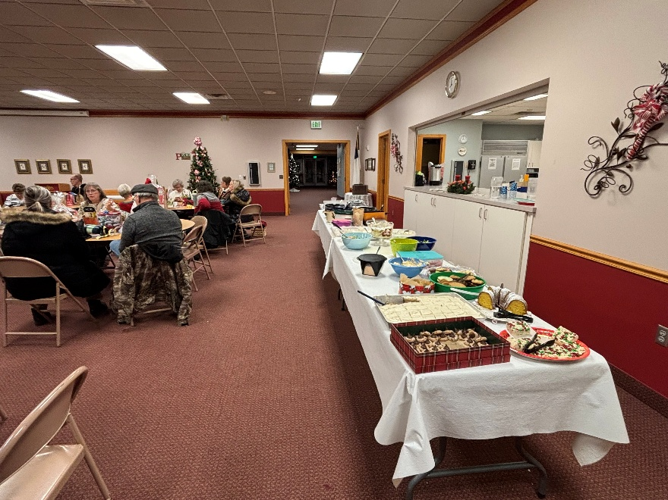

We have some awesome

cooks and bakers!

What a fantastic spread!

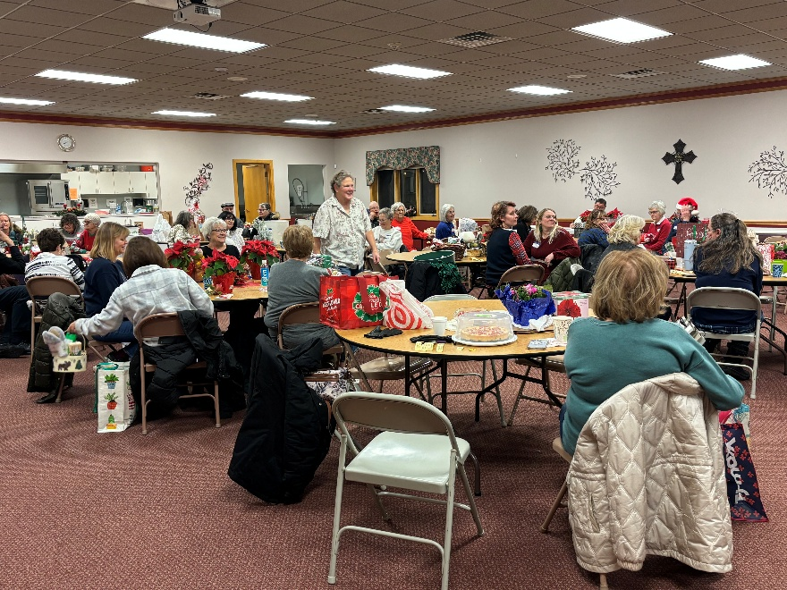

Great Conversations with
Old Friends & New

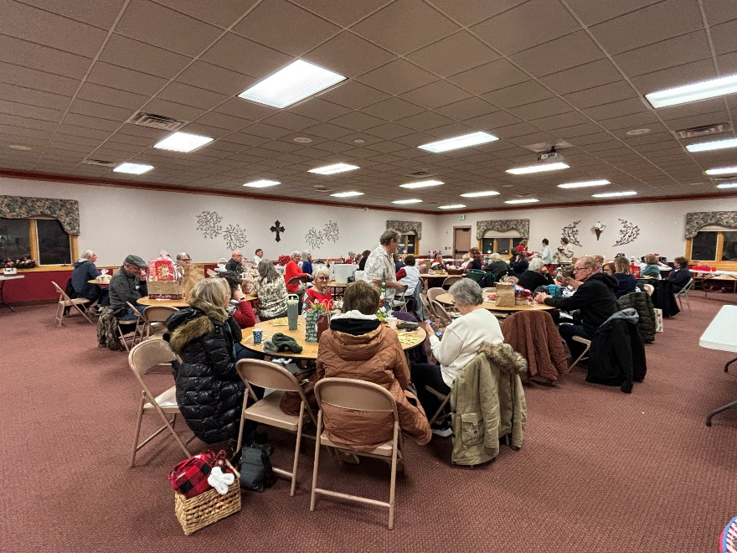

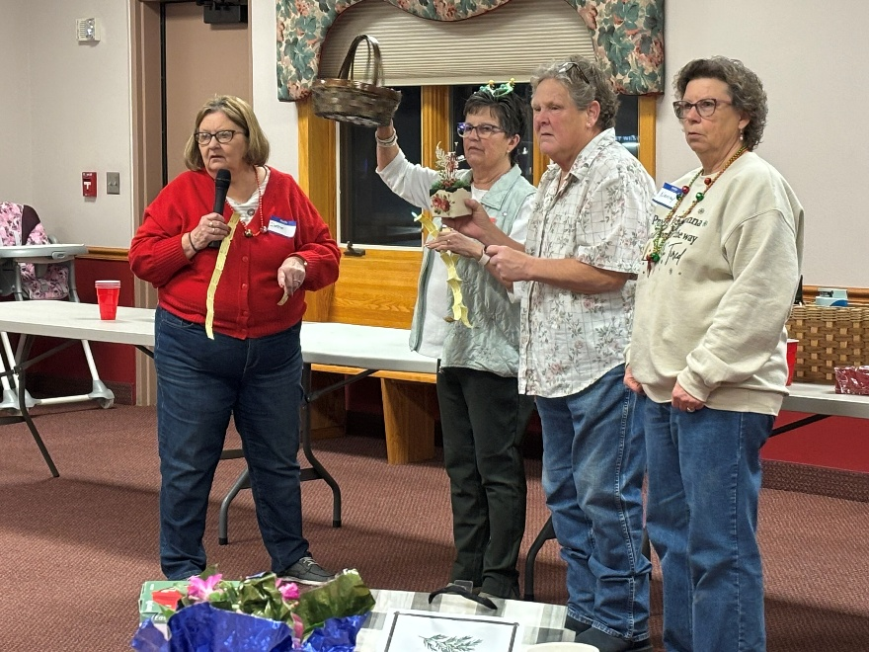

Fun and games….
Bingo, Trivia, & Door Prizes

Growing Your Own Herbs for Cooking, Baking, and Health

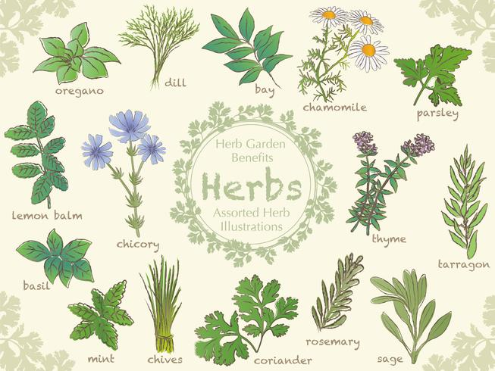
Have you planted an herb garden—or does it sound like a good idea? How confident are you when using herbs in your home? Do you like to experiment with herbs (and spices) when you cook? Or do you play it safe and follow a trusted recipe?
Herb of the Month – Basil

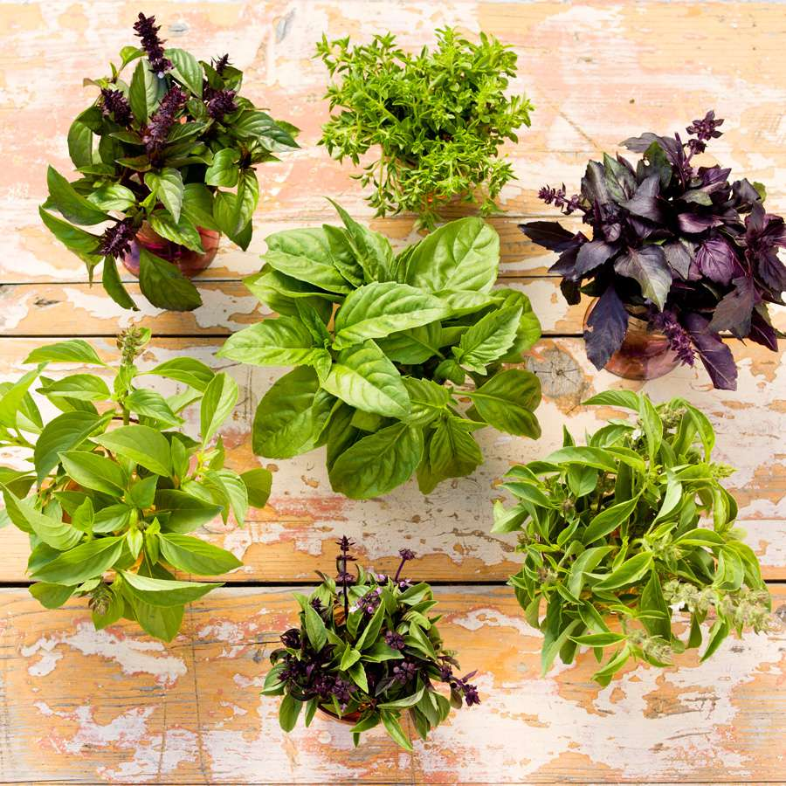
How to Grow and Care for Basil
Basil plants (Ocimum basilicum) are a popular herb belonging to the mint family. Despite their ties to Italian cuisine, they actually originate from India. Basil's aromatic leaves offer a range of flavors, from lemon-mint to cinnamon and licorice. With leaf colors varying from rich green to deep purple and textures ranging from smooth to crinkled, basil adds both taste and visual appeal to dishes. While its flowers may not be showy, they are a favorite among bees.
All types of basil grow easily in warm, sunny weather. The leaves are commonly used in cooking, but the flower buds are also edible. This fast-growing herb thrives equally well in gardens and containers. With sufficiently warm weather, new basil plants are ready for pruning (to encourage bushier growth) in about six weeks.

Common Name | Basil
Botanical Name | Ocimum basilicum
Family | Mint
Plant Type | Perennial, annual, herb
Size | 18–24 in. tall and wide
Sun Exposure | Full
Soil Type | Well-drained
Soil pH | Acidic, neutral, alkaline
Bloom Time | Summer, fall
Hardiness Zones | 10-11 (USDA)
Native Area | Africa, Asia

How to Plant Basil
Basil, a warm-weather herb, is often planted from greenhouse nursery transplants. If growing from seeds, start them indoors about six weeks before the last spring frost. Harvesting can begin 60 to 90 days after seeding.
Stop basil from blooming by pinching off the top leaves when the plant is about 6 inches tall. Once it flowers, it won't grow bushier or produce many leaves.
The size of your plant will depend on the variety, the growing conditions, and how much you harvest. Basil (Ocimum basilicum) can reach 6 feet tall but typically grows to about 18 to 24 inches—or even shorter since its height is kept in check if you're harvesting regularly and not letting the plant flower. Regularly pinching basil will encourage bushy growth with more leaves. Dwarf varieties, reaching about 6 inches, are ideal for pots.

Basil Care
These are the main care requirements for growing a basil plant:
- Does best in full sun
- Prefers well-draining soil
- Likes moisture
- Highly sensitive to frost

Light
Basil thrives in six to eight hours of full sun daily. It becomes sturdier and faces fewer diseases, though it prefers part shade in very hot climates.

Soil
Basil thrives in moist, rich, well-draining soil. Amend soil with compost or nutrient-rich mulch.

Water
Water basil deeply but ensure well-drained soil. Mulch helps retain moisture.

Temperature and Humidity
Basil loves warmth and should be planted when days are in the 70s and nights above 50ï¿½F. Sensitive to frost, it may die in fall. Extend the season by using row covers, but keep them off leaves to prevent frost damage.
If you live in a frost-free area, you might want to allow some basil plants to set flowers and self-seed in your garden. Not all varieties will do this successfully.

Fertilizer
Because you will be harvesting leaves from your basil plants, you may need to fertilize them often. An all-purpose fertilizer encourages continuous leaf growth.

Types of Basil
There are many cultivars of basil, as well as other related species with unique tastes. Try these different kinds of basil:
- 'Genovese' (Ocimum basilicum 'Genovese'): This variety has larger leaves than the species sweet basil, with all the flavor.
- 'Cinnamon' or 'Mexican Spice' (Ocimum basilicum 'Cinnamon'): Enjoy the green foliage, purple flowers, and spicy, cinnamon scent.
- Lemon basil (Ocimum basilicum x citriodorum): This is a hybrid plant with a distinct odor and taste of citrus.
- Thai basil (Ocimum basilicum var. thyrsiflora): This variety has a sweeter taste with a hint of licorice. It is very common in Asian cuisine, especially Vietnamese dishes.

Harvesting Basil
You can start harvesting basil leaves when the plants are 6 to 8 inches tall. Even if you are not using the leaves in cooking or drying or freezing them, picking leaves regularly will improve the plant's vitality. Basil leaves can be dried or frozen for use after harvest. Dried basil is convenient but at the cost of some flavor. Frozen basil has a stronger basil flavor than dried but at the cost of texture. Use frozen basil for cooked dishes. Blend fresh basil with olive oil, freeze in trays, and store cubes in an airtight container.

Propagating Basil
Basil can be propagated from seeds or cuttings. Don't take cuttings from a basil plant if it's already begun to flower. Basil can be propagated at any time of year, but if there is a risk of frost, it will need to be started indoors. Here's how to propagate basil from cuttings:
- Take a 4- to 6-inch cutting from a basil plant below a leaf node.
- Remove lower leaves.
- Root directly in moist, well-draining soil.

How to Grow Basil from Seed
Basil can be grown from seed either by starting indoors or sowing directly in the garden. Here's how:
- If starting indoors, use seed trays and plant 6 to 8 weeks before the last frost. Keep in a sunny location, like a windowsill or under a grow light under germination.
- If starting in the garden, when danger of frost passes, plant seeds in a full-sun location.
- Water consistently, but do not overwater.

Potting and Repotting Basil
Basil works in almost any type of pot or container, even a kiddie pool. But there are two rules for success: keeping the soil moist and not crowding the plants. The easiest way to follow both rules is to plant in large, deep pots, which means more soil for moisture retention and more real estate for spreading out multiple plants and ensuring adequate air circulation. You can plant them as close as 6 to 8 inches apart if you desire a full look to your containers, but spacing them 12 to 18 inches apart is better for air circulation. Overcrowded plants are vulnerable to fungal problems.

To make sure your container plants are properly hydrated, check the soil daily by sticking your finger into the second knuckle, and water when the soil feels dry at this depth. Use a quality potting soil that drains well so the roots do not sit in water. Also, make sure the container has drainage holes. If the soil is not premixed with fertilizer, add some organic plant food and mix it in well when filling the pot. Thereafter, feed the plants every two weeks with diluted liquid fertilizer.

Common Pests & Plant Diseases
Aphids are the biggest basil pest, especially with plants grown indoors. Beetles and slugs also can be a nuisance outdoors, creating holes in the leaves. Cover your entire plant with a soap solution of 2 teaspoons of dishwashing liquid to a full gallon of water to eradicate these pests.

Basil is susceptible to powdery mildew, which can be controlled by providing plenty of space between plants to improve air circulation, and avoiding overhead watering, which can splash fungal spores onto the plants. Severely affected leaves should be picked off and discarded.

Common Problems with Basil

Yellowing Leaves
There are a couple reasons your basil plant's leaves may be turning yellow. If it is getting adequate light, it could be due to overwatering. While this plant likes consistent moisture, it does not like to be overwatered. Dial back watering until the problem resolves.

Brown Spots on Leaves
Brown spots can result when a basil plant is subjected to cold temperatures. This plant prefers to be kept between 70-90°F, and if temperatures dip much lower than that at the end of summer/beginning of fall, the plant could start to develop browning on the leaves.

with many thanks to www.thespruce.com

