**Directions to Bladon Property on County Road 520, Mentone**

From Mentone (approx. 3.5 miles total / 6 minutes from center of Mentone: Hwy 117 east toward Georgia, at Camp Skyline turn LEFT onto CR 631 and go 1 mile, turn RIGHT onto CR 642 and stay to the Right when it splits, then turn left onto CR 520 which is a dirt road.

The road starts out smooth, but does not stay this way, so a 4-wheel-drive truck or ATV is needed If you plan on driving all the way to the end (property stops a few 1000 feet before the Georgia line, but the road goes more or less to the state line – this is a private road so please be considerate).

You will pass a few small houses at the beginning of CR 520, then go down a hill and pass between green posts with a road sign that says “Bladon Road”.

The northern boundary is CR 520. The southern boundary of the western area is the lake. The creek (Stillhouse Branch/Creek on maps) is in the southern area of the total lot but there is land on both sides of the creek.

**NorthWest corner of TOTAL Bladon Land\***: Coordinates 34.57 N, -85.54 W. A few hundred yards after the green posts will be a dirt road off to the left (don’t turn), and about 100 feet after that on the Right side is the NW corner, marked with pink tree ribbon, with a neighboring road/trail leading due south to a meadow area / possible home site. See photos below taken at start and along the ATV / walking path leading south.

\***This western edge is my property edge, including the lake and 75 acres north of the lake that is NOT PART of the 135 ACRE tract FURTHER EAST. Jump down to Central Area if looking at just the 135 acres and not the entire land.**

___________________________________________________________________________________

Continued…

**SouthWest corner** is at the top of the lake, marked with pink ribbon. The trail that leads here from the NW corner and main road is marked with pink ribbon and leads south toward the very upper end of the lake (quite shallow and narrow at the top, fed by Stillhouse Creek). The trail gets smaller and meanders going downhill quickly the last few hundred feet.

|  |  |  |
| --- | --- | --- |
|  |  |  |
| Follow the trail from CR 520, due South, down the gradual hill. Pink ribbons are on the left. | Look for deer and turkey in the large meadow on your left | Follow left/east of this stream downhill to lake |
|  |  |  |
| Notice the lovely Rhododendrun and Mountain Laurel along the way | SouthWest Corner, looking left / SouthEast at the very beginning of lake, fed from Stillhouse creek. | looking Right / NorthWest towards the creek that feeds Emerald Lake. |

Continued…

**Central Area, and beginning of (western edge -slanted line running NE/SW) 135 acre Eastern Parcel.**

Go approximately 2000’ past the western edge of my property, which will be 410’ past the right bend in the road. The maps below give an approximate idea of where the border line is. I apologize that it is not currently marked. The northern border is the road and the eastern border has a large trail running south (all trails are approximate, not exact).

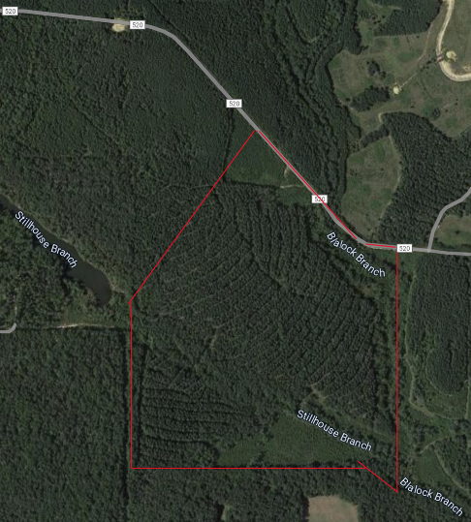 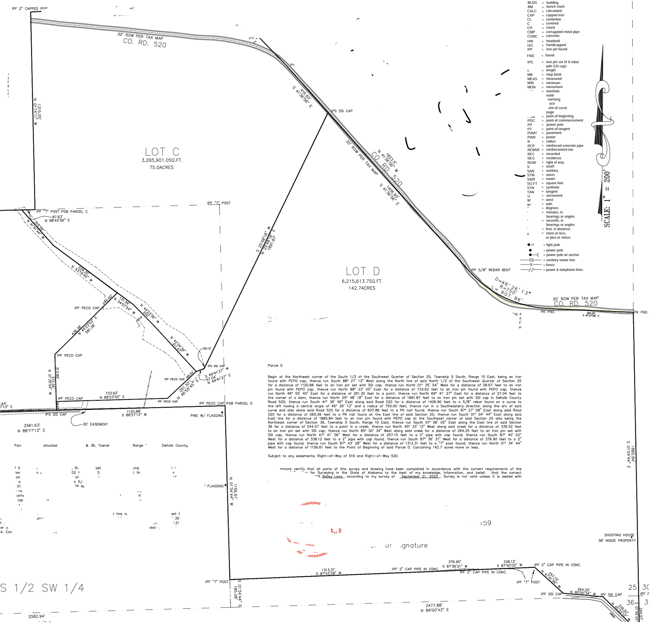



**___________________________________________________________________________________________**

**NorthEast corner**: Coordinates 34.5721 N, -85.5317 W. Marked on the right side of the road with a large green & white Forest sign. A large dirt road leads due south along the eastern border, which leads to the SouthEast corner. This is approximately 5000 feet past the NorthWest corner, along the road (0.9 miles)

|  |  |  |
| --- | --- | --- |
|  |  |  |
| Along the way, notice after crossing the culvert/bridge for Blaylock Creek | Large neighbor sign that is at the NE corner | Facing south, trail leading to SE corner |

**______________________________________________________________________________________**

**SouthEast corner** is at the large creek (approximately 20’ wide at this point). To get here, follow the dirt road/trail due south, then meander a bit near the end. Do NOT get your vehicle stuck in the large ditch - Walk the last part to be safe, gradual downhill slope the whole way. Blalock Creek will be on your right.

|  |  |  |
| --- | --- | --- |
|  |  |  |
| Follow the large trail due south for several minutes (approximately 5 minutes on an ATV, but be careful crossing the ditch & stream). PINK ribbons are on the right side. | Notice the wild Iris, daffodils, violets, and forget-me-nots scattered throughout the forest | The SouthEast corner is at the creek, which is approximately 15’ wide here, a confluence of Blaylock Creek and Stillhouse Creek. |