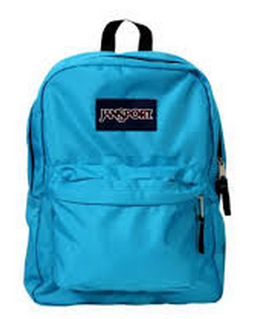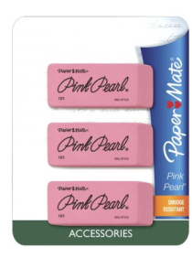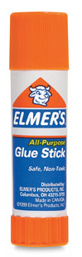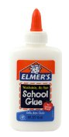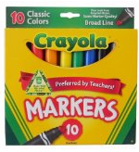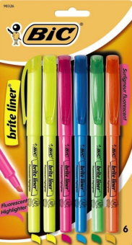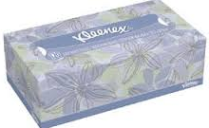
Classroom Supplies List (Grades Pre-School)

- Backpack and Lunchbox (label with child’s name)
- Water bottle (label with child’s name)
- Blanket for Nap time (label with child’s name)
- 1-2 suits change of clothes labeled in a ziplock (underwear, pants/skirts, blouse/shirt, a pair of socks)
- Pull ups (if needed, label with child’s name)
- 1 Pack Dry erase markers
- 3 Packs Glue sticks
- 1 Pair Blunt-tipped scissors (round edge)
- 1 Pack of Play dough (count 12)
- 4-6 Rolls of paper towels
- 1 Bottle of Hand sanitizer
- 1 Box Kleenex tissue
- 3-4 containers Clorox disinfectant wipes (large container)
- 1 box of baby wipes(3-6 packs)
- 2 Packages of spoons (100ct each)
- 2 Packages of forks (100ct each)
- 1 Crayola Classic Thin Line Marker set, 10 count
- 1 Crayola Classic or Ultra-Clean washable Broad Line Marker set, 10 count
- 1 Crayola Classic Crayons, 24 count
- 2 Crayola Washable Watercolor set, 16 colors
- 2 packs of construction paper (assorted)
- 1 Pack of jumbo sized pencils (small)
- 1 Pack jumbo pencil sharpener
- 1-2 bag of Pom Poms

