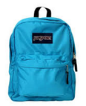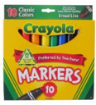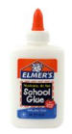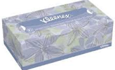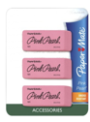

**Teacher – Mrs. Hurlock**

**GRADES 3rd – 4th 2024-25**

**SUPPLY LIST**

**Basic Supplies - Students**

1. **Pencils**: No. 2 pencils **Ticonderoga**
2. **Erasers**: Large pink erasers and pencil-top erasers
3. **Pencil Sharpener**: Handheld
4. **Crayons**: 1 Box of 24 colors
5. **Colored Pencils**: 12 or 24 count
6. **Markers**: Washable markers (broad and fine tip)
7. **Highlighters**: Various colors
8. **Glue**: Glue sticks and liquid glue
9. **Scissors**: Child-safe, blunt-tip scissors
10. **Rulers**: With inches and centimeters

**Paper Products**

1. **(2) 1 Subject Notebooks**: Wide-ruled and college-ruled spiral notebooks
2. **(6) Composition Books**: Wide-ruled
3. **1 Pack 100 Loose-Leaf Paper**: Wide-ruled
4. **(5) Folders**: Pocket folders in various colors
5. **1 Pack Construction Paper**: Assorted colors
6. **1 Pack Graph Paper**: For math and science projects

**Organizational Tools**

1. **(1) Binders**: 1-inch binders with pockets
2. **1 Pack Dividers**: For binders
3. **Pencil Cases**: Zippered or box style
4. **Backpacks**: Sturdy and spacious

**Technology Supplies**

1. **Headphones or Earbuds**: For piano class and computer use

**Hygiene Supplies**

1. **Hand Sanitizer**
2. **Disinfectant Wipes**
3. **Paper Towels**

**Miscellaneous**

1. **Books**: Age-appropriate reading material for the classroom library
2. **Educational Games and Puzzles**
3. **Paper Plates**
4. **Water Bottle (32oz)**
5. **Bible**

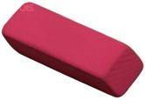 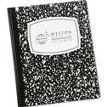page1image2993979568 