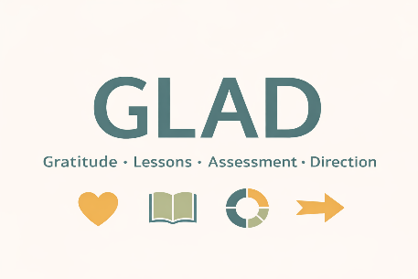
GLAD Reflection Worksheet
A quiet way to get clear
Take your time.
Write what’s true, not what sounds good.


1. Grounding
(Settle before you assess)
Before you begin, pause.
- Where are you physically right now?
- What do you notice in your body?
- What feels present or loud in your mind?
- Where/when/with whom do you feel grounded and at peace?
Notes:


2. Gratitude
(What’s working and worth preserving)
List the people, situations, or parts of your life that are supporting you right now.
- What’s going well?
- What feels steady, nourishing, or meaningful?
- What would you want to protect as you move forward?
- For what are you truly grateful?


3. Lessons
(Patterns and hard-earned insights)
Look back over recent months or years.
- What keeps repeating?
- What has life been trying to teach you?
- What do you know now that you didn’t before?
- Is there a lesson you’re resisting learning?
Notes:

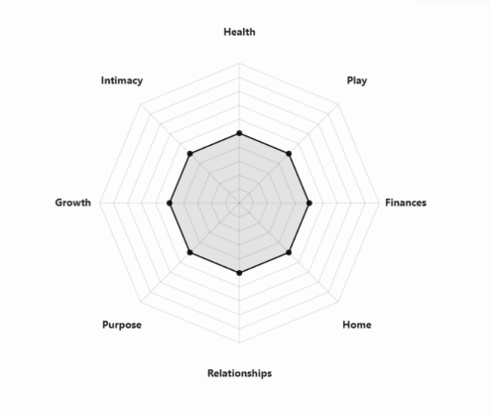
4. Assessment
(Naming reality honestly)
Without judgment, take stock.
- What’s your highest area of life satisfaction?
- What’s your lowest area of life satisfaction?
- Which area of your life needs the most attention?
- What overall difference might it make if you improved your lowest life satisfaction area by just one point?
Notes:


5. Direction
(Orientation, not a perfect plan)
Based on what you’ve written:
- What wants your attention now?
- What direction makes the most sense to move toward?
- What might you need to stop, start, or let go of?
Direction I’m choosing (for now):

Specific, tangible step(s) I’m willing to take in my chosen direction?

By when?

I’ll know I’m making progress toward my chosen direction when I see (specific, measurable result):

Resources / Support / Knowledge / Skills I may need:

Final Reflection:
What awareness / clarity do you have now that you’ve completed this GLAD reflection experience?

What else do you need to develop clarity about in your life?

Closing
You don’t need to solve everything today.
Clarity becomes useful when it turns into movement—
even small, imperfect movement.
When you’re ready, take one step in the direction you’ve named.
That’s enough.

Feedback
I hope you found this experience useful. I’d love to hear your feedback about what you liked, or would recommend to make this program more beneficial.
If you’re so inclined, drop me a line at: info@upmylife.org

