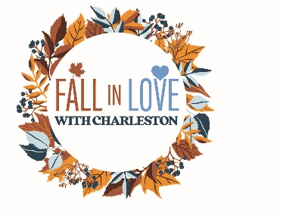

1st Annual Fall in Love with Charleston 5K Race

November 8, 2025 - 10 a.m.
Behind Charleston Post Office 300 S. Main St. Charleston, MO 63834

Registration:
$30 Registration and guaranteed t-shirt with online entry or postmarked October 22 or earlier
$35 Raceday registration from 8:30am - 9:30am. T-shirts are not guaranteed for race day registrations.
Register online at: http://www.charlestoncharm.net
Mail Paper Entries to: CHARM, P.O. Box 241, Charleston, MO 63834
Make checks payable to: CHARM
Awards:
Medals will be given to the top 3 finishers in each Male/Female category:
0-10, 11-14, 15-19, 20-29, 30-39, 40-49, 50-59, 60-69, 70-79, 80+
Find us on Facebook: CHARM
Website: http://www.charlestoncharm.net
Email: Charleston.mo.getinvolved@gmail.com

___________________________________________ ____Age ______________ Date of Birth
Name
___________________________________________ Male / Female
Address (Circle One)
___________________________________________ __________________________________
City, State, Zip Phone Number
___________________________________________
Email Address

T-shirt size: ___Small ___Medium ___Large ___XLarge ___2X

I know that walking or running in a road race is a potentially hazardous activity. I should not enter and run or walk in this race activity unless I am medically able and properly trained. I assume all risks associated with running or walking in this race including, but not limited to falls, contact with other participants, the effects of weather, conditions of the road and traffic on the course. All such risks being known and appreciated by me and having read this waiver, I, myself and anyone entitled to act on my behalf, hold harmless all sponsors and their representatives, from all claims and liabilities of any kind arising out of my participation in this activity. Registration is nonrefundable and nontransferable. Once entry is received no refunds will be given if you cannot participate, or if the event is cancelled due to weather, natural disaster or other unforeseen circumstances.

__________________________________________ __________________________________
Signature (or Parent/Guardian if under age 18) Date

