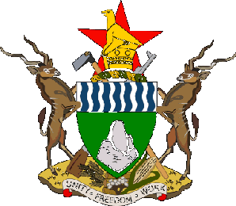
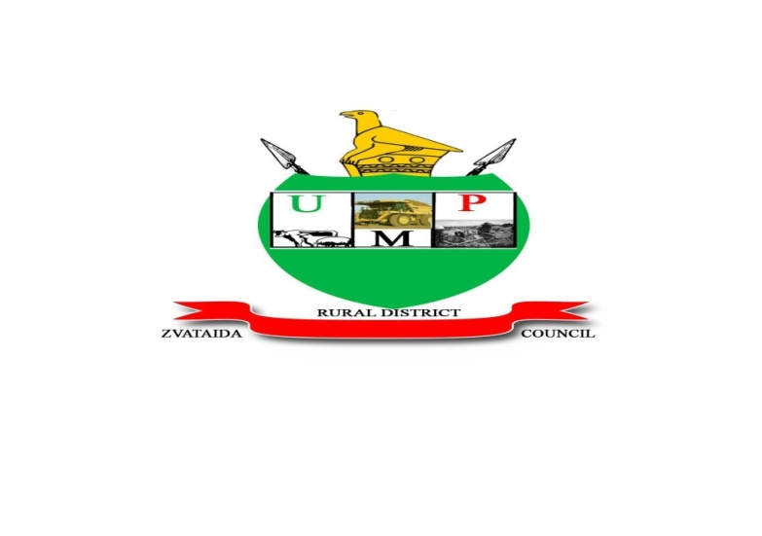

UMP ZVATAIDA RURAL DISTRICT COUNCIL

CLIENTS’ CHARTER

PREAMBLE
UMP Zvataida Rural District Council was formed in 1980 according to the RDC Act Chapter 29:13. It is situated in Mashonaland East Province 172km from Harare, North of Murewa District. We promise to provide the following;
- Effective and efficient services.
- Professionalism in our dealings with all stakeholders.
- Accountability and transparency in our operatives.
- Diligence and courtesy in the discharge of our duties.
- Honesty and integrity is our motto.

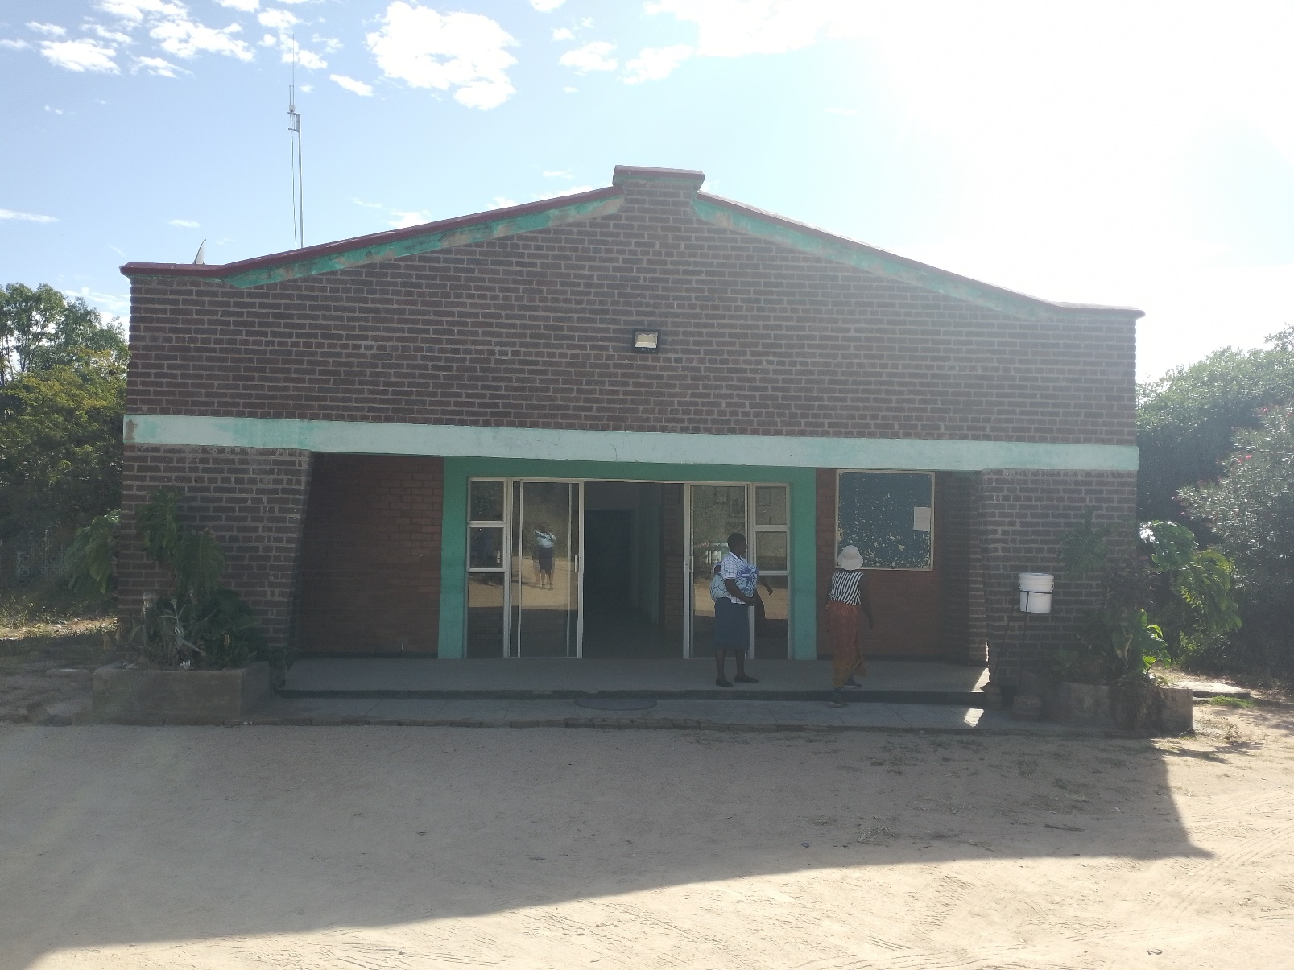

VISION
“An economically and socially empowered society by 2030”

MISSION
“To provide socio – economic services, infrastructure and self-sustaining local governance which
uplifts the welfare of the community”.

MANDATE
- Provision of Social Services.
- Infrastructure Development and maintenance.
- Spatial planning and development control.
- Revenue mobilization and management.
- Promotion of good corporate governance.
- Human capital development and management.
- Environmental management and agriculture promotion.
- Promotion of gender equity and equality
- Regulatory authority through by-laws.
- Facilitation of investment within the district.

TERMS OF REFERENCE/MANDATE
- TERMS OF REFERENCE
- Constitution of Zimbabwe Amendment (No. 20)
- RDC Act (Chapter 29:13)
- Shop Licence Act (Chapter 14:17)
- Traditional Leaders Act (Chapter 29:17), (Act no. 25 of 1998)
- Regional, Town and Country Planning Act (Chapter 29:12)
- Housing and Building Act (Chapter 22:07)
- Housing and Standards Act (Chapter 29:08)
- Cemetery Act (Chapter 5:04)
- Traditional Beer Act (Chapter 14:24)
- Roads Act (Chapter 13:18)
- Public Management Finance Management Act (Chapter 22:19)
- Communal Lands Act (Chapter 20:04)
- Public Health Act (Chapter 15:09)
- Provincial Council’s Administration Act (Chapter 29:11)

CORE VALUES
Transparency : Openness and accuracy in our operations.

Accountability : Responsible for our actions and results.

Team work : Unity for common purpose

Professionalism : Efficiency and effectiveness based on team work and zero tolerance to corruption

Integrity : Highest standard of ethical conduct, fair treatment of all people and environmentally responsible.

- DEPARTMENT OF ENVIRONMENT & AGRICULTURE

VISION
To achieve a symbiotic relationship between the Natural Environment and human activities in the District by 2030.
MISSION
To enhance the efficient and effective sustainable utilization of resources in the District in order to empower the inhabitants.
MOTTO
“We are trustees of resources for the future generation”.
KEY FUNCTIONS
- Conservation of natural resources.
- Promotion of Agriculture.
- Arbitration of land disputes.
- Mine registration.
- Creating income generating projects.

- DEPARTMENT OF ROADS WORKS

VISION
A leader in infrastructure development and maintenance and the provision of planned settlements by 2030.
MISSION
To provide and maintain infrastructure and develop planned settlements which uplift the welfare of the community and the status of our G/Ps and RSCs

FUNCTIONS
- Road Planning & development control
- Roads construction & maintenance
- Provision of technical designs for all council road works
- Provision of road infrastructure.
- Implementation of capital projects
- Revenue generation and mobilisation



- DEPARTMENT OF HUMAN RESOURCES MANAGEMENT & SOCIAL SERVICES

Vision

Building capacity to enhance competitiveness by 2030

Mission

Creating human capital base which supports the devolution agenda.

Motto
“Building capacity for posterity”

THE MANDATE OF THE COMMITTEE
- Management of staff and Councilors welfare.
- Coordinate performance management.
- Policy formulation
- Approval of organogram consistent with authorized establishment
- Recruitment and selection of new employees
- Promotion of industrial harmony.
- Human capital management and development.
- Preparation of annual development plans.
- Secretarial services and information management.
- Transport management.
- Security management.
- Asset management.
- Payroll management.
- Facilitate procurement of goods and services

- DEPARTMENT OF FINANCE
VISION
To provide a sound financial management system by 2030

MISSION
To provide a sound financial management system.

OBJECTIVE

- Preparation and consolidation of the Council annual budget.
- Sound financial management system.
- Revenue generation and mobilization.
- Expenditure commitment and control
- Debtors and Creditors management
- Investment promotion.
- Financial reporting.
- Preparation of cash budgets and cash flows

- DEPARTMENT OF INTERNAL AUDIT

Ensuring compliance with statutory, other legal and social requirements
VISION

Ensure Sound Corporate Governance by the year 2030.

MISSION
To provide independent and objective reviews and assessment of activities, operations, financial systems and internal accounting controls designed to add value and improve the council operations.

OBJECTIVE
To ensure and guarantee there are adequate systems of internal control within the council by carrying out:
- Compliance audits.
- Financial audits.
- Value for money audits.
- Investigations.
- Forensic audits.

FUNCTIONS
The Functions of the audit committee and its department is governed by an Audit Charter as established under the RDC Act Chapter 29:13
- Monitoring and evaluation of Council systems.
- Provision of consultation, advocacy and advisory services.
- Review internal controls and risk management systems.
- Review of the council’s financial, projects, programs and activities controls.
- Review and advocacy for policies formulation and overall process for identifying and assessing business risks and managing their impact on the council.
- Review the means of safeguarding and improving safety of council assets.
CLIENTS INTERNAL
- Employees
- Policy makers
CLIENTS EXTERNAL
- Miners
- Business persons
- Traditional leaders
- Government
- Parastatals
- Trade Union
- NGOs
SERVICE COMMITMENTS AND STANDARDS
- To attend to clients within 2 minutes of arrival.
- To attend to all phone calls before 2 rings.
- To allocate stands to applicants within three months of their application.
- To attend to land disputes within two weeks.
- To provide financial statements every month.
- To attend to attend to all audit queries within two days.
OBLIGATIONS AND RIGHTS
- Efficiency service
- Right to information
- Right to comment on the quality of service
REVIEW OF CLIENTS CHARTER
- Annually
- Public consultation
- Suggestion box
- Questionnaire
- Review vision, mission statement to align them with Government policies e.g. VISION 2030 & CALL TO ACTION
- FEEDBACK
- Signage
- Letterhead
- Website
- Minutes

CONTACT US

UMP ZVATAIDA
RURAL DISTRICT COUNCIL
STAND 526
MUTAWATAWA

P.O. BOX 17
+263 772 219 922
+263 772 951 628
+263 774 086 945
+263 773 079 946
+263 778 177 097
UMPRDC@yahoo.com
www.umpz-rdc.org

Produced for UMP Zvataida RDC by Management
2015

