Table of Contents
Executive Summary 2
Objectives 2
Cloud Infrastructure (Azure) 3
Security Implementation 4
Securely Deploying osTicket to Azure 5
osTicket - Network Diagram 6
osTicket - Agent Login 7
osTicket - Web application with a valid SSL certificate 7
osTicket setup and installation instructions 11
Duo MFA – Deploying a remote access solution 13
Network Architecture Overview 13
Key Infrastructure 14
Duo setup and installation instructions 14
Implementation 16
Duo MFA – Screenshots depicting Duo MFA for every user upon login 17
Drive Mapping via GPO 18
Active Directory 19
VirtualBox | Pfsense 22
Group Contributions 23
Reflection 23

The Capstone Technical Report

Executive Summary
This report details the design, deployment, and configuration of a mock infrastructure created by our team as part of the Nerd Platoon (NP) internship project. Our goal is to showcase our ability to transition NP’s legacy on-premise IT infrastructure to a modern cloud-based environment using Infrastructure as a Service (IaaS) principles.
The implementation includes Active Directory (AD), DNS, VPN, osTicket help desk, secure web and database servers, and security hardening across all systems. This project encompasses both cloud and local hypervisor deployments, as well as comprehensive network diagrams and security policies.
Our team deployed a secure remote access solution utilizing Microsoft’s Remote Desktop Gateway with Duo Multi-Factor Authentication within Microsoft Azure. This enabled us to allow domain-joined clients to be accessed remotely while ensuring strong authentication measures. Additionally, we eliminated the internal public IP addresses, thereby significantly enhancing the security of our internal resources.

Objectives
- Deploy a fully functional cloud-based mock infrastructure using Microsoft Azure.
- Develop a local virtualized mock infrastructure utilizing a hypervisor.
- Configure essential network services, including Active Directory, DNS, file storage, VPN, and osTicket.
- Implement industry-standard security practices and demonstrate secure configurations.
- Document all configurations and decisions made throughout the project.

Cloud Infrastructure (Azure)
VNetMain & Subnets
- Three isolated subnets:
  - internal (Private)
  - dmz (Public access only to SVR-GATEWAY)
  - VPN Subnet (Restricted access)
VM Deployment
- AD Server: Windows Server 2025 with Group Policy and Certificate Management
- Web Server: osTicket and Duo MFA
- Database Server: MySQL accessible only from the Web Subnet
Security Controls
- NSGs (Network Security Groups) applied per subnet
- Ports limited to only those required:
- RDP, HTTPS (Web Server), DNS (Internal), LDAP/Kerberos (AD)
Certificates
- Let’s Encrypt through certbot for the web server
- Self-signed internal certificates for domain trust, pushed via GPO

Security Implementation
Server Hardening
- Disabled unnecessary services
- Enabled firewalls following the principle of least privilege
- Scheduled updates and patch management enabled
Client Security
- Windows Defender enabled on all Windows 10/11 clients
- Certificate Trust for self-signed certs distributed via GPO
Password & Access Policies
- Enforced password complexity (change every 180 days)
- Role-based access for VPN, AD, and administrative actions

Securely Deploying osTicket to Azure
Our group successfully deployed a functional instance of the osTicket ticketing system. In the mock scenario, Dell was working to migrate their infrastructure to Nerd Platoon. Due to time constraints, they requested support from student teams to demonstrate the osTicket application deployment under strict compliance constraints.
Nerd Platoon’s primary compliance requirement, which we successfully met, was service segregation: The web frontend and backend databases must reside on separate virtual machines and be hosted on a secure internal subnet. This architecture enhances security by ensuring that the MySQL database server is not directly accessible from external networks.
To fulfill Dell’s requirements, we successfully created a virtual network within our resource group in Microsoft Azure. Within that virtual network, we created two subnets, the DMZ subnet and the Internal subnet. Within these subnets, our team deployed two Ubuntu Server virtual machines. The MySQL database is on the internal subnet, and the osTicket web server is on the DMZ subnet.

osTicket - Network Diagram
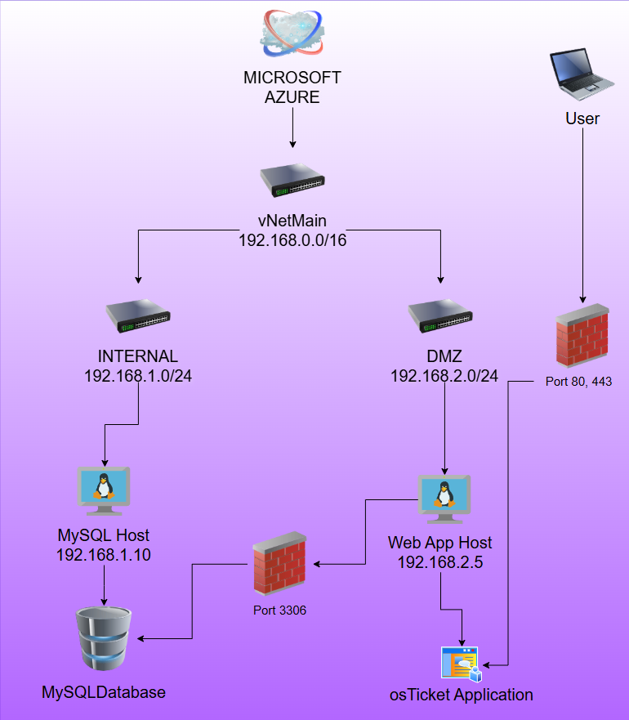

osTicket - Agent Login
Login: osticket-main
Password: Modemmain1023
Two web links (staff control panel and ticket submission):
https://mainserver.centralus.cloudapp.azure.com/scp/login.php
https://mainserver.centralus.cloudapp.azure.com/open.php

osTicket - Web application with a valid SSL certificate
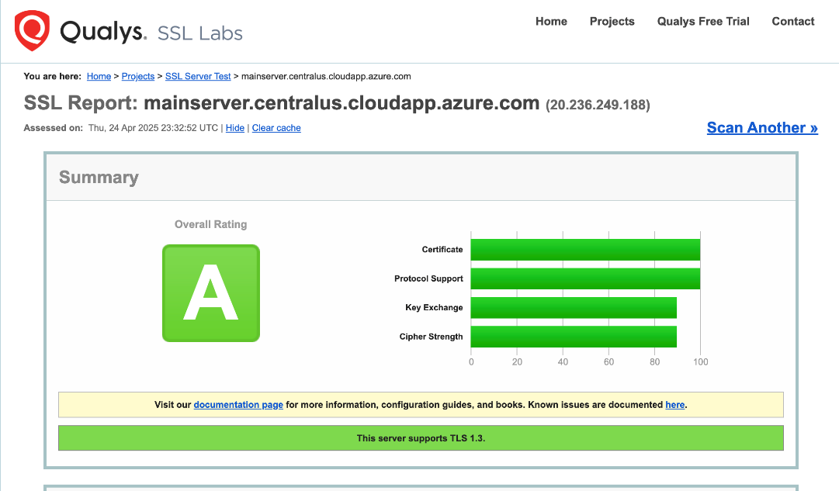

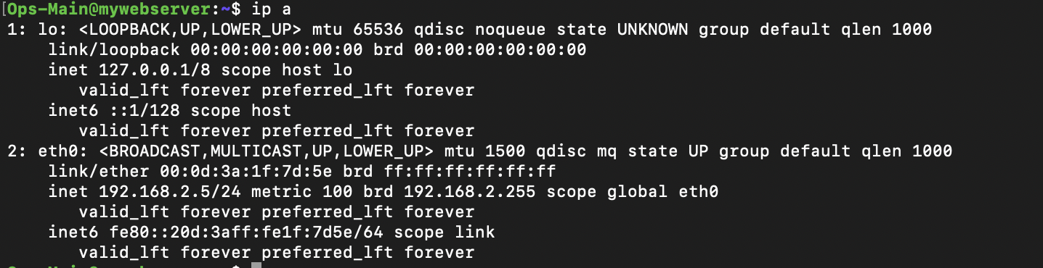
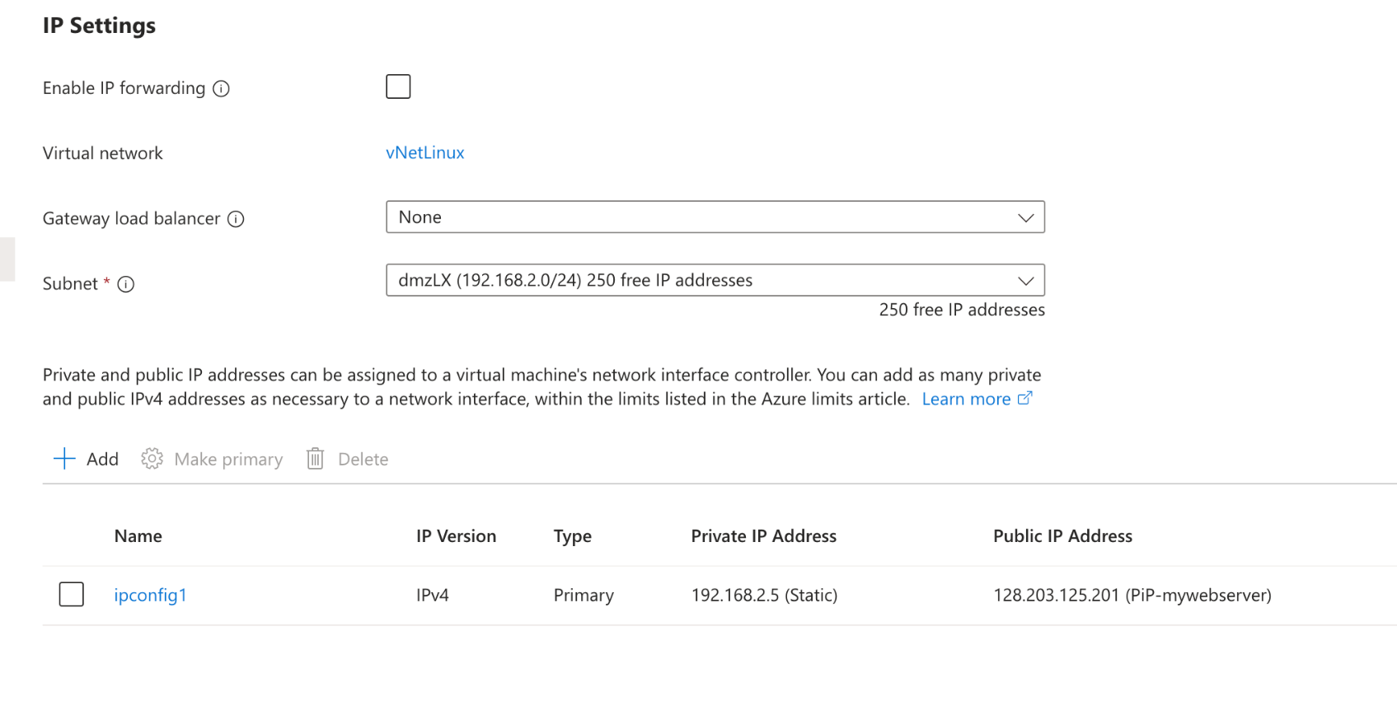
The web server is configured with a static IP address, as verified from its terminal

The database server is configured with a static IP address, as verified from its terminal
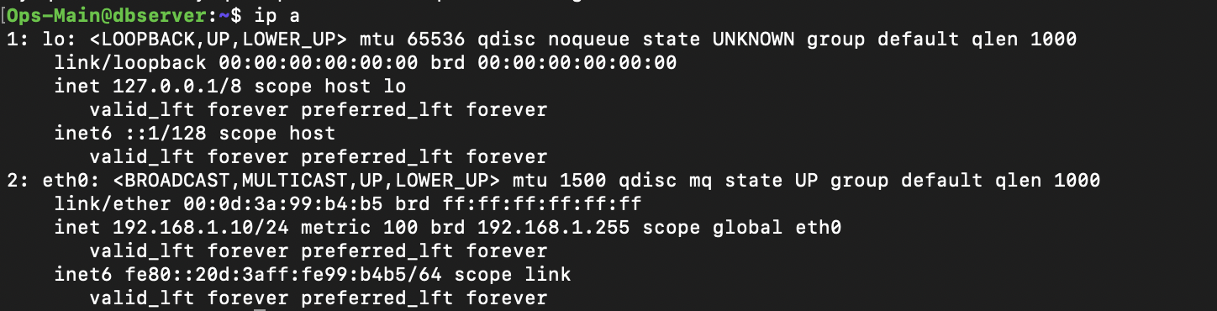
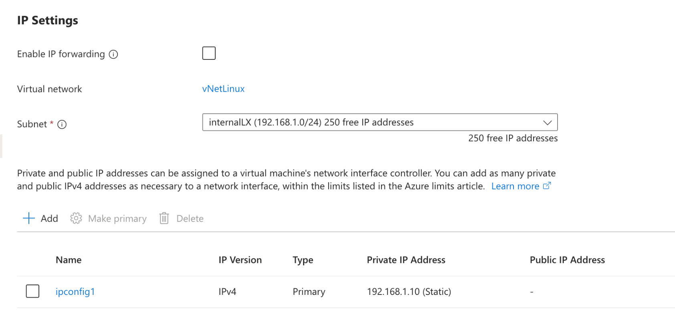
The MySQL port is open on the database server, as confirmed by a port scan performed from the web server using Nmap
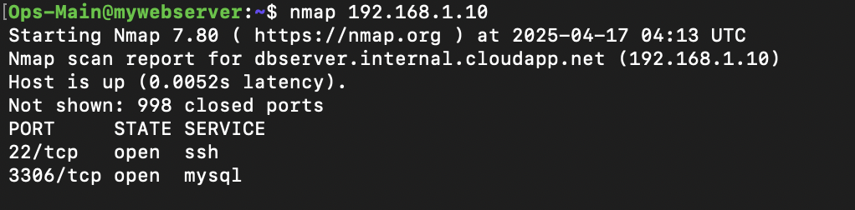

A MySQL user with non-root privileges can successfully log into the database from the web server. The MySQL instance displays the database created for osTicket.
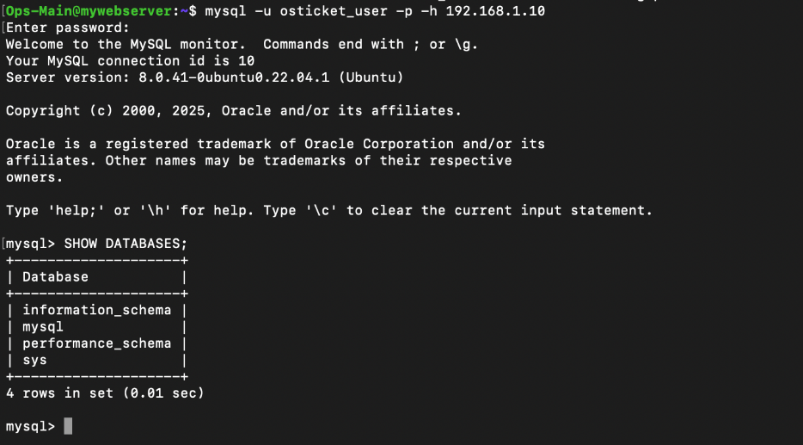

osTicket setup and installation instructions
#SSH into VM
C:\Users\localuser>ssh <vmuser>@<public IP>
vmuser@uwebserver:~$ sudo apt update && sudo apt upgrade -y
<username>@uwebserver:~$ sudo apt install apache2 mysql-server php libapache2-mod-php php-mysql php-imap php-apcu php-intl php-mbstring php-gd php-curl php-xml php-zip unzip wget -y
<username>@uwebserver:~$ sudo systemctl enable apache2
<username>@uwebserver:~$ sudo systemctl enable mysql
<username>@uwebserver:~$ sudo mysql_secure_installation
#Press “Y” at prompt, select password validation policy, enter desired password
#Press “Y” for all following prompts (ex: remove anonymous users)
<username>@uwebserver:~$ sudo mysql -u root -p
#Enter password
mysql> CREATE DATABASE osticket;
mysql> CREATE USER 'ostuser'@'localhost' IDENTIFIED BY '<password>;
mysql> GRANT ALL PRIVILEGES ON osticket.* TO 'ostuser'@'localhost';
mysql> FLUSH PRIVILEGES;
<username>@uwebserver:~$ cd /var/www/html
<username>@uwebserver:/var/www/html$ sudo wget https://github.com/osTicket/osTicket/releases/download/v1.18.1/osTicket-v1.18.1.zip
<username>@uwebserver:/var/www/html$ sudo unzip osTicket-v1.18.1.zip
<username>@uwebserver:/var/www/html$ sudo mv upload osticket
<username>@uwebserver:/var/www/html$ sudo chown -R www-data:www-data /var/www/html/osticket
<username>@uwebserver:/var/www/html$ sudo nano /etc/apache2/sites-available/osticket.conf
#PASTE ALL OF THE BELOW AND SAVE:
<VirtualHost *:80>
ServerAdmin admin@yourdomain.com
DocumentRoot /var/www/html/osticket
ServerName yourdomain.com

<Directory /var/www/html/osticket>
Options +FollowSymlinks
AllowOverride All
Require all granted
</Directory>
ErrorLog ${APACHE_LOG_DIR}/osticket_error.log
CustomLog ${APACHE_LOG_DIR}/osticket_access.log combined
</VirtualHost>
<username>@uwebserver:/var/www/html$ sudo a2ensite osticket.conf
<username>@uwebserver:/var/www/html$ sudo a2enmod rewrite
<username>@uwebserver:/var/www/html$ sudo systemctl restart apache2
<username>@uwebserver:/var/www/html$ cd ~<username>
<username>@uwebserver:~$ sudo apt install firefox
<username>@uwebserver:~$ sudo apt install xfce4 xfce4-goodies -y
#select lightdm version
<username>@uwebserver:~$ sudo apt install xrdp -y
#to enable you to rdp into the Ubuntu VM from Windows comp
<username>@uwebserver:~$ sudo systemctl enable xrdp
<username>@uwebserver:~$ sudo systemctl start xrdp
<username>@uwebserver:~$ echo "startxfce4" > ~/.xsession
<username>@uwebserver:~$ sudo cp ~/.xsession /etc/skel
<username>@uwebserver:~$ sudo adduser $USER ssl-cert
<username>@uwebserver:~$ sudo apt install nmap
<username>@uwebserver:~$ nmap 172.190.246.127
<username>@uwebserver:~$ nmap -Pn 172.190.246.127
<username>@uwebserver:~$ sudo vim /etc/mysql/mysql.conf.d/mysqld.cnf
#where it shows the binding of the port addresses you need to change it from the loopback to 0.0.0.0
<username>@uwebserver:~$ sudo systemctl restart mysql
<username>@uwebserver:~$ nmap -Pn 172.190.246.127
<username>@uwebserver:~$ nmap -Pn 172.190.246.127
#should show port 22, 3306, and 3389 as open now
<username>@uwebserver:~$ sudo systemctl status apache2
<username>@uwebserver:~$ curl http://localhost/osticket
#should show something like below, which means it’s working, but only locally
<!DOCTYPE HTML PUBLIC "-//IETF//DTD HTML 2.0//EN">
<html><head>
<title>301 Moved Permanently</title>
</head><body>
<h1>Moved Permanently</h1>
<p>The document has moved <a href="http://localhost/osticket/">here</a>.</p>
<hr>
<address>Apache/2.4.41 (Ubuntu) Server at localhost Port 80</address>
</body></html>
#open port 80 on Azure and then do below to do below:
<username>@uwebserver:~$ sudo ufw allow 80
<username>@uwebserver:~$ ls -ld /var/www/html/osticket
<username>@uwebserver:~$ sudo apache2ctl configtest
<username>@uwebserver:~$ sudo systemctl reload apache2
<username>@uwebserver:~$ sudo apt-get install ca-certificates apt-transport-https software-properties-common
#Press “Y” at prompt
<username>@uwebserver:~$ sudo add-apt-repository ppa:ondrej/php
<username>@uwebserver:~$ sudo apt-get update -y
<username>@uwebserver:~$ sudo apt-get install php8.0 libapache2-mod-php8.0 php8.0-common php8.0-fpm php8.0-cgi php8.0-bcmath php8.0-gd php8.0-imap php8.0-intl php8.0-apcu php8.0-cli php8.0-mbstring php8.0-curl php8.0-mysql php8.0-xml unzip -y
<username>@uwebserver:~$ php -v
<username>@uwebserver:~$ sudo systemctl reload apache2
<username>@uwebserver:~$ sudo apt install software-properties-common -y
<username>@uwebserver:~$ sudo add-apt-repository ppa:ondrej/php
<username>@uwebserver:~$ sudo apt update
<username>@uwebserver:~$ sudo apt install php8.2 libapache2-mod-php8.2 php8.2-common php8.2-mysql php8.2-imap php8.2-apcu php8.2-intl php8.2-mbstring php8.2-gd php8.2-curl php8.2-xml php8.2-zip -y
<username>@uwebserver:~$ sudo a2dismod php7.4
<username>@uwebserver:~$ sudo a2enmod php8.2
<username>@uwebserver:~$ sudo update-alternatives --set php /usr/bin/php8.2
<username>@uwebserver:~$ sudo systemctl restart apache2
<username>@uwebserver:~$ php -v
#To view osTicket screen, navigate to 172.190.246.127/osticket

Duo MFA – Deploying a remote access solution

Network Architecture Overview
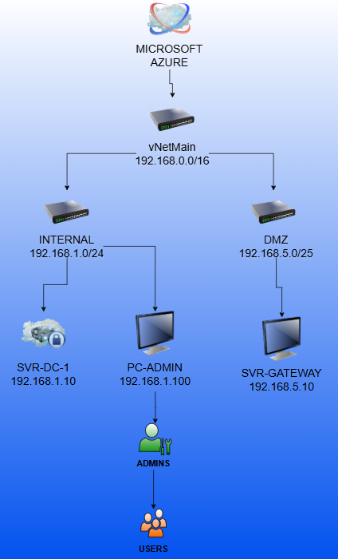

Key Infrastructure
NAME | ROLE | IP ADDRESS
SVR-GATEWAY | RD Gateway w/ Duo MFA | Public: 4.156.59.190  Private: 192.168.5.10
PC-ADMIN | Domain-joined client | 192.168.1.100
SVR-DC-1 | Domain controller | 192.168.1.10

We created subnets for internal domain access and controlled public exposure via Azure NSGs and NAT standards.

Duo setup and installation instructions
Create a Service Account in Active Directory
Dedicated account for Duo Authentication Proxy to bind to Active Directory and query user authentication data.,
This service account was placed inside the Users container and given read-only permissions to prevent unnecessary write access.,
Configured Read-Only Access for the Service Account
Verified security settings in Active Directory Users and Computers (ADUC).,
Ensured the account had read permissions for AD objects without modification rights.,
The service account acts as a binder connection, allowing Duo Authentication Proxy to authenticate users via LDAP.
Set Up Duo Authentication Proxy as a RADIUS Server
Since there is no traditional RADIUS server, Duo Authentication Proxy acted as one to handle authentication requests.
Configured authproxy.cfg with:
[radius_client]
radius_ip_1=BOUNCER_VM_IP
radius_secret_1=YOUR_SHARED_SECRET
Instead of a physical RADIUS server, Duo Proxy processed authentication requests directly using the service account as a binding connection.,
Defined LDAP Queries in Authentication Proxy
Set search_dn=DC=ops,DC=internal to allow Duo to retrieve user credentials from AD.,
The service account is used as a binder connection, allowing Duo Proxy to authenticate users against LDAP.
Ensured the service account had the correct permissions to query AD objects.
Validated the Duo Authentication Proxy Configuration
Used Duo’s built-in validation tool, which flagged LDAP connection issues.
Checked Duo logs (authproxy.log) for error details.
Tested Network Connectivity and LDAP Access
Used Test-NetConnection to verify LDAP port 389 was accessible from the VM.
Ran Get-ADUser to confirm Active Directory queries worked.
Checked service account permissions and adjusted settings.
Service Account
Acts as a binder connection for Duo Proxy to authenticate users via LDAP.,
Implements a least privilege model—only requires read access instead of admin rights.,
Automates authentication without manual intervention.,
Enhances security by using a non-privileged account to avoid unnecessary changes in AD.,
Duo Proxy Replaced a RADIUS Server
Since there was no existing RADIUS server, Duo Authentication Proxy acted as one.
Instead of setting up a separate RADIUS IP, the BOUNCER VM handled authentication traffic.

Implementation
Domain Setup
- Installed AD DS on SVR-DC-1
- Created user and group objects (e.g. xxx, xxx)
- Joined PC-ADMIN and SVR-GATEWAY to the domain
RD Gateway Installation
- Installed RD Gateway role on SVR-GATEWAY
- Configured CAPs and RAPs to allow access from domain users to internal resources
Duo MFA Integration
- Set up a Duo account and the application for RD Gateway
- Installed Duo RD Gateway plugin
- Configured Duo to require push notifications for MFA
- Verified Duo MFA prompt on RDP connection
Duo User Dashboard

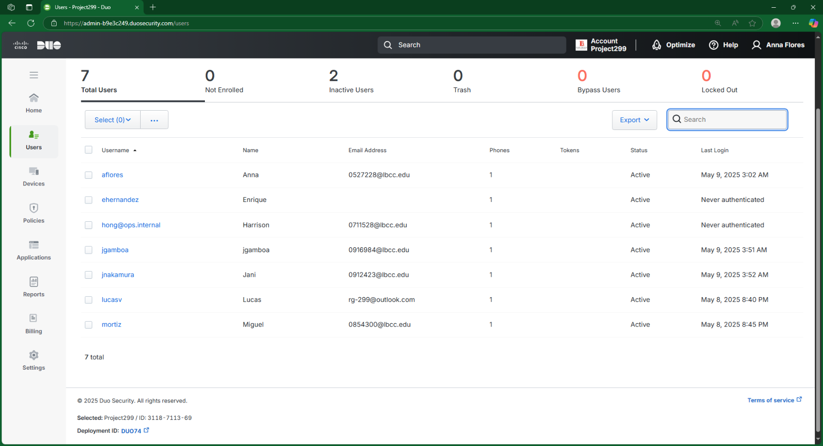

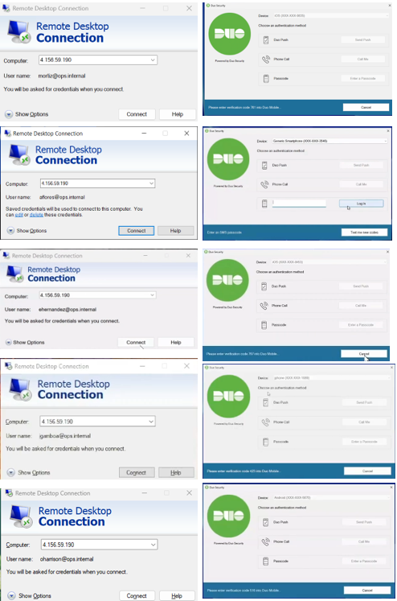
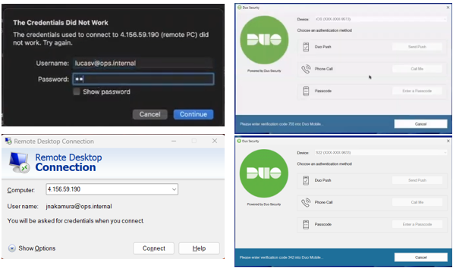
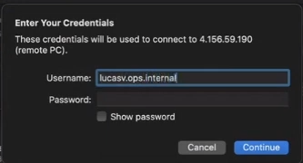
Duo MFA – Screenshots depicting Duo MFA for every user upon login
Duo MFA prompt upon RDP Login

Drive Mapping via GPO
- Created a GPO that maps a network share based on group membership
- Verified that the mapped drive appears via RDP
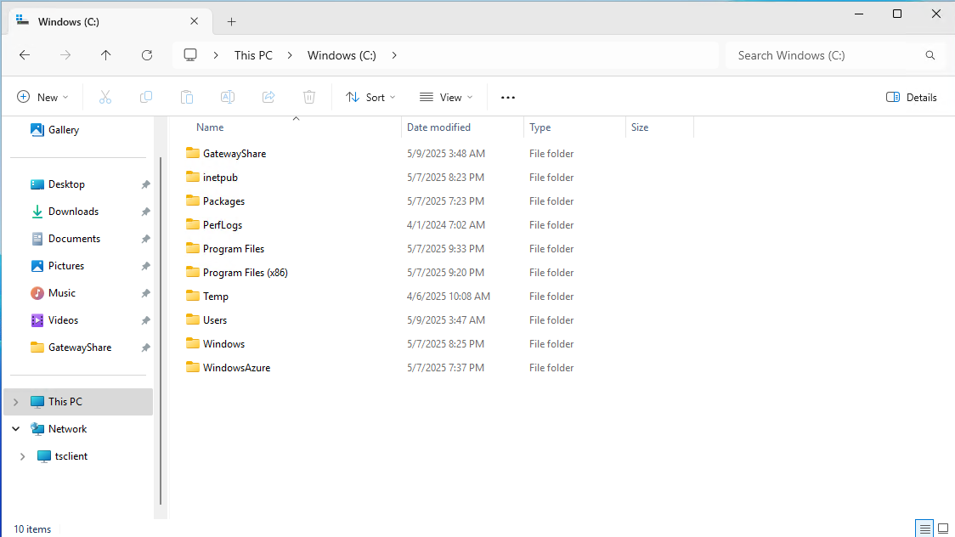

Active Directory
SVR-GATEWAY Active Directory Dashboard

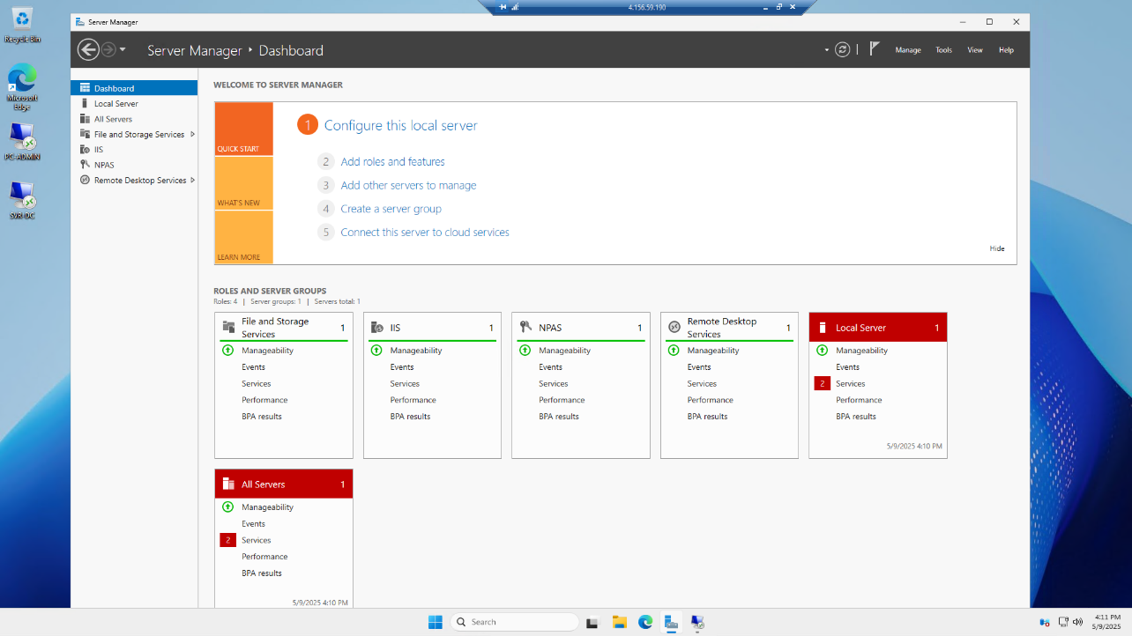
SVR-DC-1 with Duo Security application

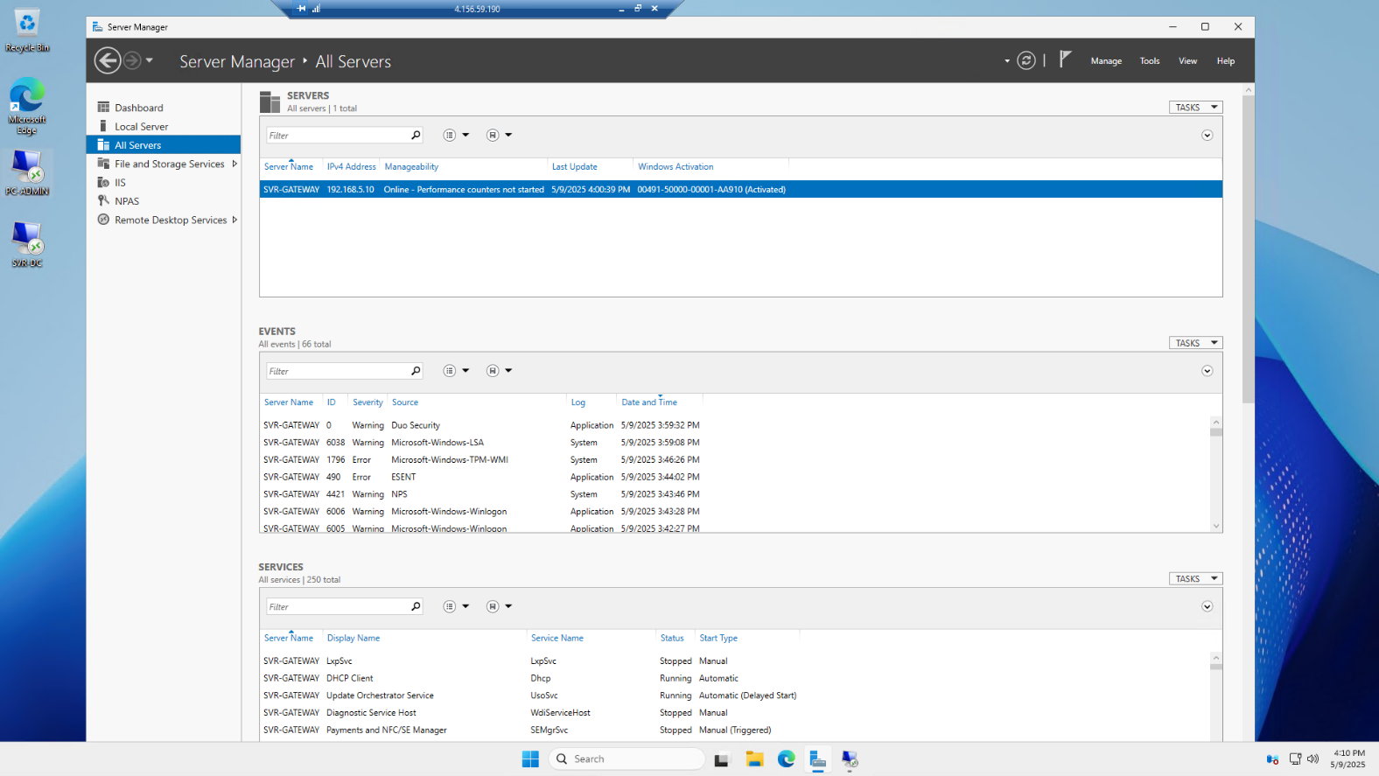
SVR-DC-1 Active Directory Dashboard
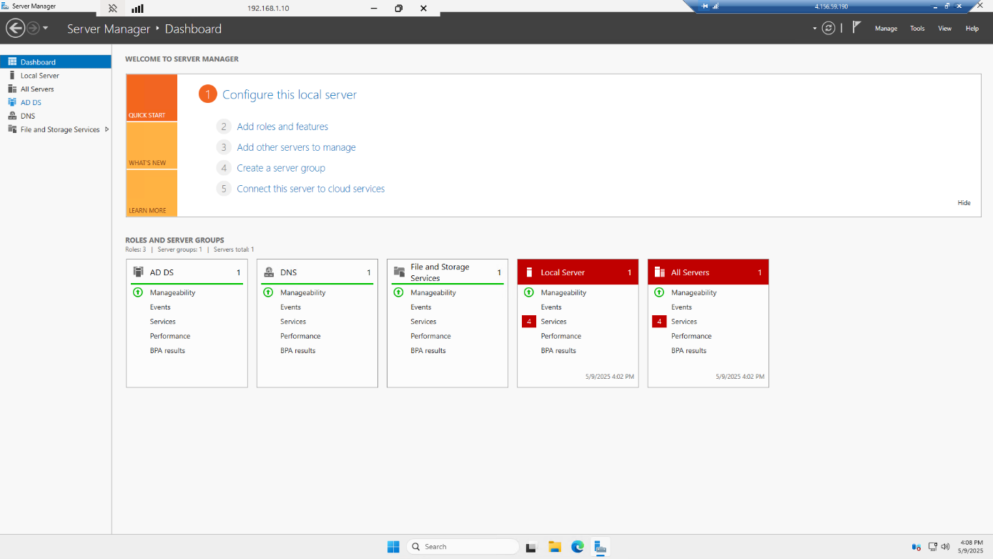
SVR-DC-1 AD Users and Computers

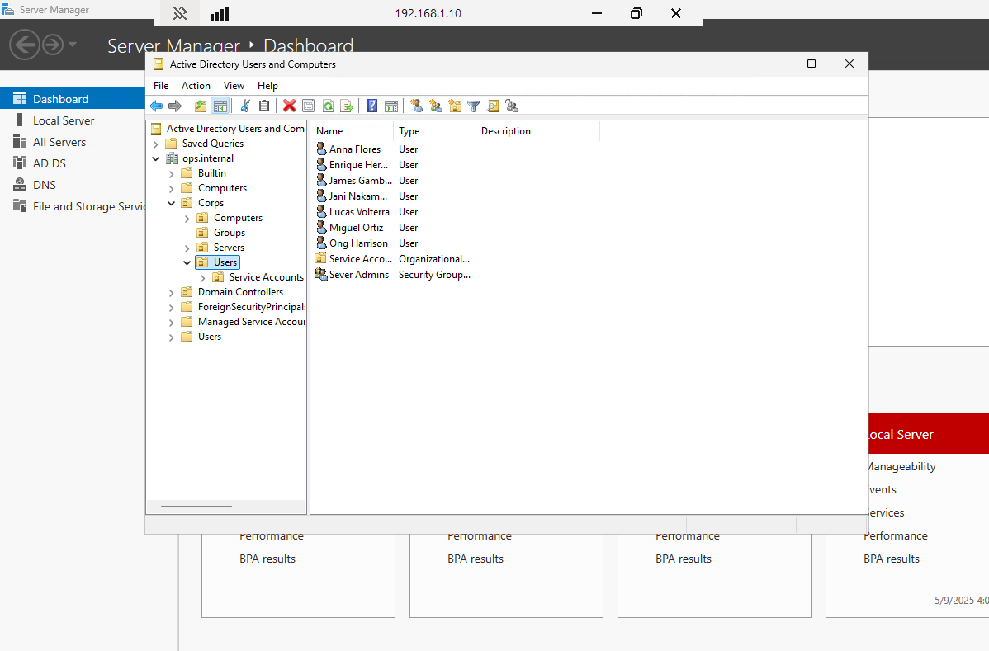

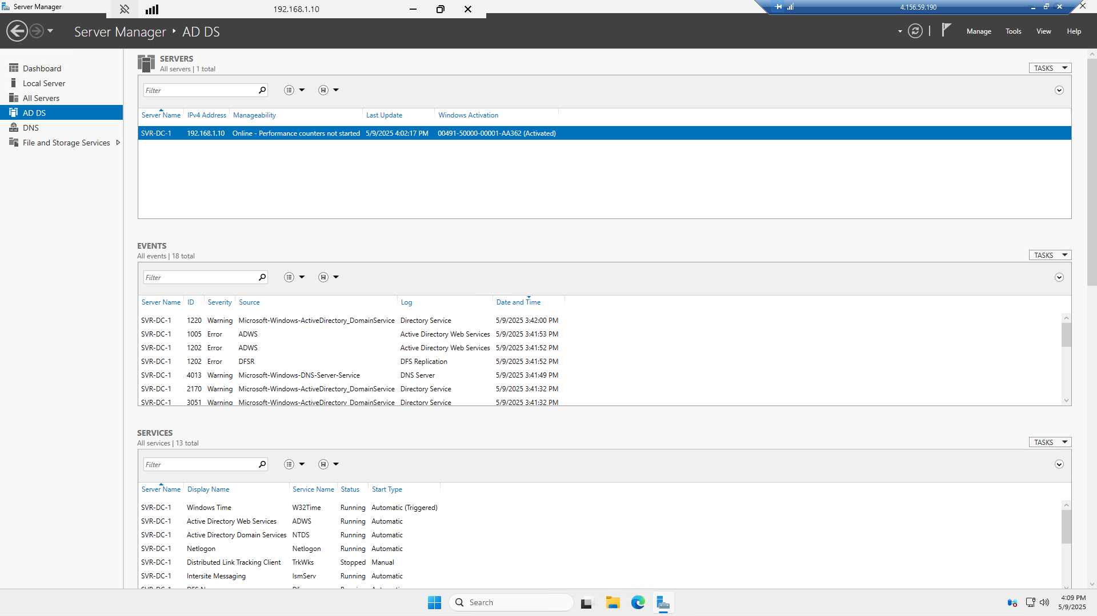
SVR-DC-1 with Active Directory Domain Services (AD DS)

VirtualBox | Pfsense
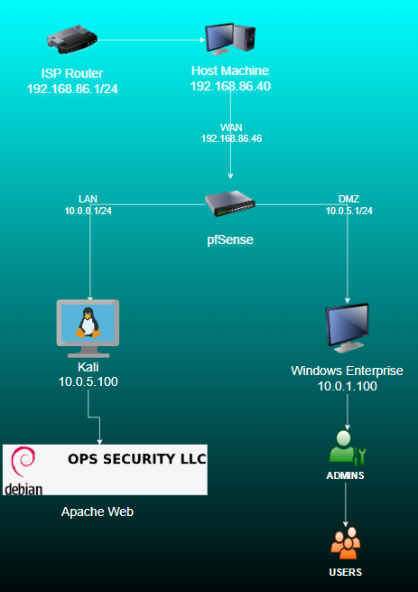

Reflection
This lab provided an in-depth, hands-on experience in planning, deploying, and securing an enterprise-level IT infrastructure across both cloud and on-premises platforms. We demonstrated our technical knowledge in areas such as domain services, secure remote access, certificate management, and web applications. Our mock implementation meets the technical and security requirements outlined by Nerd Platoon, positioning us as qualified candidates for assisting in their real-world infrastructure migration.

