Catalog Sculptures
Prices are on request
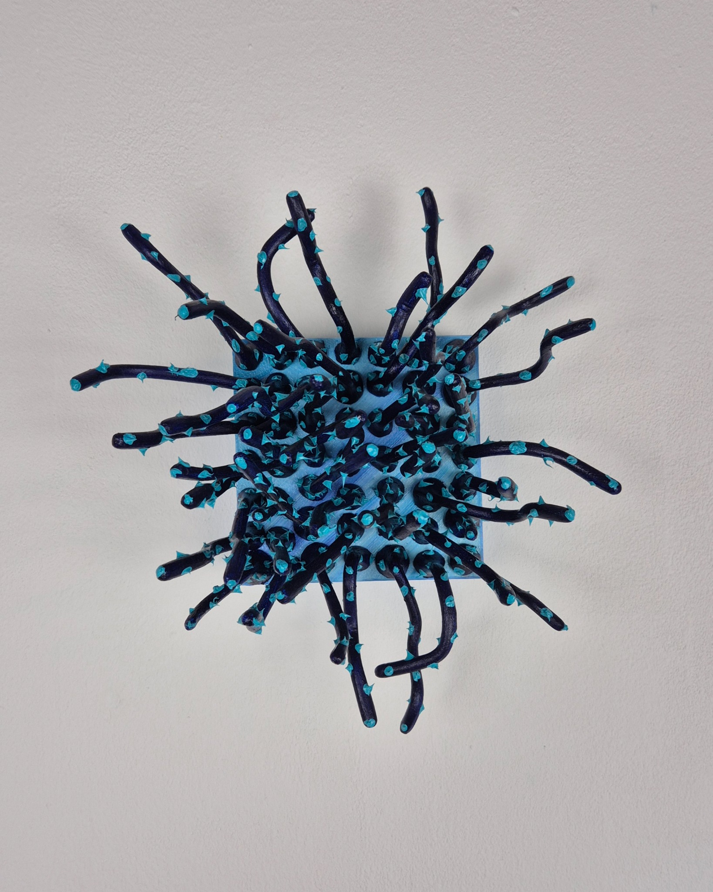
Title: Small Coral in Dark Blue and Light Blue
Year: 2024
Medium: Resin,Alkyd, Oil paint, Wood
Dimensions: 10 cm x 10 cm
Ref Nbr : #S001
SSSSSSSS

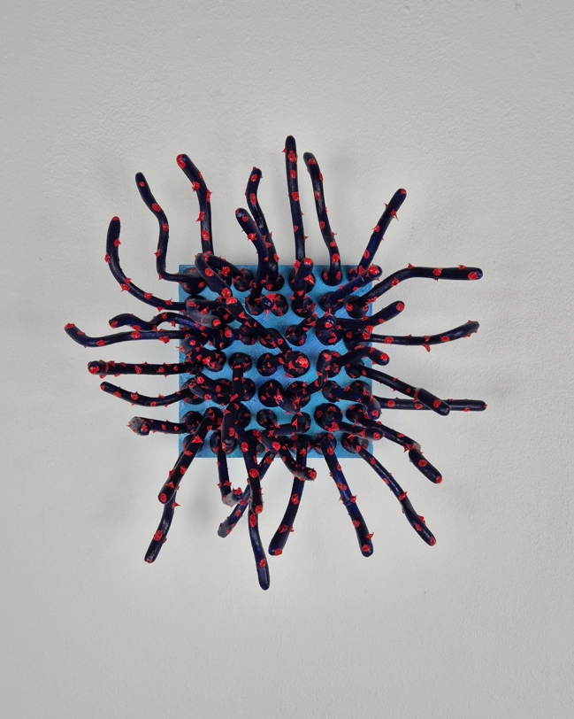
Title: Small Coral in Dark Blue and Vivid Red
Year: 2024
Medium: Resin, Alkyd, Oil paint, Wood
Dimensions: 10 cm x 10 cm
Ref Nbr : #S002

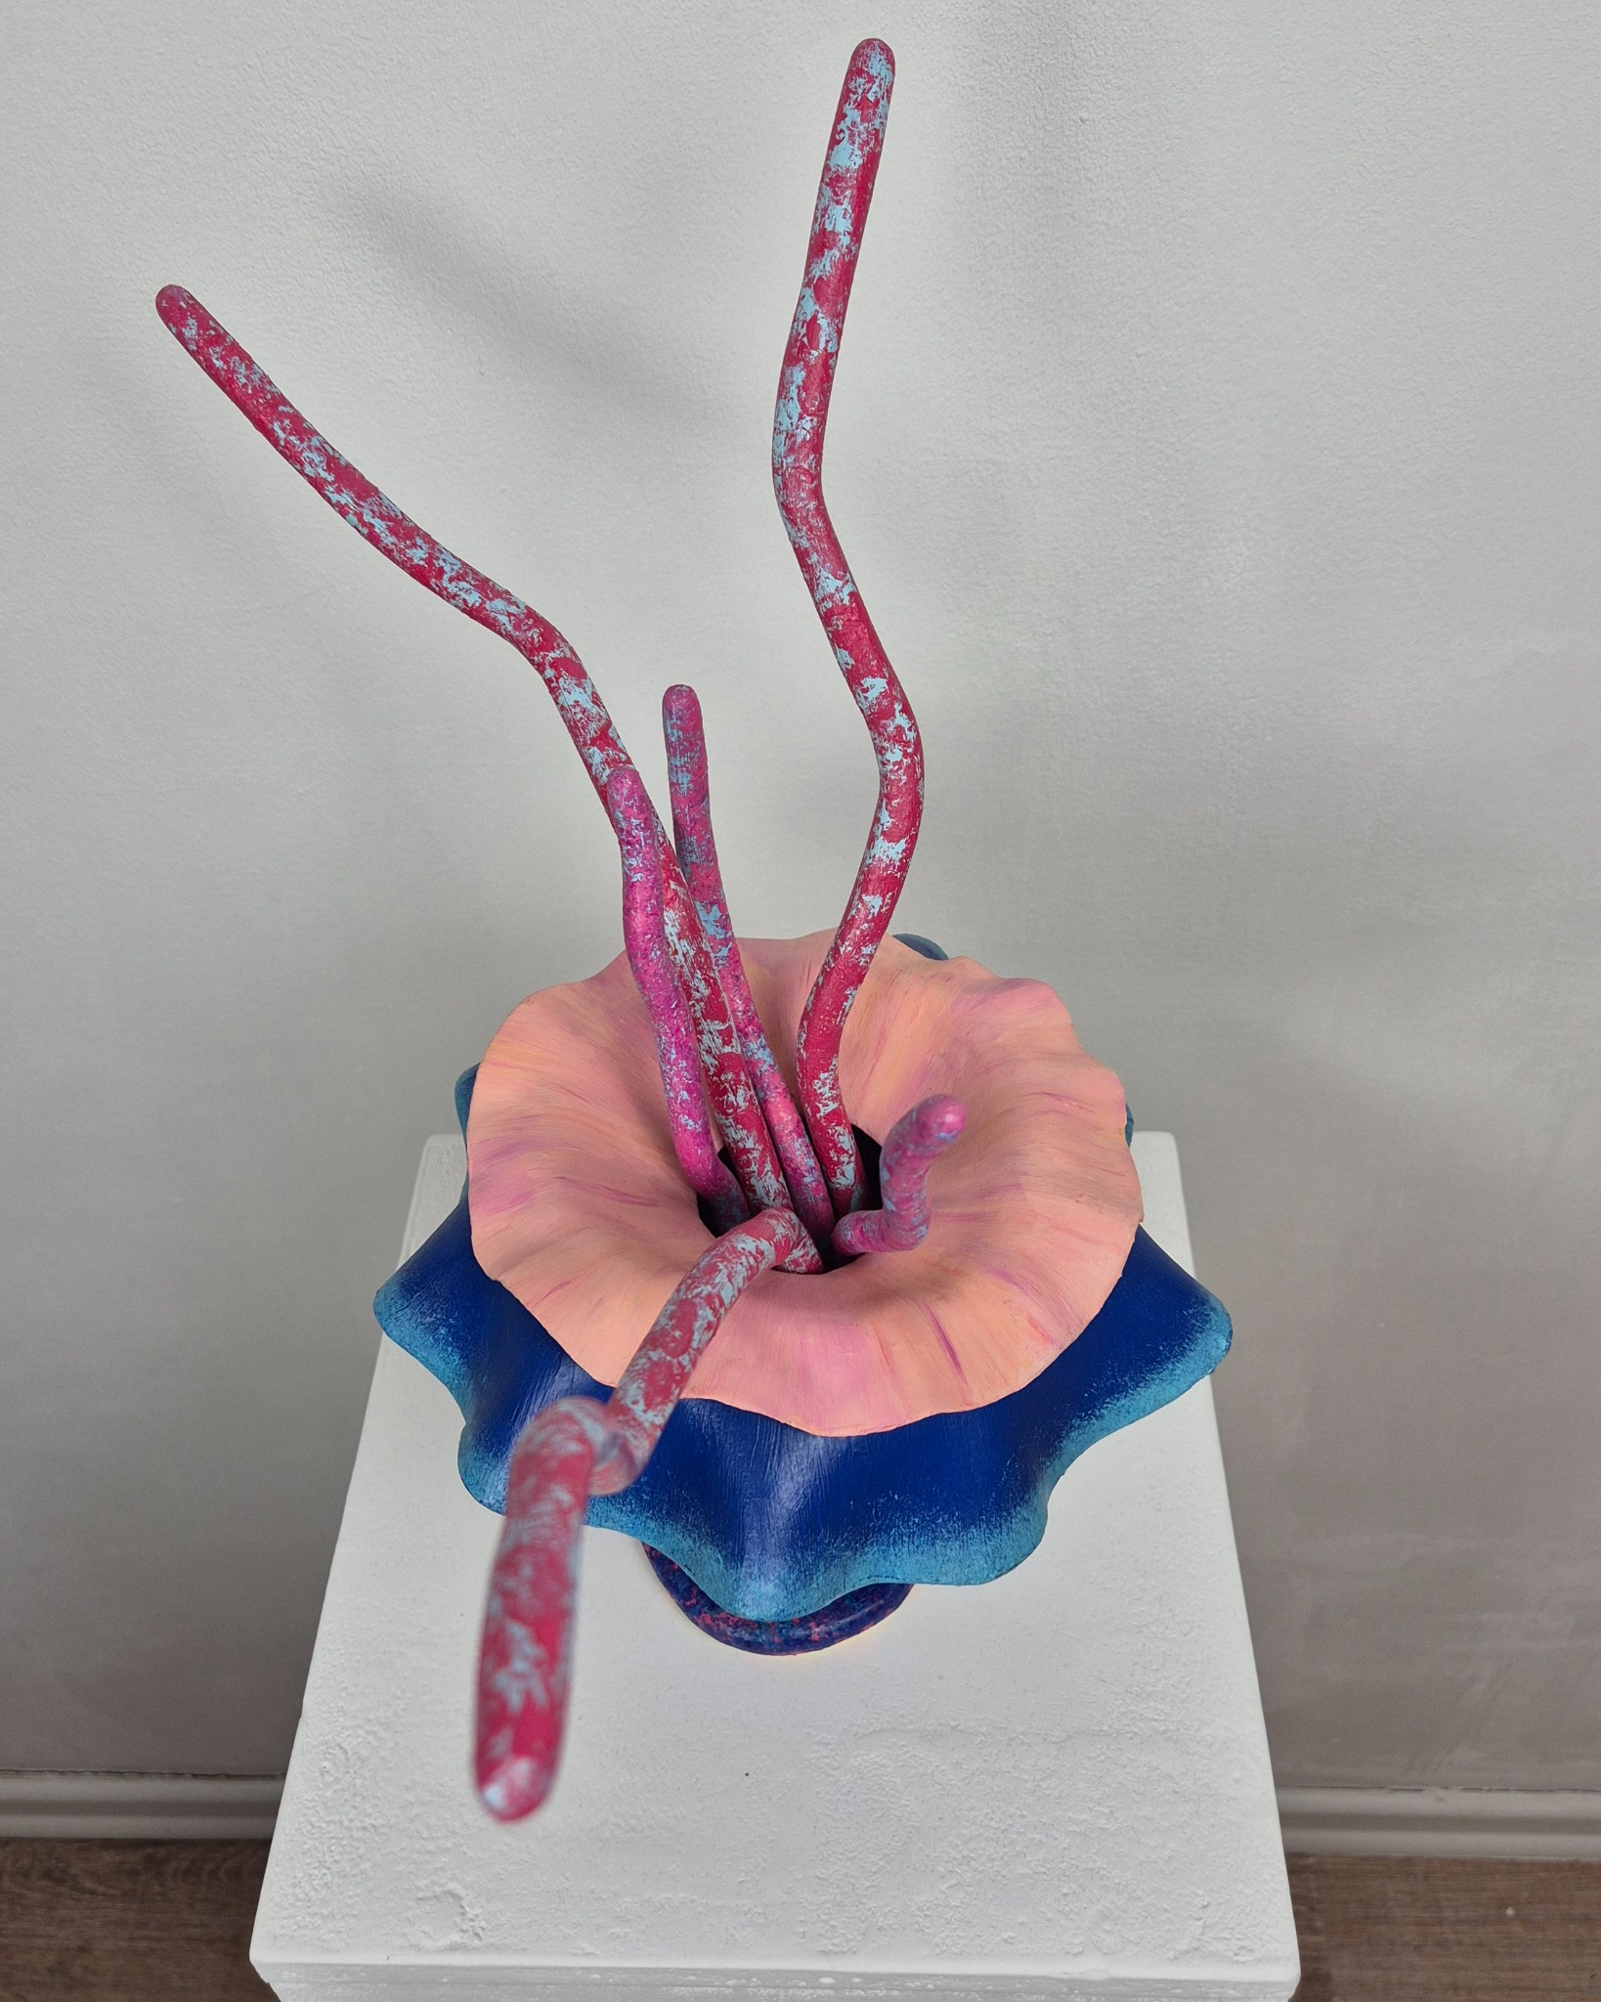
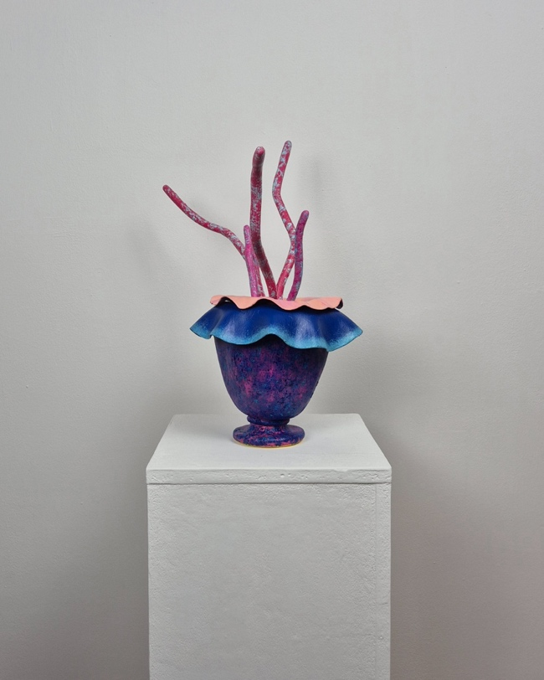
Title: Anemone #001
Year: 2024
Medium: Modeling compound, Resin, Oil paint
Dimensions: approx. 35 cm high x approx. 25 cm width
Ref Nbr : #S003

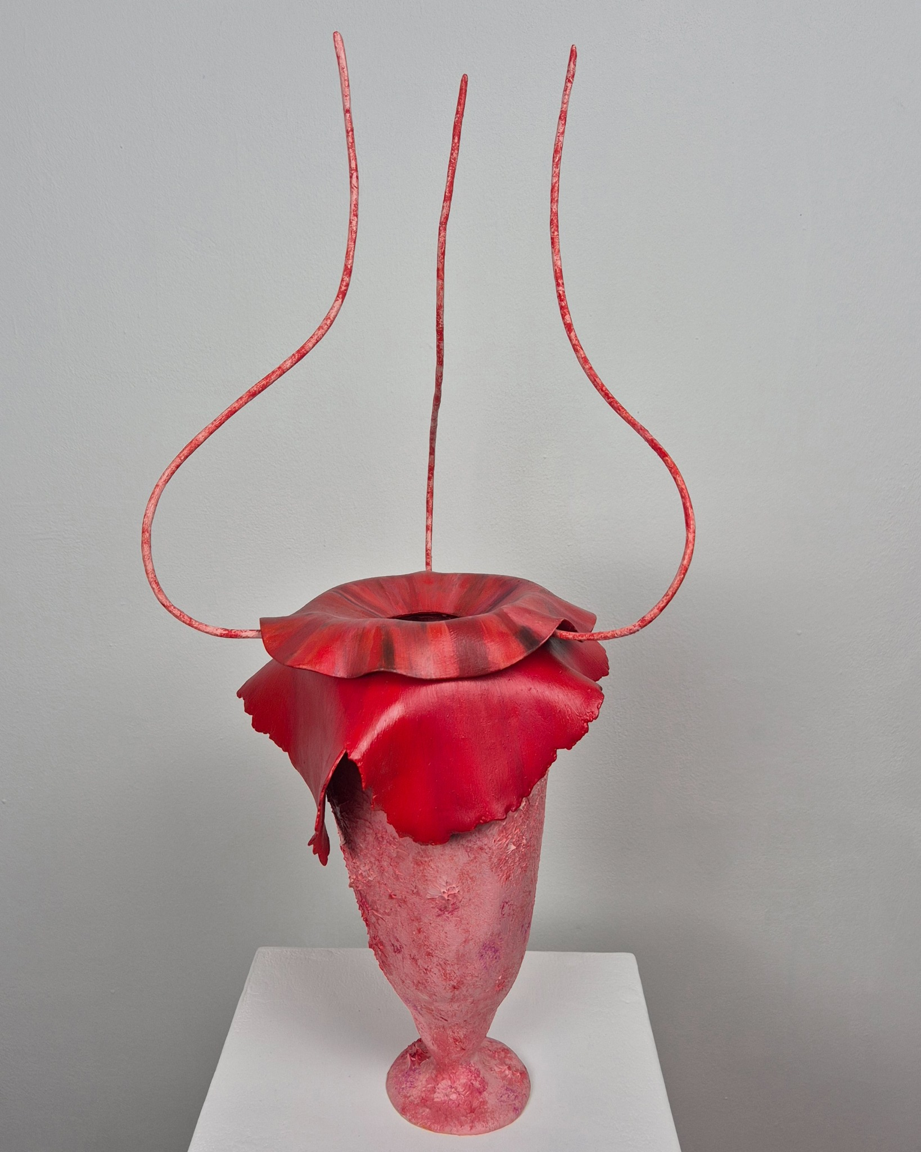
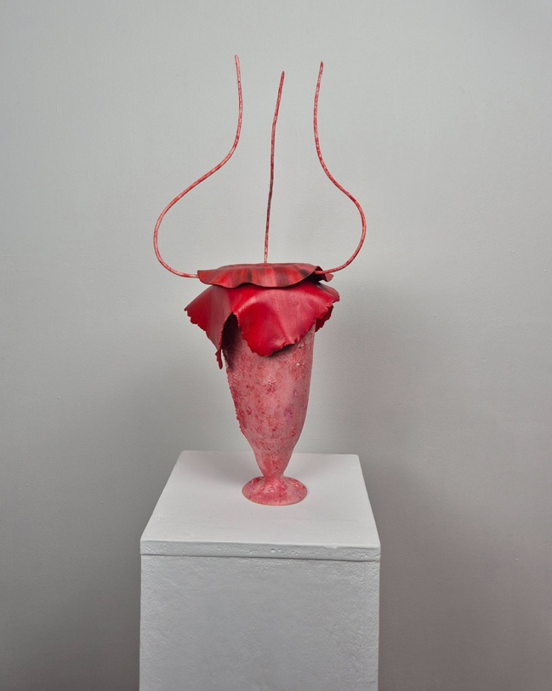
Title: Anemone #002
Year: 2024
Medium: Modeling compound, Oil paint
Dimensions: approx. 40 cm high x approx. 25 cm width
Ref Nbr : #S004

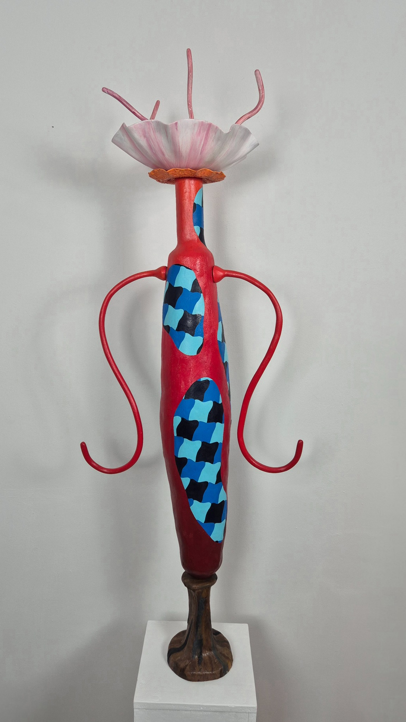

Title: Protector - Anemone #003
Year: 2024
Medium: Modeling compound, Resin, Oil paint
Dimensions: approx. 135 cm high x approx. 50 cm width
Ref Nbr : #S005

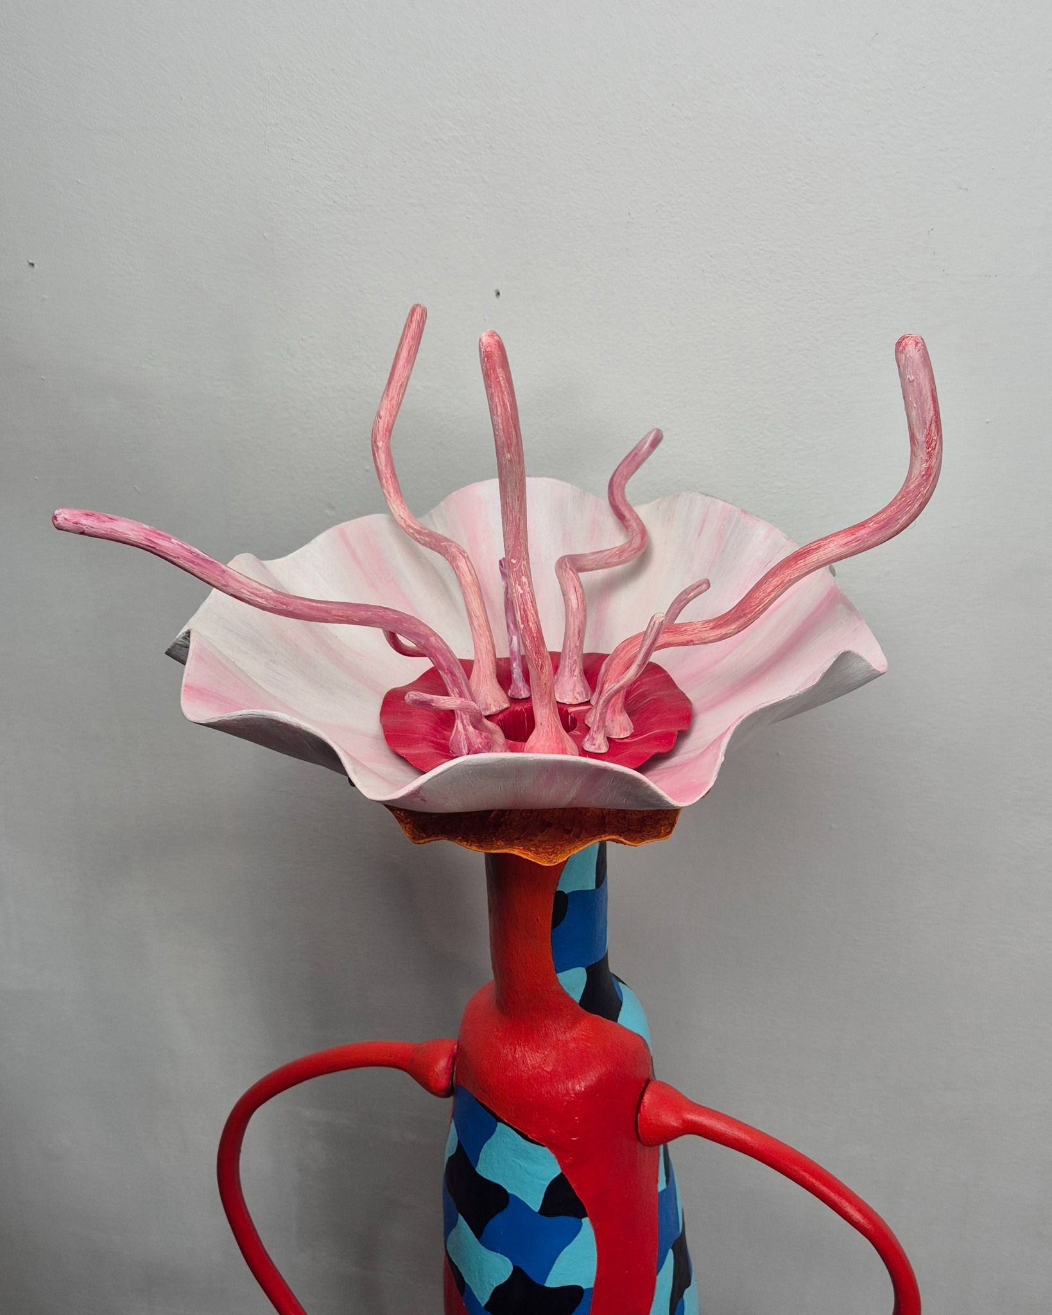

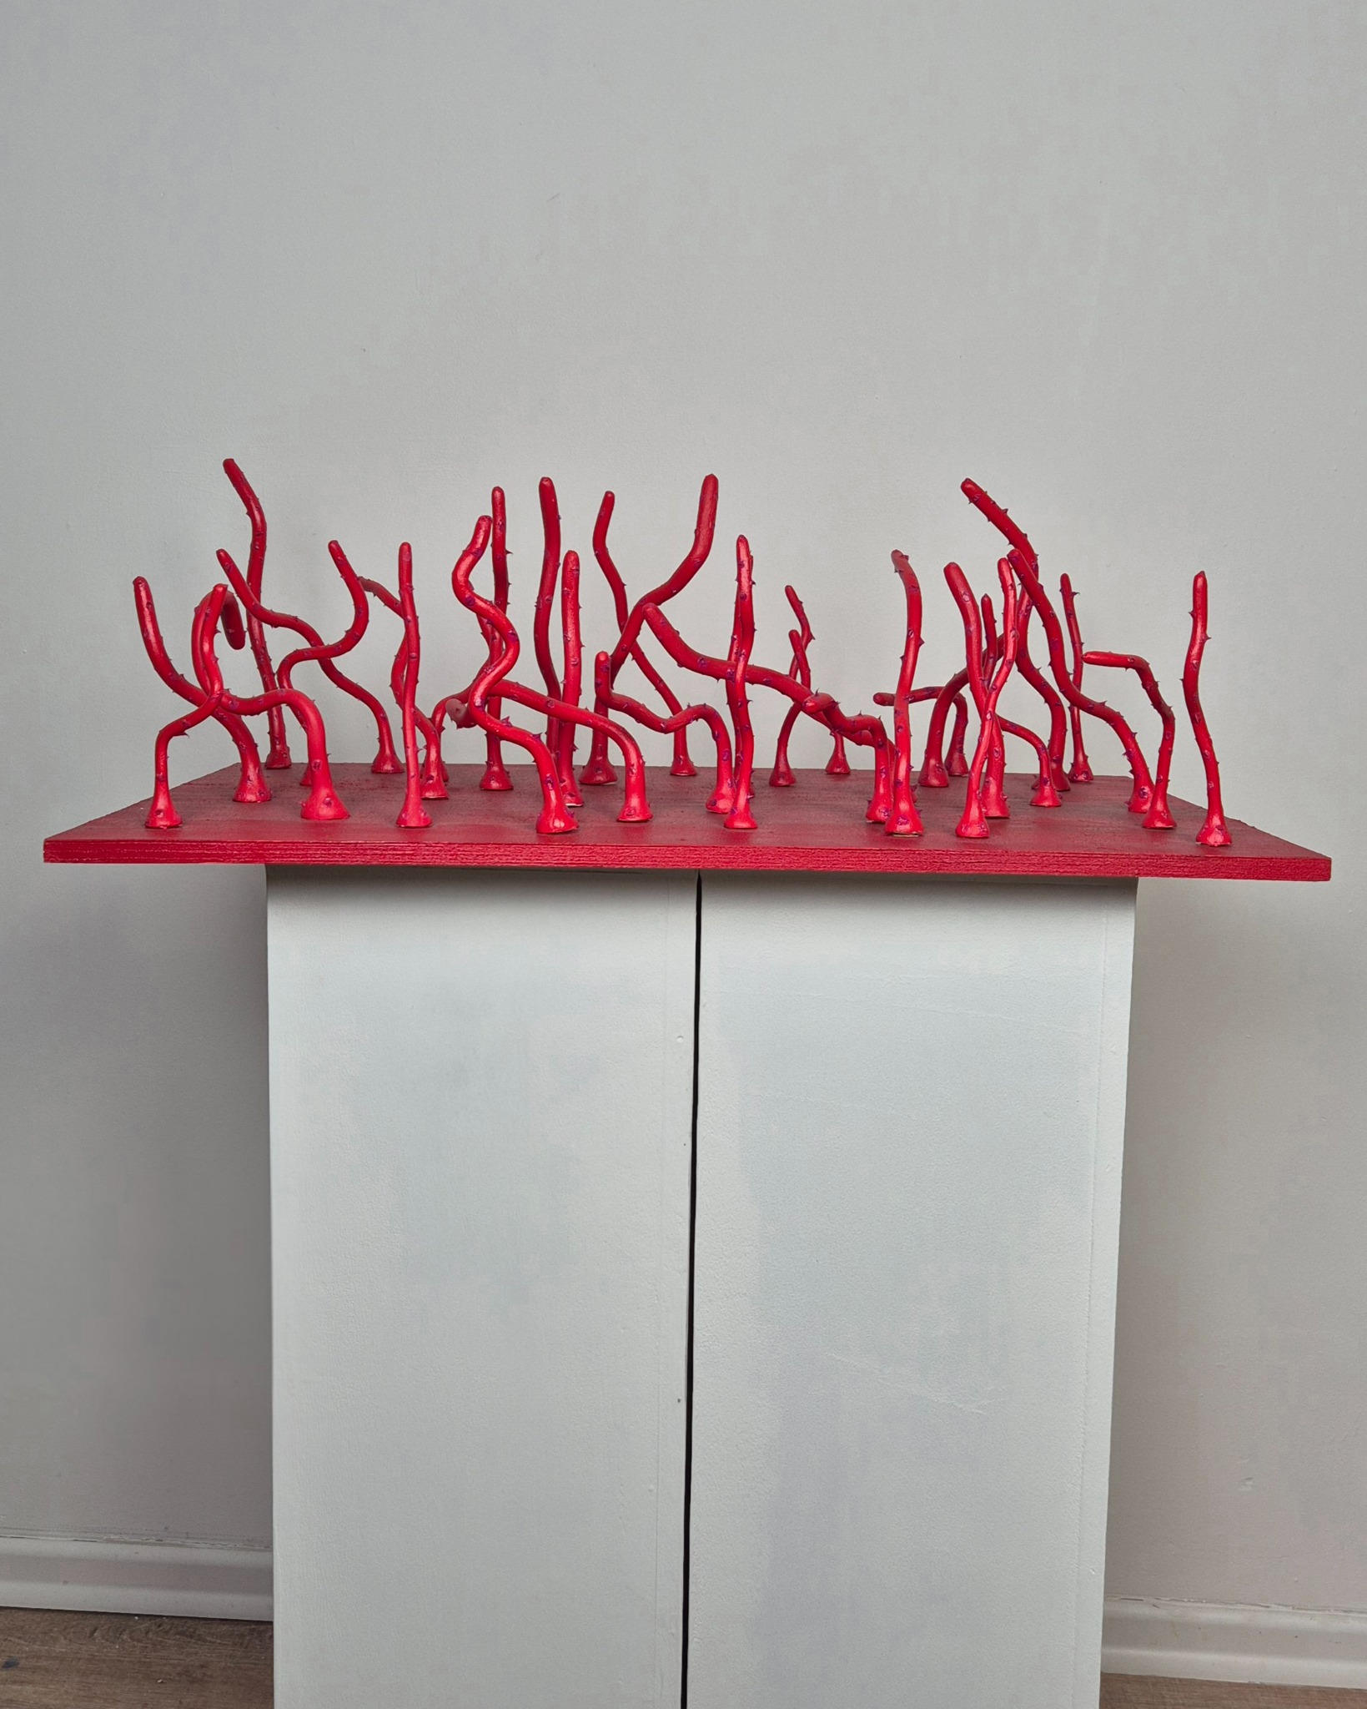
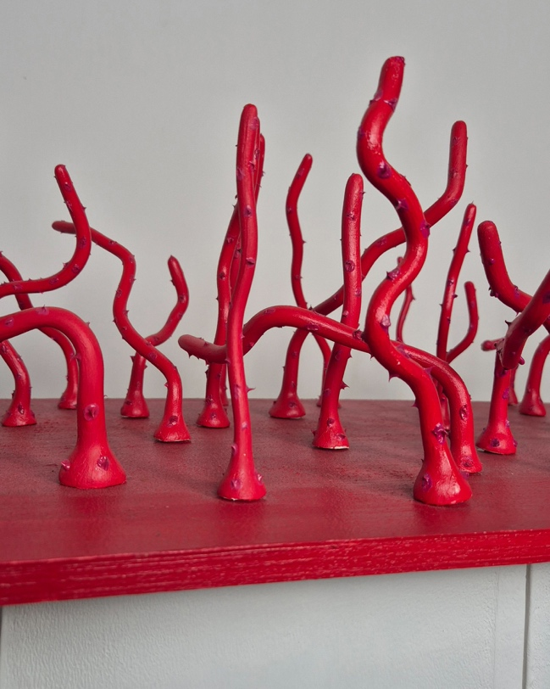
Title: Medium Coral in Bright Red and Light Purple
Year: 2024
Medium: Resin, Oil paint, Wood
Dimensions: 39 cm x 67 cm
Ref Nbr : #S006

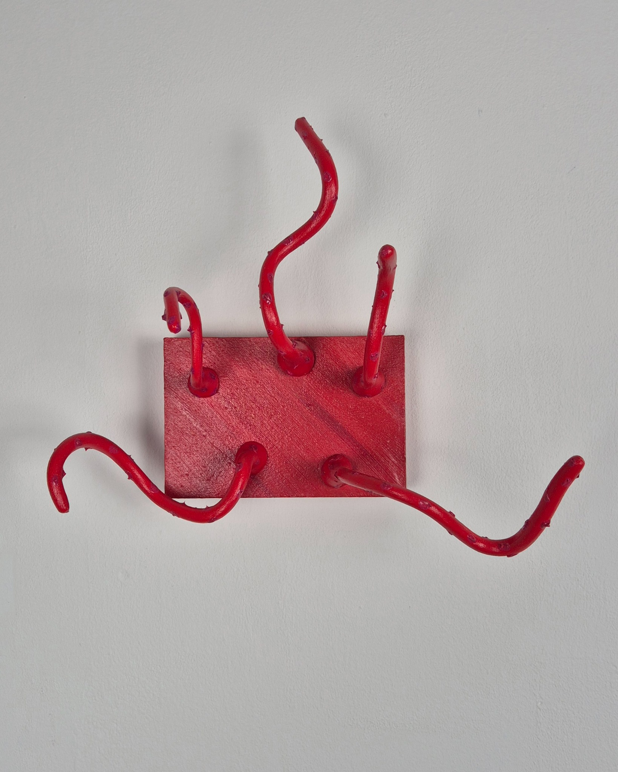
Title: Medium Coral in Bright Red and Light Purple
Year: 2024
Medium: Resin, Oil paint, Wood
Dimensions: 10 cm x 15 cm
Ref Nbr : #S007

