**UK Ultra Group Recce Runs**

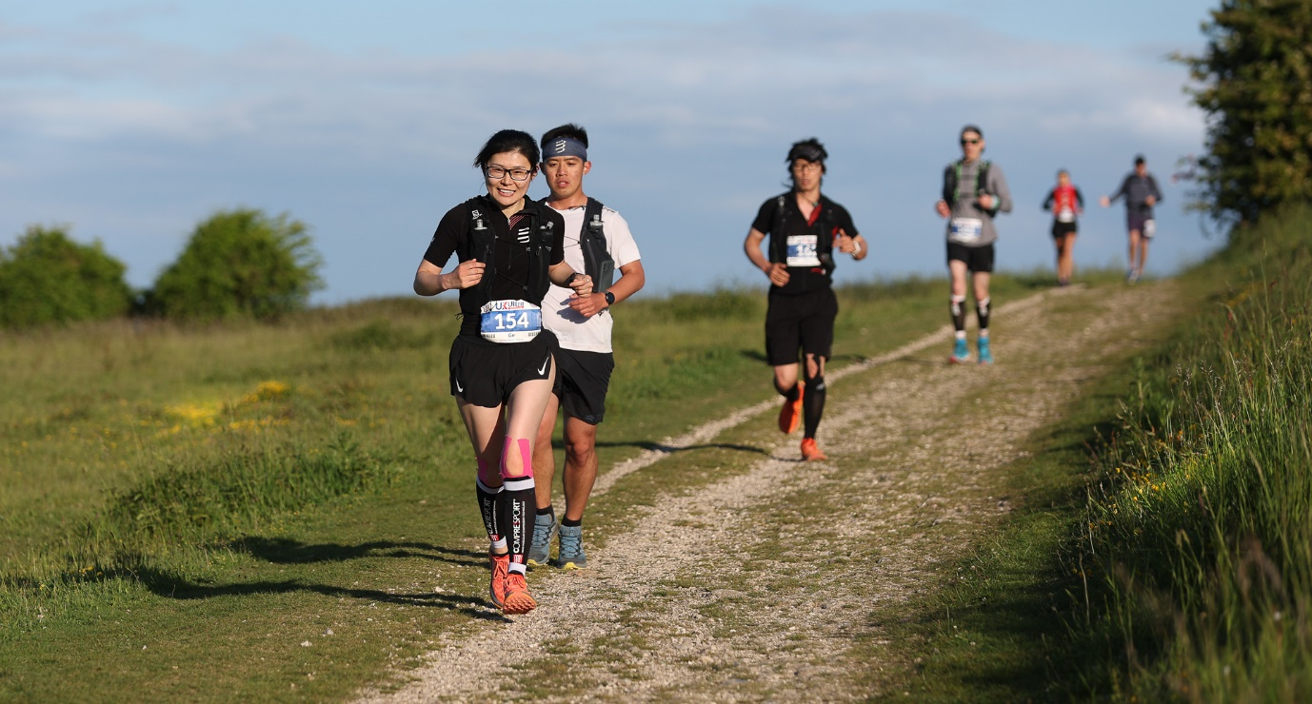﻿

﻿

﻿﻿﻿We have partnered up with local company Trail-Run Explorers to offer guided runs along our routes from 2023.

Trail Run Explorers is based in Sussex and offers Guided Runs to everyone, at various locations across the country, with the aim of making trail running accessible to as many people as possible.

Trail-Run Explorers is a 'place' where runners who want to enjoy getting out on the trails to explore, can do so, without having to worry about where they are going or how safe they are on their own. Led by runners who are passionate about running and bringing likeminded individuals

Our Reece runs are a great way to get some longer training runs in with company and also to familiarise yourself with the routes/terrain of the UK Ultra races.

The runs will be available for both UK Ultra race entrants and anyone that wishes to come along for the day. As all 4 of our races are essentially on parts of the same route at some point, they will be broken down into 7 separate runs covering in the region of 15-31 miles. The runs are for all levels of fitness and will be run at a pace that is good for all. If you are a fast runner and want to shoot off at 6 min pace then this is probably not for you. Everyone will stay relatively close together throughout and essentially just enjoy the day/route.

The cost of each recce will be £12 for anyone signed up to one of our races and £15 for everyone else. All of the runs will be point to point with runners having the choice of meeting at the start location, finish location or in Eastbourne where all our races finish.

There will be a bus service in operation for each day that will travel from Eastbourne to the finish location of the run and then to the start. For example a run might be from Arundel to Saddlescombe Farm. Runners will have the choice of getting on the bus at Eastbourne, driving to the finish(Saddlescombe) location and getting on the bus to the start(Arundel) or meeting at the start (Arundel) and making their own way home from the finish.

The bus will meet everyone at the end of the run(Saddlescombe) and travel back to Eastbourne. It won’t be able to take runners back to the start of the run(Arundel) but will be able to drop anyone to the local train station near the finish(Saddlescombe) before travelling back to Eastbourne. Obviously some runs will actually finish in Eastbourne. The cost for each bus ticket will depend on how far you are travelling and which recce run, but will be in the region of £10-£20 which is payable to the driver in cash on the day. To book a place on the bus the please email [neil@ukultra.co.uk](mailto:neil@ukultra.co.uk)

A packed lunch will be included in the price for anyone that would like one and this will be available after the run has finished on the bus.

One of our sponsors, Langham Hotel in Eastbourne, will be offering very cheap hotel stays for anyone that wishes to make a weekend of it. This offer is for a double/twin room, B&B at £88.40 or a single room B&B at £55.25. The Hotel is situated on the seafront and is where the bus will depart each morning before the runs. Anyone wishing to get the bus must meet here at the designated time which can be seen below.

If you wish to stay at the hotel you must be booked into and take part in the runs and can book this by going to the hotel website and using the following codes on your chosen dates:

UKULTRAINING1: 9th, 10th, 11th, 12th of March

UKULTRAINING2: 23rd, 24th, 25th, 26th of March

UKULTRAINING3: 6th, 7th, 8th, 9th of April

UKULTRAINING4: 20th, 21st, 22nd, 23rd of April

<https://www.langhamhotel.co.uk/>

As mentioned, there will be 7 Reece runs which can be seen below. Start times are 8.30am for all runs baring the night run. Please arrive for at the start location for 8.15am as there will be a safety briefing before heading out. If you are staying in Eastbourne and require the bus then the times for this can be seen depending on which recce run you are doing.

March 11th: Arundel to Beeding Hill. Bus departs Eastbourne at 8am. Run starts at 9.30am.

March 12th: Beeding Hill to Housedean Farm. Bus departs Eastbourne at 8.15am. Run starts at 9.30am.

March 25th: Falmer to Alfriston. Bus departs Eastbourne at 8.30am. Run starts at 9.30am.

March 26th: Alfriston to Eastbourne. Bus departs Eastbourne at 8.45am. Run starts at 9.30am.

April 8th: QECP to Goodward Racecourse. Bus departs Eastbourne at 7.30am. Run starts at 9.30am.

April 22nd: Bignor Hill to Saddlescombe Farm. Bus departs Eastbourne at 3.30pm. Run starts at 5.30pm.

To book any of these please hit the link to the Trail Run Explorers website and do so on there.

<https://www.trailrunexplorers.com/>

All details of the runs and basic kit you will need to bring will be emailed out in the lead up to the runs. Please get in touch with any questions you might have in the meantime.

Best Wishes  
Neil 