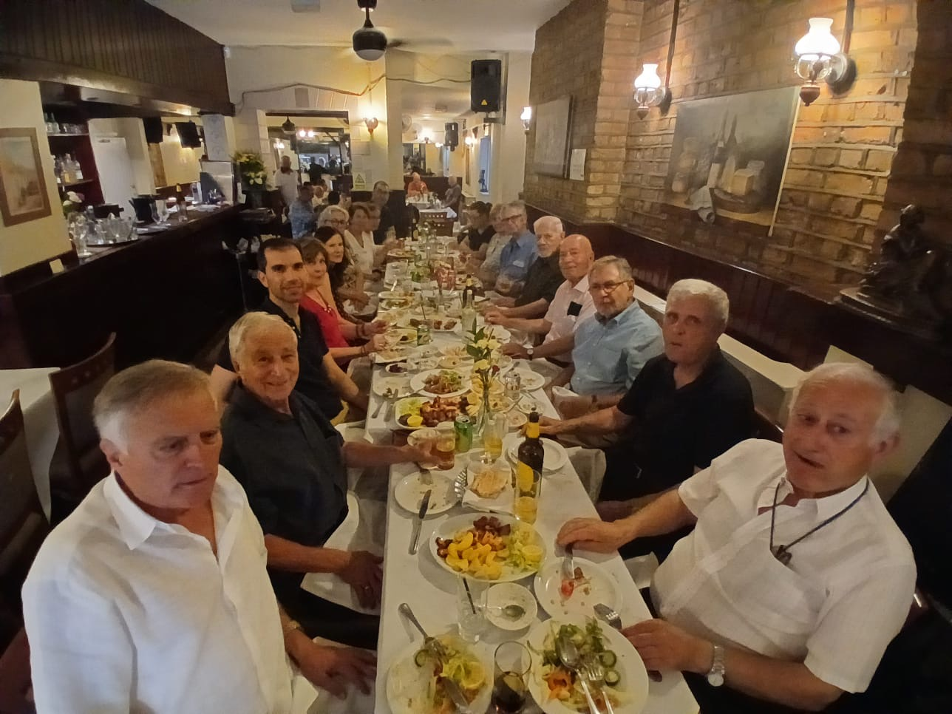

**FAREWELL SAVVAS:** On Friday 11th July we said our farewells to our General Secretary Dr Savvas Hadjifilippou, who is relocating to Cyprus with his family. Savvas spend many years as our G. Secretary and his help was invaluable. We will miss him, but our best wishes are with him and his family. Our President gave a brief farewell speech, thanking Savvas for all his help, and Savvas replied, stating how much he had enjoyed contributing to our cause and thanking everyone for being present at the farewell dinner.

The post of our General Secretary has been unanimously allocated to our member Niki Rossou Andreou, whose brother is still missing. We have no doubt that Niki will carry out the G.S.’s duties with great success.

**OBITUARIES:** Our sincere condolences to our President Neoklis, who recently lost his mother. Another mother of a missing person passed away, without knowing the fate of her missing son, Pavlos.

Condolences also to committee member Theoris for the loss of his beloved wife.

May they both rest in peace!

**IDENTIFICATIONS:** The following identifications were announced: Demetrios Theocharides from Lefkosia. CMP figures now stand at Greek Cypriots identified 757 still missing 753 and Turkish Cypriots 296 and 196 respectively.

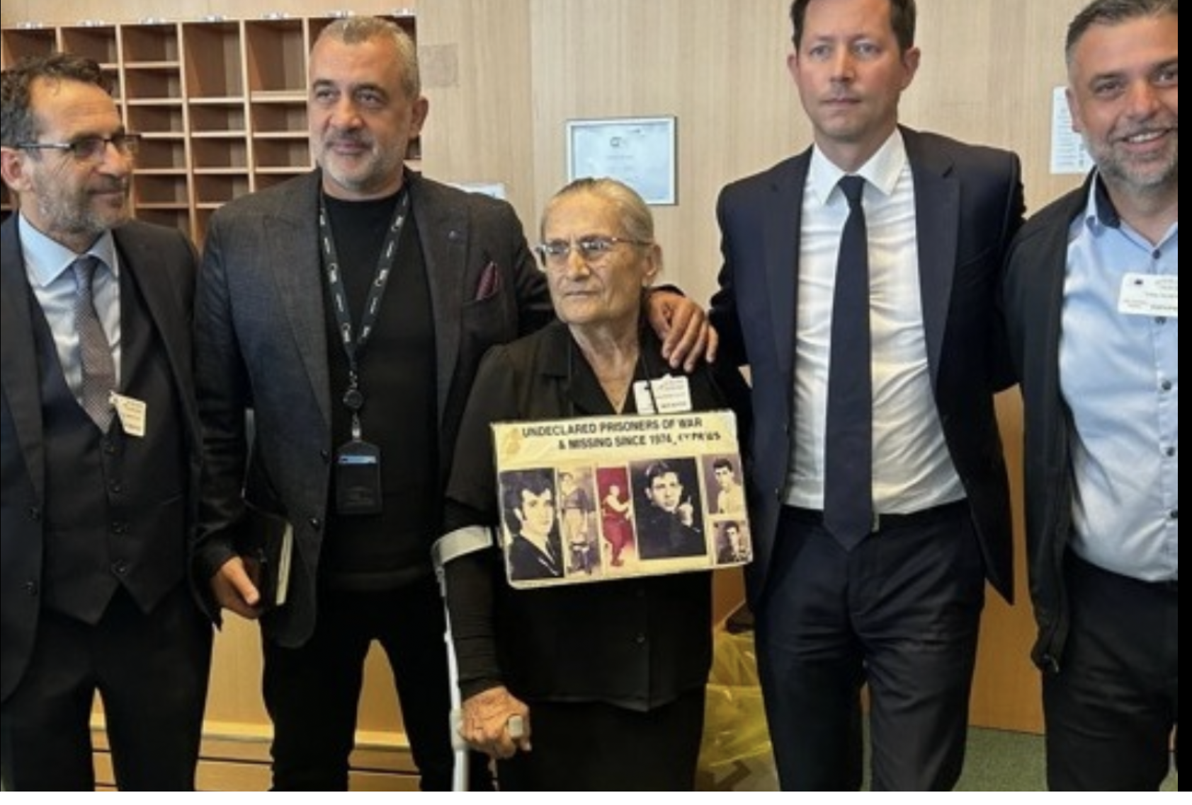

Below: L to R: *Mr Fourlas 2nd, Mrs Mandoles and Mr Akansoy 5th.*

***Enough is enough! 51 years is long enough!***

**E.U. PARLIAMENT COMMITTEE:** 24th June 2025 was a historic day at the European Parliament and one of the most emotional days experienced by the Cypriot MEPs.

MEP Loucas Fourlas suggested that a discussion takes place about the missing of Cyprus and that was embraced, and the relatives of the missing persons were heard for the first time in the Committee on Civil Liberties of the European Parliament.

Harita Mandoles and Erbay Akansoy moved all by opening their hearts and asking for justice for all the relatives of the missing.

The Presidency, the Envoy, and political groups pledged to do everything possible to accelerate exhumations and identification processes.

Pressure will be applied on Turkey to open its archives.

The responsibility is huge, and Mr Fourlas promised that he, along with his colleagues, will do everything they can to relieve the pain of the relatives.

.

**NEWS BULLETIN JUNE-AUGUST 2025**

**DONATIONS:**  Mr L.M.Loizou £400, Mr Y.Kashimeris £100. ***Thank you for your kindness and generosity!***

**OUR NEW WEBSITEIS NOW AVAILABLE:** Yes we have nowcompleted our new website and you are more than welcome to look at it and maybe suggest any new ideas for it! **https://ormc-uk.org**

**ORGANISATION OF RELATIVES OF MISSING CYPRIOTS (UK)**

# Telephone: Office 020-8805-6939

# 

**E-mail:** [**ormc1974@btopenworld.com**](mailto:ormc1974@btopenworld.com) **Website:** [**http://www.ormc-uk.org**](http://www.ormc-uk.org)

**Facebook:** [**https://www.facebook.com/ormcuk**](https://www.facebook.com/ormcuk)

**Twitter:**  <https://twitter.com/ORMC_UK>