SHORT INSPECTIONS
Before inspection

The lead inspector’s preparation
Before a short inspection, the lead inspector will “evaluate a range of available contextual and performance information”, including:
- The previous section 5 inspection report (or where applicable, the most recent short inspection report)
- Responses from Parent View, Ofsted's online survey for parents
- Information on the school’s website
- Published data for attendance and exclusions

Notification of inspection
Ofsted will normally contact the school by telephone to announce the inspection at, or just after, midday on the working day before the short inspection.
During this phone call, the lead inspector will request that the school makes a range of documents available. These are listed in paragraph 76 of the handbook for section 8 inspections (the information above is taken from paragraphs 70 to 76).

During inspection
Paragraphs 80-87 of the section 8 handbook set out what happens on the day of a short inspection.

No 'standard' timetable
The lead inspector will construct a timetable for the short inspection based on:
- The key lines of enquiry identified during preparation; and
- Any areas identified through discussions with the headteacher, governors and/or senior leaders
This timetable may be adapted as new evidence becomes available or other issues emerge. There is therefore no ‘standard’ short inspection timetable. Every short inspection is different.
Inspectors will not arrive before 8am. At the start, they will meet the headteacher and/or senior leadership team (SLT) and will:
- Discuss the school’s self-evaluation and the key lines of enquiry inspectors have identified during their preparation
- Confirm arrangements for meetings with pupils, staff and representatives of those responsible for the governance, and parents, as relevant
- Confirm arrangements for providing feedback to the school at the end of the day
- Request information about staff absence and any other practical issues
- Ascertain whether there are particular reasons why any teachers should not be observed, for example, where they are subject to capability procedures
The handbook highlights the importance of safeguarding and says:
Inspectors must always judge whether the school’s arrangements for safeguarding are effective. They will check the SCR and look at a small sample of case studies of referrals, checking how the referral was made and the thoroughness of any follow-up.
Short inspections will focus on evidence of how effectively the school’s leaders and managers, including governors, are:
- Sustaining a good quality of education for pupils
- Demonstrating capacity to remedy any minor weaknesses that are not of sufficient concern for the lead inspector to convert the inspection from a short to a section 5 inspection


How do short inspections differ from full inspections?
Jean explained that headteachers predominantly lead short inspections with their own information. This can include:
- Contextual information about the school
- Information on the school's journey since the last inspection
- Progress and attainment data
- The school's perceived strengths and challenges
The reduced timeframe of a short inspection means that it is important for the school's evidence to be easily accessible, as there is no time for finding additional evidence.
At the end of her school’s short inspection, advice and guidance was given as to why the school was not 'outstanding', along with suggested refinements that would be needed to achieve this.

What will inspectors consider?
Inspectors will focus on “whether leaders and managers are demonstrating the capacity to drive improvement”. They will also consider, where relevant:
- Whether the quality of teaching, learning and assessment is being sustained or improved
- Aspects of the personal development, behaviour and welfare of pupils, with particular reference to pupils’ attitudes and conduct
- Whether good outcomes are being achieved, including in the Early Years Foundation Stage and/or 16 to 19 study programmes
- The impact of any external or internal support, and the challenge provided to the school by the local authority, proprietor, trust or sponsor
Our associate education expert, David Driscoll, told us that during a short inspection, the lead inspector will want to discuss past and current tracking data with the most appropriate person.
He also stressed that safeguarding will always be checked during both short and section 5 inspections.

Feedback at the end of a short inspection
At the end of a short inspection, the inspector will give brief oral feedback that will typically:
- Report the range of evidence gathered
- Provide the school with a judgement about whether the school remains ‘good’
- Report whether safeguarding is effective
- Make clear that the text of the short inspection report may differ slightly from the oral feedback
- Ensure that leaders are clear about the procedures leading to the publication of the report

Possible outcomes of a short inspection
There are 4 possible outcomes for a short inspection, which are summarised in the diagram below. You can also find this diagram on page 15 of the handbook.
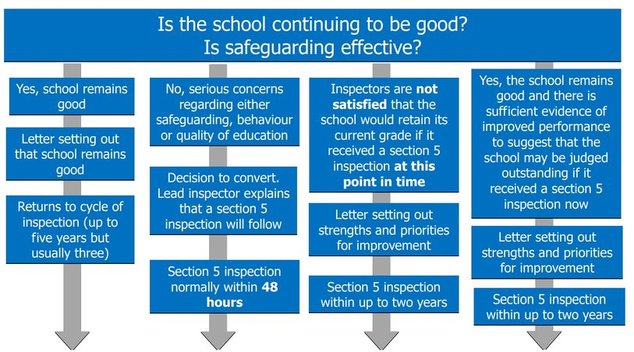
Source: Handbook for short, monitoring and unannounced behaviour school inspections, GOV.UK – Ofsted, page 15

After inspection
The school will receive a report in the form of a letter setting out the findings of a short inspection. The letter will include:
- The date of the inspection
- A brief summary of any significant changes to the context of the school
- A summary of the type of evidence gathered during the inspection and the context of the school
- The judgement that safeguarding is effective
- The judgement that the school is still providing a good quality of education, or, where there is insufficient evidence that the school remains 'good' or concerns that the school may no longer be 'good', that the current judgement that the school is providing a good quality of education has not changed and that the next inspection of the school will be a section 5 inspection
- Any next steps the school should take
This information is set out in paragraph 88 of the section 8 inspection handbook.

