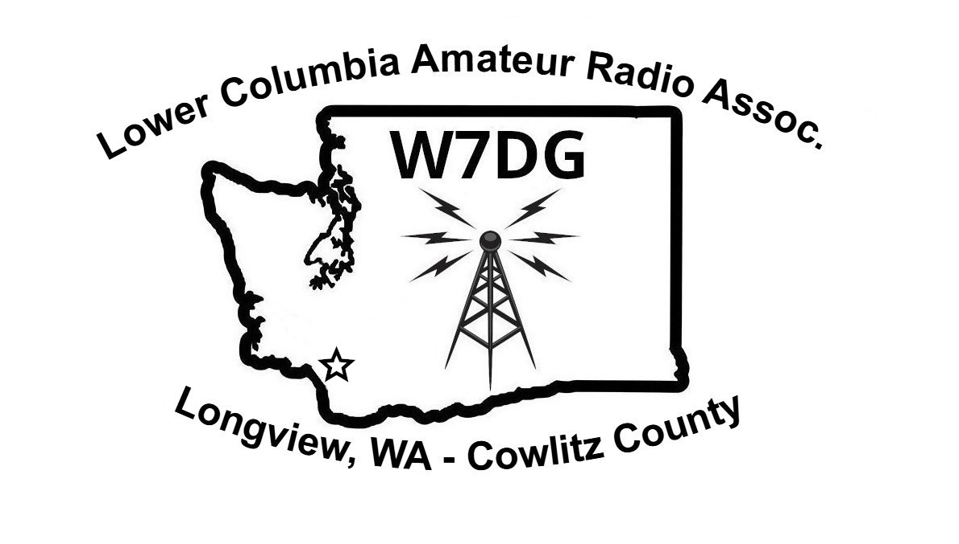

Constitution and Bylaws
of
The Lower Columbia Amateur Radio Association
~ W7DG ~
19 November, 2025
Mission Statement
“The mission of the Lower Columbia Amateur Radio Association is to promote and foster amateur radio, further the advancement in the art of radio and technology in a manner that honors and exemplifies amateur radio and the radio amateur’s code, the continuation of ham radio’s unique ability to enhance international goodwill, to provide facilities and equipment for the Association members and guests to operate on the Amateur Radio bands”

Article I

Title
The legal title of this organization is
“Lower Columbia Amateur Radio Association” A Nonprofit Corporation, 501(c)(7) Social Club, Hereafter in these Bylaws referred to as the Association.

Article II

Board of Directors, Finance Committee, Technical Committee.

Section I - The Board of Directors of the Association shall be President, Vice-President and Secretary/Treasurer. The Board of Directors may individually be referred to as ‘Officers’ of the Association.

Section II - A Board of Directors meeting shall consist of at least two (2) out of three of the above in Section I to conduct Association business i. e. minimum quorum rule of two (2). All members of the Board of Directors shall be reasonably notified before any meeting(s) or actions taking place. The Board of Directors cannot vote by proxy and must be present to consider resolutions or Committee reports and vote accordingly by majority. Remote Meetings are acceptable and The Board of Directors may elect to have conference calls or similar methods that allow comment and response by Officers and/or members at the same time. *Members of the Association may attend a Board of Directors meeting. Only the Officers, having been elected by the Association membership, can vote at a Board of Directors meeting. No one Officer has the final say on any singular club issue. Association Members can vote on items presented to them at regular Business Meetings.*

Section III - The Finance Committee, when formed, would consist of the Secretary/Treasurer and at least 4 general members. If the Committee agrees to a path forward on a particular subject, the Secretary/Treasurer would bring the information to the Board of Directors for discussion and vote.

Section IV - The Technical Committee, when formed, would consist of at least one Officer and at least 4 general members. If the Committee agrees to a path forward on a particular subject, the officer shall bring the information to the Board of Directors for discussion and vote.

Section V - Officers must be members of legal age (18) and in good standing with current year’s club dues paid and continue to hold a valid amateur radio license. Any Officer who is not a member in good standing or who is absent for three (3) consecutive monthly business meetings without just cause, may be subject to removal from office as outlined in Article V, Section II. It is a requirement that Board of Directors live within 35 miles of the Kelso/Longview region. Reasonable time response may be necessary to discuss or act on club business.

Article III

Duties of the Board of Directors, Finance Committee and Technical Committee

Section I - President: It shall be the duty of the Association President to preside over designated Board of Directors meetings of the Lower Columbia Amateur Radio Association.

Section II - Vice-President: It shall be the duty of the Association Vice-President to function as President in the absence of the President.

Section III - Secretary/Treasurer: It shall be the duty of the Association Secretary/Treasurer to record the official minutes of all business meetings and post a printed copy on the club bulletin board as soon as is reasonably possible, but before the next regular business meeting. The minutes shall also be sent to members via email. The minutes of the previous meeting shall be brought up as the first order of business, whereupon the question will be asked if there are any corrections or additions to the minutes. After any corrections or additions are made, a motion to accept the minutes will be asked for. Reading of the entire minutes shall be read by the club Secretary/Treasurer at each business meeting. The Secretary/Treasurer shall report club correspondence and may occasionally distribute important news bulletins concerning activities of the Association. The minutes and attendance record shall be on file at the clubhouse. By the next month’s meeting, the Secretary/Treasurer’s Report shall be attached to the minutes and remain on file at the clubhouse.

It is additionally the responsibility of the Association Secretary/Treasurer to collect and record membership dues, file the annual federal income tax documents for a 501(c)(7) Social Club nonprofit organization, and conduct all Association monetary business matters as approved in Article IX Section I, or as otherwise directed by the Board of Directors. The Secretary/Treasurer shall provide monthly budget activity reports and a yearly budget at the appropriate business meetings. These reports shall be available for review at the clubhouse by the membership.

Section IV – Trustee: The Trustee shall assume responsibility for: (1) The four repeater coordination's using the call-sign W7DG every 5 years through WWARA. (2) Renewal of the W7DG license when it comes due every 10 years. The Trustee is a ‘Non-Officer’ position and therefore carries no term limit. Trustee can volunteer or may be appointed by the President. The Trustee shall hold a valid Extra Class Amateur Radio License.

Section V - The Board of Directors: The Board of Directors shall meet, when necessary, to conduct business that cannot be postponed until a regularly scheduled meeting. They should try to meet at least twice per year if possible however, more often is encouraged to discuss the best interests and well-being of the Association. The Board of Directors is the governing body and shall provide oversight and final decision over all club business matters along with membership voter approval depending upon subject matter. Not all subject matter will require a full membership vote. Article II Section II *Asterisks*

Section VI - Finance Committee: The Finance Committee, when formed, should meet at least twice per year if possible to discuss financial standing with the Board of Directors of the Association. Meeting more often is encouraged. Only the Board of Directors is authorized to make changes to Association finances when approved by at least three (2) Directors.

Withdrawal of funds from the investment account(s) shall only be transferred to the Association’s checking account. The Secretary/Treasurer of the Board of Directors is authorized to communicate the transfer of funds to our investment firm between the investment account(s) and the Association’s checking account when approved by at least two (2) of the Board of Directors. For security purposes, no member or officer is able to arrange any changes to our income or investment growth accounts. For changes to our investments or income growth accounts to occur through our investment firm, a minimum of two (2) Board of Directors must conduct a special meeting and submit official meeting minutes to the investment firm. The Secretary/Treasurer shall submit the wishes of the Directors along with a copy of the special meeting minutes. To maintain transparency, the Association Secretary/Treasurer shall post the monthly investment statement on the bulletin board prior to each meeting.

Section VII - Technical Committee: A Technical Committee should meet at least twice per year if possible to discuss and suggest possible changes if any, regarding the Association’s station equipment and infrastructure. Meeting more often is encouraged. Significant changes to Club infrastructure and equipment must be approved by the Board of Directors if cost is involved, up to $500. In the event it is discovered that incidental repairs are needed to Association infrastructure that may affect the use and operation of the club station, the Trustee and/or at least one other Officer shall be notified. An Association member shall be allowed to execute repairs of an urgent nature “if” they possess reasonable knowledge and ability. Oversight and assistance from a more technically experienced club member is acceptable and may be required depending upon the technical nature of the issue. Outside help is also acceptable if the need arises.

Article IV

Terms of Office

Section I - The term of office for all Officers shall be two (2) calendar years, commencing with the first regular Association meeting held in January, and ending with the last meeting in December of the second (2nd) year.

Section II - The position of Trustee has no term limit.

Article V

Election of Officers
Section I - The President, Vice-President and Secretary/Treasurer shall be elected every two (2) years. These are association members who are elected at the November business meeting during odd years whose offices begin on January 1st of the next year. Elections must be attended by a quorum of the membership. The current President, may, at their discretion, appoint a nominating committee. Nominations for Officers for the election year will be opened at the September meeting and closed prior to elections at the November business meeting.

Section II - In the event an Officer is in violation of Article II, Section V, they may be removed from office by a quorum of at least sixty-six and two-thirds percent (66 2/3%) of the total voting members present at a regular Association business meeting. If an Officer resigns or is removed from their position, replacement(s) for the vacant position(s) shall be appointed by the Association President, or Vice-President in event the President is unavailable, with the advice and consent of the Board of Directors to complete the current term.
Article VI

Eligibility for Membership

Section I - Any person holding a valid Amateur Radio License and others as defined in Article VII are eligible to apply for membership in the Association.

Section II - It shall be each member’s responsibility to become familiar with and/or be trained by a knowledgeable club member before operating any club radio equipment. Members shall operate within their individual license privilege or within the privilege of a higher licensed class amateur radio operator acting as a control operator and operate within compliance with Part 97 of the FCC Rules and Regulations. All club members operating club radio equipment are responsible for the appropriate and lawful use of the equipment and club call-sign.

Section III - *No person shall operate “non-club owned equipment”. (1) 911 Radios, Emergency Management Radios, or any other Served Agency equipment, without proper authorization. Proper authorization would consist of training by the Responsible Person for said equipment. Agency equipment shall be identified as such and segregated from amateur radio equipment.* The above section between asterisks relates to Auxiliary Communications Service (ACS). This equipment is not considered private per MOU with LCARA. (2) Loaned/private amateur equipment. Loaned/private equipment is not allowed to remain in the club building as defined in the “Private Equipment Use & Storage Policy” which is a companion document. The club shall not be responsible for any loss, damage or otherwise of loaned/private equipment. If it can be determined there is an extenuating circumstance where its beneficial that special equipment be allowed to remain in the club, the membership shall be allowed to hear it. The use of the club storage container is for club property only.

Section IV - Membership in the organization is dependent on a person's ability to conduct themselves in a morally and ethically acceptable manner, due to Association activities that include family members of all ages, and the responsibility for presenting a positive image of amateur operators and the LCARA to the community. Criminal acts, improper social behavior, intentional misrepresentation of facts, and operating practices contrary to FCC regulations can result in denial or discontinuation of membership in the organization, as determined by a majority decision of the Executive Board.

Article VII

Dues and Classes of Membership

Section I - Association Membership. The amount for Association membership dues may be changed by the Board of Directors with the consent of a simple majority vote of the membership, at or by the November business meeting of any year. A new member may, at the discretion of the club President, and after at least three (3) months of membership, be issued the combination to the Association’s building’s front door. Expired memberships for current members may be reinstated upon full payment of the current year’s dues.

Section IA - Memberships are considered expired January 31st. Previous members returning to the Association after a full year’s absence are treated like new members. New members may join at any time by paying one twelfth (1/12) of the annual dues times the number of months left in the year, including the month of application. However, past long time Association members who are past the January 31st dues deadline, cannot be considered “brand new members” to the Association, thereby taking advantage of the one twelfth (1/12) pro rate.

Section II - Honorary Lifetime Membership. This is defined as an honor bestowed upon selected association members, an Honorary Lifetime Membership may be nominated from the floor at any time. Election of an Honorary Lifetime Membership must be by at least three-fourths (3/4) of the Association’s membership present at a regular scheduled business meeting. An Honorary Lifetime Member shall have all the rights and privileges of a regular member and shall not be required to pay annual Association dues.

Section III - Family Membership. Any current member of the Association, paying full membership dues may enroll any Immediate Family Member(s) living in the same household, who possesses a valid Amateur Radio License of any class, as a Family Member. Family Membership dues are fifty percent (50%) of the current Association Membership dues. Family members who are under the age of eighteen (18) years would qualify for a Junior Membership(s). – See Section VI of this Article. Immediate Family Members as explained above are eligible to vote at business meetings.

Section IV - Associate Family Membership. Any non-amateur fulfilling the requirements as an Immediate Family Member, as defined in Section III of this Article, may become an Associate Family Member. Associate Family membership dues are ten dollars ($10.00) per year. Associate Family Members will not be eligible to vote on Association business, shall not be eligible to be elected to an Association office, and shall not be considered in determining a quorum.

Section V - Senior Membership. Defined as a member of the Association with an age of eighty (80) years or above. Members who qualify to be a Senior Member carry all of the rights and privileges of an Association Membership with a dues rate of ten dollars ($10) per year.

Section VI - Junior Membership. Defined as a member of the Association who is under the age of eighteen (18) years. (a) The “Only” Association Member in the household or (b) a Family Member as outlined in Section III of this Article. The Junior Membership in the Association carries all of the rights and privileges of an Association Membership. The Junior Membership dues are ten dollars ($10) per year.

Article VIII

Meetings and Business
Section I - Business meetings of the Association shall normally be held on the third (3rd)
Wednesday of each month, except for the month of December. The December meeting shall be the Annual Christmas Dinner Meeting. No business except paying of Dues or of an emergency nature will be conducted at the dinner. If such dinner meeting is not scheduled, then the official meeting for the month of December shall be held on the third (3rd) Wednesday of December where usual business will be conducted.

Section II - In order to conduct Association business at the monthly business meeting of the Association, a quorum of not less than six (6) members must be present. At least 2 Board of Directors and 4 regular members. Motions must pass with simple majority.

Section III - The Board of Directors, as defined above in Article II, Section II, may conduct Association business of an emergency nature that it deems necessary, and be reported to the membership at the next regular Association meeting.

Section IV - The Board of Directors, by majority vote, is authorized to spend up to five hundred dollars ($500.00) without first obtaining membership approval.

Section V - The Association is an alcohol, drug and smoke-free environment, adhering to all Washington State Non-Smoking Laws. This includes e-smoking in any form.

Section VI – Policies/MOU’s, approved by the Board of Directors shall become a companion document and have their own binder to remain at the front table.

Article IX

Payment of Bills
Section I - Payment of Association expenses shall be by check. Recurring bills, such as PUD, telephone, mailbox, or propane, shall be allowed to be paid by electronic transfer. The Treasurer may pay recurring bills and expenses authorized in a member approved yearly budget, up to five hundred dollars ($500.00), without a vote of the membership.

Section II - The President, Vice-President and Secretary/Treasurer shall be authorized to sign checks in the name of the Association. All checks must be signed by at least two (2) of the above officers in order to be valid.

Article X

Audit

The Association Treasury Records shall be audited annually in January by the Secretary/Treasurer and two (2) Association members.

Article XI

Constitution and Bylaws Changes
Section I - The Association’s Constitution and Bylaws may be opened for amendment by simple majority vote of the membership at any regular business meeting. The Bylaws may be opened and closed for amendment no more than two (2) times in one calendar year beginning on 01/01 of said year to12/31 of same year.

Section II - The Bylaws shall be changed in a 3-step process over a three (3) month period. Step 1. At the first (1st) month’s regular scheduled business meeting: Open the Association Bylaws for amendments. Request the membership to submit amendments. Notify Association members who were not present, the Bylaws have been opened for amendments. Amendments received will be given to a Bylaws Committee who will begin processing them into the Association’s Bylaws structure.
Step 2. At the second (2nd) months regular scheduled business meeting: The Bylaws Committee will report proposed amendments for Discussion, Rejection, Adoption, or further Amendments to the Association’s members attending the meeting.
Step 3. At the third (3rd) regular scheduled business meeting: The final amendments processed by the Bylaws Committee will be presented by the Association’s President, to Association members attending the meeting, asking for a majority vote for each approved amendment. Approved changes made by majority vote of Association members will take effect the first day of the month following approval.

This amended Constitution and Bylaws were approved under the provision of Article XI on 19 November, 2025.

Validated by: Board of Directors, signed this date ~ 19 November 2025

President: Ralph Roggenback N2RJR

x____________________________________

Vice President: Duaine “Butch” Lytle AE7KJ

x____________________________________

Secretary/Treasurer: Brian Rickman KJ7OX

x____________________________________

