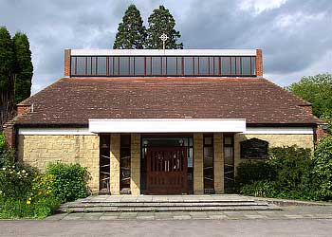
ROMAN CATHOLIC ARCHDIOCESE OF SOUTHWARK
ST THOMAS MORE RC CHURCH
MORE PARK, LUCKS HILL
WEST MALLING, KENT, ME19 6HN
TEL: 01732 843302 Email: westmalling@rcaos.org.uk
Website: westmallingrc.org.uk
Archdiocese of Southwark Registered Charity No 235468

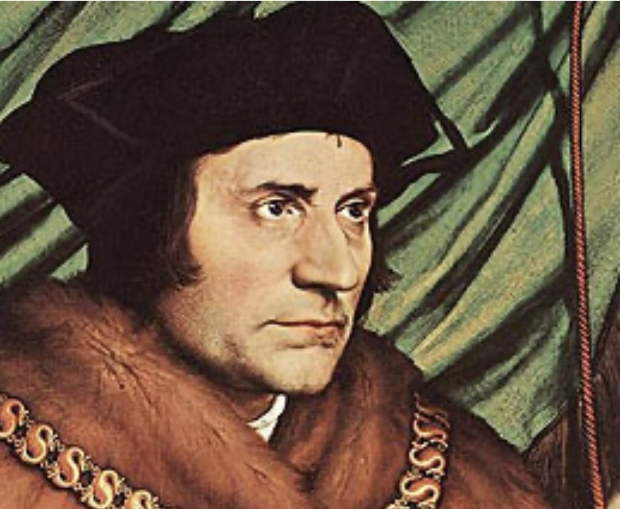

REGISTRATION FOR SACRAMENT OF BAPTISM

Child’s Surname: __________________________________________________________________

First Name(s): ____________________________________________________________________

Date of Birth:_____________________________________________________________________

Date of Baptism:___________________________________________________________________

Place of Baptism:__________________________________________________________________

Father’s Name: ___________________________________________________________________

Mother’s Name: ____________________________________________ Nee: ________________

Telephone: _____________________________ Alternative: ____________________________

Email: ___________________________________________________________________________

Child’s address: ___________________________________________________________________

Postcode: ________________________________________________________________________

Godfather(s): __________________________________________________________________

Godmother(s):____________________________________________________________________

Please return completed form to the parish office
DONATION £50

Signed______________________________________________________

Date:_______________________________________________________

NB: The main Godparent must be a CONFIRMED CATHOLIC. The Godparents must be Christian.

