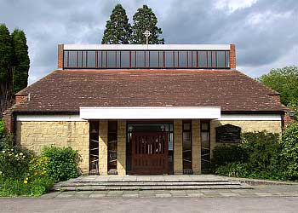
ROMAN CATHOLIC ARCHDIOCESE OF SOUTHWARK
ST THOMAS MORE RC CHURCH
MORE PARK, LUCKS HILL
WEST MALLING, KENT, ME19 6HN
TEL: 01732 843302 Email: westmalling@rcaos.org.uk
Website: westmallingrc.org.uk
Archdiocese of Southwark Registered Charity No 235468

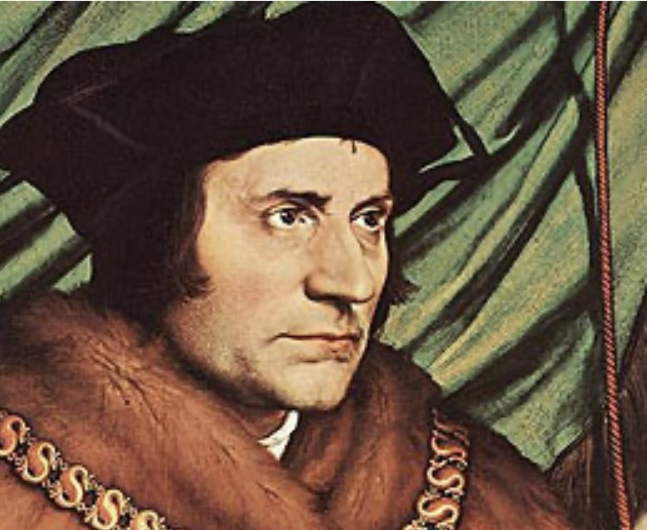

RCIA REGISTRATION

Surname: ________________________________________

First Name(s): __________________________________________________________________

Date of Birth____________________________________________________________________

Place of Birth_________________________________________________________________

Date of Baptism (if any)_________________________________________________________

Place of Baptism: (if applicable)__________________________________________________

Church of Baptism:_____________________________________________________________

Father’s Name: _________________________________________________________________

Mother’s Name: ________________________________________________________________

Godfather(s): ________________________________________________________________

Godmother(s):__________________________________________________________________

Marriages (1) Name of Spouse:_____________________________________________________

(2) Name of Spouse:_____________________________________________________

(3) Name of Spouse:_____________________________________________________

Divorce: (If applicable) Divorce decree must be provided_________________________________

Signed______________________________________________________

Date:_______________________________________________________

Donation: £50.00)

