**Dear Valued Community Supporter,**

We are thrilled to invite you to be part of the **5th Annual Runnells River Bottoms Festival — “Where the River Meets the Rails" —** taking place on **Saturday, October 4, 2025, in Runnells, Iowa.** This cherished community tradition is made possible through the generous support of sponsors like you. Your contribution helps us create a day filled with fun, connection. and celebration- and most importantly, it directly benefits the Runnells community. 100% of the proceeds are reinvested locally.

This year, our fundraising efforts are focused on supporting the local food bank and assisting community members facing unforeseen challenges. Our goal is to raise $20,000 through both individual and business sponsorships. All sponsors will be recognized on festival banners, social media, and the RRBF website. We welcome donations of any amount and are offering the following sponsorship levels…

# **VIP Sponsor - $1500**

Includes

* 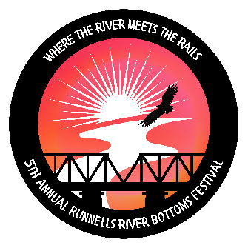4 Festival T-shirts
* 4 Wristbands for the street dance

 4 Drink tickets

# **Gold sponsor - $1000**

Includes

* 3 Festival T-shirts
* 3 Wristbands for the street dance
* 3 Drink tickets

**Silver Sponsor - $500**

Includes

 2 Festival T-shirts

* 2 Wristbands for the street dance
* 2 Drink tickets

**Bronze Sponsor - $250**

Includes

* 1 Festival T-shirt
* 1 Wristband for the street dance
* 1 Drink ticket

If you're able to contribute, please make checks payable to RRBF Foundation and mail them to: 5341 SE 104th St, Runnells, IA 50237.

All donations and sponsorships are tax-deductible, as the RRBF Foundation is a registered non-profit.

**When sending in your donation, please include the following as this information will be used to issue your tax deduction letter:**

 Your name and phone number

* How you'd like your company name/logo to appear
* Your mailing address and/or email
* Preferred T-shirt size(s) and color(s)

*We also invite you to register for the parade, which kicks off at 10:00am with line up at 9:30am at the water tower.*

*For more information. please contact* ***Val @ 515-313-7718 or email us at:*** [***RiverBottomsRRBF@gmail.com***](mailto:RiverBottomsRRBF@gmail.com) ***to reserve a spot in the line-up.***

Thank you for considering this opportunity to make a meaningful impact and help keep this wonderful tradition alive. We hope you'll join us in making this year's festival the most successful yet!

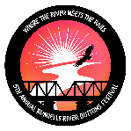

Warm regards,

The RRBF Foundation -Festival Committee

RunnellsRBF.com * 5341 SE 104th St. Runnells, IA 50237 * 515-313-7718 * RiverBottomsRRBF@gmail.com