Law Dept
4 employees (not including Prosecutor “section”)

Marc Ross was Asst Law Director left in 2020 or 2021. Was there just one position – same question for Finance Dept – wasn’t there just the one “Assistant” position prior to 2022 (law) and 2025 (finance)?

Jill Allen
Law Director (same job since 2019)
2019-2023: Salary increased from $95,920 to $159,834 or $63,914 or 66.6%.
2023 increase alone: $136,047 to $159,834 or $23,787 or 17.5%.
2024: increased $159, 834 to $170,835 or $11,001 or 6.88%.
So, 2019-2024, in the same job: $95,920 to $170,835 or $74,915 or 78%.

Jason Irick
Asst Law Director
Just using 2021-2024. I think he came for ½ year in 2019, no data in 2020.
2021 to 2023: Salary increased from $93,424 to $112,864 or $19,440 or 20.8%.
2023 increase alone: $101,728 to $112,864 or $11,136 or 11%.
2024: increased $112,864 to $120,665 or 7,801 or 7%.
So, 2021-2024, in the same job and only with the city for 3 years: $93,424 to $120,665 or $27,241 or 29%.

Randall Stevenson
Asst Law Director
2022 (hired mid-year, earned $50,895 = ~$101,000 for a full year)
2023: $101,000 to $111,970.
2024 (and 2022-2024 increase): increased $111,970 to $119,084 or $7,114 or 6.3%.
So 2022-2024, two years, his salary increased from $101,000 to $119,084, an increase of $18,000 or 18%. In 2 years as a new employee.

Sarah Gillis
Admin Assistant
Hired in 2022 -$57K to $59K. Still less than $75K in 2024.

Finance Dept
20 employees (not including IT and Meter Readers)
One Assistant Finance Director?

Katie Eviston
Finance Director
Her jobs:
2019: Accounting Budget Manager at $76,277.
2021 Budget Manager at $91,791.
2022-2023 Assistant Director of Finance at $101,116 and $114,504
2023-2024 Director of Finance $147,095 then $165,143.
So, from 2019-2024, in 4 jobs flying up the ranks to replace the retiring person, I believe, her salary increasd from $76,277 to $165, 143 or $88,866 or 116.5%.

Nicole Weber
Assistant Finance Director
2019-2022, she was Grants acct, staff acct, etc. with significant increases.
For example, as City Treasurer (2019-2020), her salary increased from $69,991 in 2019 to $86,193 in 2020, or $16,202 or 23%.
(In 2021, she took a year as Finance Consultant at $57,711.)
In 2022, she was promoted from City Treasurer at $86,193 to Asst Finance Director at $108,649, an increase of $22,456 or 26%.
In 2023, her salary increased from $108,649 to $133,441 or $24,972 or 22.8%. (year from the heavens)
In 2024, her salary increased from $133,441 to $143,611, or $10,170 or 7.6%.
So, as Asst Finance Director, from 2022 to 2024, her salary increased from $108,649 to $143,611, or $34,962 or 32%. In TWO years.

Assistant Finance Director
NEW JOB?!?! Did they have 2 before?
No record of salary yet, hired in 2025, but salary below
https://www.governmentjobs.com/careers/springfieldoh/jobs/newprint/4851495

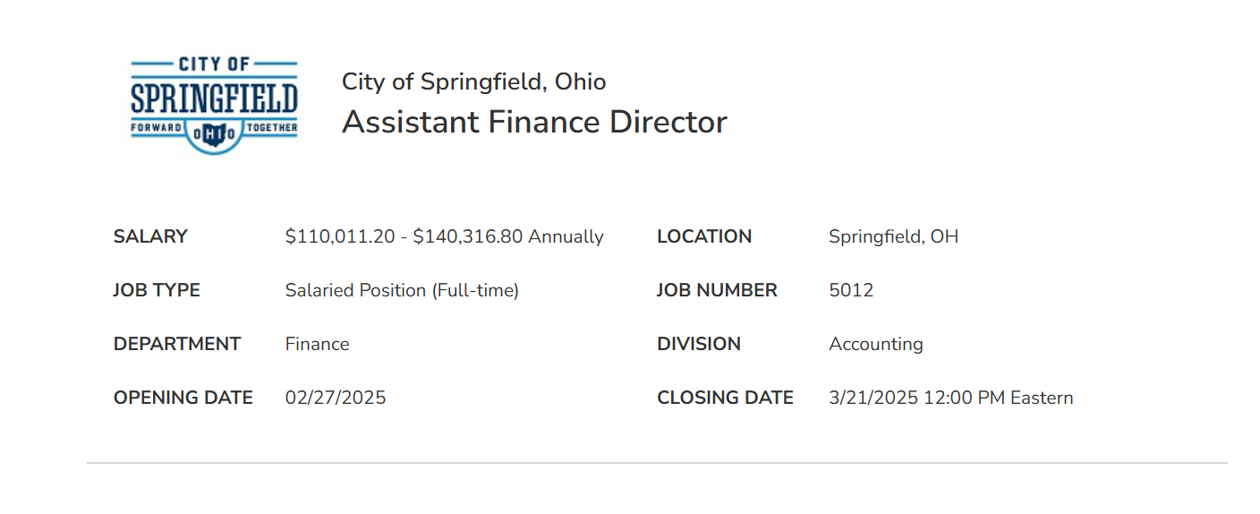

Bryan Heck
City Manager (same job since 2019)

2019-2023: Salary increased from $126,712 to $187,918 or $61,206 or 48.3%.
In 2019, Bodenmiller was City Manager and going to retire the next year. But we paid him a salary of $137,014. But Heck was appointed City Manager on February 1, 2019 and his salary was $126,712.
So, in 2019, we paid two City Managers $263,726.

2023 increase alone: $167,617 to $187,918 or $20,301 or 12%.
2024: increased $187,918 to $209,547 or $21,629 or 11.5%.
So, 2019-2024, in the same job: $126,712 to $209,547 or $82,835 or 65.3%.

And he approves his own T&E reports. 2023 (again the year from the heavens) Paris, for example.
Expenses: $5,171.10
Salary for a week: $3,613 ($187,918/52)
Total taxpayers spent for him to go to an airshow in Paris in June: $8,784
Multiply that by “a delegation” - 5?: $43,920 (took people making around his salary, I assume)

Hotel = 2, 180
Mileage = 65.37 (I think he opted for this instead of the $150 Uber?
Air = 1,570.73
Meals = 984 (164 a day allotment, so go big or go home)
Ubers = 150 (just added his 3, assuming others had about the same)
Airshow Badge = 221
Heck's total = 5,171.10

Chris Moore
Services Director (same job since 2019)
2019-2023: Salary increased from $115,913 to $163,108 or $47,915 or 41.3%.
2023 increase alone: $141,209 to $163,108 or $21,899 or 15.5%.
2024: increased $163,108 to $173,080 or $9,972 or 6%.
So, 2019-2024, in the same job: $115,913 to $173,080 an increase of $57,167 or 49%.

Shawn Wilson
Deputy Service Director (same job since 2019)
2019-2023: Salary increased from $98,772 to $138,544, an increase of $39,772 or 40.2%.
2023 increase alone: $120,914 to $138,544 or $17,630 or 14.6%.
2024: increased $138,544 to $145,267 or 5% (reasonable).
From 2019-2024, in the same job: $98,772 to $145, 267, an increase of $46,495 or 47%.

Tom Franzen
Assistant City Manager and Econ Dev
2019-2023: Salary increased from $135,092 to $167,825 or $32,733 or 24%.
2023 increase alone: $141,209 to $167,825 or $26,616 or 18.8%. (year from the heavens)
2024: increased $167,825 to $177,822 or $9.997 or 6%.
So, 2019-2024, in the same job: $135,092 to $177,822 or $42,730 or 31.6%.

Jason Via
Public Safety Director
Appointed to this new job in 2023 at $119,819
Salary increased in 2024 to $130,599, a raise of $10,780 or 9%.

Allison Elliott
Police Chief
Appointed to this new job in 2023 at $152,406.
Salary increased in 2024 to $167,686 or $15,280 or 10%. In first year.

Karen Graves
Communications Director
Hired mid 2023 as DEI Manager at $92,522 then promoted to Comms Director.
Salary increased in 2024 to $103,788 or $11,266 or 12%, in one year, maybe reasonable for the promotion, I guess?
BUT she created a Digital Media Specialist position to work for her. Trent Devine was hired in October 2024 at less than $75K (not in 2024 payroll query > 75K people).
So, her cost went from $92,522 in 2023 to $180,000 in 2024. Doubled.

Community Development Dept
20 employees - including a Deputy Director, an Admin Asst, a Neighborhood Svcs Manager (new and vacant), a Neighborhood Services Specialist, a Federal Programs Specialist (new and vacant).

And still spent $207,000 of taxpayer money to outsource to the 2025-2029 HUD Consolidation Plan and related surveys to Grow America.
Logan Cobbs
Community Development Director
She’s both confused and confusing.
2019: Assistant To the City Manager
2020-2021: Left for a year.
August 2021- November 2022: promoted to Deputy City Director.
July 2024: came back in Community Development Director job.
So, 2021’s salary of $75,143 to 2022’s salary of $82,943 to not here in 2023 to return to 2024’s salary of $151,322 (came back July, earned $75,661 so I doubled that).
So, from 2021 (as Deputy City Manager) to 2024, her salary increased from $75,143 to $151, 322 or $76,179 or 101.3%. And she wasn’t even here in 2023, so TWO YEARS.

Steve Thompson
Community Dev Deputy Director
(Promoted to job in 2021 probably to take over for Shannon Meadows didn’t have a Deputy Director. He was her Planning and Zoning person. I think he was probably in place to take over for her when she retired/left. But Heck appointed Cobbs.)
Promoted from Planning Zoning Code Administrator to Deputy Community Dev Director in 2021, from 2019-2023, his salary increased $33,424 or 39.5%.
His raises in 2021 and 2023 were 8% and 10%, respectively.
From 2021-2024, $99,908 to $127,626 or $27,718 or 27.75%. In 3 years.

Some Fire

$5 million in ARPA funds for FIRE PAYROLL.

Matthew Smith
Assistant Fire Chief
From 2019-2024 in the same job: His salary increased from $98,034 to $140,220 or $42,186 or 43%.
2023 increase alone: From $122,704 to $137,59 for an increase of $14,887 or 12%.

Brian Leciejewski
Assistant Fire Chief
From 2019-2024 in the same job: His salary increased from $84,921 to $139,191 or $54,270 or 64%.
2023 increase alone: From $111,963 to $133,244 for an increase of $21,281 or 19%. (year from the heavens)

Brian Miller
Chief
From 2019-2023 in the same job: His salary increased $109,566 to $167,844 or $58,278 or 53%.
They hired a new Fire Chief named Jacob King in 2023 and paid him $140,550 in 2023 and $142,517 in 2024.
So, in 2023, taxpayers paid full salaries for both Miller and King totaling $308,394.

HR Department

Jim Bodenmiller
(retirement benefits AND salary now)
HR Director
In 2019, his salary as City Manager was $137,014. But Heck was appointed City Manager on February 1, 2019 and his salary was $126,712.
So, in 2019, we paid two City Managers $263,726.
He was retired in 2020-2021.
2022: Heck hired him back in June 2022 as HR Director and we paid him $134,650. For half a year?
In 2023, his salary increased to $141, 524, and in 2024, again to $155,736.
From 2022-2024, his salary increased from $134,650 to $155,736 or $21,086 or 15.66%.

Leslie McDermott
Deputy HR Director (2023)
Deputy Services Director (2019-2022 under Chris Moore?)
From 2019 – 2022 in Deputy Services Director job, her salary increased from $79,010 to $111,980 or $32,970 or 41.7%.
From 2023-2024, in Deputy HR Director job, her salary increased from $111,980 to $130,028 or $18,048 or 16%.
From 2019-2024, in Director roles, she went from $79,010 to $130,028 for an increase of $51,018 or 64.6%.

