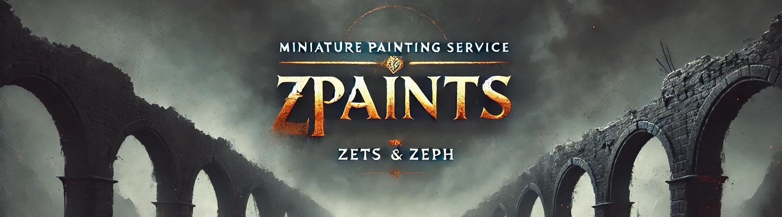Miniature Painting Price List

Standard Miniatures
Model Size / Type | Price
28mm and under | £13
28mm and under – Character | £17.50
32mm | £15
32–40mm – Character | £20
40mm | £18

Larger Miniatures
Model Size / Type | Price
50mm | £20
50mm – Character | £25
60mm | £25
60mm – Character | £30
Models with wings or flying bases may incur additional costs

Cavalry
Model Size / Type | Price
Small Cavalry | £22
Medium–Large Cavalry | £25
Cavalry Character | £35

Transport & Vehicles
Model Size / Type | Price
Small–Medium Transport | £45
Large Transport | £65
Small–Medium Tank | £55
Large Tank | £65
Super Heavy Tank | £100

Walkers & Artillery
Model Size / Type | Price
Small Walkers | £45
Large Walkers | £55
100mm Artillery | £50

Special / Hero Models
Model Size / Type | Price
Primarch (or equivalent) | £120
Demon Primarch (or equivalent) | £180

