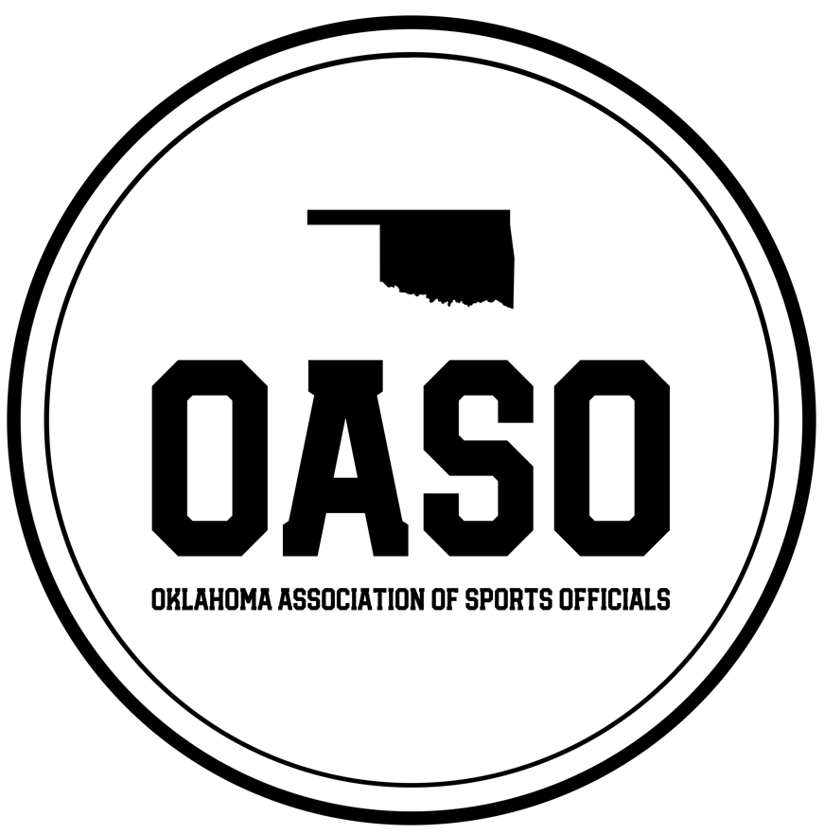
April 1st, 2025

Dear Esteemed Community Supporter,

We hope this letter finds you well. At OASO, we are driven by a profound commitment to nurturing the potential of our youth, recognizing the imperative to pave the way for the next generation. As you are likely aware, the shortage of sports officials in the United States has reached a critical level. In response, the OASO Association, a non-profit 501c3 organization, was established with a clear mission: to recruit, educate, equip, assign, and retain sports officials in Oklahoma and its surrounding areas.

Our aim is simple yet impactful: to enhance the landscape of American intercollegiate and interscholastic sports by cultivating a community of skilled and principled officials. We believe in upholding the highest standards of integrity, fostering fairness, sportsmanship, cooperation, and mutual understanding among all stakeholders in sports, including officials, athletes, coaches, athletic directors, and the media. Our focus, particularly, lies in nurturing these values within youth and secondary education sports officials.

It is with great excitement that we announce our 2nd Annual OASO Charity Golf Tournament, a fundraising endeavor poised to benefit not only the OASO Association but also the commendable causes of Officials vs Cancer and Coaches vs Cancer. With an ambitious target of $12,000, we aspire to provide essential support to new officials by furnishing them with uniforms and alleviating financial burdens such as registration dues and camp fees during their formative years in officiating. This tournament marks the genesis of an annual tradition, one that we envision as a cornerstone of our fundraising efforts, made possible through the boundless generosity of sponsors like you.

As a prominent leader in our community, we extend to you an invitation to join us in championing the future of sports officiating, and thus youth & secondary sports, by becoming a sponsor of this event.

The OASO Charity Golf Tournament is scheduled to take place at the esteemed Battle Creek Golf Course in Broken Arrow, OK, on Friday, July 11th, 2025. Registration and sponsorship opportunities are available now.

Sponsorship Opportunities:
Your sponsorship not only affords you the opportunity to elevate your brand and showcase your company’s offerings to a diverse audience but also serves as a tangible demonstration of your commitment to supporting the development of new officials and the fight against cancer through the Officials vs Cancer & Coaches vs Cancer foundations. We offer a range of sponsorship tiers to suit your philanthropic vision (Donations are tax deductible as we are 501c3 Corporation):

- Hole Sponsorships (18) - $200
  - Recognition certificate
  - Company advertisement on a designated hole
  - Logo on website and sponsor banner
  - Option to reserve the same sponsorship for next year.
- Cart/Beverage Sponsorship (1) - $750
  - Recognition certificate
  - Registration for up to 2 players
  - Company advertisement at the tournament
  - Logo on website and sponsor banner
  - Logo/Name on all beverage carts and/or beverage stations
  - Option to reserve the same sponsorship for next year.
- Player Gift Sponsorships (2) - $1000
  - Recognition certificate
  - Logo on player gift bags
  - Logo on website and sponsor banner
  - Up to 2 players registered in the tournament.
  - Option to reserve the same sponsorship for next year.
- $10,000 Hole In One Sponsor - $1200
  - Recognition certificate
  - Registration for 1 team of 4 players
  - Recognition banner on the $10,000 Hole In One
  - Logo on website and sponsor banner
  - Option to reserve the same sponsorship for next year.
- $50K Shootout Sponsorship (1) - $1200
  - Recognition certificate
  - Registration for 1 team of 4 players
  - Recognition banner on the $10,000 Hole In One
  - Logo on website and sponsor banner
  - Option to reserve the same sponsorship for next year.
- Silver Sponsorships (8) - $1500
  - Recognition certificate
  - Registration for 1 team of 4 players
  - Company advertisement through event marketing and at the tournament
  - Logo on website and sponsor banner
  - Option to reserve the same sponsorship for next year.
- Gold Sponsorships (2) - $3000
  - Recognition plaque/certificate
  - Registration for up to 2 teams of 4 players
  - Company advertisement in event marketing
  - Logo on website and sponsor banner
  - Opportunity to connect with players met at the event.
  - Option to reserve the same sponsorship for next year.
- Platinum Title Sponsorship (1) - $5000
  - Recognition plaque/certificate
  - Registration for up to 12 players (3 teams)
  - Choice of Hole # for teams to tee off.
  - Company advertisement in all event marketing
  - Branding in email communications and social media posts
  - Opportunity to post special offers on the event website.
  - Introduction at the Opening Ceremony
  - Opportunity to insert promotional material in goody bags.
  - Main Logo on website and Sponsor banner
  - Opportunity to speak at the awards ceremony.
  - Option to reserve the same sponsorship for next year.

For additional details about the OASO Charity Golf Tournament, please visit oasocharitygolf.com

To learn more about the OASO non-profit 501 C 3 organization, please visit www.oaso.info

Should you have any inquiries or require further assistance, please do not hesitate to contact us via email at info@oaso.info

In anticipation of your invaluable support, we extend our sincerest gratitude.

Warm Regards,
OASO Officers

