**An Extraordinary Holocaust Memoir By The Son Of Two Survivors & His Search To Understand Who His Parents Were**

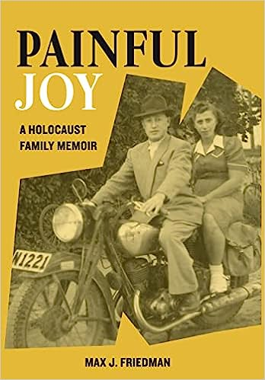

"A sweeping and nuanced story of living with the effects of trauma."

- ***Kirkus Reviews***

A few decades after Max Friedman’s parents died, his grandson asked to know more about Friedman’s parents, a pair of Holocaust survivors who met in a Swedish refugee camp and came to America to start over. Friedman realized he knew very little of who his parents really were, especially about their lives before they met one another. They never spoke of their lives before the Holocaust and very little even about the Holocaust years. He was determined to find out and ended up discovering, after a five-year, multi-nation search, who they really were – and who he had become as a result.

“My parents had a marriage that existed out of death and despair,” says Max Friedman, 72, a resident of Larchmont, New York, and the author of ***Painful Joy: A Holocaust Family Memoir***.

“They were each married when World War II broke out in Poland. Their entire families were murdered, including my mom’s first husband and my father’s first wife, and their two young daughters. My parents found each other after they had lost everything – but all was not love and happiness for them as they struggled to move beyond their lives as victims.”

World War II killed, injured, displaced, and destroyed well over 100 million people, including the lives of six million Jews during the Holocaust. But the suffering for those Holocaust survivors did not end with the war’s conclusion nor did it evade the next generation. Friedman, too, is a survivor, and his book reveals a powerful, poignant, and insightful story.

“This book is about two people who survive the unsurvivable and then, wounded in too many ways, find love, but not redemption, discover hope, but not without suffering greatly, and search for peace, but too often in all the wrong places,” says Friedman. “It seeks to unravel their lives and answer questions: What were their lives like before the Holocaust? Who and what could they have become? How indeed did they survive when so few came out the other side? These universal questions rarely have simple answers, if any at all. *Painful Joy* explores what was and what might have been and in so doing, seeks to restore the humanity of those who lost too much to bear.”

*Painful Joy* represents five years of intensive research in the U.S., Poland, Sweden, Israel and Germany, seeking to unearth the real-life stories of two people in order to discover their roots, recreate their lives and times and uncover both their remarkable journeys and painful secrets. Part memoir, part genealogical mystery and part history, the book is an absorbing, heartwarming and, at times, heartbreaking tale as readers accompany the author on his extraordinary exploration of the complicated relationship between two Holocaust survivors who meet in Sweden after their liberation from the notorious Bergen-Belsen concentration camp, relocated to America, and experience the "painful joy" of a love too often touched by death, pain and anguish.

**Friedman is available to discuss the following:**

* The unending toll of the Holocaust on its survivors.
* How the children raised by Holocaust survivors have become survivors too.
* What he had to do over five years across several countries to find the truth about his parents.
* What he needed to understand about his parents – decades after they died.
* The joyful power of love and the pain that goes with it.
* Why the lessons of the Holocaust need to be taught today.
* How we can help combat the stunning rise of antisemitism in America and elsewhere.
* Historical insights on Jewish life in Eastern Europe before the Second World War.
* A 1950’s immigrant’s story of growing up in Brooklyn’s Coney Island and Brighton Beach.

As Friedman uncovers surprises and insights in the process of researching and writing his book, his parents are transformed from complete strangers to him and to readers, to people who deserve to see their humanity restored. As he peels away layers long hidden in time and memory, his parents come to life – even as they endure so much loss. The author forever has come to see them in a new light -- and so will the reader.

“I explore how the experiences of one’s parents affect one’s own life,” says Friedman. “The long-term psychological effects of survivorship are very real and complex. My parents lived with the scars of their experience in different ways, each struggling with the tension between remembering and forgetting.”

**Media Contact**: Brian Feinblum 914-462-2038 [brianfeinblum@gmail.com](mailto:brianfeinblum@gmail.com)

**Max Friedman**

**Biography**

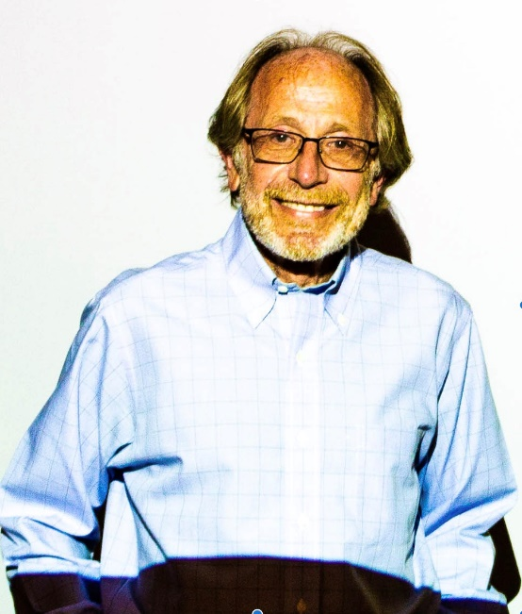

Max Friedman has been telling the stories of others for his whole career — as a journalist, publicist, corporate editorial director, and book ghostwriter. He finally got to share his story by penning a stirring family memoir, ***Painful Joy: A Holocaust Family Memoir*** (Amsterdam Publishers).

Early in his career, he held a variety of positions in the communications field, ranging from newspaper and magazine journalism (with articles featured in the *The New York Times, Chicago Tribune, Washington Post, TV Guide,* and elsewhere) to serving as director of editorial services at Channel 13, New York's public television station as well as the unit publicist for *Bill Moyers* *Journal*.

At Bristol-Myers Squibb for two decades, as vice president of communications, he was primarily responsible for the company's global internal communications efforts. He joined the company in 1983 and his work there included speechwriting, employee publications, development and oversight of the company's internet site, brochures, multimedia presentations, corporate advertising, video production, the company's intranet efforts -- including a webzine - - and its annual report to shareholders.

What he is most proud of are his efforts to demonstrate how everyone has a story to tell -- patients, physicians, scientists -- and that only by telling those stories -- can we appreciate the efforts we all must make to extend and enhance human life. It wasn't until he retired from corporate life and working as an editorial consultant and writer, that he finally realized he had to come face to face with his own story.

He also worked in publishing as an advertising copywriter with Macmillan, in the government (as a spokesman and editor at the U.S. Environmental Protection Agency), in education as a grant proposal writer for the City University of New York and in public relations, as an account executive with Ruder & Finn (now Ruder Finn).

He holds a BA in English and Asian Studies from Columbia College and a Masters in Journalism from the University of California at Berkeley Graduate School of Journalism.

Max and his wife, Jennifer, a reference librarian, live in Larchmont, New York. They raised twin boys and have two grandchildren, one of which lives in China. For more information, please consult: [www.maxfriedman.net](http://www.maxfriedman.net)

**Max J. Friedman**

**Q & A**

***Painful Joy***

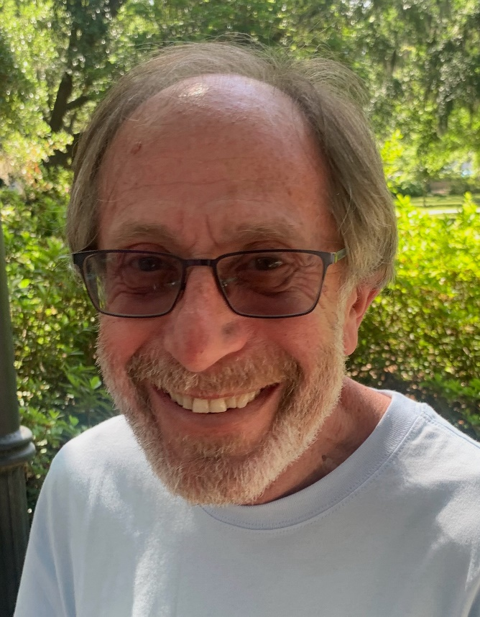

1. **What finally prompted you, years after your parents died, to find out who they were before they turned into World War II Holocaust survivors?** Frankly I was always a bit curious about my family history -- and had actually made a few attempts to find out more. In 1998, shortly after my mother died, we traveled to Sweden to at least try to discover where we lived and how and when my parents met there. Still, I never undertook any serious research after that, perhaps because I was very busy with a full-time job and an all-consuming consulting practice. But in 2014, I turned to ghost writing memoirs for a former CEO and his wife, a philanthropist. At that point, I began to feel some old-fashioned Jewish guilt about never having focused that much attention on my own family.
2. **Max, you penned a powerful book, *Painful Joy: A Holocaust Family Memoir*. What inspired you to write it?** Two catalysts. First in 2016, my sister was contacted by a Jesuit teacher from a Mobile, Alabama, parochial high school. He and several of his colleagues realized their students knew too little about the Holocaust and thought they could inspire them to learn more by uncovering the stories of local residents who had been touched by the Holocaust. My parents had moved to Mobile, where my sister lived, in 1991 when my father was ill and they couldn't live alone any longer. The second catalyst also occurred in 2016, when our then 8-year-old grandson questioned me about survival after I had told him a bit about my parents and their difficult lives. He wanted to know whether he could have inherited the strength of my parents and could be a survivor one day as well. I didn't know what to say and decided to find out.
3. **You spent five years intensively researching their lives through scraps of records in the United States, Sweden, Israel, Poland, and Germany, needing to translate your findings from Swedish, Yiddish, Polish, and German. Were there times when you just felt like giving up?** Actually, once I started, I began to find so many small things out, details like where my parents were actually born -- and who their parents were -- and what kinds of places they had lived in, that I just became more and more curious. The more I learned, the more I wanted to know. At the beginning, it was the excitement of the hunt itself and actually learning bits and pieces. Then it was about finding more and better sources who could explain what I was discovering. Sometimes I felt that I knew too much rather than too little. So, the short answer is no -- I actually was deluged with sources and pieces of information. I needed guidance to discover which paths were the most important to follow and what some of my discoveries meant.
4. **So, what did you find out?** That's a very big question and we don't have five years for me to answer it. Basically, I discovered that both my parents had complex lives before the Holocaust -- that they were poor, came from large families where many children did not survive into adulthood, and faced challenges very early in their own lives. My father's father died suddenly when my father was just 4, and he had to become the family breadwinner when he was 12. My mother and her family, also poor, lived on the streets and refugee camps of Prague for about five years during World War I when she was also about 4 or 5, an experience that probably was instrumental in forming her world view, and that probably gave her some early training in surviving. And that was just about the first years of their lives.
5. **In the process of discovering who your parents really were, did you revise in your mind, how they raised you?** **Did it provide more context for understanding how they lived after the war?** I suppose the answer is that in those early years my parents experienced the challenges of survival at a very basic level. And they brought their fears into their new lives in America and to their second family. They were the original helicopter parents, worried beyond measure that harm would come to us -- so they had to protect us from the outside world. What they didn't realize is that how they behaved with each other and reacted to the outside world themselves became models for us that actually caused even greater fears in both my sister and me. They were protecting us from the forces outside of our little apartment and world, but not from what was going on their own traumatic worlds -- which was equally if not much scarier.
6. **Did you, in effect, discover who you were as well?** I wouldn't go that far. I would say that I have continued to consider how their lives and psyches affected me and my sister and continue to gain some possible insights. For example, and most especially, my persistent need to persevere no matter what -- to rarely give up -- is something I attribute to them -- and frankly, as I get older, it seems to be even more evident. Also my relatively short fuse when it comes to getting stressed out and not being able to come back quickly - essentially my fight and flight response -- seems to be inefficient. It takes too long to regain my composure and too little time to lose it again.
7. **Each of your parents were married to other people. Your father had two young girls at the start of World War II. Both of your parents would lose their spouses, and nearly all of their family members, including your dad’s daughters. Is it a miracle that they found each other in a Swedish refugee camp after the war, falling in love, and raising a new family?** Yes it had to be a miracle, because given how different they were from each other and how mismatched they were -- it was not something that I think would have happened in the natural course of a normal life. I think they would have been repelled by their respective personalities if those were regular times and if they were not desperate to start again, to find love again. Of course, my mother had her own story for how they met -- which turned out not to be true, as so many of her stories were. She said they were in a hospital and she had seen that there was a Friedman in the hospital and she went to see if that was her first husband, who was also named Friedman. It wasn't, so instead they decided perhaps, that fate brought them together.
8. **They got married and had two children, you and your sister. All of you relocated to the United States in the early 1950s. What was it like to start over as immigrants in the America?** I was only two at the time, so I'm not sure I can answer that with any insight. I can tell you that we were desperately poor -- so much so that I remember vividly how we had to hide in a closet when the landlord came for the rent, because we didn't have the money to pay. There were the normal things -- my parents leaving us alone to go to night school to learn what they needed to become citizens. And my father worked six days a week as a warehouse clerk so we would have enough food to eat. We lived in a tiny apartment in a crappy area of Coney Island. I shared the living room with my parents on two separate sofa beds and my sister, the girl, got the bedroom.
9. **You said you discovered that a lot of what your parents told you about their pasts were inaccurate, re-imagined fragments of their realities. Why did they lie or not recollect correctly?** Who knows for certain. As for my father, I think he felt great shame and guilt about surviving when his wife and two children were murdered, so he made up a story that at least had him hiding out with them for a time. The fact is, he was already in a concentration camp when they were taken to Auschwitz. My mother always lived a fantasy life -- and her aim was, in a sense, to look back and say that everything was better then that it was now, with our own family. That was not true -- nothing was better then -- except for her reimagining of the past. She never grew up and never accepted what was, but instead imagined what she wanted her life to be. That was one way they each survived.
10. **Your dad almost never talked about the Holocaust while your mom told stories often. What impact did it have on you, to know you are the son of two survivors of something so unimaginable, and atrocious?** Did you feel other kids your age understood the environment you were being raised under? The only people who could begin to understand our lives were people and kids who were living with people who had these unique -- in terms of being able to survive, while everyone around them were killed -- experiences. I knew many kids who had crappy lives -- but it was usually based on a father who drank too much, or just being poor, or the like. But they were not as afraid of the world as I think we were -- and our parents were. Honestly, they seemed to be just the opposite. We did know one family where the mother and father were survivors, and who had a daughter. I actually found her recently and discovered that her life was even worse than ours was. I never imagined that was even possible.
11. **Tell us more about your parents and what your childhood was like as a second -generation survivor?** **What made your lives different?** First, their nightmares were our constant companions, and we had to wake our parents up from their terrors fairly regularly. We had become child parents. Second, we came to realize that we couldn’t really count on them to give us a normal life, not only the Father Knows Best or Ozzie and Harriet kind of normal we saw on television -- but really normal like we saw in other kids. We early on knew that they had been in concentration camps and were told by our mother what that was like. So, we realized that they had suffered and so we had to keep them away from anything to do with the camps or with wars that would be portrayed on television. Our job was to protect them from the world -- and they thought that was their job.
12. **You said you and your sister spent your youth trying to make sure your parents never watched any documentaries, films, or TV shows depicting the Holocaust. Why?** **Then you all went to see *Schindler’s List* in 1994. What was that moment like?** As I explained, our parents lived on the edge of being stressed out about the tiniest things. Anything could set them off and result in a fight or screaming and yelling. Or in fact, crying. So we had to protect them from the world and themselves. Or try to. As for *Schindler's List*, we didn't go with them, of course. They spent their last years in Mobile, Alabama, near my sister -- so I saw *Schindler's List* only with my wife and boys. I had stayed away from all that -- and reluctantly agreed to go to the movies. It opened my eyes, because there on the big screen were the people my mother had talked about so much -- Mengele, Goeth and the places she had been imprisoned in, the Krakow Ghetto, Plaszow and Auschwitz. Suddenly her story was real and not imagined -- at least at that level.
13. **Is there a lesson to be learned from Sam and Freida’s story?** There are so many lessons I'm not sure I could begin to enumerate them all. Their story demonstrates what hate can do when we dehumanize individuals or an entire people. Their story tells us that to survive, we sometimes have to reimagine our lives, forget things that are most painful and sometimes create new and even happier or at least not so devastating memories. It tells us that to have a chance to survive the unimaginable, one must live only one moment at a time, that there is no past, or future. It tells us that each moment is more precious than we can ever believe and despite the worst of times, there is hope. It tells us that we need to be more empathetic for people like my parents, into whose shoes we can never imagine walking, while realizing that they did. They need to be admired.
14. **As we approach the 84th anniversary of the onset of the Second World War and the Holocaust, what must we always understand and remember about that most cruel period in modern history?** We must realize that it can happen again, and it has happened again and again -- if not on quite the same deliberate and massively planned and executed scale. We must understand that human beings are capable of extraordinary and deliberate cruelty as well as being able to survive in that hell. I think human beings, they say, are actually incapable of remembering the actual feeling of pain. They can only they recall that they experienced it. But because we can't remember what it felt like, we are likely to inflict it on others, or to be the victims of others again and again. Yet, despite it all, love is still possible -- if briefly or only periodically. What changes is the nature of that love. I think that's why I called my book Painful Joy -- because love that is touched by death can never be the same kind of love as most of us experience ever again.
15. **There has been an ugly rise in antisemitic acts committed in the United States and abroad. Why do you think this is happening?** We are not teaching our children effectively enough, if at all, about just how horrible the Holocaust was -- and how when one starts going down the road of hate of groups of people -- for whatever reason, they no longer become people -- just objects of hate. When that happens, the worst is possible. That is as true for racism as antisemitism and it is becoming even as true in politics and in gender identity. We don't remember the lessons of the past -- or the extreme suffering that one human can inflict on another. We are in a world of me instead of us. It gives me more than pause, it makes me fear for the future.

**Testimonials & Praise**

“Max opens a door for us to enter a shared world; a world touched by his family's pain, longing, love, sorrow and hope. His gentle, respectful and caring writing style will leave a mark upon you after you close the book for the last time - inviting you to open the door again.”

**-- Rabbi Steven Silberman, Congregation Ahavas Chesed, Mobile, AL**

“A narrative unique to second-generation Holocaust survivors' experiences that searches to understand 'beyond the ghosts that haunted them.'”

**-- John Heffernan, Director, Genocide Prevention Initiative, United States Holocaust Memorial Museum and President, Foundation for Systemic Change**

“Factual content, precise descriptions of environs, explanations of customs and mores ... as well as personal musings are beautifully woven within the memoir. Friedman's command of the English language is superb, and the reader will be immersed in the narrative.”

**-- Millie Jasper, Executive Director, Holocaust & Human Rights Education Center, White Plains, NY**

“*Painful Joy* is like no other Holocaust story I have read. It is mostly biography ... But it is also memoir ... and autobiography ... all told against the backdrop of a once vibrant Jewish life in Poland, the Holocaust, and immigrant life in the United States.”

**-- Gerald Darring, Co-Director, Gulf Coast Center for Holocaust and Human Rights Education, Mobile, AL**

“It explores how this family learned to overcome pain, demons, death and mental illness while finding justice in celebrating life. This story offers a stark reminder of why it's important to keep the memories of those lost in the Holocaust alive and powerfully shows that in order to move forward, our darkest moments in history can only be met with love, hope, faith and family.”

**-- Lisa Sherman-Cohen is Communications/PR Director, World Jewish Restitution Organization (WJRO)**

“This powerful and poignant book tells of two interweaving journeys. As the son of two Holocaust survivors, Max sought to discover the story of his parents' lives before, during and after the Holocaust and thus his own story. Meticulously researched over several years, he makes discoveries that help give meaning to both their and his experiences. Given what we now know about the effects of trauma and PTSD, attachment theory, epigenetics and the physiological effects of trauma on the next generation, Max re-explores his relationships with his parents from childhood through adulthood. This makes for a fascinating and compelling journey and a testimony to the complexity, resilience and ultimately love that can prevail despite the most devastating and tragic of circumstances.”

**--Ronald Garson, M.D., Psychiatrist, Washington, DC**

**Sample Of 5-Star Amazon Book Reviews**

**Joe Levine**: “As the last Holocaust survivors die off, Friedman’s exquisite book helps ensure that one of humankind’s most savage chapters will continue to reverberate – not through the brutal images of life in the camps, but by revealing, with great compassion and nuance, how a couple’s experiences play out in the lives of their children, and grandchildren, and will continue to play out for generations to come. At a moment when history, once again, seems to be repeating itself, Painful Joy could not be more timely or poignant.”

**MP**: “*Painful Joy* is a powerful exploration of the Holocaust's effects on one family: Holocaust survivors and their children. The effects on the 2nd generation (including the author) are illuminating and unexpected, not an aspect that I had considered in any depth previously. The author explores these issues with clarity, meticulous in-depth scholarship and sharp insight. It's a well written, readable book, highly recommended to anyone wishing to truly understand these issues and gain a wider view of the Holocaust's profound effects at the personal level.”

**[Deborah S.](https://www.amazon.com/gp/profile/amzn1.account.AEPRLZ6RK32OWV4ZVGAQNJJ4V4LA/ref=cm_cr_arp_d_gw_btm?ie=UTF8)**[:](https://www.amazon.com/gp/profile/amzn1.account.AEPRLZ6RK32OWV4ZVGAQNJJ4V4LA/ref=cm_cr_arp_d_gw_btm?ie=UTF8) “Max's extremely well researched and heartfelt memoir of his parents' journey of pain and joy envelopes his life, along with his entire family, with compassion and understanding.  
As a reader, it does the same, and I am proud to be among those who have met them.  
I felt love for this story.”

**[Sara G.](https://www.amazon.com/gp/profile/amzn1.account.AHZFJRQNQHXRWHNAEUAR42O6GZQA/ref=cm_cr_arp_d_gw_btm?ie=UTF8)**[:](https://www.amazon.com/gp/profile/amzn1.account.AHZFJRQNQHXRWHNAEUAR42O6GZQA/ref=cm_cr_arp_d_gw_btm?ie=UTF8) “This is a book that makes history and current events personal. I was surprised to encounter stories very like those told by my own grandfather. The effort to research and write this book was extraordinary and the poem that names it is perfect.”

**[Mark C Franek](https://www.amazon.com/gp/profile/amzn1.account.AGODLVGELLDD2HWDRWL5LJGOOBHA/ref=cm_cr_arp_d_gw_btm?ie=UTF8)**[: “](https://www.amazon.com/gp/profile/amzn1.account.AGODLVGELLDD2HWDRWL5LJGOOBHA/ref=cm_cr_arp_d_gw_btm?ie=UTF8)Mr. Friedman’s memoir reminds all of us that we are vessels of hope. And while we may carry heavy loads, unique to each of us, we bear the weight, and control our destinies.”

**[JB:](https://www.amazon.com/gp/profile/amzn1.account.AF7TP5RK7F6TAVHMNEV4RLVNIFLA/ref=cm_cr_arp_d_gw_btm?ie=UTF8)**“An engrossing memoir, borne from the detective work of an author son trying to piece together the improbable lives and hardships faced by his parents, Frieda and Sam Friedman, Painful Joy combines the painstaking research derived from records and testimony, scoured from Europe to Israel to the USA, from before, during, and after the Holocaust, with the experiences and memories of the author and his sister to recreate for Sam and Frieda's descendants (and for any other curious reader) a recording of their lives, the commemoration made all the more poignant by its imperfect nature, imperfect due to the records and experiences that could not be recovered and could only be surmised. This book will appeal to those interested about how the effects of a family's past trauma can affect future generation. Highly recommended.”

**[Geoffrey A. Bass:](https://www.amazon.com/gp/profile/amzn1.account.AFXMWBNYNJXKJFSSTBKVU5C4FYEA/ref=cm_cr_arp_d_gw_btm?ie=UTF8)**“A haunting, beautifully written book. .. Max Friedman has crafted finely wrought stones with deep feeling and empathy for his parents' suffering and triumph - he and his sister, and their children and grandchildren, like other descendants of Holocaust survivors, are a triumph over their suffering, of joy over pain.”

**Kathryn R. Bloom**: “A sensitive and compelling family study.”

**Selected Excerpts**

**A Love Story**

"Five years ago, I took it upon myself to go back and revisit what had been, to consider who they were and ultimately, through this memoir and considerable research, to paint a picture of what they were like and what the times in which they lived meant for them. I hoped thereby to help restore their humanity in some small way. Of all the things I imagined this memoir would be, I never imagined it as a love story."

**Hope & Possibility**

"By discovering the love that emerged in all its complicated forms, we can realize how measures of kindness, when shared - even in the face of great cruelty or even greater despair - can benefit us all. On too many days, Sam and Frieda were challenged by life and had to choose a path to take and then deal with the consequences of their choices. I hope readers will come to realize that no path is always the right one. The important thing is to choose and then move ahead, not looking back in anger or recrimination, but instead looking forward with hope and possibility."

**Demons Chased His Parents**

"Throughout this memoir, one central fact must be recognized: When I was growing up, I knew virtually nothing about Sam and Frieda, beyond the fact that as they were Holocaust survivors, my sister and I too often saw them as tragically damaged human beings. They also seemed very different from pretty much everyone else I encountered as a child, a teenager, an adolescent and even as an adult. Living with them was sometimes a challenge. Discovering or surmising just who they were before tragedies befell them has been a considerable challenge as well. I’ve given it my best, always keeping in mind not only the sadness I saw but also the love that often came with it. For too much of their lives, my parents seemed to be eternally wrestling with and reliving past tragedies. My mother especially bemoaned missed opportunities. She often looked for others to blame for the totality of her life. My father, however, simply sought to move on. Sadly, her demons would add to his own tragic experiences."

**Surviving Parents Who Were Survivors**

"We already knew one thing: as I have indicated, our parents, for better or worse, left their psychic fingerprints all over us and possibly some of their DNA imprints as well. In ways big and small, it all translated into my sister and me taking on many of the marks of survivorship, some of which we then passed on to our children and even our grandchildren. After spending four years developing memoirs for other people, I realized that I had let my own parents down. For too long I had failed to do what those teachers in Mobile, in their generosity of spirit, had attempted to do: to tell my parents' stories. They had gone online and collected information about my parents that I had never seen before and frankly had never even imagined trying to uncover. I felt embarrassed and ashamed."

**Enduring Against The Odds**

"Good advice, but as you have seen in this memoir, my parents never had the chance to travel the straight and narrow. Their lives were too often defined by the unexpected, by others, by circumstances beyond their control and sometimes beyond anyone's imagination. They endured twists and turns, some unimaginable, some even descending through the circles of Hell. Yet they came out the other side."

**Discovering Who He Is**

"I’ve spent the last many pages and the past five years trying to figure out who these people were before they came to be the way we came to know them, each in our own way. For those who are meeting them for the first time in these pages, you probably have the picture by now. I hope I have done my parents justice, opened up some eyes and fresh perspectives and touched some hearts with their story, their struggles and their triumphs. Sam and Frieda's story is both universal and very personal."

**Fascinating & Horrifying**

"In many respects, writing this memoir has been a joy because I learned so much. It was also an emotional roller coaster, in part because I wanted to learn more but couldn't. What I did learn was alternately fascinating and horrifying. My nightmares began from the moment I started, and night sweats followed, not every night, but still on too many. But once again, even that experience provided a window into what it might have been like for my parents when they couldn't shut their thoughts out either. Their thoughts were much more real and constant than mine."

**Honor Thy Parents**

"The aim of this memoir is to honor their memory and restore their humanity by reconstructing their story as best I could. Having started with virtually nothing, I have journeyed a long distance to present two lives and their times. I hope I have succeeded in that, at least to some extent."