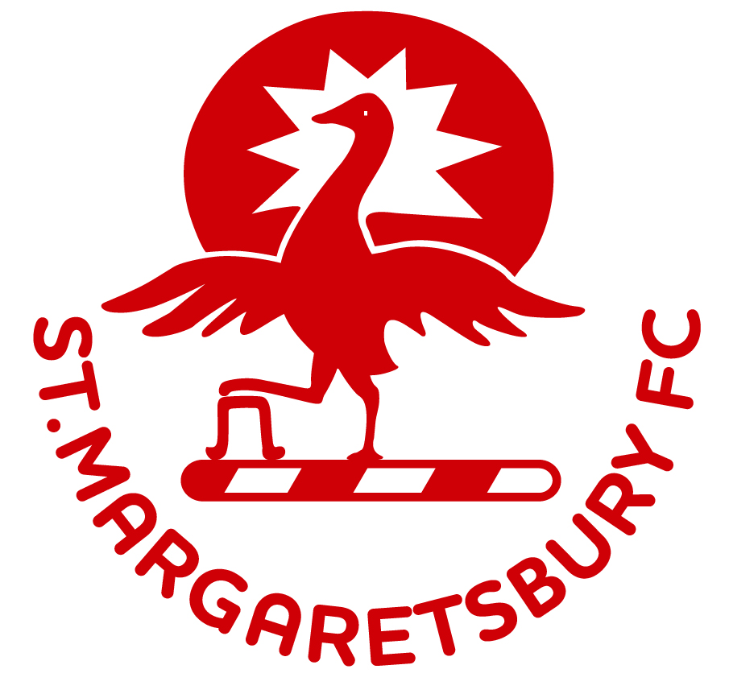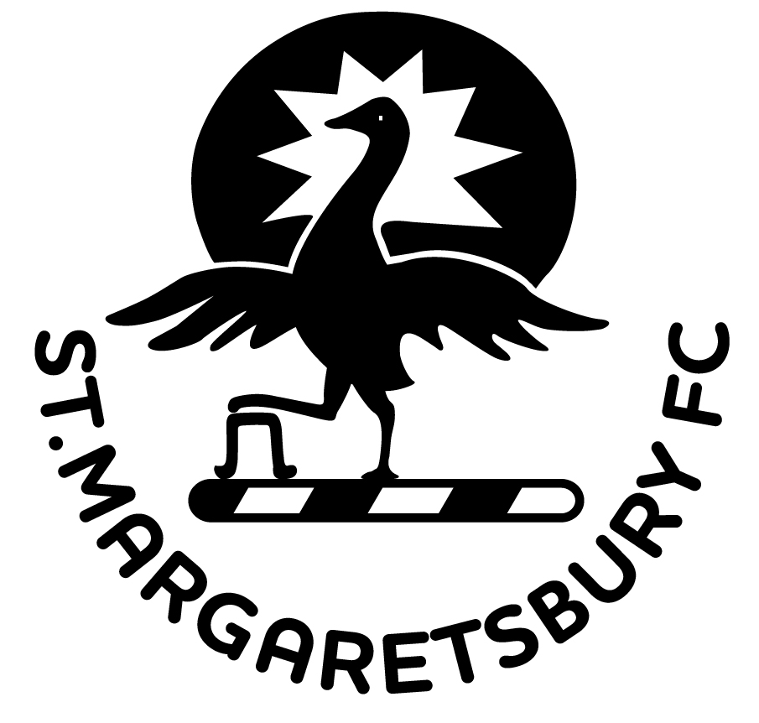
Brief and Complete Club history:

Brief History of St Margaretsbury FC
Founded in 1894 as Stanstead Abbotts FC, with their home at Mill Field, Cappell Lane in Stanstead Abbotts. Playing in the Herts County League, East Herts and Hertford & District Leagues they won the local Graphic Cup during the 1920’s and 1930’s. After 1945 the Club played in the Waltham & District League, re-joining the Herts County League in season 1947/48. In their first season back in the Herts County League the Club won Division two, gaining promotion and winning the Aubrey (League) Cup. In 1962 the Club moved to their present location, St Margaretsbury Recreation Ground, one of the conditions being they change their name to St Margaretsbury FC. The Club’s next honour was in 1972 when again they won the Aubrey Cup. At the end of the 1987/88 season the 1st XI were briefly relegated to Division One, but returned to the Premier Division at the start of 1991/92. After 44 years in the Herts Senior County League the 1st XI became members of the London Spartan League, Premier Division for the start of season 1992/93, finishing in a very creditable 6th place. That season also saw the Club gained its first County Cup by winning the Herts Senior Centenary Trophy, defeating Sawbridgeworth Town 2-1, at Ware FC. By 1993/94 our league position had progressed to finish 3rd and while celebrating our 100 years centenary we came 2nd in 1994/95. In 1995/96 the Club won the Premier Division Championship and the Reserves and the 3rd X1 made it a treble of Championships by winning their respective Divisions in the McMullen’s Hertford and District League. The Roy Bailey Memorial Trophy was won that same season, defeating Ware 2-0 at Enfield FC. In 1997/98 the 1st XI won the Herts Charity Shield, defeating London Colney on penalties. In 1998/99 the 1st XI were accepted into the newly formed Minerva Footballs Spartan South Midlands League, Premier Div. Another Milestone in 2000/01 when the Club qualified for entry into the FA Cup. In 2001/02, the Club was awarded the Houghton Regis Cup by the Spartan South Midlands League for achievements in the FA Cup competition. In the same season the Club gained its first Spartan South Midlands League competitive trophy, when they won the Premier Division Cup, beating Potters Bar Town 2-0 in the final. Season 2003/04 had another good run in the F.A.Cup, having negotiated three rounds before going down to Kettering Town 0-2 away. In the same season, the South Midland Floodlit Cup was won with a 3-2 victory against Wooton Blue X and finished 3rd in the league. Season 2004/05 saw changes in management and key players, and although viewed as a building season the club still managed a credible 7th place in the premier league. Season 2005/06 saw a good FA Cup run, with a dramatic 3-2 away win against Ryman Premier League Billericay Town. Bury finishing 12th in the league. Season 2006/07 saw major changes… not unfortunately good changes! This started with new Chairman John Tobin, and a newly appointed Director of Football Steve Dix. Paul Gurney was first team manager, and it was a very tough season, coming close to relegation but finally finishing 15th in the league. Season 2008/09 – a very turbulent season that put a strain on every aspect of our efforts to achieve our true potential. But new First team manager Lee Judges still managed to hit a credible 14th league position and came in as runners up in the Premier Division Cup. Season 2009/10 – the club saw new Chairman Gary Stock take up his position, who along with an almost completely new committee. The majority of our youth teams had been moved and renamed in more than questionable circumstances under the the control of MHRML Chairman Steve Dix. With derisory finances on handover in a recession year, this was without doubt one of the toughest starts to any season. But the team somehow still matched the previous season’s 14th league position and were runners up in the Herts Charity Shield final. Season 2011/12 – Our U18’s SCFYL team performed magnificently, winning their own division and then going on to beat Academy side Boreham Wood U18’s in the 4 team divisional final, to become overall League Champions. Our 1st team finished 18th, whilst the reserves finished 3rd and won the Floodlit Cup. Season 2011/12 – The club’s restructuring and regeneration program was complemented by the successful merger of John Warner Youth FC. The First team finished 12th in the league and were Premier League Cup Finalists, while the Reserves were Finalists in the Floodlit Cup. The Senior Club also achieved Chartered Standard, Season 2012/13 – The First Team had an exceptional season, finishing in 4th position in a very strong league. First Team Manager Lee Judges and Assistant Manager Clive Brooks decided to step down at the end of the season. Season 2014/15 – The first team finished 8th and the Reserves went on to win their South East division. Season 2015/16 – John Barker is appointed to 1st Team Manager, joined by club legend Kaine Lovett appointed to Reserves/U25 Dev Manager. A very tough 1st team season finishing 19th and the Reserves/U25 Dev a well-deserved 4th. Season 2016/17 – Another very tough season for the 1st team finishing 20th. Again, the U25 Dev under Kaine Lovett excel and finish 3rd in their league. Season 2017/18 – We were one of the first clubs nationally to start publishing our match programme online. Season 2018/19 – After 20 consecutive years in the SSML, the 1st team is moved to play in the Essex Senior League. By choice our Reserves/Development team moves to the Herts County League. Manager John Barker stepped down in late Sept to give priority to his family life, and Max Mitchell was appointed 1st team manager, finishing 7th while also reaching the final of the Gordon Brasted Trophy. Unfortunately, fate struck again with 7 games to go, when Max moved to a step 4 club battling relegation. With core players going with him, our season fizzled out. Season 2019/20 – Covid-19 took centre stage! Season 2020/21 - Ray Bartlett deservedly gets his chance as he is appointed First Team manager. Season 2021/22 – After 11 games played, Ray Bartlett stepped down to focus on some health issues and we subsequently appointed Paul Holding to the first team Manager position. 2022/23 the 1st team are relegated to step 6 after 23 years at step 5. 2023/24 – Gavin Wood comes on board as Club Chairman, while Paul Holding and Shane Bambridge are joint managers. 2024/25 – Gavin Wood takes over 1st team management with Terry Gritton and Ryan Jessey as Assistant coaches and Dom Woods as tech coach and kitman. 2025/26 - Now relegated to Step 7 playing in the Herts Senior County League, Mike Sharman and Neil Tilley take up the first team management promotion challenge!

The Complete History of St Margaretsbury FC

The Club was Founded in 1894 as Stanstead Abbotts FC, with their home at Mill Field, Cappell Lane in Stanstead Abbotts. Prior to 1940 they played in the Herts County League, East Herts and Hertford & District Leagues and were winners of the local Graphic Cup during the 1920’s and 1930’s. After 1945 the Club played in the Waltham & District League, re-joining the Herts County League in season 1947/48. In their first season back in the Herts County League the Club won Division two, gaining promotion and also winning the Aubrey (League) Cup.

In 1962 the Club moved to their present location, St Margaretsbury Recreation Ground, one of the conditions being they change their name to St Margaretsbury FC.
The Croft family were the previous owners of the ground and agreed the sale to three parishes, Stanstead Abbotts, Great Amwell and St Margarets, providing that it was used for sporting and recreation purposes. It was also a condition that the ground should be known as St Margaretsbury Recreation Ground. St Margaretsbury Cricket Club has used the ground since 1946 and in 1962 the St Margaretsbury Tennis Club was founded.

The Club’s next honour was in 1972 when again they won the Aubrey Cup. In 1985/86 they entered the FA Vase competition for the first time and although losing out in the 3rd round, they played to a record crowd of almost 400. In the same season the Aubrey Cup Final was also strongly contested with Wingate FC winning 3-1. After a spell of 10 years in the Premier Division the 1st XI were briefly relegated to Division One at the end of the 1987/88 season, but returned to the Premier Division at the start of 1991/92.

After a spell of 44 continuous years in the Herts Senior County League the 1st XI became members of the London Spartan League, Premier Division for the start of season 1992/93, finishing in a very creditable 6th place. The 1st XI also reached the final of the Roy Bailey Memorial Trophy, losing 1-0 to close neighbours Wormley Rovers, at Enfield FC. But that season also saw the Club gain its first County Cup when winning the Herts Senior Centenary Trophy, defeating Sawbridgeworth Town 2-1 at Ware FC.

When the 1st XI team joined the London Spartan League in the 1992/93 season, the Reserves and the 3rd XI also had to leave the Herts Senior County League and so became members of the McMullens Hertford & District League. The Reserves and 3rd XI have achieved considerable success during the past 20 years, winning championships and cup competitions in the Herts Senior County League and McMullens Hertford & District League.

By 1993/94 the 1st XI’s league position had progressed to finish 3rd and they then topped that in 1994/95 by finishing 2nd.

In 1994 the Club celebrated its centenary and published a book covering the Club’s 100 years history.

In 1995/96 the Club celebrated its 4th season in the Spartan League by winning the Premier Division Championship, winning 18 out of 30 games and pipping Hillingdon Borough by 2 points. The Reserves and the 3rd X1 made it a treble of Championships by winning their respective Divisions in the McMullen’s Hertford and District League. The Roy Bailey Memorial Trophy was also won that same season, defeating Ware 2-0 at Enfield FC.

Floodlights were installed in October 1997 and in 1997/98 season the 1st XI won the Herts Charity Shield for the first time, defeating London Colney on penalties following a 0-0 draw. In 1998/99 the 1st XI were accepted into the newly formed Minerva Footballs Spartan South Midlands League, Premier Division, having finished 9th in the Premier Division South the previous season.

The ”Sunday Section” was revived in 1986 with success at both youth and senior levels with the Herts Sunday Junior Cup being won in 1994 and again in 1995. Since then they have won a number of league and cup competitions within the Mercury Waltham & District League (seniors) and the Mid-Herts Rural Minors League. There are currently one mens and three youth teams competing in Sunday Football.

In season 1997/98 the Reserves were accepted into the Essex & Herts Border Combination. In the 1999/2000 season they won promotion to the Premier Division also winning the Combination Cup, beating Harlow Town 2-0.
Since 1998/99 the Club has entered an Under 18 team in the Southern Counties Midweek Floodlight Youth League. In season 2003/04 our youth team (U18) entered the Youth FA Cup for the first time.

Another Milestone was reached in 2000/01 when the Club qualified for entry into the FA Cup and has earned the reputation of giant killers having disposed of more senior opposition in successive competitions. In 2001/02, the Club was awarded the Houghton Regis Cup by the Spartan South Midlands League for achievements in the FA Cup competition, after victories were recorded against Gorleston Town, Hertford Town and Wembley before succumbing to Stafford Rangers. In the same season the Club gained its first Spartan South Midlands League competitive trophy, when they won the Premier Division Cup, beating Potters Bar Town 2-0 in the final.

The 2001/02 season also saw the withdrawal of the Reserves from the Essex & Herts Border Combination due to the long midweek journeys involved and the team reverted to competing in the McMullens Hertford & District League for the 2002/03 season. In the season 2003/04 there was another good run in the FA Cup, having negotiated three rounds before going down to Kettering Town 0-2 away. In the same season, the South Midland Floodlit Cup was won with 3-2 victory against Wooton Blue X and finished 3rd in the league. In 2003/04 the Reserves joined the newly formed World Class Homes Senior Reserves League (Herts County League), which unfortunately disbanded in 2004/05 due to lack of support. The Reserves then joined the Spartan South Midlands League Reserve Division One.

Over recent years there has been major redevelopment of the Recreation Ground with the conversion of the training area to a full-size pitch suitable for FA Cup competition. This resulted in a complement of two senior pitches and one junior. In 2002, grants from the Football Stadia Improvement Fund and the Local Authority enabled various improvements such as major drainage works on the main playing surface, an extension to the covered seating area, fencing for the enclosure of the playing and spectator areas and the installation of a PA System. Added security was also provided with the installation of CCTV equipment.

St Margaretsbury Girls and Womens teams existed for a number of years and in the 2003/04 season they amalgamated to start playing in the Eastern Region Women’s League. Unfortunately, this folded in season 2004/05 following difficulty in recruiting players.

Season 2004/05 saw major changes in management and key players, and although viewed as a building season the club still managed a credible 7th place in the premier league.
The robustness and foundation of the club continue to build in season 2005/06 with the introduction of additional youth teams, ranging from under 12’s up to under 18’s into the senior team. A good FA Cup run, with a dramatic 3-2 away win against Ryman Premier League Billericay Town, only to be knocked out 1-0 by the less impressive Folkestone Invicta. A tough league season followed with the Bury finishing 12th.
Season 2006/07 saw major changes… not unfortunately good changes! This started with new Chairman John Tobin, and a newly appointed Director of Football Steve Dix! Paul Gurney was first team manager, and it was a very tough season, coming close to relegation but finally finishing 15th in the league.
Season 2008/09 – a very turbulent season in terms of internal club issues that put a strain on every aspect of our efforts to achieve our true potential. Despite these First team manager Lee Judges still managed to hit a credible 14th league position and came in as runners up in the Premier Division Cup.
Season 2009/10 – the club saw new Chairman Gary Stock take up his position, who along with an almost completely new committee, having had to overcome issues at the club that started with the previous Chairman & Director of Football being banned for gross misconduct. With the majority of our youth teams being moved away from the club by the Director of Football (who was Chairman of MHRML at the time), derisory finances on handover in a recession year, this was without doubt one of the toughest starts to any season. But the team somehow still matched last season’s 14th league position and were runners up in the Herts Charity Shield final.

Season 2010/11 – the club has now started to put some much-needed structure, organisation and processes into place, along with ground work and improved facilities like the pitch-side snack bar new last season. Our U18’s SCFYL team performed magnificently, winning their own division and then going on to beat the much-admired Academy side Boreham Wood U18’s in the 4 team divisional final, to become overall League Champions. Our First team finished 18th in the league, whilst the reserves finished 3rd and won the Floodlit Cup.
Season 2011/12 – The club’s restructuring and regeneration program was complemented by the merger of John Warner Youth FC. This has reintroduced the critical mass of youth back into the club. The First team finished 12th in the league and were Premier League Cup Finalists, while the Reserves were Finalists in the Floodlit Cup. The Senior Club also achieved Chartered Standard,
Season 2012/13 – The First Team had an exceptional season, that challenged for the league title until around January, when their form dipped, but still finished in 4th position in a very strong season where the eventual league champions Dunstable Town did not lose one game. First Team Manager Lee Judges, and Assistant Manager Clive Brooks announced they were to step down at the end of the season, Lee having spent 6 seasons and Clive 3 seasons at the Club.
Season 2013/14 – The club announced the appointment of Gavin Kelsey to First Team Manager, and with Gavin stepping up from the Reserves Manager, he subsequently appointed Paul Tomkins to the position of Reserves Manager. Both senior sides had another very strong season, with the first team again finishing 4th in the league and the Reserves winning their division to become League Champions. The Club’s youth section continues to apply the ‘Streaming’ method as it’s underlying youth strategy.
Season 2014/15 – New appointments come into place as we re-introduce an U18 Academy side to play in the SCYFL, managed by Eddie McLoughlin. Alex Ward was appointed to replace Paul Tomkins. The first team finished 8th and the Reserves went on to win their South East division.
Season 2015/16 – Our 1st team Manager leaves to join our neighbours Hoddesdon Town, with pretty much all three senior squads following him, just leaving coach John Barker and 6 players. John Barker is appointed 1st Team Manager and has a real baptism of fire and somehow manages to pull three senior teams together almost from scratch to allow us to compete. He’s joined by club legend Kaine Lovett who is appointed to Reserves Manager. With a new management team around them, they both deliver – the 1st team finishing 19th to avoid relegation, and the Reserves a well-deserved 4th.
Season 2016/17 – Another very tough season for the 1st team finishing 20th. Again, the U25 Dev under Kaine Lovett excel and finish 3rd in their league.
Season 2017/18 – We were one of the first clubs nationally to start publishing our match programme online.
Season 2018/19 – After 20 consecutive years in the SSML, our 1st team has been moved to play in the Essex Senior League. By choice our Reserves/Development team moves to the Herts County League. Manager John Barker stepped down in late Sept to give priority to his family life, and Max Mitchell was appointed 1st team manager. Max brought a number of players on board and we climbed the table to eventually finish 7th while also reaching the final of the Gordon Brasted Trophy. Unfortunately, fate struck again with 7 games to go, when Max moved to a step 4 club battling relegation. With core players going with him, our season fizzled out, albeit a young a new squad of players narrowly lost the GB final 1 nil, but suffered a humiliating 10 – 0 defeat in the last league game.
Season 2019/20 – ended as no other with Covid-19 taking centre stage! Season 2020/21 - Ray Bartlett deservedly gets his chance as he is appointed First Team manager, but again Covid curtails the season. Season 2021/22 – After 11 games played, Ray Bartlett stepped down to focus on some health issues and we subsequently appointed Paul Holding to the first team Manager position.
2022/23 the 1st team are relegated to step 6 after 23 years at step 5. Paul Holding and Marcè Collington are appointed as joint Managers. Tony Wild is appointed to the Club Chairman role. 2023/24 – Gavin Wood comes on board as Club Chairman, while Paul Holding and Shane Bambridge are joint managers. 2024/25 – Gavin Wood takes over 1st team management with Terry Gritton and Ryan Jessey as Assistant coaches and Dom Woods as tech coach and kitman. 2025/26 - Now relegated to Step 7 playing in the Herts Senior County League, Mike Sharman and Neil Tilley take up the first team management promotion challenge!

St Margaretsbury FC Honours

Saturday Section
1919/20 East Herts League Div 2 Champions
1920/21 East Herts League Div 1 Champions
1935/36 Rolleston Charity Cup Winners
Graphic Cup Winners
1946/47 Waltham & District League Champions
1948/49 Aubrey Cup (HCL) Winners
Herts County League Div 2 Champions
1951/52 Hertford & District League Div 1 Winners (Res)
1971/72 Aubrey Cup (HCL) Winners
1978/79 Herts County League Div 3 Champions (Res)
1982/83 Herts County League Div 1 Champions (Res)
1984/85 Herts County League Reserve Cup Winners
1986/87 Herts County League Div 1 Champions (Res)
Herts County League Reserve Cup Winners
1987/88 Herts County League Reserve Cup Winners
1992/93 Herts Senior Centenary Trophy Winners
1994/95 McMullens League Div 3 Cup Winners (A XI)
1995/96 Spartan League Premier Division Champions
Roy Bailey Memorial Trophy Winners
McMullens Lge Premier Division Champions (Res)
McMullens League Div 3 Champions (A XI)
1997/98 Herts Charity Shield Winners
1999/2000 Essex & Herts Border Combination Cup Winners
2001/02 Minerva Spartan South Midlands League Premier
Division Cup Winners
2003/04 Senior Floodlit Cup Winners
2009/10 Challenge Trophy winners (Res)
2010/11 Divisional League Champions (U18 SCFYL) Floodlit Cup winners (Res)
2011/12 Floodlit Cup finalists (Res)
2013/14 Charity Shield Finalists
League Champions (Res)
2014/15 Challenge Trophy Finalists
South & East Divisional Champions (Res)
2018/19 Gordon Brasted Trophy
Runners up.

Sunday Section
1966/67 Waltham & District League Prem Div Champions
1983/84 Rural Friendly League U11’s Champions
Rural Friendly League U11’s Cup Winners
1989/90 Mid Herts Rural League U18’s Champions
1990/91 Mid Herts Rural League U17’s Champions
1991/92 Cheshunt Youth League U18’s Cup Winners
1992/93 Mercury League Div 3 Champions
Mercury League Div 5 Champions (Res)
1993/94 Herts Junior Cup Winners (Res)
Mercury League Reserve Cup Winners
1994/95 Mercury League Div 1 Champions
Mercury League Div 3 Champions (Res)
Herts Junior Cup Winners (Res)
1997/98 Mercury League Cup Winners (Res)

Under 12’s
2005/06 BSMHRML Premier League Winners
Under 14’s
2005/06 Cheshunt League Cup Winners
Under 15’s
2004/05 MHRML Premier League Winners
MHRML League Cup Winners
Under 16’s
2003/04 Mid Herts Rural minors league
Division 1 Winners
2005/06 BSMHRML Premier League Winners
2012/13 U16 Rovers - MHRML Div 3 Winners
Under 17’s
2000/01 Mid Herts Rural Minors league
Premier Division Winners
Under 18’s
2007/08 Colwyn Cup Winners
2010/11 Southern Counties Floodlit Youth league
Divisional Winners & League play-off Champions

Womens Section
2021/22 Bedfordshire and Hertfordshire Womens League
Div 3 League Champions

