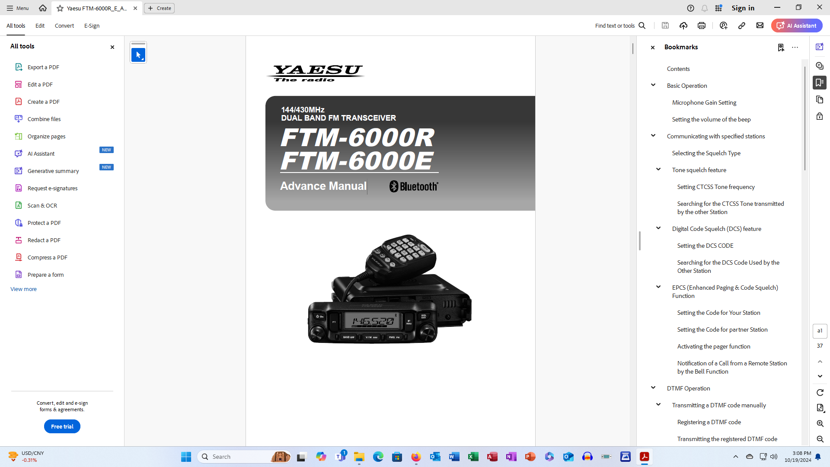

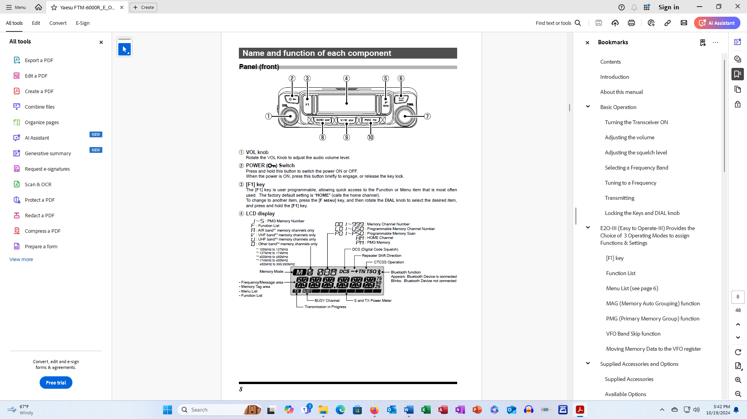
Front Panel

Front Panel
How to Turn On/Off
Press and hold the POWER (Lock) button (#2) (Upper left-hand corner) to turn the radio On or Off

Volume Control
Turn the Volume Dial (#1) (Lower left-hand corner) to adjust the volume.

How to Select a Channel
If the M icon is not displayed, press the V/M button (#9). You can select a channel by either:
- Enter the 3-character channel number using the number pad on the microphone, using a leading zero (0) as necessary, or
- Rotate the Dial knob (#7).

Squelch Control
Press the [SQL Back] button (#6) (Upper right-hand corner), then rotate the Dial knob (#7) to adjust to a level where the background noise is muted. After adjustment, press the [SQL Back] button again or do nothing for 2 seconds, the SQL Meter will return to the Normal screen.

How to connect headphones
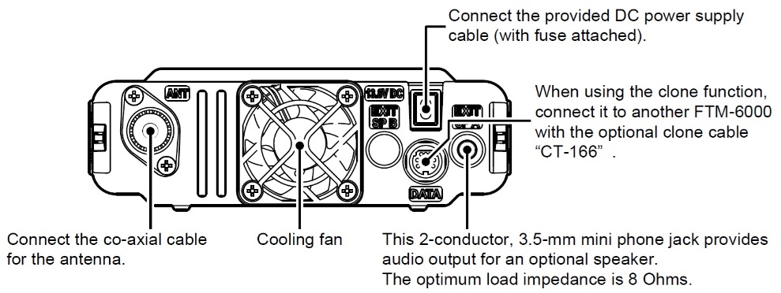
The input jack for headphones is on the far right-hand side of the back panel of the Yaesu FTM-6000R as shown. Look for an extension cable which may already be installed.
How to Turn On/Off
Press and hold the POWER (Lock) button (#2) (Upper left-hand corner) to turn the radio On or Off

Volume Control
Turn the Volume Dial (#1) (Lower left-hand corner) to adjust the volume.

How to Select a Channel
If the M icon is not displayed, press the V/M button (#9). You can select a channel by either:
- Enter the 3-character channel number using the number pad on the microphone, using a leading zero (0) as necessary, or
- Rotate the Dial knob (#7).

Squelch Control
Press the [SQL Back] button (#6) (Upper right-hand corner), then rotate the Dial knob (#7) to adjust to a level where the background noise is muted. After adjustment, press the [SQL Back] button again or do nothing for 2 seconds, the SQL Meter will return to the Normal screen.

How to connect headphones
The input jack for headphones is on the far right-hand side of the back panel of the Yaesu FTM-6000R as shown. Look for an extension cable which may already be installed.

