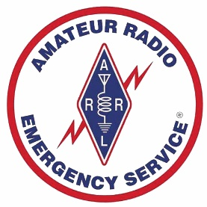 | SPOKANE COUNTY ARES  Membership Application | 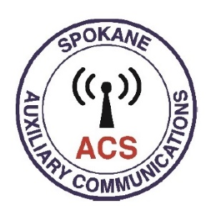

Call: ____________________________  Last Name: ________________________________  First Name: ________________________________  Middle Initial: ___ ARRL member (Y/N): _____  Tech: ___ General: ___ Amateur Extra: ____  Address: __________________________________  City: ______________________________________  State: ______ ZipCode: __________  Email: ____________________________________  Home Phone: _____________________________  Work Phone: ______________________________  Cell Phone: _______________________________  Carrier: ___________________________________  Emergency Contact: _______________________  EMC Phone: _______________________________  Availability (Y/N):  Day: ____ Night: ______ Weekends: _____  Please list any constraints that might limit your participation in any ARES activities:  ___________________________________________  ___________________________________________ |  | Station Capabilities (Y/N): HF: ___ VHF: ___ UHF: ___  Emergency Power at home (Y/N): ____  Portable Power (Y/N): _____  Proficient with: CW: ______ WPM  Winlink (Y/N): _____  Other digital modes (List): ______________________  ___________________________________________  Vehicle(s) (Y/N): 4W/D: ______ P/U/SUV: _____  Self-Contained RV: _______  Other Special talents or training?  ___________________________________________  ___________________________________________  ___________________________________________  Additional Comments:  ___________________________________________  ___________________________________________  ___________________________________________  Please send your completed application to Frank Hutchison, AG7QP, at AG7QP@arrl.net or bring to an ARES meeting and give it to the ARES Emergency Coordinator or Assistant Emergency Coordinator.

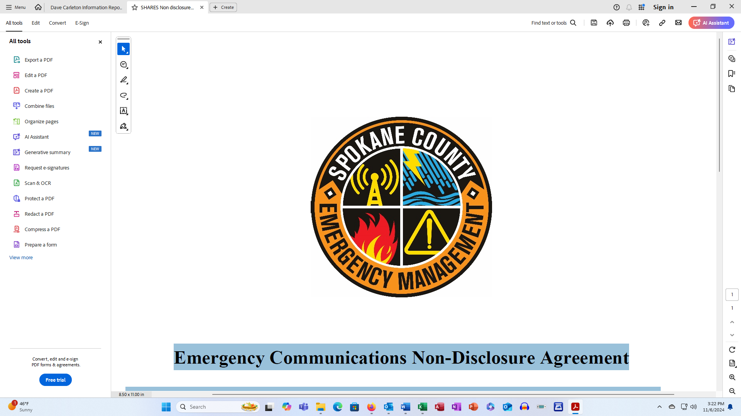

Spokane County Emergency Management (SCEM)
Emergency Communications Non-Disclosure Agreement

Radios and computers in the Communications Room, Trailers and at SCEM stations in the local hospitals contain information that is restricted by Federal law and is For Official Use Only (FOUO). SCEM volunteers are not allowed to place any information from SCEM computers or radios on personal computers or radios unless they hold a current SHARES station license.

All personnel that access Spokane County Emergency Management’s communications facilities and equipment must comply with the following security procedures for handling FOUO material, which includes frequencies and operating procedures, as specified in NCSH 3-3-1, Chapter 1, para 1.9:
(1) The information shall not be released in any manner to the public or other personnel who do not have a valid need-to-know,
(2) the information shall not be photocopied or electronically reproduced,
(3) when unattended, the information shall be stored in a locked container or in a room with sufficient physical access control measures to afford adequate protection to prevent unauthorized access,
(4) when stored on a computer, the information shall be password protected,
(5) the information shall be disposed of in such a manner as to ensure destruction beyond recognition and reconstruction.

_______________________ _________________________ __________
Name (Printed) Signature Date

