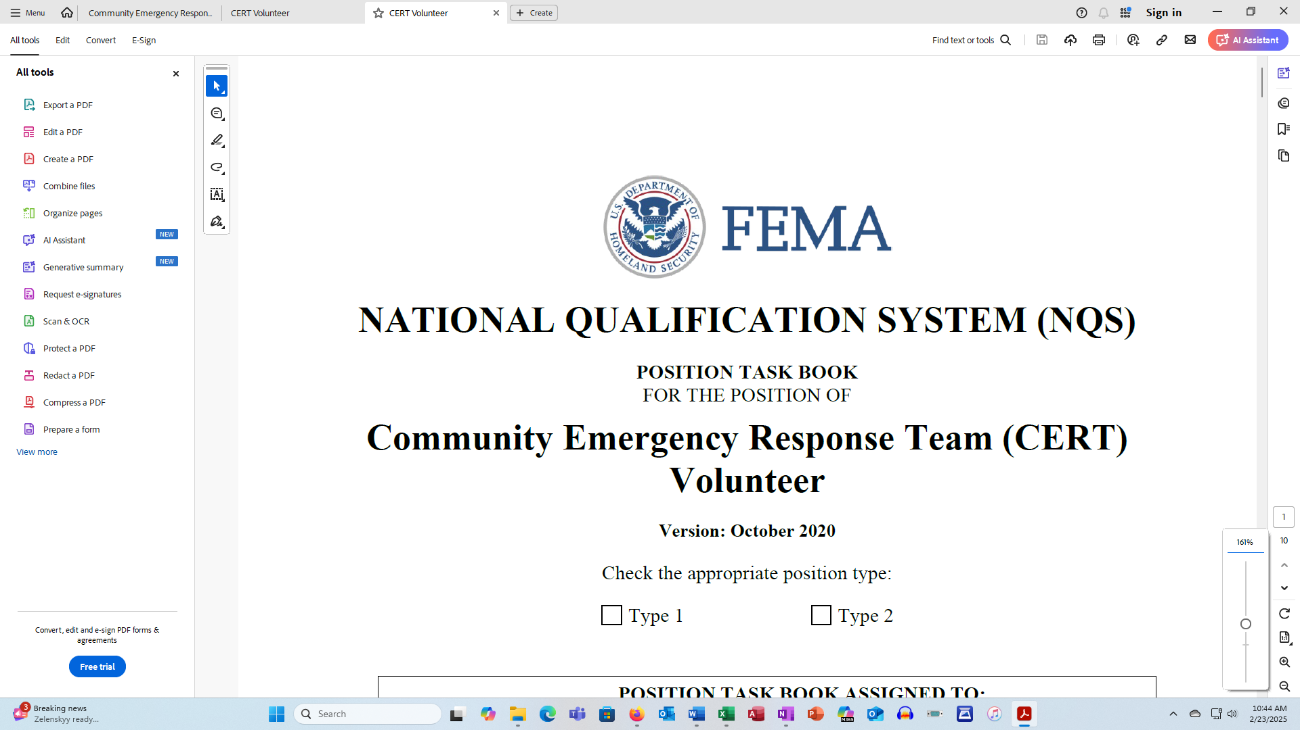

**NATIONAL QUALIFICATION SYSTEM (NQS)**

**POSITION TASK BOOK**

FOR THE POSITION OF

**Community Emergency Response Team (CERT) Volunteer**

**Version: October 2020**

Check the appropriate position type:

 Type 1  Type 2

|  |
| --- |
| **POSITION TASK BOOK ASSIGNED TO:** |
| TRAINEE’S NAME: |
| AGENCY NAME: |
| PHONE NUMBER: |
| E-MAIL: |
| POSITION TASK BOOK INITIATED BY: |
| OFFICIAL’S NAME: |
| TITLE: |
| AGENCY NAME: |
| PHONE: |
| E-MAIL: |
| **POSITION TASK BOOK WAS INITIATED:** |
| LOCATION: |
| DATE: |

**Evaluator Verification**

(Do not complete this form unless you are recommending the trainee for all-hazards certification.)

|  |
| --- |
| **FINAL EVALUATOR**  **VERIFICATION** |
| I verify that ______________________________________________________________  has successfully completed all tasks as a trainee and should therefore be considered for certification in this position. I also verify that all tasks are documented with appropriate initials. |
| FINAL EVALUATOR’S SIGNATURE: |
| DATE: |
| FINAL EVALUATOR’S PRINTED NAME: |
| TITLE: |
| AGENCY NAME: |
| PHONE: |
| E-MAIL: |

**Documentation of Agency Certification**

|  |
| --- |
| **FINAL EVALUATOR**  **VERIFICATION** |
| I certify that ______________________________________________________________  has successfully met all the criteria set out in the National Incident Management System (NIMS) Job Title/Position Qualifications document for the position and will hereby receive certification of his/her qualification. |
| OFFICIAL’S SIGNATURE: |
| DATE: |
| OFFICIAL’S PRINTED NAME: |
| TITLE: |
| AGENCY NAME: |
| PHONE: |
| E-MAIL: |

**Position Task Book Overview**

The Position Task Book (PTB) documents the performance criteria a trainee must meet to be certified for a position within the National Qualification System (NQS). The performance criteria are associated with core NQS competencies, behaviors, and tasks.

***Evaluation Process***

* Evaluators observe and review a trainee’s completion of PTB tasks, initialing and dating each successfully completed task in the PTB.
* Evaluators complete an Evaluation Record Form after each evaluation period documenting the trainee’s performance.
* The Authority Having Jurisdiction (AHJ) may not have enough resources to ensure every evaluator is qualified in the position being assessed. Therefore, a trainee’s supervisor may evaluate the completion of PTB tasks. For example, a Logistics Section Chief has the authority to sign off on completed PTB tasks for a Food Unit Leader trainee.
* The final evaluator is a leader who verifies that a trainee has completed the PTB and met all requirements for the position. A final evaluator is generally qualified in the same position for which the trainee is applying. When possible, the evaluator and the final evaluator should not be the same person, but in situations with limited resources, the evaluator can also serve as the final evaluator.
* Once the final evaluator has completed the Final Evaluator Verification, he/she forwards it to the Qualification Review Board (QRB) along with supporting evidence that the trainee has completed all position requirements. It is recommended that states have at least one member of the QRB be an experienced Auxiliary Communicator with Public Safety experience.
* After the QRB review, the AHJ completes the Documentation of Agency Certification form as appropriate.

***Transferring Qualifications***

* Personnel who have documentation of previous education, training, or significant on-the-job incident experience may receive credit toward qualification for a given position. Each AHJ establishes the requirements for transferring qualifications from another AHJ.
* If an AHJ chooses not to accept a trainee’s existing certification of qualification, the trainee may be reevaluated in the specific position and issued a new PTB.
* An individual may hold multiple certifications of qualification (that is, the Final Evaluator Verification form and the Documentation of Agency Certification form) along with the completed PTB.

**Position Task Book Competencies, Behaviors, and Tasks**

|  |
| --- |
| **The PTB sets minimum criteria for certification for a position. The AHJ has the authority to add content to the baseline PTB competencies, behaviors, and tasks as necessary in an AUXC Addendum.** |

The PTB covers all type levels for a given position, but a trainee may check only one “Type” box and work on only one type at a time. (The National Incident Management System (NIMS) Job Title/Position Qualifications document describes all types.)

Command and General Staff job titles/positions qualifications are typed based on incident complexity, while all other NIMS positions are typed based on the minimum qualifications.

***Definitions***

**Competency:** An observable, measurable pattern of knowledge, skills, abilities, and other characteristics that an individual should possess to perform an activity and its associated tasks. A competency specifies the skillset a person needs to possess to complete the tasks successfully.

**Behavior:** An observable work activity or a group of similar tasks necessary to perform the activity.

**Task:** A specific, demonstrable action necessary for successful performance in a position. Trainees must demonstrate completion of required tasks.

* + Occasionally, PTB tasks are unique to one of the types; for example, certain tasks apply only to a Type 3 Incident Commander, not to a Type 2 or Type 1 Incident Commander. In those cases, the PTB indicates the corresponding type at the beginning of the task.
  + All tasks require evaluation; however, bullet statements within a task are examples.

***PTB Task Codes***

Each task in the PTB model has at least one corresponding code conveying the circumstances in which the trainee can perform the task for evaluation. Evaluators may assess trainees during incidents, in classroom simulations and training sessions, in functional and full-scale exercises, and in other work situations. If a task has multiple codes, the evaluator may evaluate in ANY of those circumstances. The trainee does not need evaluation in all the listed circumstances.

**Code C:** Task performed in a training or classroom setting, including seminars and workshops.

**Code E**: Task performed during a full-scale exercise with equipment deployed under the Incident Command System (ICS).

**Code F**: Task performed during a functional exercise managed under the ICS.

**Code I**: Task performed during an incident or event managed under the ICS. Examples include oil spill, search and rescue operation, hazardous materials (hazmat) response, fire, and emergency or non- emergency (planned or unplanned) events.

**Code J**: Task performed as part of day-to-day job duties.

**Code T**: Task performed during a tabletop exercise.

**Code R**: Task performed very rarely and required only if applicable to the event.

**How to Complete the Evaluation Record Form**

Each Evaluation Record Form (see next page) covers one evaluation period. Evaluation periods may involve incidents, classroom simulations, or daily duties, depending on what the PTB recommends. The AHJ determines the number of evaluations required for position qualification and certification. If evaluators need additional evaluation periods, they can copy pages from a blank PTB and attach them to the PTB in question.

**Complete these items AT THE START of the evaluation period:**

***Evaluation Record Number:*** Label each evaluation record with a sequential (1,2,3, etc.) number to identify the incident(s), exercise(s), or event(s) during which the trainee completed the PTB tasks. The evaluator should also write this number in the PTB column labeled “Evaluation Record #” for each task performed satisfactorily. This number enables reviewers of the completed PTB to ascertain the evaluators’ qualifications before signing off on the PTB.

***Evaluator’s Name, Incident/Office Title, and Agency:*** List the name of the evaluator, his/her incident position or office title, and the evaluator’s home agency.

***Evaluator’s Home Unit Address and Phone:*** List the evaluator’s home unit address and phone number.

***Name and Location of Incident or Simulation/Exercise:*** Identify the name (if applicable) and location where the trainee performed the tasks.

***Incident Kind:*** Enter the kind of incident (such as hazmat, law enforcement, wildland fire, structural fire, search and rescue, flood, or tornado).

**Complete these items AT THE END of the evaluation period:**

***Number and Kind of Resources:*** Enter the number of resources assigned to the incident, and their kind (such as team, personnel, and equipment) pertinent to the trainee’s PTB.

***Evaluation Period:*** Enter inclusive dates of trainee evaluation. This time span may cover several small, similar incidents.

***Recommendation:*** Check the appropriate line and make comments below regarding the trainee’s future development needs.

***Additional Recommendations/Comments:*** Provide additional recommendations and comments about the trainee, as necessary.

***Date:*** List the current date.

***Evaluator’s Initials:*** Initial here to authenticate your recommendations and to allow for comparison with initials in the PTB.

***Evaluator’s Relevant Qualification:*** List your certification relevant to the trainee position you supervised.

**Evaluation Record Form**

**(Should be duplicated as needed for each evaluator utilized)**

|  |
| --- |
| TRAINEE’S NAME: |
| TRAINEE POSITION: |
| Evaluation Record Number: |
| Evaluator’s Name: |
| Incident/Office Title and Agency: |
| Evaluator’s Home Unit Address and Phone: |
| Name and Location of Incident or Simulation Exercise: |
| Incident Kind: |
| Number and Kind of Resources: |
| Evaluation Period: |
| **Recommendation:**  The above-named trainee performed the initialed and dated tasks under my supervision. I recommend the following for this trainee’s further development:  ______The trainee has successfully performed all required tasks for the position. The AHJ should consider the individual for certification.  ______The trainee could not complete certain tasks or needs additional guidance. See comments below.  ______Not all tasks were evaluated on this assignment. An additional assignment is needed to complete the evaluation.  ______The trainee is severely deficient in the performance of tasks and needs further training prior to additional assignment(s) as a trainee for this position. |
| Additional Recommendations/Comments: |
| Date: |
| Evaluator’s Initials: |
| Evaluator’s Relevant Qualification: |

Form Version March 2019

**Community Emergency Response Team (CERT) Volunteer**

***1. Competency: Assume position responsibilities***

*Description*: Successfully perform the role of CERT Volunteer and required position activities at the appropriate time according to the following behaviors*.*

**1a. Behavior: Gather, update, and apply situational information relevant to the assignment**

|  |  |  |  |
| --- | --- | --- | --- |
| TASK | CODE | EVALUATION RECORD | EVALUATOR’S INITIALS AND DATE |
| 1. Obtain initial briefing from the Branch Director, Operations Section Chief, or Incident Commander (IC):  * Obtain current Incident Action Plan (IAP) or other relevant plans | E, F, I |  |  |
| 1. Collect information from outgoing CERT representative:  * Information on incident relevant to CERT activities * Information on the Incident Command System (ICS) organizational structure | E, F, I |  |  |
| 1. Coordinate with functional areas within the incident management structure:  * Participate in operational and functional area briefings | E, F, I |  |  |

***2. Competency: Communicate effectively***

*Description:* Use suitable communication techniques to share relevant information with appropriate personnel on a timely basis to accomplish objectives in a potentially rapidly changing environment*.*

**2a. Behavior: Ensure the exchange of relevant information during briefings and debriefings**

|  |  |  |  |
| --- | --- | --- | --- |
| TASK | CODE | EVALUATION RECORD | EVALUATOR’S INITIALS AND DATE |
| 1. Effectively communicate options, considerations, and recommendations during briefings. | E, F, I |  |  |
| 1. Obtain periodic progress reports from adjacent resources. | E. F. I |  |  |

**2b. Behavior: Ensure documentation is complete and disposition is appropriate**

|  |  |  |  |
| --- | --- | --- | --- |
| TASK | CODE | EVALUATION RECORD | EVALUATOR’S INITIALS AND DATE |
| 1. Ensure that incident documentation and administrative requirements are complete, as the Operations Section Chief or IC requires:  * Submit incident narrative to supervisor * Complete and submit activity log to Documentation Unit or appropriate personnel for each operational period * Ensure all personnel and equipment time records are complete and submitted at the end of each operational period | E, F, I |  |  |

**2c. Behavior: Communicate incident priorities and operations**

|  |  |  |  |
| --- | --- | --- | --- |
| TASK | CODE | EVALUATION RECORD | EVALUATOR’S INITIALS AND DATE |
| 1. Communicate priorities, objectives, and any changes as appropriate. | E, F, I |  |  |
| 1. Report unexpected occurrences (such as injuries, illnesses, accidents, political contacts, or property loss or damage):  * Ensure that standard information contains nature of event, location, scope, personnel involved, initial action taken, and appropriate subsequent action * Protect Personally Identifiable Information (PII) while reporting | E, F, I |  |  |
| 1. Provide timely feedback in response to requests from other ICS sections. | E, F, I |  |  |

**2d. Behavior: Develop and implement plans**

|  |  |  |  |
| --- | --- | --- | --- |
| TASK | CODE | EVALUATION RECORD | EVALUATOR’S INITIALS AND DATE |
| 1. Help prepare the IAP, planning meeting agenda, and strategic plan for the next operational period: | E, F, I |  |  |
| 1. Participate in preparing other relevant plans:  * Demobilization plan * Continuity of Operations (COOP) plan * Contingency plans |  |  |  |

***3. Competency:* Ensure completion of assigned actions to meet identified objectives**

*Description:* Identify, analyze, and apply relevant situational information and evaluate actions to complete assignments safely and meet identified objectives. Complete actions within established time frame.

**3a. Behavior: Execute assigned tasks, assess progress, and make necessary adjustments**

|  |  |  |  |
| --- | --- | --- | --- |
| TASK | CODE | EVALUATION RECORD | EVALUATOR’S INITIALS AND DATE |
| 1. Adjust tactics in response to opportunities or problems encountered. | E, F, I |  |  |
| 1. Implement objectives and special instructions for CERT:  * Monitor work progress and evaluate incident situation * Develop recommendations for next operational period | E, F, I |  |  |
| 1. Apply a continuous risk management process:  * Situational awareness * Hazard assessment * Hazard control * Decision point * Evaluation | E, F, I |  |  |

**3b. Behavior: Transfer position duties while ensuring continuity of knowledge**

|  |  |  |  |
| --- | --- | --- | --- |
| TASK | CODE | EVALUATION RECORD | EVALUATOR’S INITIALS AND DATE |
| 1. Coordinate an efficient transfer of position duties when mobilizing/demobilizing resources:  * Inform assigned personnel and supervisor * Communicate with incoming personnel concerning when and where transition of positions will occur * Conduct transition effectively * Document follow-up actions. | E, F, I |  |  |

**3c. Behavior: Plan for demobilization**

|  |  |  |  |
| --- | --- | --- | --- |
| TASK | CODE | EVALUATION RECORD | EVALUATOR’S INITIALS AND DATE |
| 1. Help develop, approve, and implement demobilization plan:  * Coordinate with supervisor during development and implementation * Provide information to supervisor to assist with decisions on release priorities. | E, F, I |  |  |
| 1. Complete process for demobilizing CERT responsibilities:  * Reinforce emphasis on safety and accountability during this phase of the operations * Demobilize equipment, as necessary * Brief replacement, if necessary | E, F, I |  |  |
| 1. Participate in agency administrator’s organization closeout and After Action Review (AAR). | E, F, I |  |  |