How to Program QYT KT-8900

Basic Instructions using Speaker Microphone:
Press [F Key] + [# Key] + [# Key]
Select value
Press [F Key] to save it
Press [Exit/AB]

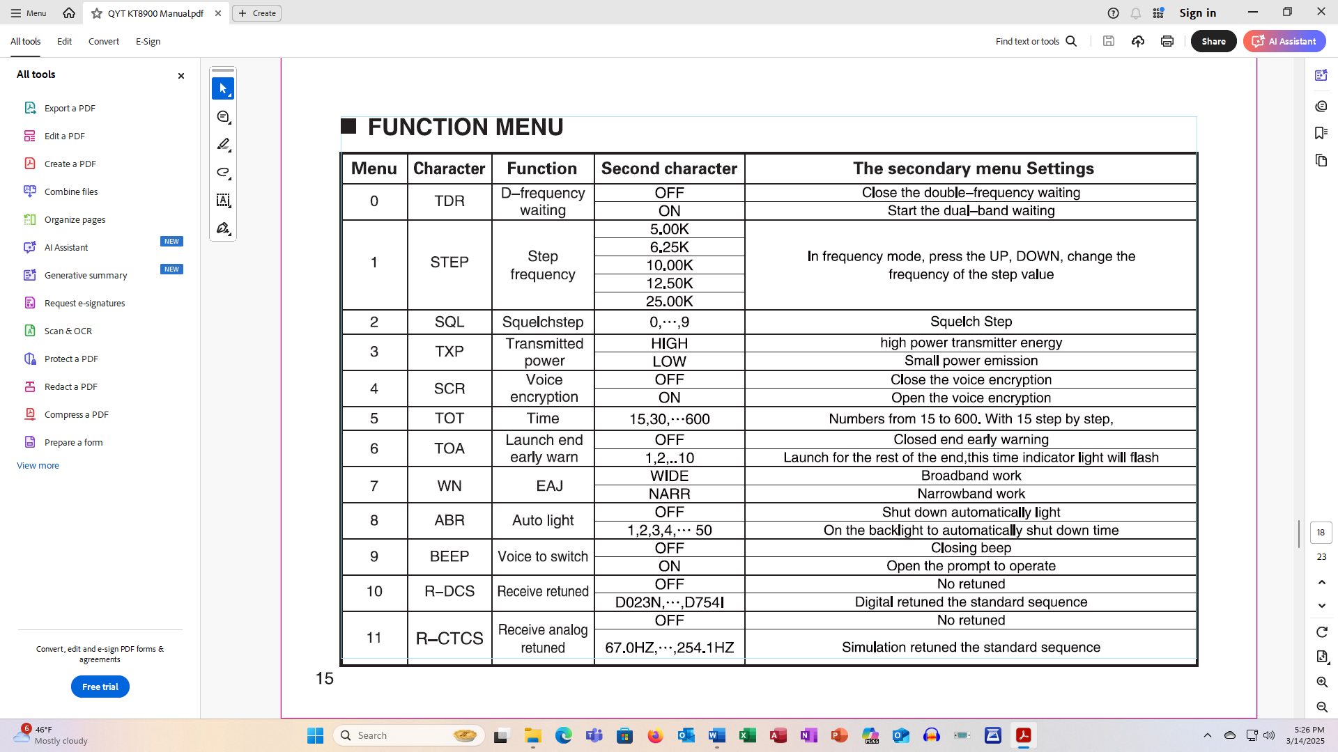
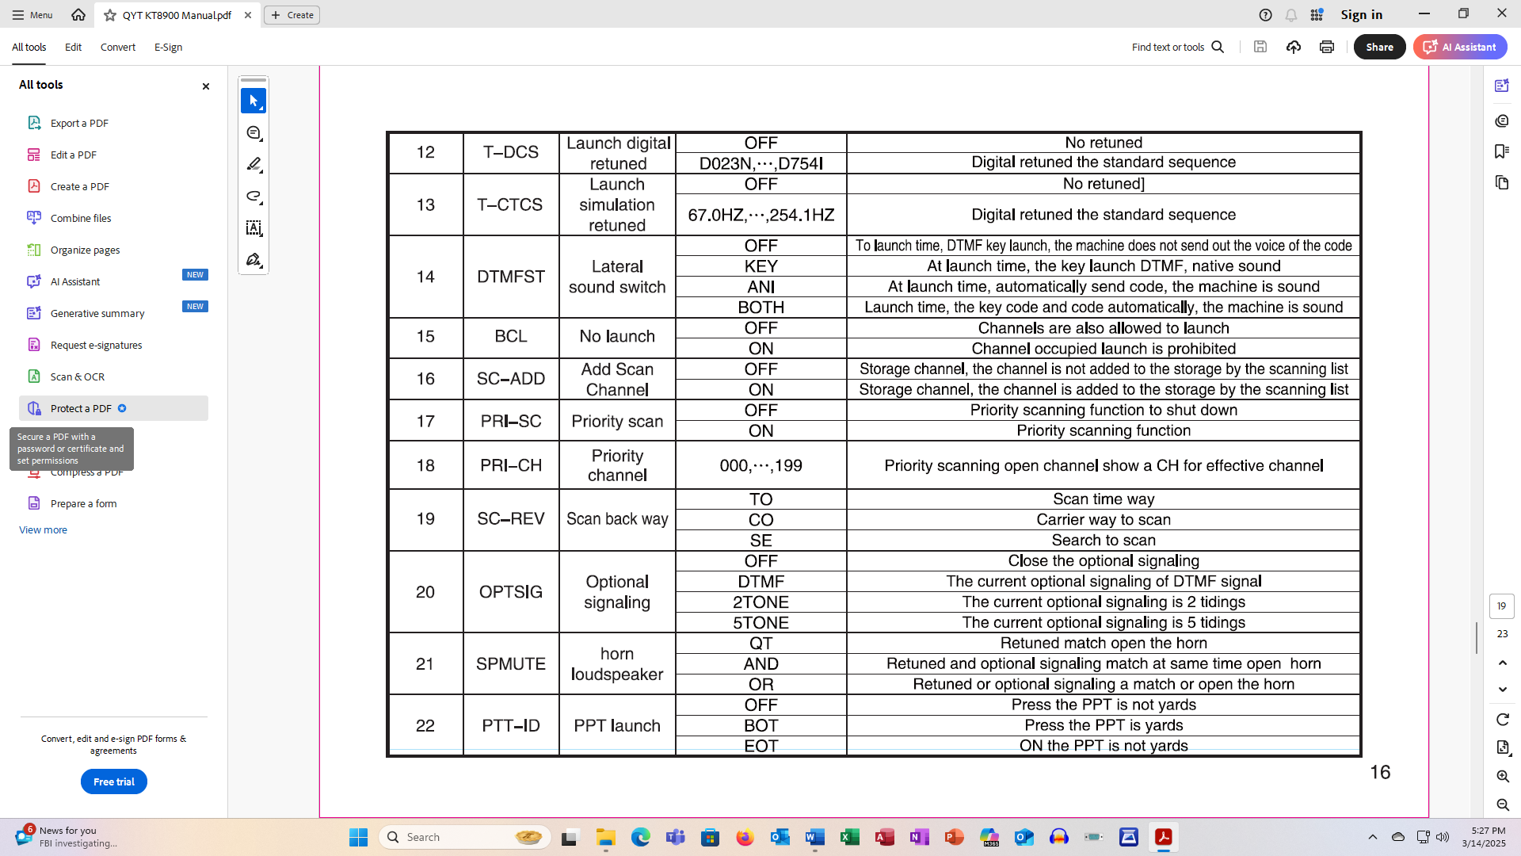
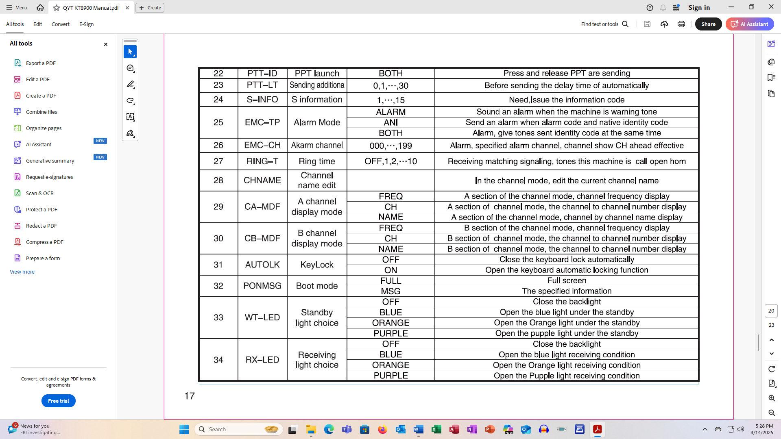
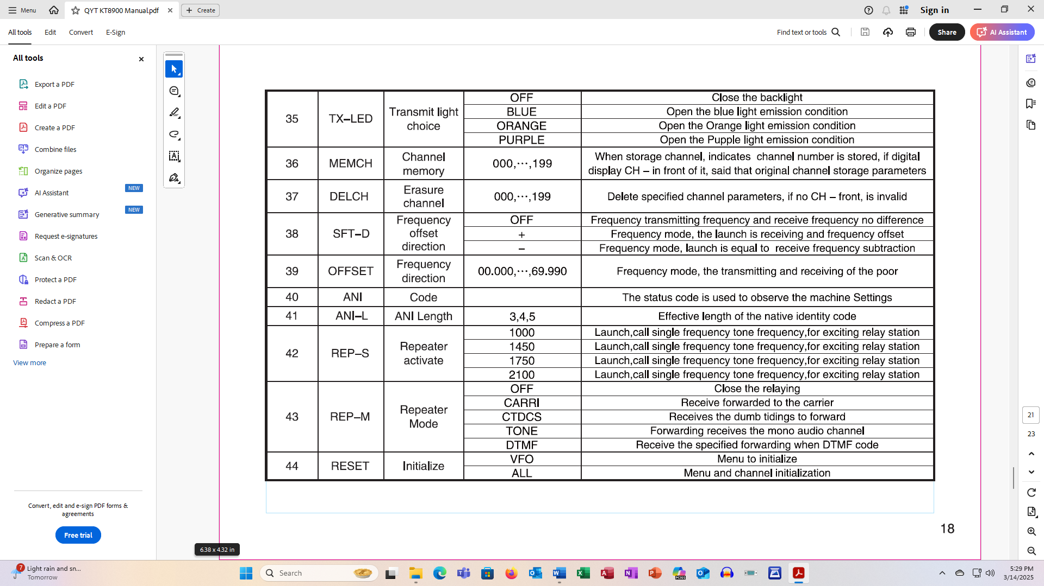
1. Start in VFO mode.
2. Punch in Transmit frequency
3. CTCSS Tone on Transmit side – 13 (TX CTCSS)
4. Shift Direction - 38
5. Shift Value – 39

How to Program QYT KT-8900

Basic Instructions using Speaker Microphone:
Press [F Key] + [# Key] + [# Key]
Select value
Press [F Key] to save it
Press [Exit/AB]

Programming a Repeater
1. Start in VFO mode.
2. Punch in Transmit frequency
3. CTCSS Tone on Transmit side – 13 (TX CTCSS)
4. Shift Direction - 38
5. Shift Value – 39

