“I Am Safe” Messages
Situation: Commercial communications, landline telephone, cell phone, and Internet are NOT available. A neighbor (client) wants to let their loved ones know they are okay.
Purpose: To pass “I Am Safe” messages to loved ones outside the disaster area during a commercial communications outage. This radio traffic should not interfere with higher-priority emergency communications.
Contents:
Hub Organization: 2
Email Address 6
Cell Phone Number With Carrier 12
Cell Phone Number and No Carrier, or a Landline Number 15
Postal Address 17
Winlink Operator 18
General 18
Paper Form with Email Address 18
Paper Form with Email Address and Short Prepared Phrase Numbers 23
Paper Form with Cell Phone Number and Carrier 27
Paper Form with Landline, Cell Phone Number (No Carrier), or Postal Address 31
RRI Radiogram Option 35
Telephone Relay Person Option 40
Thumb Drive with Quick Welfare Message Files. 43
Thumb Drive with RRI Welfare Radiogram File 46
Thumb Drive With Email Messages as .Txt Files 49
Using A HF Relay Station If No FM Gateways Are Available 52
Appendix 1 Cell Carrier Domains 54
Appendix 2 Strategies for Winlink Operators 55
Appendix 3 Off-Line Help Documentation from Radio Relay International 57
Overview 57
Installation 57
Form Use and Guide 57
Why No Reply? 58
Some Guidelines 59
General Information 60
The Radiogram Format 60
Getting the Message into the System 61

Hub Organization:
The client supplies contact information for their loved one—an email address, phone number, or postal address.
Hub volunteers collect the information, review for legibility (important), and pass to the hub ham (Winlink Operator). Winlink Operators have the ability to pass “I Am Safe” messages using radio and the Winlink Global Radio Email network. “I Am Safe” messages may have to be deferred to allow for higher-priority messages to get through. The Seattle EOC and net Control will determine when “I Am Safe” messages can be sent.
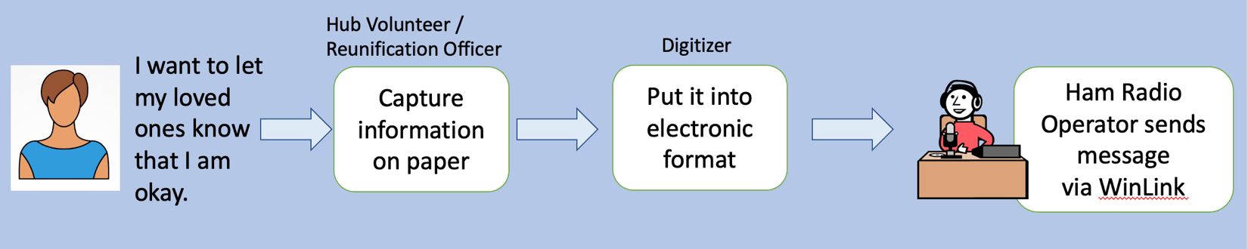

If the queue to send “I Am Safe” messages to loved ones is long, Hub volunteers can divide up clients based on what contact information they have for their loved one. See flow below.
In these separate lines
- Those with an email address or cell phone with carrier – there will be less information to collect and the line should move rapidly
- Those with cell phone but no carrier, landline, or mailing address go into a different digital template requiring more details about the intended destination and will take more time to complete.
The Hub has flexibility for volume of messages and number of volunteers
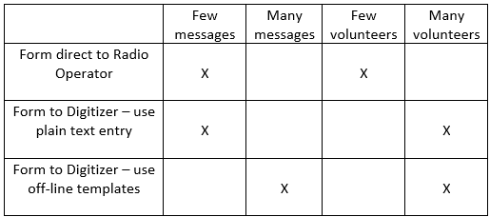
Tools:
Intake table
- Signage has been created to aid in creating short, effective messages.
- Intake form - two sided, the backside has the most common messages sent as “I Am Safe” quick messages. The Off-line templates will upload those messages from the numbers selected.
Digitizer –
- Computer – personal laptop, if possible, Hub supplied laptops are not likely to be updated.
- Thumbdrives
- Off-Line templates - available at Winlink.org and through the Winlink Operator. Help documents are in Appendix 3
Winlink station
- Ham radio operator with training and equipment
- Need not be at the hub. See Appendix 2 for strategies.
Persons in the Process:
Hub Volunteer/Reunification Officer
- Works with clients at the hub to get the information needed – legibly and completely
  - Hand out blank “I Am Safe” Message forms (examples below), or
  - In lieu of forms, post information needed and collect necessary information through interviews.
- IMPORTANT: Reviews all forms for completeness and legibility before the sender leaves. It may be difficult to track down the sender later for clarification.
- Passes completed forms to the Digitizer
Digitizer
- This person does not need to be a radio operator. They do not need to be stationed at the Hub.
- Uses a laptop/computer – preferably their own since they know where the various applications and folders are located and should be close to the hub ham.
- If available, on Hub supplied thumb drives, there will be an off-line Winlink template for these messages, which will standardize the information and reduce the typing needed at the Radio Operator station.
  - The Digitizer enters the information given to them by the Hub Volunteer into that off-line template
  - OR The Digitizer enters the information given them by the Hub Volunteer into plain-text files using Windows WordPad or the Mac TextEdit app.
- If using the off-line templates, the file will automatically name itself when saved. If using plain text, name each unique file.
- Saves the created files to a folder on the laptop titled “To be sent.”
- Copies all files from the “To be sent file” to a thumb drive.
- Passes the thumb drive to a Winlink-capable ham radio operator. This might be the ham radio operator positioned with the Hub or the thumb drive may need to be carried to a Winlink Operator outside of the Hub location. See Appendix 2.
  - If a Digitizer isn’t available, paper forms can be passed directly to the Winlink Operator.
  - Note on the form the time the message was passed and save for follow-up queries.
Off-line Template help documents are in Appendix 3
How the message is prepared and sent depends on what information the client was able to provide:
- Email address > Direct Winlink message Page 6.
- Cell phone number—knows the carrier > Quick Welfare message Page 12.
- Landline, cell phone number, but does NOT know the carrier, or postal address > RRI Welfare Radiogram Page 14.

Email Address
Client has an email address. This is the easiest solution since folks often have email addresses as part of contacts list on device. Sample message form completed by the client: 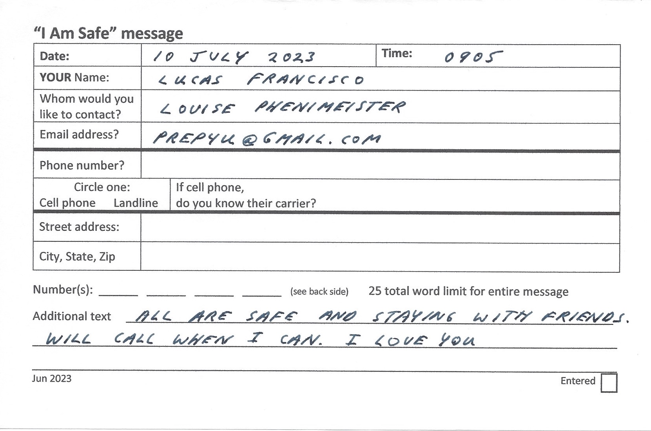
Complete the offline Quick Welfare Message template like this
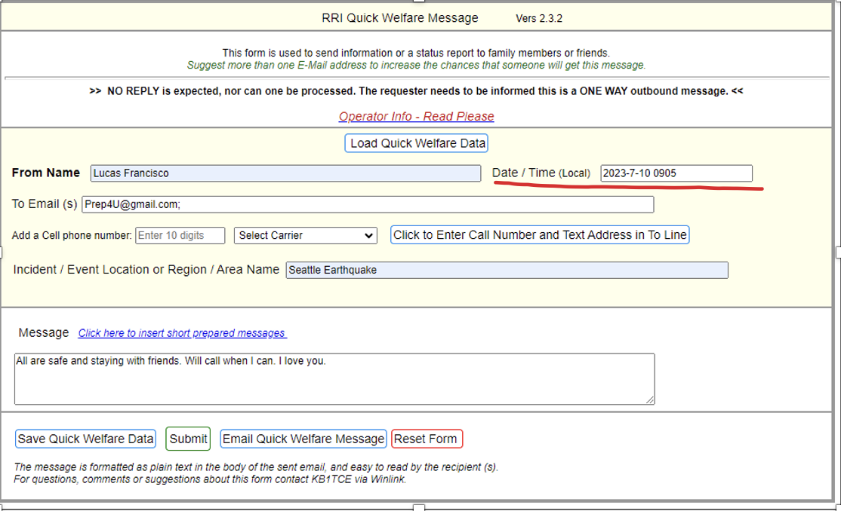
Update the Date/Time with the information on the form.
The client can choose short prepared messages from a list on the back of the form.
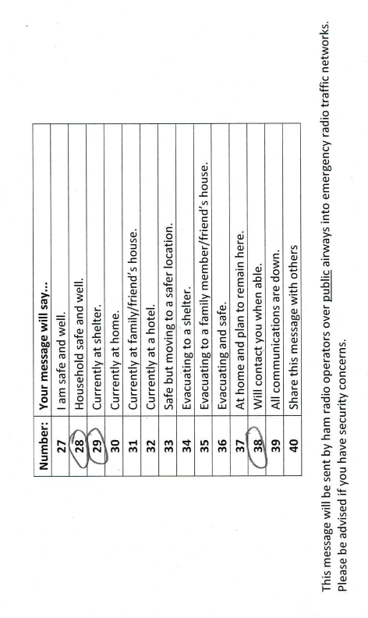
The form will look like this
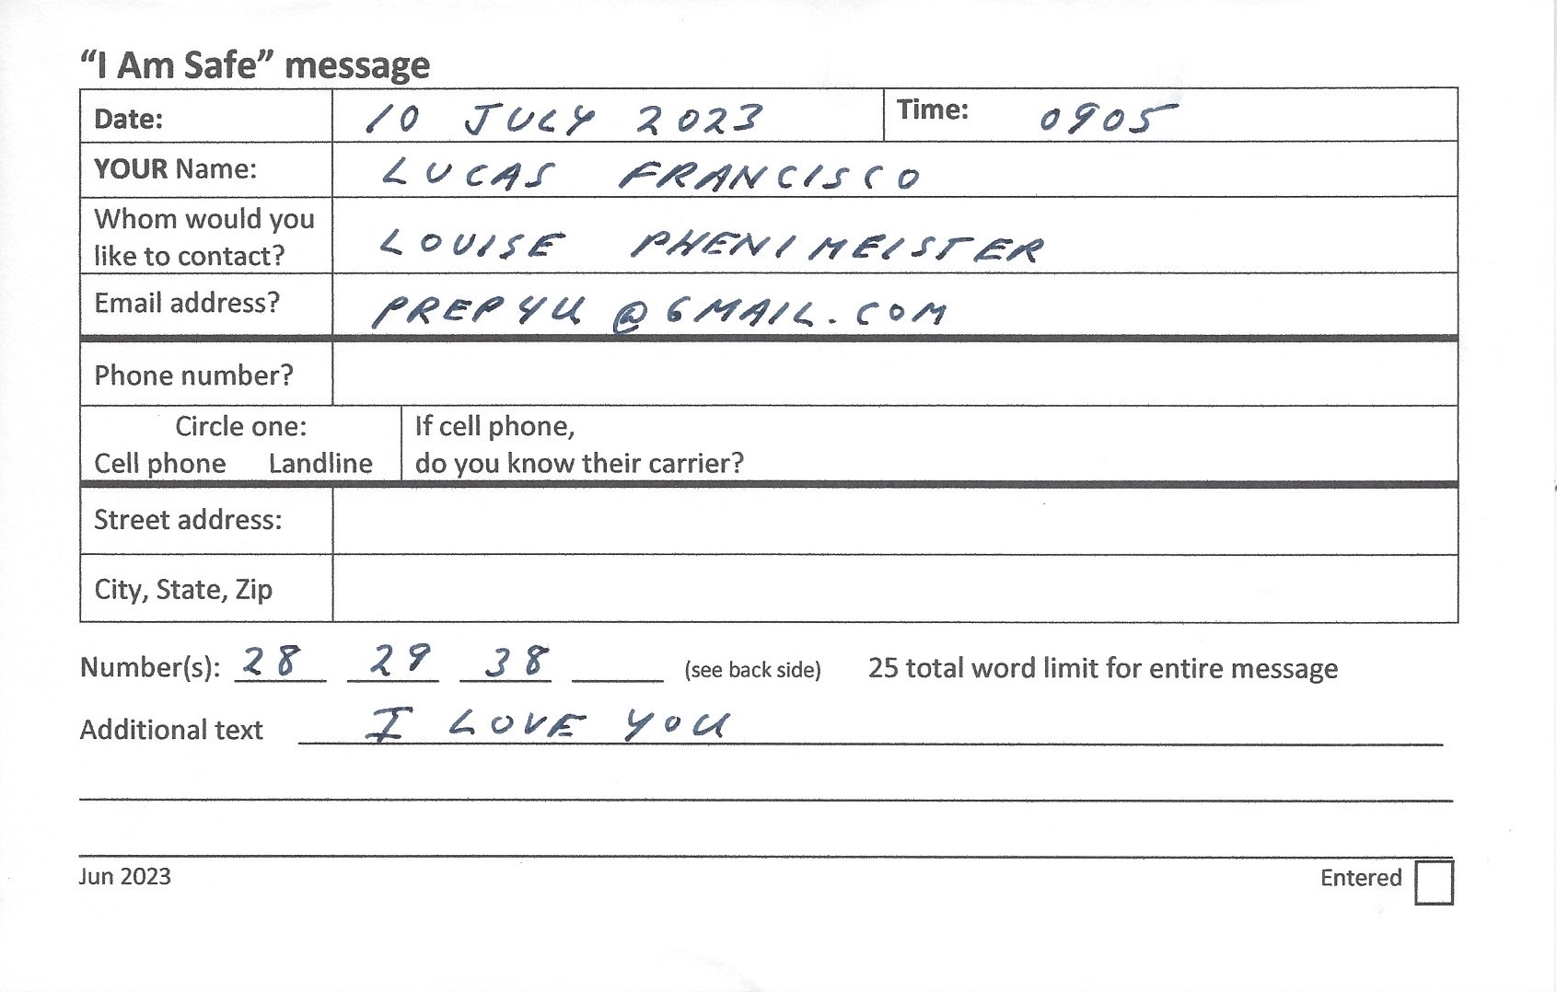
In the Quick Welfare Message template use “Click here to insert short prepared messages.”
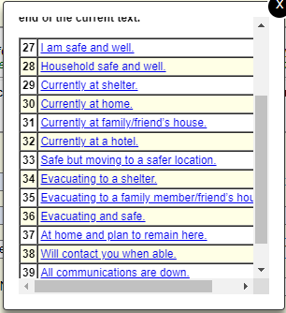
Select the messages from the form. Add any additional text.
The template will look like this.
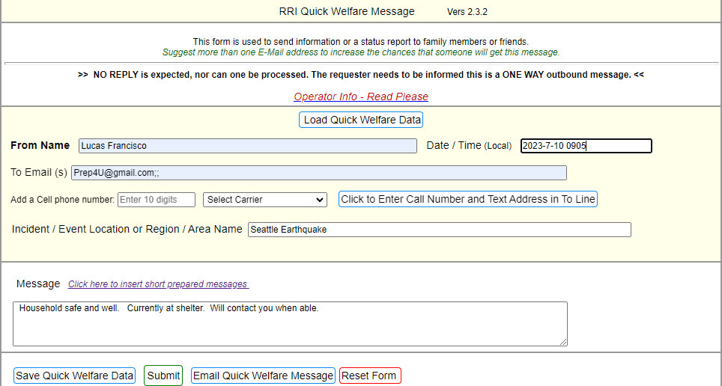
Add any additional text.
Update the Date/Time from the form.
Save Quick Welfare Data to a thumb drive and to a directory on the laptop.
Pass the thumb drive to the Winlink Operator.
Tips for the Digitizer:
- Verify legibility of the form. Once the client leaves there will be no opportunity to clarify handwriting.
- Email addresses are entered directly on the email line.
- Cell numbers are entered at phone number, the carrier selected and “Click to Enter Call Number and Text Address in the To Line” to add the properly-formatted phone number into the email line.
- Save Quick Welfare Data to a thumb drive and to a directory on the laptop. The file will be named Quick
If no offline template is available Digitizer composes a plain text message using Word Pad (Windows) or TextEdit (Mac) to include in this order:
- Date/Time from the form
- Email address
- Name of sender
- Message
- The paper form may include short prepared message numbers. Transcribe those into the body of the message, e.g., instead of 28 enter “Household safe and well.”
Example in Text Edit:
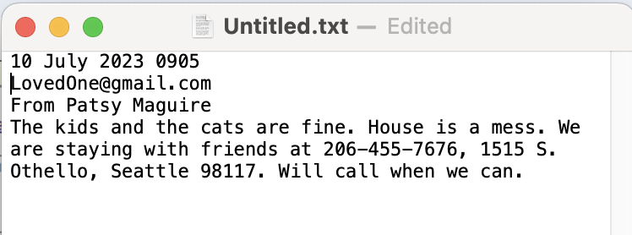

Save as a .txt file to a thumb drive and to a directory on your laptop.
Pass the thumb drive to the Winlink Operator.

Cell Phone Number With Carrier
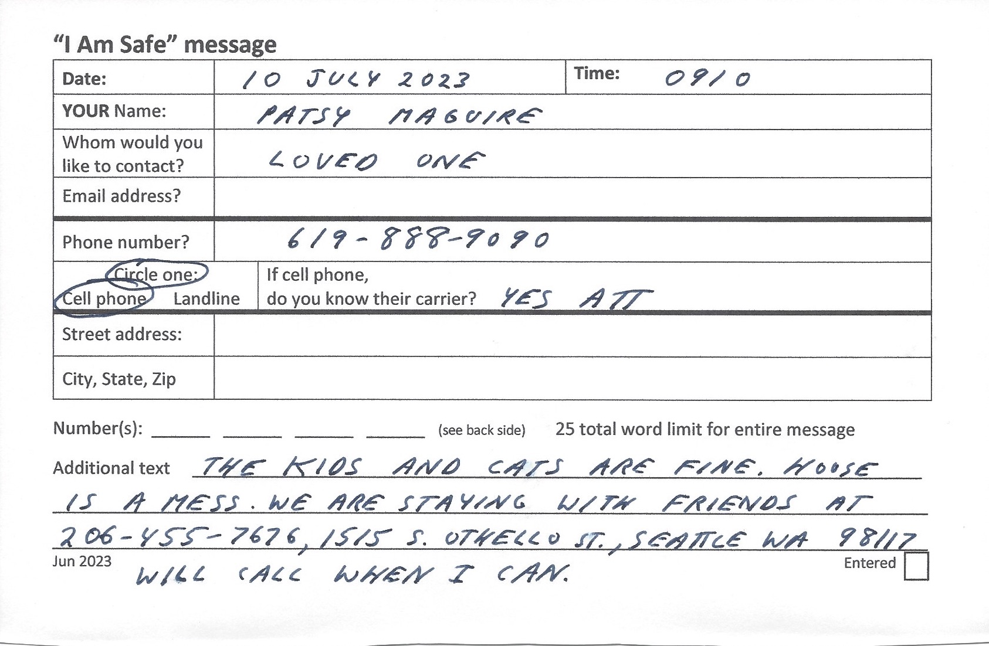

Prepare a message using the offline RRI Quick Welfare Message template using the “Select Carrier” drop down list then “Click here to Enter Cell Number and Text Address in the To Line.” The proper address populates the template.
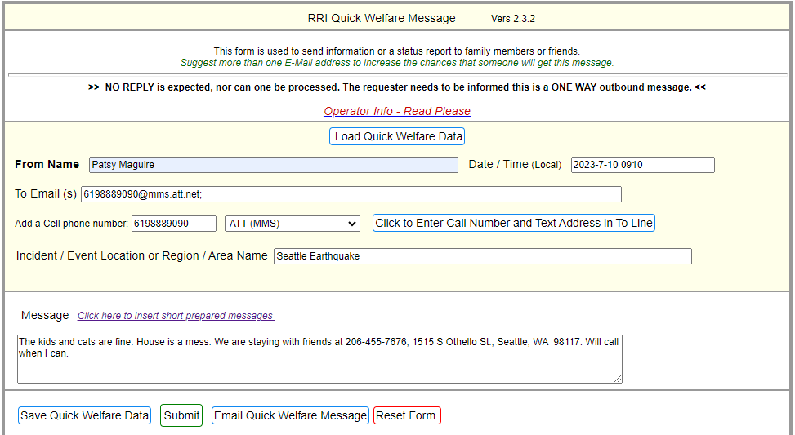
Update the Date/Time with the information from the form.
Save Quick Welfare Data to a thumb drive and to the laptop.
If the template is not used, the Digitizer composes a plain text message using Word Pad or TextEdit to the loved one to include (in this order):
- Date/Time
- Email address. See Appendix 1 for carrier domain names.
- Name of sender in subject line.
- Message, to include any contact information
- The paper form may include short prepared message numbers. Transcribe those into the body of the message, e.g., instead of 28 enter “Household safe and well.”
Example in Text Edit:
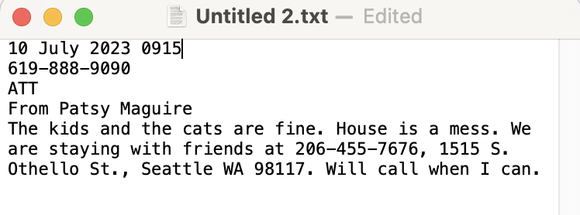
Save the .txt file to a thumb drive and to the laptop.
Pass the thumb drive to the Winlink Operator.

Cell Phone Number and No Carrier, or a Landline Number
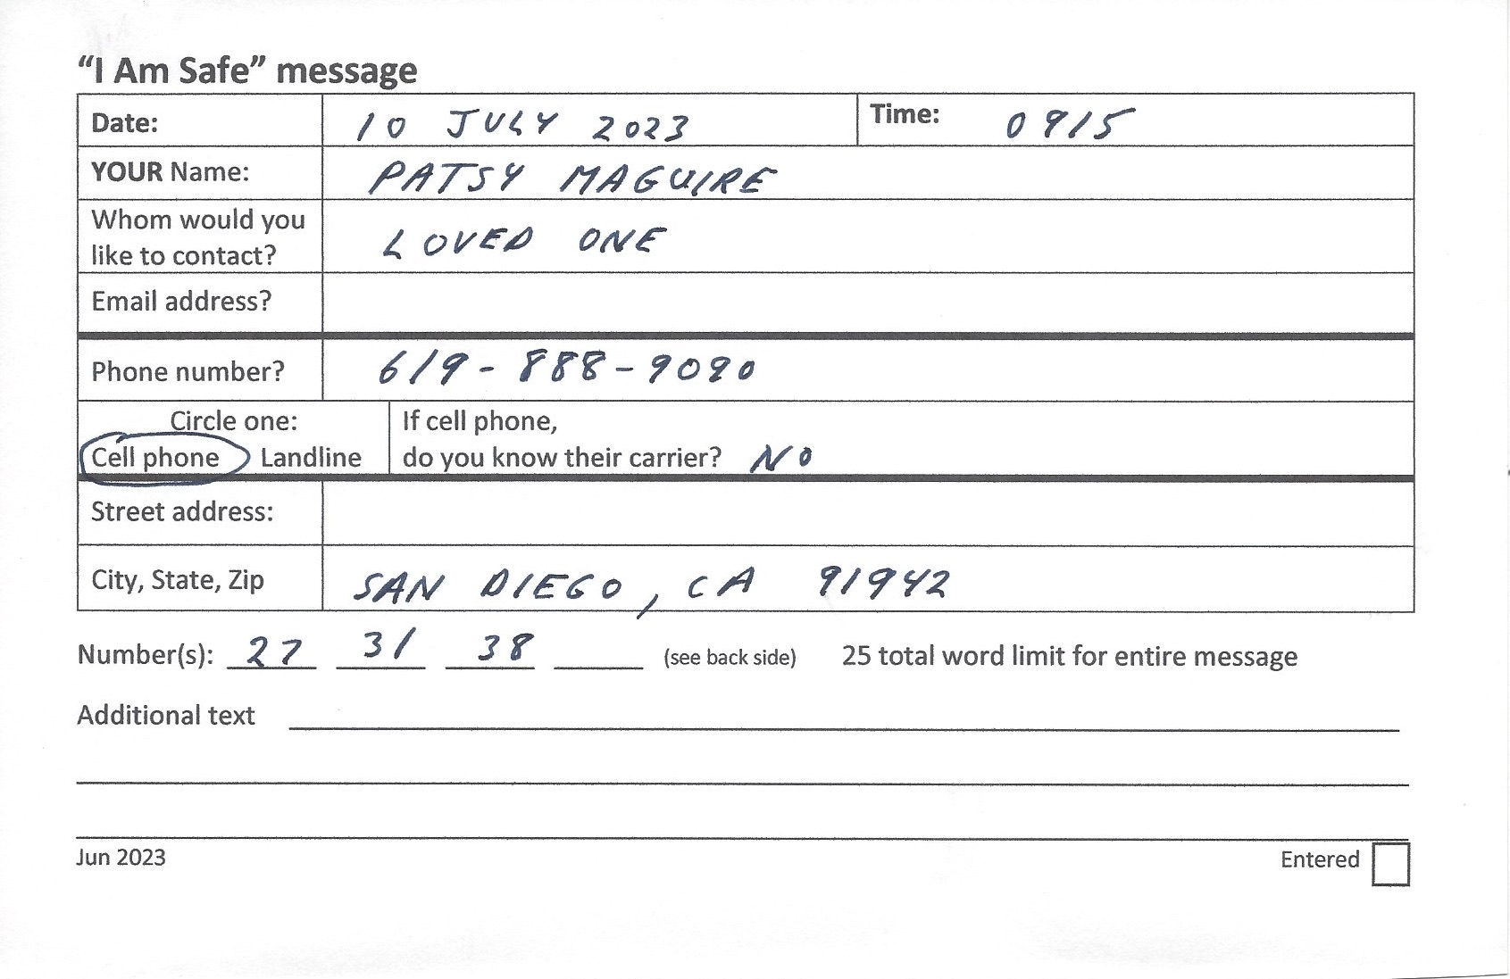
Use the RRI Welfare Radiogram offline template (different than the RRI Quick Welfare template).
Transcribe information including the Date/Time from the form.
Use “Click here to insert short prepared messages.” The template will look like this

TEMPLATE EXAMPLE RADIOGRAM

Save Quick Welfare Data to a thumb drive AND a to directory on the laptop.
Pass the thumb drive to the Winlink Operator
IF NO TEMPLATE IS AVAILABLE
Digitizer composes a plain text message using Word Pad or TextEdit to the loved one to include (in this order):
- Date/Time
- Email address
- Name of sender in subject line
- Message, to include any contact information
- The paper form may include short prepared message numbers. Transcribe those into the body of the message, e.g., instead of 28 enter “Household safe and well.”
Example in Text Edit:
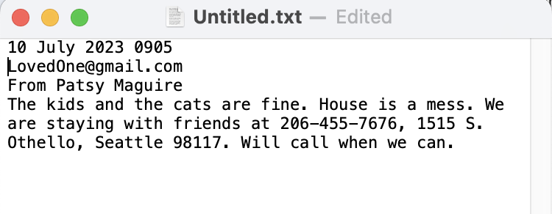
Save the .txt file to a thumb drive and to your laptop.
Pass the thumb drive to the Winlink Operator who will cut and paste information into a template.

Postal Address
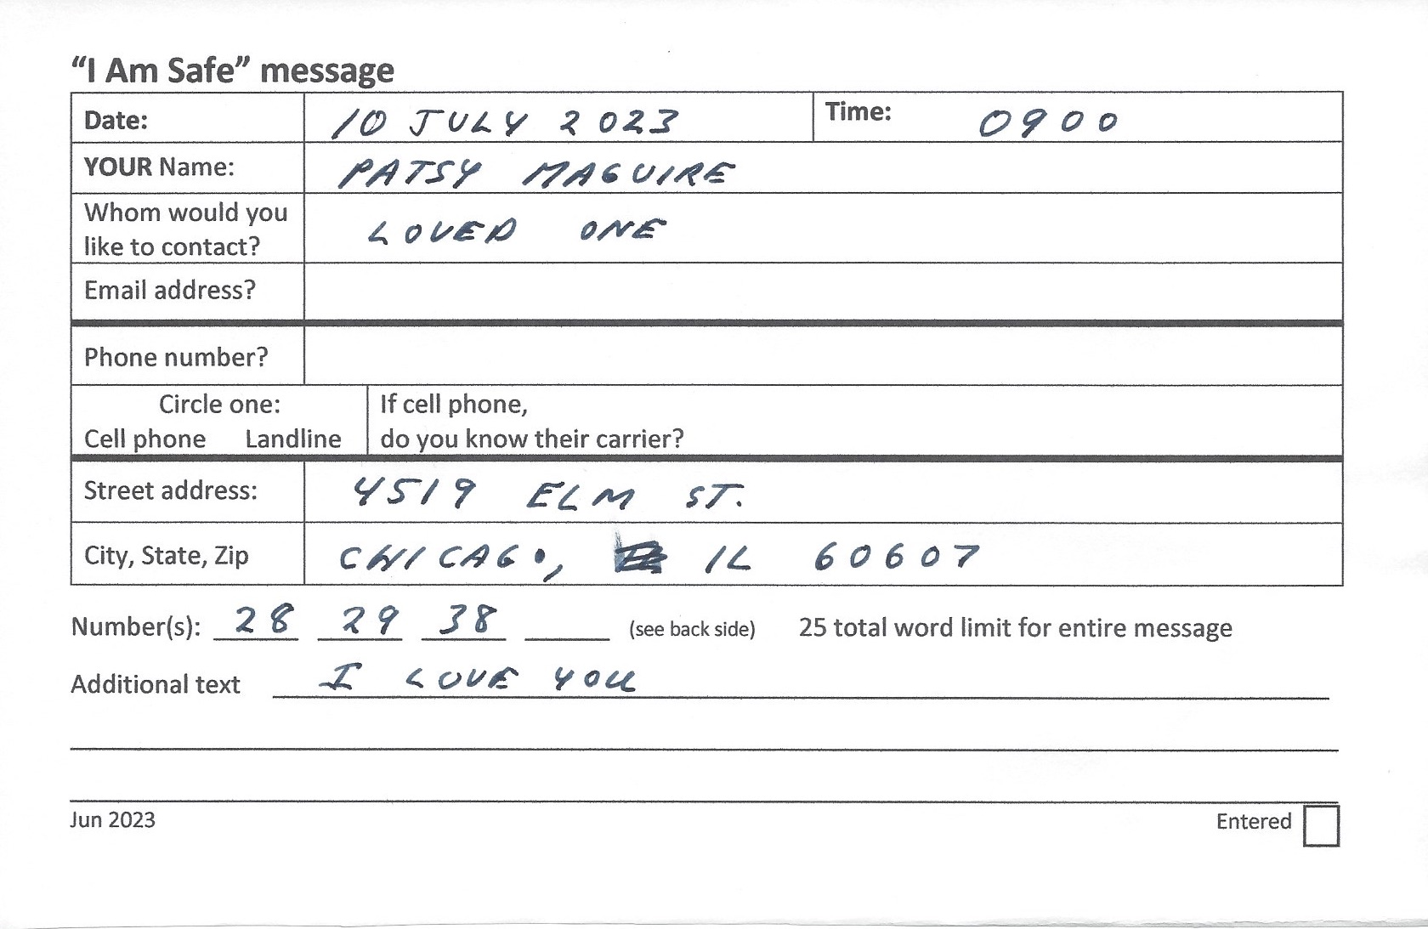

Use the RRI Welfare Radiogram template just like the phone number with no carrier. These messages will go to volunteer radio operators in the National Traffic System who live near the address of the loved one.
NTS volunteers will mail a letter or post card through the US Postal Service. It may take several days for a letter or post card to arrive to the loved one.

TEMPLATE

Winlink Operator
Thank you for helping to pass I Am Safe messages during this difficult time. Your efforts will bring comfort to your neighbors and their loved ones. Hub volunteers have gathered messages and will present them to you as a paper form or on a thumb drive. This procedure guides you through the messaging process. Welfare traffic has a priority lower than operational traffic. Coordinate with net control as to the time and frequency to send welfare messages.

General
Ideally the operator will have a station including a laptop, hardware, software, radio, and antenna to send and receive Winlink messages. Seattle has numerous Vara FM remote message server (RMS) gateways and there are other Vara and packet gateways in the region. If an HF station is available, traffic can be sent to distant gateways unaffected by the disaster.
The Winlink Operator will be presented with
- A paper form, or
- A thumb drive with .txt files to be loaded into Winlink templates.
Winlink welfare messages will fall into two categories
- Email messages and cell phone numbers with the carrier—RRI Quick Welfare Message.txt template.
- Cell phone numbers without the carrier, landline numbers, and postal addresses—RRI Welfare Radiogram.txt template.

Paper Form with Email Address
If the operator is presented with a paper form such as this
In Winlink Click on Message/New Message/Select Template to get Template Manager
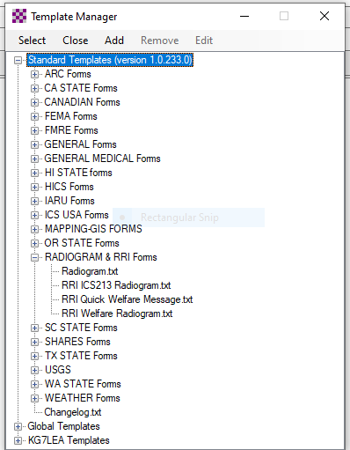

- Open Standard Templates
- Open RADIOGRAM & RRI FORMS
- Click on RRI Quick Welfare Message.txt
This template opens. Transcribe the information from the form to the template as follows
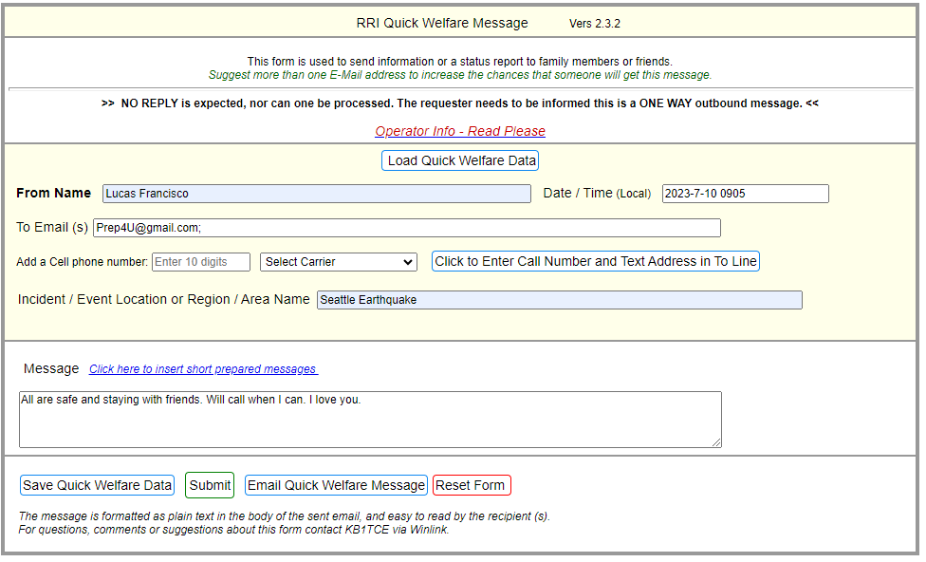
Enter the date and time from the information on the form.
Click Submit to view a Winlink message like this
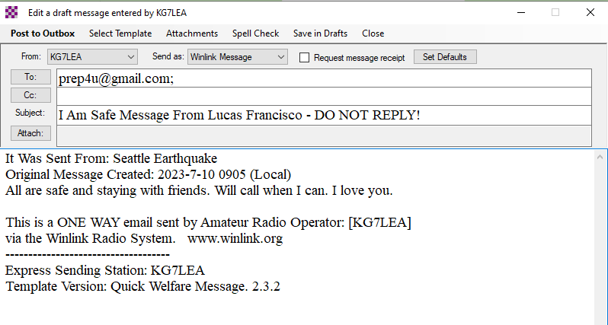

- Post to Outbox or
- Save to Drafts directory If the message is to be sent later. Move to Outbox when ready to send.
- Send via available RMS gateway. See Appendix 2 for strategies.
- Note on the paper form the date and time Winlink message sent. Keep the form until collected by hub volunteers. A copy of the message will remain in the Sent folder.

Paper Form with Email Address and Short Prepared Phrase Numbers
The paper form can include short prepared phrase numbers.
The numbers come from the back of the form.

In Winlink Click on Message/New Message/Select Template
- Open Standard Templates
- Open RADIOGRAM & RRI FORMS
- Select RRI Quick Welfare Message.txt
- Blank template opens. Enter the data from the form.
- Use the “Click Here to Insert Short Prepared Messages” to select the numbers on the form.

The completed template will look like this with the short prepared message. Add any additional text.
Enter the date and time from the form.
Click Submit. You will get a Winlink message like this.
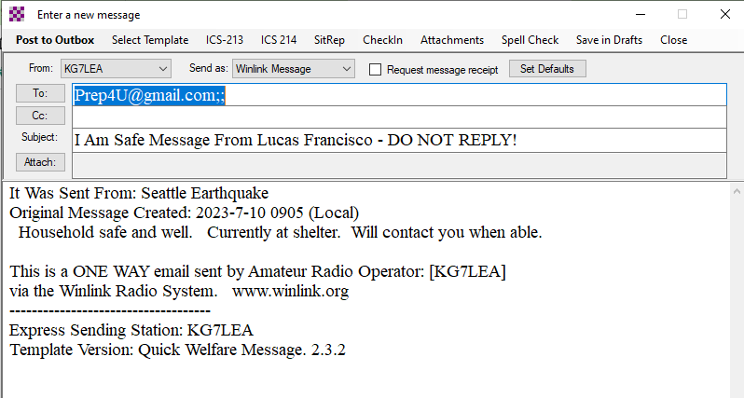
- Post to Outbox or
- Save to Drafts directory if the message is to be sent later. Move to Outbox when ready to send.
- Send via available RMS gateway. See Appendix 2 for strategies.

Paper Form with Cell Phone Number and Carrier

In Winlink Click on Message/New Message/Select Template to get the Template Manager
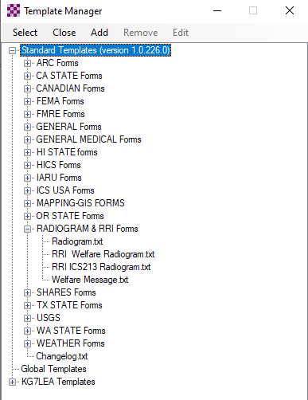

- Open Standard Templates
- Open RADIOGRAM & RRI FORMS
- Select RRI Quick Welfare Message.txt
- Transcribe information including the date and time.
- Click Submit
The Winlink message looks like this
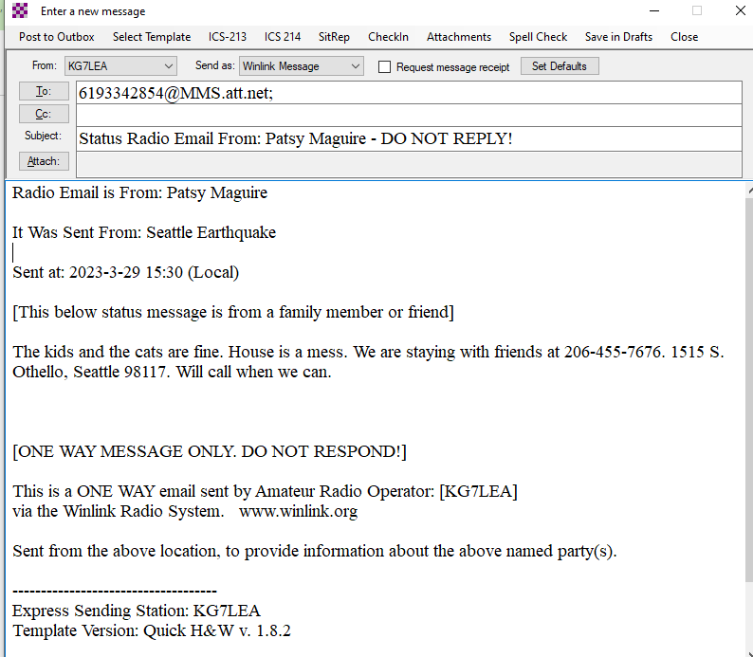
- Post to Outbox or
- Save to Drafts directory if the message is to be sent later. Move to Outbox when ready to send.
- Send via available RMS gateway. See Appendix 2 for strategies

Paper Form with Landline, Cell Phone Number (No Carrier), or Postal Address
In Winlink Click on Message/New Message/Select Template
- Open Standard Templates
- Open RADIOGRAM & RRI Forms.
- Select RRI Welfare Radiogram.txt. NOTE: This is a different form.
- Transcribe the information from the paper form.
- City and State are required. If no Zip Code available enter 00000.
- Enter the date and time from the paper form.
- Use “Click here to insert short prepared messages” and this box will appear
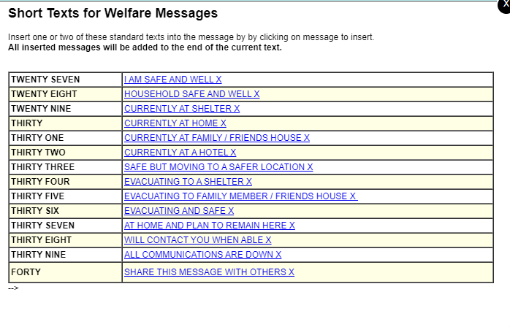
Select each of the numbered messages from the paper form. They automatically populate the template which will look like this.
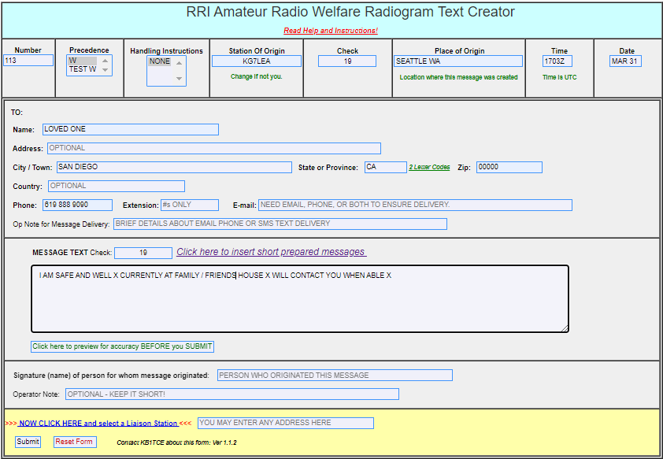
Use “NOW CLICK HERE and select a Liaison Station” for a list like this
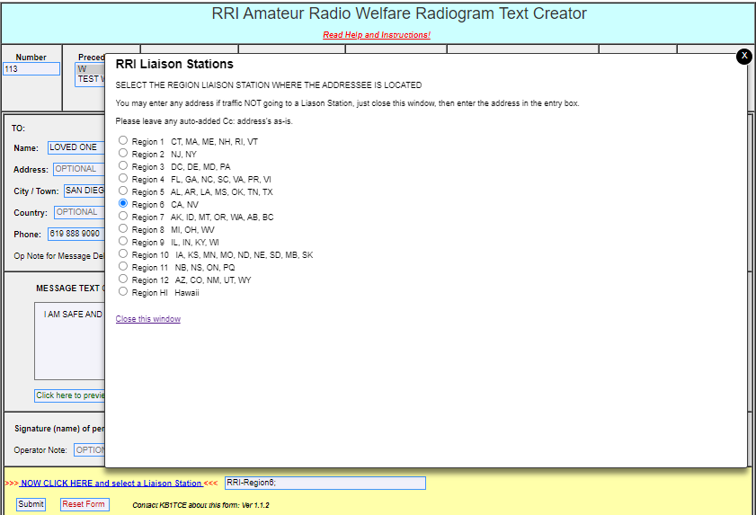

- Select the region with the state
- Close this window
- Submit. Prompts will appear if data is needed.
The Winlink message formatted for the traffic system appears like this
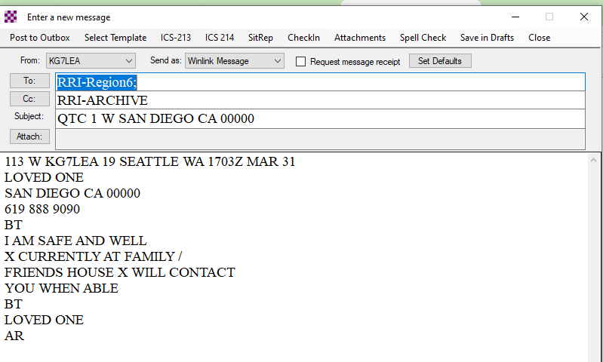

The template populates the appropriate addresses and formats the message for use by National Traffic System/RRI volunteers.
- Post to Outbox or
- Save to Drafts directory if the message is to be sent later. Move to Outbox when ready to send.
- Send via available RMS gateway. See Appendix 2 for strategies.
- Note the date and time sent on the paper form.

RRI Radiogram Option
Messages to landline numbers, cell phone numbers, and postal addresses can go to volunteer radio operators in the National Traffic System (NTS) and Radio Relay International (RRI) across the country. They will forward messages by telephone, text, or postal service.
Paper Form
The client completes a form using the short prepared messages from the list on the back.
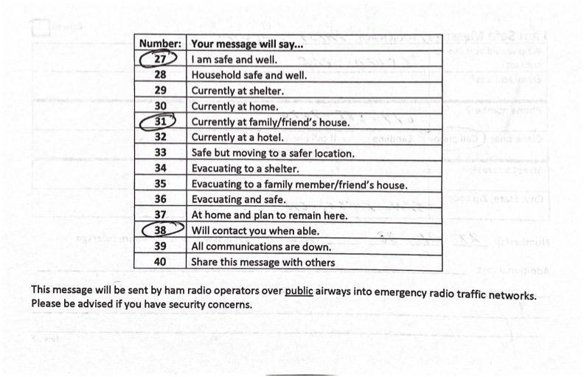
A city and state are REQUIRED. If you don’t know the zip code, use 00000.

- In Winlink click Message/New Message/Select Template/Standard Templates/RADIOGRAM AND RRI Forms
- Select RRI Welfare Radiogram.txt
- Transcribe information from the paper form.
- Use Click here to insert short prepared messages.
- Use Time and Date from the form.

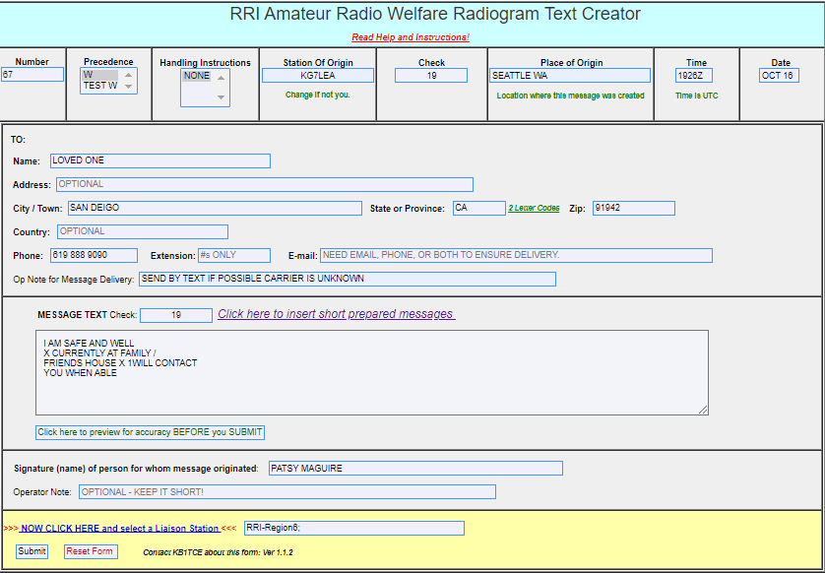

Use “NOW CLICK HERE to select a Liaison Station” for this menu. Select a region for the addressee.
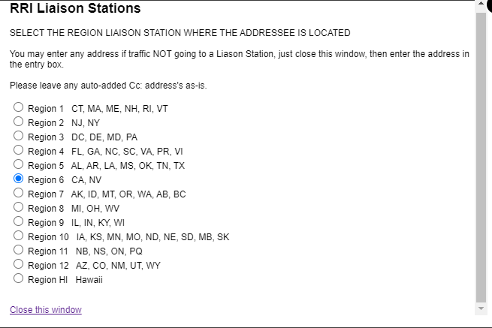
Click “Close this Window.”
- Click Submit.
The template populates a Winlink message something like
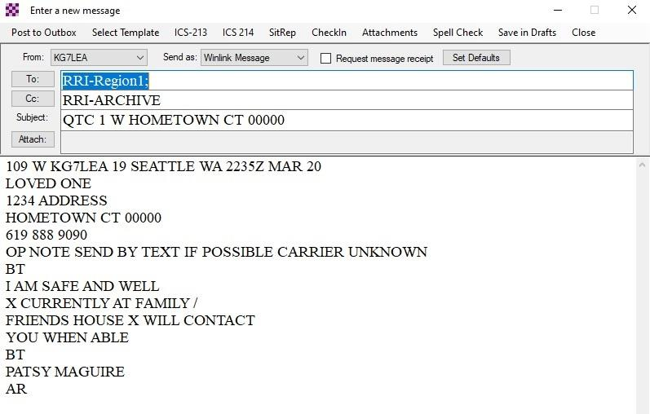

- Post to Outbox or
- If the message is to be sent later, save to Drafts directory. Move to Outbox when ready to send. See Appendix 2 for strategies.
- Send via available RMS gateway

Telephone Relay Person Option
A Relay Person is an individual outside the affected area who is willing to telephone loved ones and deliver their messages. The Relay Person needs to be able to receive emails and have the time and organizational skills necessary to complete the required tasks.
- Hubs can maintain a list of Relay Persons who have agreed to help, or they can identify someone they believe would be willing/able to help after the disaster.
- The Winlink Operator emails the Relay Person and confirms that they are willing/able to act as a Relay Person. The first message might read as follows...
Subject: Message from Ann Forrest in Seattle
As you may have heard, we have experienced a serious disaster and have lost all commercial communications. This is coming to you through a Ham radio operator and the Winlink global radio email system. We urgently need someone to forward “I Am Safe” messages from our neighbors to their loved ones out of the disaster area. Can you help?
These messages are very important to us.
This process will continue until commercial communications are restored here but you are free to let us know you cannot continue at any time.
If the workload becomes too much, consider recruiting trusted friends/neighbors to help out.
Please respond to this email letting us know if you are able to help - or not.
More information will follow.
Love,
Ann
- If the Relay Person agrees to help, the Winlink Operator might send the following:
Subject: “I Am Safe” Messages from Seattle
Dear Friend,
Thank you for helping us. You will receive emails from me with messages from our neighbors reporting their safety and well-being. Please telephone the person in the email and pass along the message. Explain to the person that you received the message via a Ham radio operator from the sender’s neighborhood.
Please keep track of your progress for example, message delivered, left a voicemail, no answer, wrong number, etc. Explain to each person that you will not be able to pass messages back to the sender.
Please email me once you receive this and let me know if you have any questions.
Best,
Dave, KG7LEA
Seattle Auxiliary Communications Service

- Digitizers create text messages from forms or interviews using the Off-line template or in plain text. For example:
To: Molly Maguire 619-888-9090
From Patsy Maguire. The kids and the cats are fine. House is a mess. We are staying with friends at 206-455-7676, 1515 S. Othello, Seattle 98117. Will call when we can.

To: Alex Hamilton, 714-244-3434
From: Jim Monroe. Aaron Burr is uninjured, but shaken. Tom Jefferson was at work and we have not heard from him yet. We are safe at home without power or cell service. Will let you know when Tom checks in.
From the text files provided by the Digitizer, the Winlink radio operator creates Winlink messages in batches that will look like
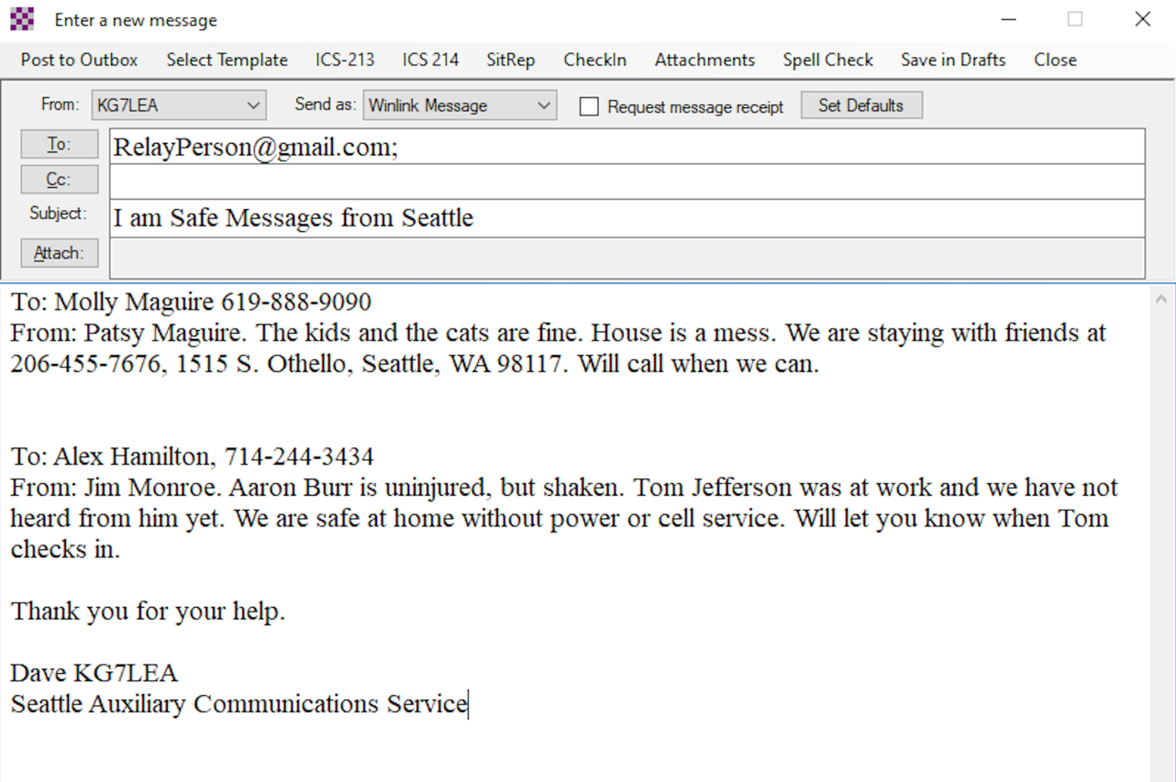
The Relay Person will telephone addressees and deliver the messages or leave voice mails.
- Avoid long-winded messages, but be complete and be compassionate. The volunteers in this process will be handling lots of traffic under difficult circumstances.
- Hub volunteers or the clients themselves should format the messages as above making certain each message is separate and clear. Several messages can be sent in the same email but the Relay Person needs to be able to distinguish between the calls to be made.
- Consider providing a Hub volunteer with a laptop and allow neighbors to compose their own messages. After screening for completeness, the composed messages can be saved to a thumb drive and given to the Winlink Operator for transmission.
- Post to Outbox or
- Save to Drafts directory if message is to be sent later. Move to Outbox when ready to send.
- Send via available RMS gateway

Thumb Drive with RRI Quick Welfare Message Files.
On the thumb drive in the “To Be Sent” folder with files such as

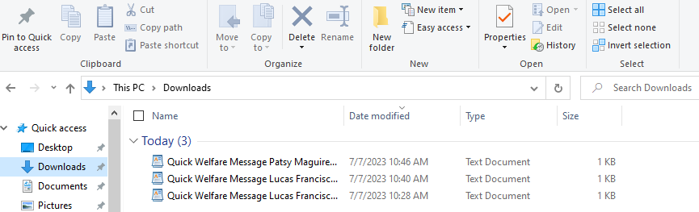
In Winlink Click on Message/New Message/Select Template
- Open Standard Templates
- Open Radiogram and RRI forms
- Select Quick Welfare Message.txt
Template opens
- Click on Load RRI Quick Welfare Data at top
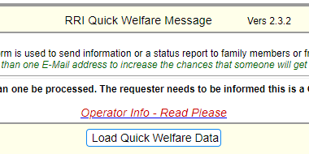
- Select file from To Be Sent folder. Data populates the template.
- Do not change the date/time.
Completed template will look like this
- Click Submit.
- Post to Outbox or
- Save to Drafts directory if the message is to be sent later. Move to Outbox when ready to send.
- Send via available RMS gateway
With the number and the cell phone carrier the addressee will receive a text message like this (varies by carrier)

Status Radio Email From: Patsy Maguire - DO NOT REPLY!
Radio Email is From: Patsy Maguire
It Was Sent From: Seattle Earthquake
Sent at: 2023-3-29 15:30 (Local)
[This below status message is from a family member or friend]
The kids and the cats are fine. House is a mess. We are staying with friends at 206-455-7676. 1515 S. Othello, Seattle 98117. Will call when we can.
[ONE WAY MESSAGE ONLY. DO NOT RESPOND!]
This is a ONE WAY email sent by Amateur Radio Operator: [KG7LEA]
via the Winlink Radio System. www.winlink.org
Sent from the above location, to provide information about the above named party(s).
------------------------------------
Express Sending Station: KG7LEA
Template Version: Quick H&W v. 1.8.2

Thumb Drive with RRI Welfare Radiogram File
Digitizers save a .txt file from an offline Winlink RRI Welfare Radiogram template. The .txt file will look like this (different from a template file above). This file does not populate into the Radiogram template. The information must be copied and pasted.

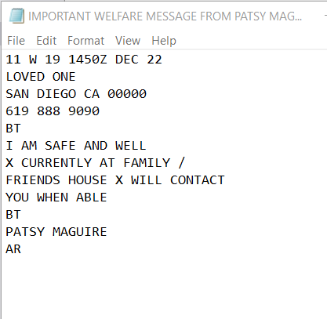

- Open Winlink, Select Message/New Message
- Copy and paste the contents of the .txt file into the body of the message.
- Address the message to “RRI-REGIONX” X being the number of the region from this list.

- In the Subject field enter “QTC” the number of the region, “W”, the city, the state, and the Zip Code. This helps the NTS route the message.
The Winlink message will look like this. Note the addressees and the Subject field.
- Post to Outbox or
- Save to Drafts directory if the message is to be sent later. Move to Outbox when ready to send. See Appendix 2 for strategies.
- Send via available RMS gateway
Back of paper form

This will require collaboration between the hub volunteers and the operator. There are two options, Telephone Relay Person and Radiogram.

Thumb Drive With Email Messages as .Txt Files
The “To Be Sent” folder on the drive will have plain .txt files such as
Prep4U@gmail.com
From Lucas Francisco
All safe and staying with friends. Will call when we can. I love you.
- In Winlink Click on Message/New Message/Select Template. Template Manager opens.
- Open Standard Templates
- Open Radiogram and RRI Forms

- Click on RRI Quick Welfare Message.txt
This template opens. Transcribe or cut and paste the information from the .txt file like this
Enter the date and time from the file on the thumb drive.
Click Submit to get a Winlink message like this

- Post to Outbox or
- Save to Drafts directory If the message is to be sent later. Move to Outbox when ready to send.
- Send via available RMS gateway. See Appendix 2 for strategies.
- On the thumb drive move sent files into a Sent folder.

Using A HF Relay Station If No FM Gateways Are Available
- Save each template message to a .TXT file in a folder using the Save Data button.
- Compress all the “I Am Safe” .TXT files into a Zip file
  - In Windows File Explorer select the .TXT files to be compressed.
  - Click on the Share tab
  - Click Zip
  - Zip file ready to be attached
- Establish voice contact with a HF Winlink station on a clear frequency and confirm they can handle Winlink traffic and can receive a Peer-to-Peer message. Net control can help locate a station.
- Compose a Winlink Peer-to-Peer message addressed to the HF station.
- Attach the Zip file.
- In the body of the message include these instructions for the HF station
Instructions for relaying Winlink welfare messages.
Thank you for agreeing to forward our welfare traffic. Attached to this message is a Zip file with individual .TXT files, one for each message. Open the Zip file and make note of where the files are saved on your computer.
Start a New Message in Winlink, one for each .TXT file.
Open a RRI Quick Welfare Message or RRI Welfare Radiogram template found under Standard Templates/Radiogram and RRI forms. The .TXT file name will indicate the template to be used.
From the template, Load the Data file. All the fields including the addressee will populate the template.
Update the date and time in the template with the information in the file name.
Click Submit. Save to Outbox.
Send the Winlink messages to an available HF RMS gateway.
Notify the originating station the messages were sent.
- Winlink Operator sends the Peer-to-Peer message with these instructions and the attached Zip file to the HF station.
- The HF station will send the messages.

Appendix 1 Cell Carrier Domains
If you have a cell phone number and know the carrier, you can address a Winlink email message directly to the addressee. It will arrive as a text message.
SMS is a short message, 160 characters.
MMS (best) can contain up to 1600 characters. This is best.
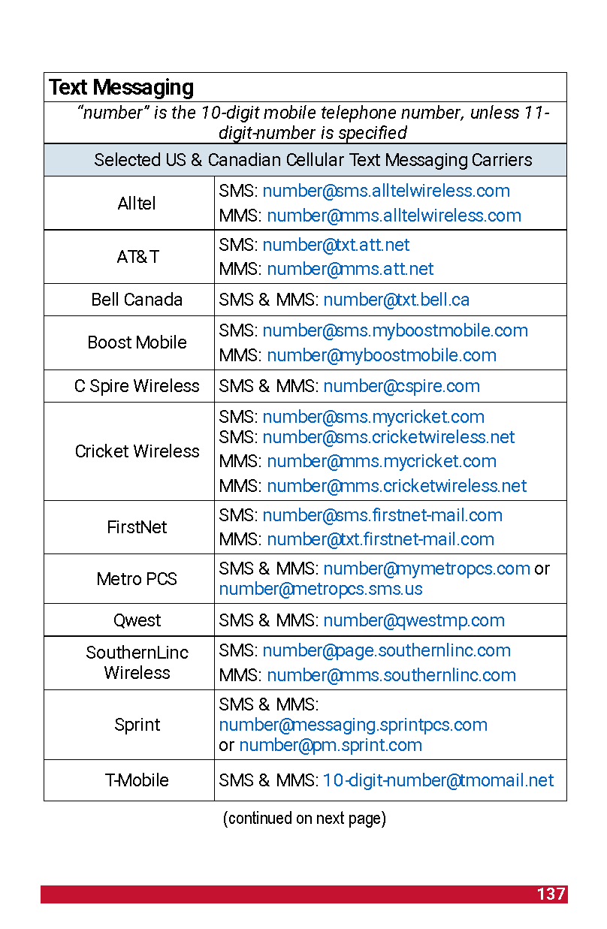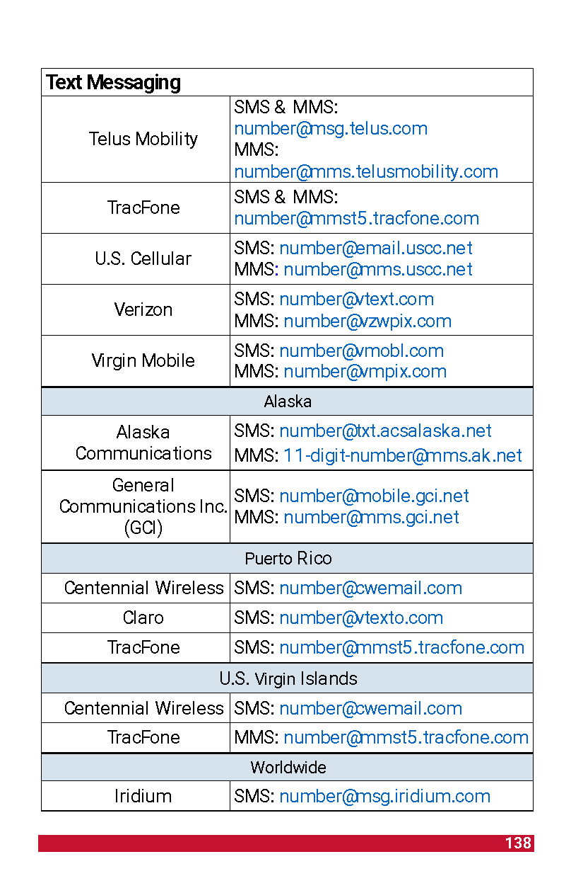
Source: Department of Homeland Security, National Interoperability Field Guide 2022

Appendix 2 Strategies for Winlink Operators
Ideally the hub ham/Winlink Operator will have a laptop, soundcard, and radio, and be able to send Winlink messages directly when net control determines “I Am Safe” traffic can proceed. Response and recovery traffic will have priority. There are a variety of solutions to passing this traffic.
- Send “I Am Safe” messages via a local Vara FM or Packet RMS gateway when net control approves.
- If a FM gateway is unavailable, send messages via Winlink Peer-to-Peer to a station with Winlink and access to HF, a FM gateway, or Telnet. This will require coordination by voice. Net control can provide guidance. See steps on page 51 for a relay strategy.
- If the communications outage is extensive and local gateways are not functioning at all, HF stations with Winlink might be able to send traffic outside the affected area. See steps on page 51.
- If a Starlink or Hamwan dish is available, use that Internet signal to send messages using Winlink Telnet. This is a really good solution to an Internet and cell phone outage.
- If the hub ham has no Winlink capability, ask net control what stations can handle “I Am Safe” traffic. Net control is your friend. This might be a ham at another hub or a ham at home with the necessary equipment. It may take time, several days even, to establish processes for moving this traffic. Completed forms and thumb drives will need to be hand-carried to these stations. Keep track of messages transferred in this way.
As commercial communications are gradually restored, continue to send “I Am Safe” messages until all are handled.
Have a volunteer stationed near the operator to answer questions from visitors and collect information. This keeps the operator from becoming distracted.
It may be easier for the operator to compose all Winlink messages on a laptop directly from the paper forms completed by the clients. Work with your hub team for the best solutions. Use hub volunteers to spread the work especially in transcribing messages to a laptop. There is no single right solution.
Moving “I Am Safe” messages by voice is error-prone, ties up a frequency, and could compromise client privacy. Use voice for welfare traffic only if net control approves. Always ask, “Is this frequency available?” before transmitting over an open channel.
Do not send images in “I Am Safe” messages.
Reunification messages are intended within the affected area and are handled differently. That procedure is also in the hub box.
KEEP A LOG of messages sent or not sent. Winlink tracks outgoing messages and you can create a report at Message/Generate ICS-309 Communications Log. Winlink has other forms in the template directory such as an ICS-214 the operator can maintain and save on the laptop.

Appendix 3 Off-Line Help Documentation from Radio Relay International

Overview
This template is an off-line version of the Quick Health and Welfare or Information Message that is included in the Winlink Express Standard Templates. This form may be found under General - Quick Welfare Message. There is also a link from the Radiograms and RRI Forms folder.
The off-line form also adds functionality for sending a message to an SMS or MMS text address. As an adjunct to the RRI Welfare Radiogram template, it also contains 14 standardized short text messages that may be selected from a drop down list.
Unlike the Winlink Express version, there is no coupling to the message transmission function. Instead, the user may either save the file to any chosen location or the message may be sent by standard email if the internet is available to the operator.
This off-line version may be used in situations where there are many parties in a given location wishing to send radiograms. This template may be run on any computer with a web browser.
For example, in a shelter where many people may wish to send messages to loved ones, copies of the template may be installed on thumb drives and then be given to the data entry people. They would then create individual messages, saving each one to the thumb drive. The drives can then be given to a radio operator for sending.

Installation
When used in a shelter environment an appropriate method for deployment is to install the template files on thumb drives. There are two files that are distributed as a zip file. They are RRI Welfare Message.txt and RRI Welfare_Message.html. Both must be installed in the same location.
To use the template, open the html file and the template will appear in the browser.
If the internet is available, the message may be sent by standard email using the Send to Email button. Otherwise, save the file to the thumb drive. Be sure you have set your browser preferences to ask for the save to location. This will permit you to select the correct drive and also permit you to change the file name from the default.

Form Use and Guide
This is a one way form template to allow simple status of an individual or family to be sent to E-mail address(es). This does not supplant the Red Cross Safe and Well process, it is a simple delivery to email(s) that are outside the affected area.
There is no anticipated reply and the party(s) you are sending for needs to be informed of this. The message is formatted as plain text in the body of the sent email and easy to read by the recipient(s)

Why No Reply?
It will be too distracting to attempt to process replies and then figure how to deliver them. You also may not be the person sending all the time with your Winlink Base call-sign. Replies would garner the need for responses back, thus the information chain and effort to maintain become difficult and time consuming.
Form Information
- BE SURE TO INFORM THE PARTY THIS IS ONE WAY WITH NO GUARANTEE OF DELIVERY Why? You are sending to an email address that has to be received and READ by the intended party(s).
- From Name: This needs to be the person's full name that you are sending for. Example: John S. Borman OR John Borman and Cinthia Faux OR The John Borman Family.
- To Email(s): Suggest more than one email to try to ensure several friends or family obtain, separated by a semicolon; You can modify or change prior to posting. Verify with the party prior to posting and sending!
- Add a SMS address: If you know the mobile phone number and the carrier (ATT, Verizon, etc.) you can send a text message to that number. Enter the 10 digit phone number with no spaces or other characters and then select the carrier from the drop down list. Use the MMS listing to assure that the complete message will be received. SMS may either truncate the message or send it as multiple messages. When the information has been added, click the Enter Text Address to To Line button to move the information to the To Email line.
- Incident/Event location or Region/Area Name: be descriptive as to your location, the disaster name, anything that will ensure the recipient(s) know where you are sending from. This entry will be retained for follow-on messages.
- Message: This is a brief message from the person and is limited to 500 characters. This keeps messages short and brief. You can select from a list of standard short prepared messages. These messages coincide with the short texts in the RRI Welfare Radiogram.
- Example: The family and I are fine at a Red Cross shelter at the Berkins High School in Parkinsville. Will contact again when we can. Please inform all.
- The sent email is in plain text and informs the recipient(s) this is a ONE WAY message and DO NOT REPLY. Again be sure your party knows this and again suggest several emails.
Questions or suggestions concerning the Radiogram templates or their use may be submitted via Winlink to KB1TCE.
Help File - The Off-Line Amateur Radio Welfare Radiogram Text Creator

The Winlink Express Amateur Radio Welfare Message Text Creator is a special purpose adaptation of the general purpose Amateur Radio Radiogram Text Creator. It is fully compliant with the amateur radio radiogram format but includes some special features and excludes items that are not necessary. It was developed as a cooperative effort between the Seattle Emergency Communication Hubs (http://seattleemergencyhubs.org/), Seattle Auxiliary Communication Service (ACS) (https://www.seattleacs.org/), Radio Relay International (radiorelay.org) and the Winlink Development Team (winlink.org). The Northwest Washington American Red Cross provided additional input with regard to the short message texts.
This Text Creator template is intended for brief outbound Welfare/Safe and Well communications from a person in a disaster area to family/loved ones. There are a couple of differences from the standard general purpose Radiogram Text Creator template:
- The preamble is simplified. Precedence is restricted to Welfare and Test Welfare, there are no handling instructions and UTC is autofilled as the time of origination.
- There is a list of suggested short messages that may be inserted into the message text. These are, in some part, derived from the American Red Cross Safe & Well list of short texts. In the drop down list, clicking on any item will transfer the text into the message pane;. More than one standard text can be added as well as free text but the check should still stay within 25 groups.

Some Guidelines
Be sure to inform the party that is sending the message that this is a one way communication with no guarantee of delivery. It’s a volunteer service by amateur radio operators and a best effort is made in every case.
The best practice is to get as much information about the addressee as possible. The traffic network is forgiving to some extent and the delivering operator can do some additional research if possible and practical.
For example, the sending party may not know the postal (zip) code of the addressee. There are off-line look up lists that may be downloaded free or for a nominal fee, At the minimum, the state is required and the first two digits of the zip code followed by 000, e.g. 04000. This will get the message to the correct state.
Also, if the phone number or email address is known, the message may be delivered from any location that has one or both of those services available.
Delivery methods include telephone, email and USPS letter. If the recipient can receive text messages, that should be indicated in the OP NOTE.
For handling a volume of messages, it is recommended to use the off-line version of this template. The off-line tool runs in a browser and outputs a file in the correct format for the radio operator to send.
For raw input information, there is a Multi-Client Worksheet. that may be found in Winlink Express. It is located in the same folder as this Radiogram template. Just click on "Multi Client Work Sheet.txt". Printed copies may be handed out to facilitate template entry, when you have many wishing to send a Radiogram. This worksheet is an HTML, that you can open and then copy/paste to any text editor.

General Information
The purpose of any of the family of Winlink Express Radiogram Text Creators is to provide a structured forms-based approach to producing a correctly formatted radiogram with a text output that appears in the Winlink Express New Message panel. The completed radiogram can then be sent to a regional Winlink-RRI Liaison Station. That station will then inject the radiogram into the traffic system.

A radiogram is simply a telegram message that is sent by a radio-only network that is comprised of amateur radio operators. These interoperable networks are sponsored by the ARRL (National Traffic System or NTS) and by Radio Relay International (RRI). The networks use phone, cw (Morse code) and digital modes. The cw and phone nets operate through a precisely sequenced and layered system of nets that cover local, section, region, area and transcontinental relays. The digital system consists of a mesh network configuration of automated data mode hubs that are accessed by appointed Digital Traffic Station (DTS) operators.
The system is structured to move many messages out of a disaster zone to a point near the destination.

The Radiogram Format
The radiogram format has been in existence since 1949 and is very similar to the old commercial Western Union telegram as well as contemporary military formats.
The radiogram has 4 primary sections, The following describes this Welfare specific version.
• The first line is the preamble and includes the message number (assigned by the originating station) and precedence (classification of the message i.e. Welfare or Test Welfare). This is followed by handling instructions for the delivering station. In this case there are no handling instructions since the message flow is one way from the affected area. The originating station is for the amateur radio call sign of the sending station. The check is the number of words/groups in the message body. The place of origination is the town and state (e.g. SEATTLE WA) where the message was created. This is followed by the time and date of origination.
• The preamble is followed by the recipient’s address and contact information. It is very important to note that routing through the entire system is based on the recipient’s postal code, state and town. The street address and phone number (10 digits only 555 555 5555) and other information are used by the delivering station.
It is understood that in a situation where there are people who are displaced from their homes that they may not have complete contact information. The network is guided by human operators and it is possible to deliver messages with some level of incomplete information. Name, town and state are very important. An email address and state is sufficient if it is valid. Likewise a mobile phone number is sufficient and even better if it can accept text messages.
• The message body is enclosed between breaks (BT). For compatibility with all transmission modes, the radiogram uses a limited character set, as is true throughout the radiogram. The period character is interesting as there are several uses. A period at the end of a sentence becomes an X. A decimal point is R, such as 146R750 The ".com” in an email address is DOT COM. Other substitutions include QUERY for the question mark, ATSIGN for @, UNDERSCORE for _. The slant bar (slash) / is a permitted character. Telephone numbers are 10 digits - area code, exchange and number with no dashes. An entered extension is numbers only and will add EXT to the front. The / (stroke) can be entered and will remain as a /. The Text Creator assists with all of this by making the substitutions for you, or not allowing certain characters.

• The last section is the signature of the sender. All radiograms must have a signature, (name). In the case of Welfare 3rd party messages, the signature is that of the person who provided the message - not the originating stations ham radio operator.
The first OP NOTE is for special instructions to the traffic handlers. This could be a note that the addressees phone number is a daytime work number, additional delivery instructions, etc. This is a place where the mobile phone provider (e.g. Verizon) could be added to simplify the process for delivery by text message.
The second OP NOTE is normally reserved for reply instructions but is not normally used for one-way Welfare traffic.
Please keep OP NOTES brief!

Getting the Message into the System
The traditional way to get a message into the network is to check into a local or section traffic net and transmit the message by voice or cw. As a Winlink Operator, you will need to get your message to a Winlink-RRI Liaison Station. These are listed as tactical addresses in the drop down at the bottom of the form. When you are ready to send your message, select the Liaison Region that is associated with the addressee's location.
The most up to date information on RRI and message handling is being provided by Radio Relay International http://radiorelay.org/.
The Traffic Operations Aid or Pink Card is a concise 2-page summary of radiogram formatting and transmission procedures for voice, cw and digital. Have a copy at your operating position as you enter a message into the Winlink Text Creator.
Direct link to the PDF: https://img1.wsimg.com/blobby/go/a7c9f25d-31a7-4462-ba9c-709656c16385/downloads/RRI-TRAFFIC-OPERATIONS-AID-1720r3.pdf?ver=1659017815248
The RRI Publications page https://radiorelay.org/publications has a number of other useful guides and aids. Two of special note are the Traffic Operations Field Manual FM-001 and the RRI Training Manual TR-001.
Questions or suggestions concerning the Radiogram templates or their use may be submitted via Winlink to KB1TCE

