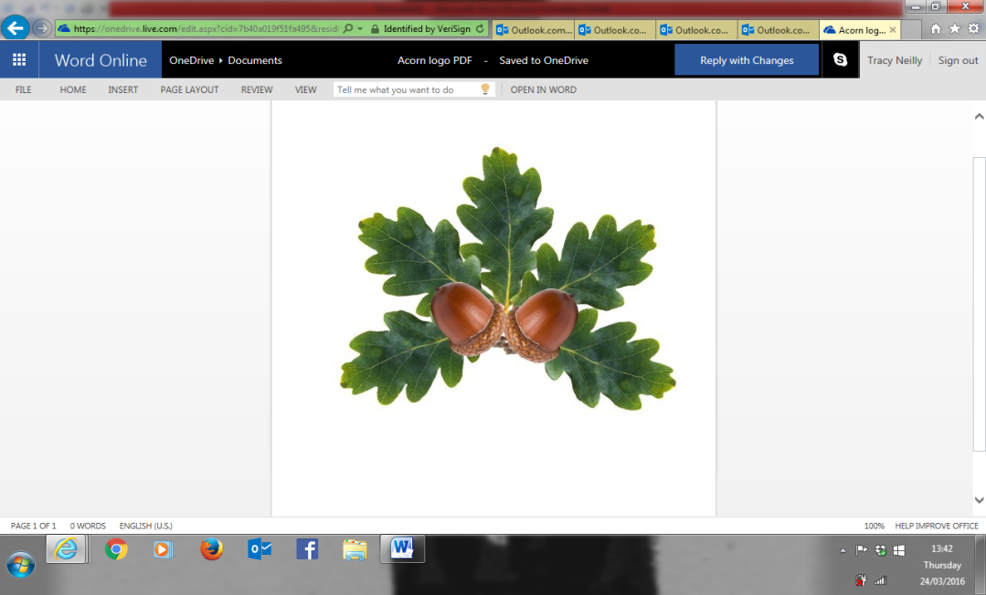

**Little Acorns Pre-School Folkestone C.I.O**

**Grounds of**

**Folkestone Baptist Church**

**Hill Road**

**Folkestone**

**Kent**

**CT19 6LY**

**Manager: Mrs T. Neilly**

**Tel: 01303 245562**

**Ofsted No: 2774263 Mobile: 07879202160**

**Registered Charity No:1204181 E-mail:littleacorns13@hotmail.co.uk**

Child’s Name: ……………………………………………………………..

**Delivery Pattern**

|  |  |  |  |  |
| --- | --- | --- | --- | --- |
| **Day** | **Early Bird** | **Morning** | **Afternoon** | **Full Day** |
| Monday | 8:15am-9:15am (1 hour) | 9:15am- 12:15pm (3 hours) | 12:15pm- 3 :15pm (3 hours) | 9:15am-3 :15pm (6 hours) |
| Tuesday | 8:15am-9:15am (1 hour) | 9:15am- 12:15pm (3 hours) | 12:15pm- 3 :15pm (3 hours) | 9:15am- 3 :15pm (6 hours) |
| Wednesday | 8:15am-9:15am (1 hour) | 9:15am- 12:15pm (3 hours) | 12:15pm- 3 :15pm (3 hours) | 9:15am- 3 :15pm (6 hours) |
| Thursday | 8:15am-9:15am (1 hour) | 9:15am- 12:15pm (3 hours) | 12:15pm- 3:15pm (3 hours) | 9:15am- 3 :15pm (6 hours) |
| Friday | 8:15am-9:15am (1 hour) | 9:15am- 12:15pm (3 hours) | 12:15pm- 3 :15pm (3 hours) | 9:15am- 3 :15pm (6 hours) |

**Please circle the individual sessions above that you require for your child**

Fees

Any sessions you require outside of your child’s free hours will be charged as set out below:

Each 3-hour session is charged at £18  
Each 6-hour session is charged at £36.

Sessions can be changed by giving a terms notice.

Fees for the term will be issued at the beginning of each new term. These can be paid as and when but MUST be paid in full, by the date set by the Pre-School before the end of each term.

Fees are calculated for the whole term for the days your child attends. This means that if your child has time off due to sickness or holiday, you will still be charged. If Pre-School cancels a session, you will not be charged. This is an Ofsted policy.

**If you are late collecting your child, you will be charged £10.00 per 15 minutes your child is in Pre-School after 12:15pm or 3:15pm. These charges apply whether your child is in receipt of Free Early Education or not**

Signed: _____________________ (Parent/Guardian) Date: ___________________