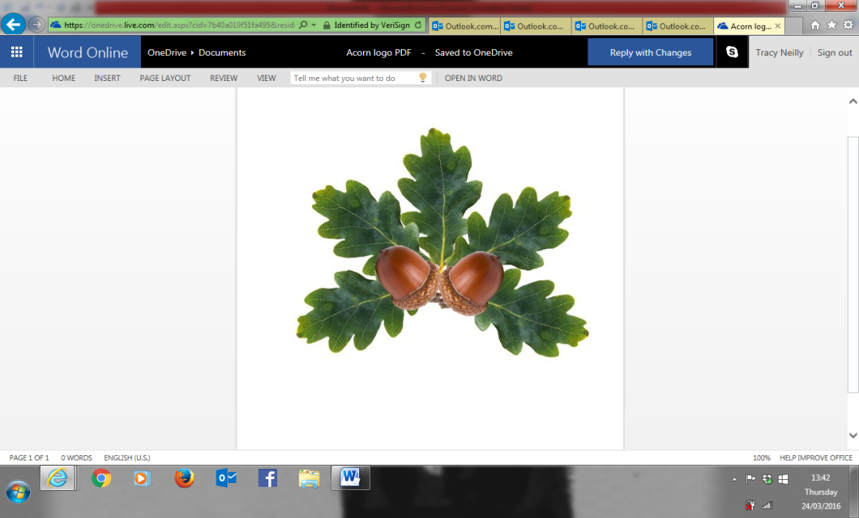 **Little Acorns Pre-School Folkestone CIO**

**Grounds of**

**Folkestone Baptist Church**

**Hill Road**

**Folkestone**

**Kent**

**CT19 6LY**

**Manager: Mrs T. Neilly**

**Tel: 01303 245562**

**Ofsted No:2774263 Mobile: 07879202160**

**Registered Charity No:1204181 E-mail:littleacorns13@hotmail.co.uk**

Concerns and Complaints

A concern may be defined as *‘an expression of worry or doubt over an issue considered to be important for which reassurances are sought’*. A complaint may be defined as ‘*an expression of dissatisfaction however made, about actions taken, or a lack of action’*.

We hope you and your child will always be happy here at Little Acorns. If, however, you are unhappy about anything, please do not hesitate to speak to myself or any member of staff to make us aware.

I will do my upmost to rectify the issue as quickly as possible and keep you updated of the progress.

If you are not satisfied with how the issue has been dealt with and would like to make a formal complaint, you can contact the Little Acorns committee team by telephone.

Name: Claire Harris - Chairman

Email: clairepillips_99@hotmail.co.uk  
Telephone: 07799875799

If you are unsatisfied with how your formal complaint has been dealt with

, you can contact.

**Ofsted by telephone.  
  
Telephone: 0300 123 1231**